**Workshop on “Entrepreneurship Orientation Program”**

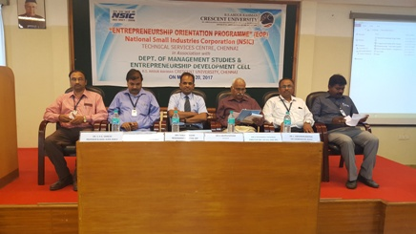

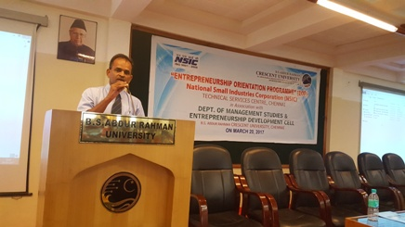

**Resource Person : Mr.T. Vallinayagam, NSIC, MSME**

**Date : 20th March 2017**

**Venue : BSA University**