**One day workshop on “Composite design” and “Paper Presentation”**

Association of Polymer Technologist (APT) organised one day workshop on “Composite design” and “Paper Presentation” during Crestech 2017 on 24 – 25 March, 2017. More than 50 participants and 30 teams respectively from various technical universities and engineering institutions participated.

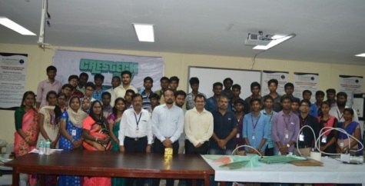

**Date : 24 – 25 March, 2017**