Training Workshop on Financial Mathematics with hands on R Programming

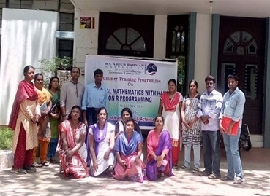

Date : 6th June – 11th June 2016.

Venue : BSA University