**"Advanced Composite Materials- A Research Perspective" National workshop**

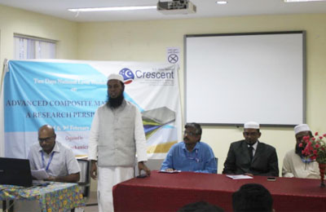

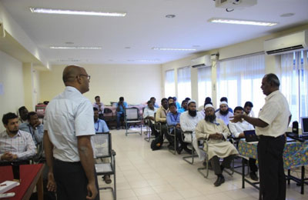

Presentation - Dr. M. Balasubramanian, Professor, Dept. of Metallurgical & Materials Engg – IIT MADRAS

**VENUE : B. S. Abdur Rahman Crescent Institute of Science&Technology, Chennai**

**Date : 2 -3 February 2018**

**Participation: 42 members of** Academicians, Researchers and Scientists