**“Development of Materials for Aerospace applications” National Seminar**

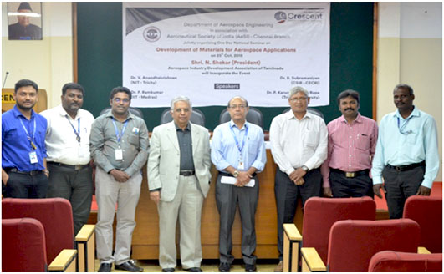

**Venue : Department of Aerospace Engineering,**

**B S AbdurRahman Crescent Institute of Science & Technology.**

**Date : 25th Oct 2018**