**"Application of Civil Engineering Softwares" - Two day workshop**

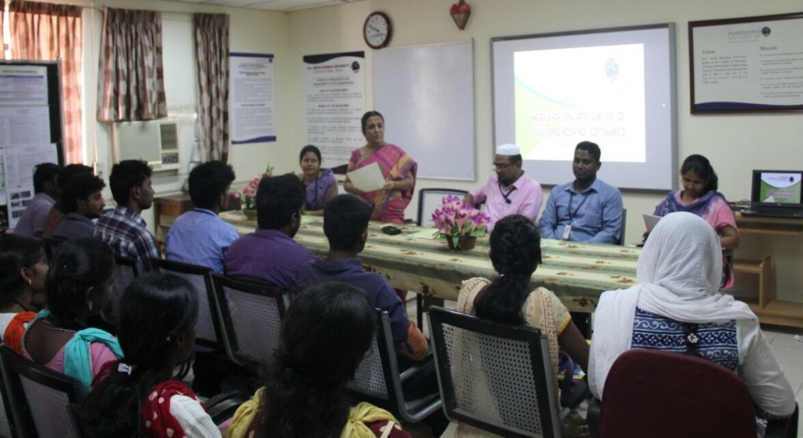

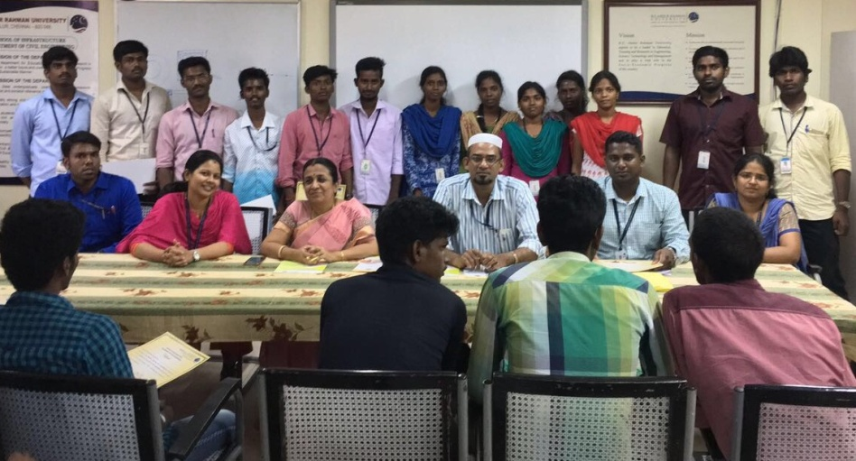

**Venue: Department of Civil Engineering B.S.Abdur Rahman University**

**Date : 22-23 March 2017**