Workshop on “Industrial IoT for Remote Monitoring and Management”

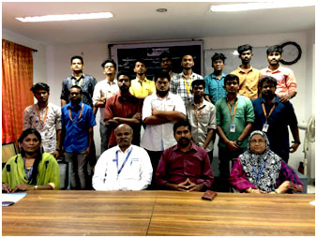

**Date : 21-22 March 2019**

**Venue: B S ABdur Rahman University**

**Participants : Department of Electronics and Instrumentation Engineering in association with Ostara Research (Alumni ICE) and Denvik Technologies (Alumni ECE)**