**Programme on Data Science and Big Data Analytics**

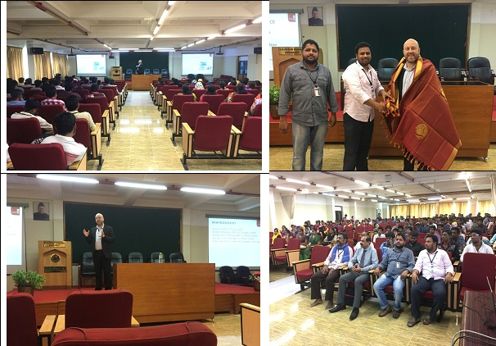

**Guest Speaker - Mr. NicoDecourt, Staffordshire University**

**Participants - Faculty**

**Venue - BS Abdur Rahman University**