**Workshop – Internet of Things**

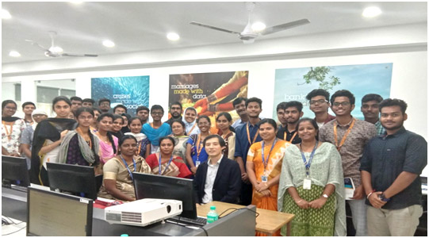

**Guest Speaker - Dr.Kazuaki Tanaka, Assoc.Prof., Kyushu Institute of Technology, Japan**

**Participation - Dept of CSE Students - BSAU**

**Date - 21st January, 2019**