Speech Segmentation using OTSU, K-MEANS and FCM Clustering Algorithm

- Speech Signal
- Speech Spectrogram
- Binary Image using
  - OTSU Method
  - K-Means Clustering Algorithm
  - FCM Clustering Algorithm
- Blocking Black Area Method
- Image Segmentation using Shape Recognition

PX NO. | GRAY VALUE | MS VALUE ASSOCIATED WITH CLASS#1 | MS VALUE ASSOCIATED WITH CLASS#2 | MS VALUE ASSOCIATED WITH CLASS#3 | CLOSEST CLASS
1 | 0.000 | 0.976 | 0.019 | 0.006 | 1
2 | 0.000 | 0.976 | 0.019 | 0.006 | 1
3 | 0.098 | 0.997 | 0.002 | 0.001 | 1
4 | 0.588 | 0.006 | 0.984 | 0.010 | 2
5 | 1.000 | 0.000 | 0.000 | 1.000 | 3
6 | 1.000 | 0.000 | 0.000 | 1.000 | 3
7 | 0.000 | 0.976 | 0.019 | 0.006 | 1
8 | 0.098 | 0.997 | 0.002 | 0.001 | 1
9 | 0.322 | 0.431 | 0.512 | 0.057 | 2
10 | 0.588 | 0.006 | 0.984 | 0.010 | 2
11 | 0.588 | 0.006 | 0.984 | 0.010 | 2
12 | 1.000 | 0.000 | 0.000 | 1.000 | 3
13 | 0.098 | 0.997 | 0.002 | 0.001 | 1
14 | 0.322 | 0.431 | 0.512 | 0.057 | 2
15 | 0.588 | 0.006 | 0.984 | 0.010 | 2
16 | 0.322 | 0.431 | 0.512 | 0.057 | 2
17 | 0.161 | 0.945 | 0.046 | 0.010 | 1
18 | 0.588 | 0.006 | 0.984 | 0.010 | 2

PX NO. | GRAY VALUE | MS VALUE ASSOCIATED WITH CLASS#1 | MS VALUE ASSOCIATED WITH CLASS#2 | MS VALUE ASSOCIATED WITH CLASS#3 | CLOSEST CLASS
19 | 0.588 | 0.006 | 0.984 | 0.010 | 2
20 | 0.588 | 0.006 | 0.984 | 0.010 | 2
21 | 0.161 | 0.945 | 0.046 | 0.010 | 1
22 | 0.098 | 0.997 | 0.002 | 0.001 | 1
23 | 0.098 | 0.997 | 0.002 | 0.001 | 1
24 | 0.322 | 0.431 | 0.512 | 0.057 | 2
25 | 0.588 | 0.006 | 0.984 | 0.010 | 2
26 | 0.322 | 0.431 | 0.512 | 0.057 | 2
27 | 0.098 | 0.997 | 0.002 | 0.001 | 1
28 | 0.000 | 0.976 | 0.019 | 0.006 | 1
29 | 0.000 | 0.976 | 0.019 | 0.006 | 1
30 | 0.098 | 0.997 | 0.002 | 0.001 | 1
31 | 1.000 | 0.000 | 0.000 | 1.000 | 3
32 | 0.588 | 0.006 | 0.984 | 0.010 | 2
33 | 0.322 | 0.431 | 0.512 | 0.057 | 2
34 | 0.000 | 0.976 | 0.019 | 0.006 | 1
35 | 0.000 | 0.976 | 0.019 | 0.006 | 1
36 | 0.000 | 0.976 | 0.019 | 0.006 | 1

PX. NO. | GRAY VALUE | BELONGING CLASS
1 | 0.000 | 3
2 | 0.000 | 3
3 | 0.098 | 3
4 | 0.588 | 2
5 | 1.000 | 2
6 | 1.000 | 2
7 | 0.000 | 3
8 | 0.098 | 3
9 | 0.322 | 1
10 | 0.588 | 2
11 | 0.588 | 2
12 | 1.000 | 2

PX. NO. | GRAY VALUE | BELONGING CLASS
13 | 0.098 | 3
14 | 0.322 | 1
15 | 0.588 | 2
16 | 0.322 | 1
17 | 0.161 | 3
18 | 0.588 | 2
19 | 0.588 | 2
20 | 0.588 | 2
21 | 0.161 | 3
22 | 0.098 | 3
23 | 0.098 | 3
24 | 0.322 | 1

PX. NO. | GRAY VALUE | BELONGING CLASS
25 | 0.588 | 2
26 | 0.322 | 1
27 | 0.098 | 3
28 | 0.000 | 3
29 | 0.000 | 3
30 | 0.098 | 3
31 | 1.000 | 2
32 | 0.588 | 2
33 | 0.322 | 1
34 | 0.000 | 3
35 | 0.000 | 3
36 | 0.000 | 3

M15

 | Original Speech | Spectrogram
Sentence #1  No. of Words = 6 | 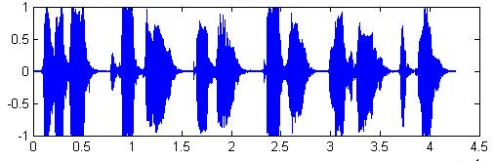 | 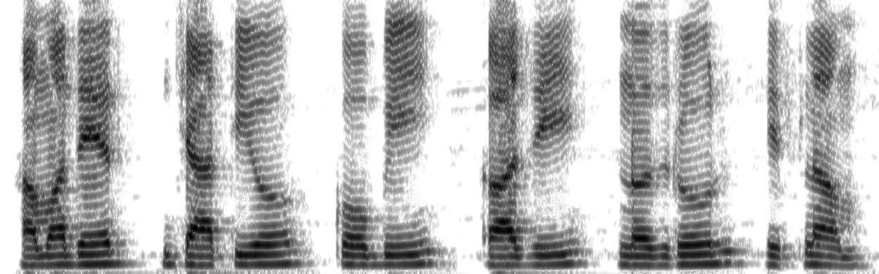
Binary Image using OTSU Method | Blocking Black Area | Segmentation
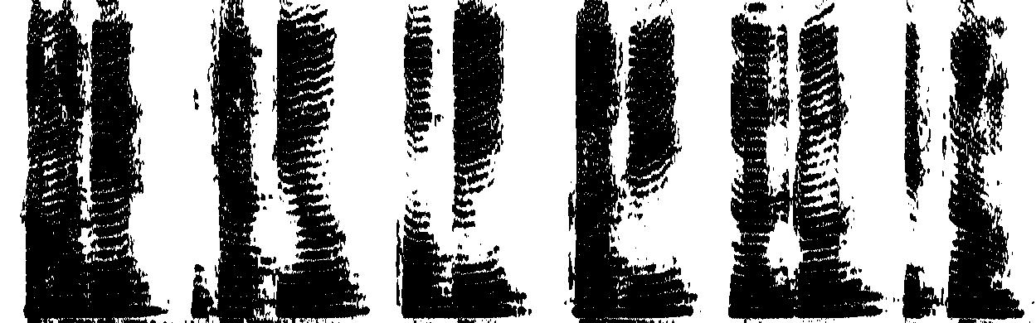 |  | 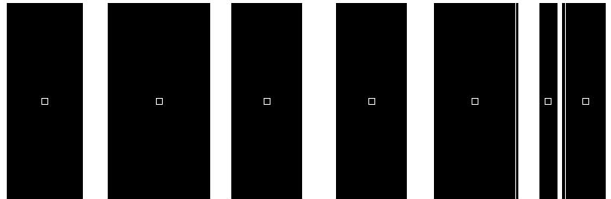7
Binary Image using K-MEANS Clustering
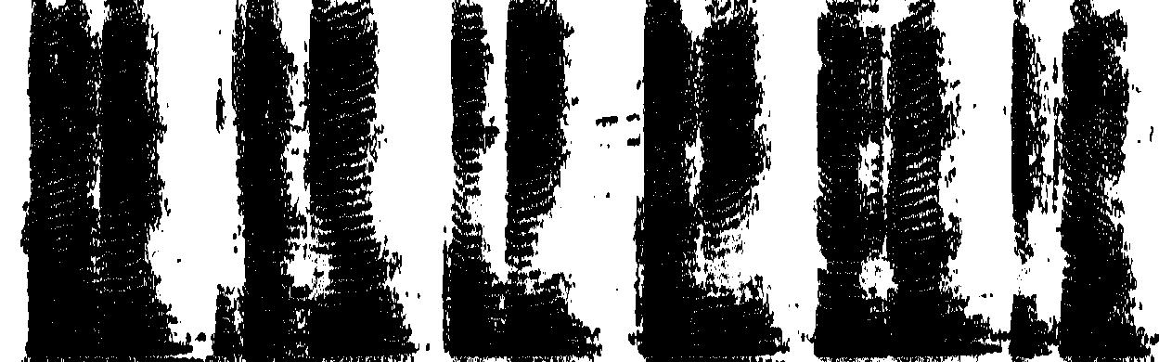 |  | 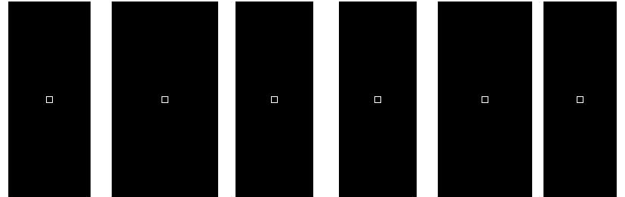6
Binary Image using FCM Clustering
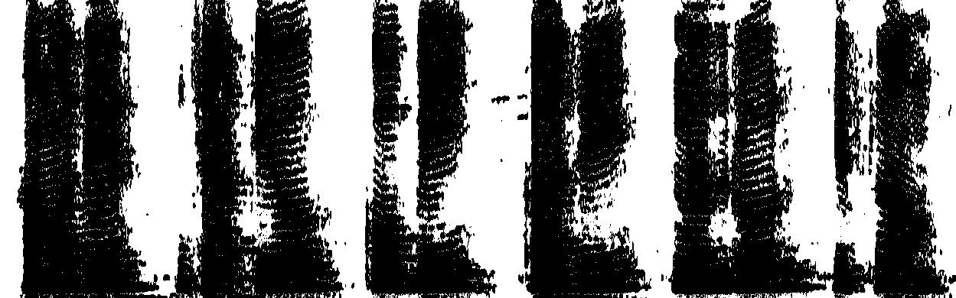 |  | 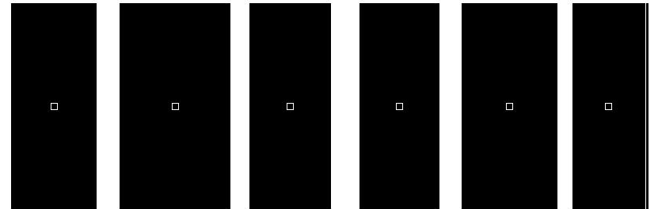6

M25
Spectrogram
 | Original Speech | Spectrogram
Sentence #2  No. of Words = 10 | 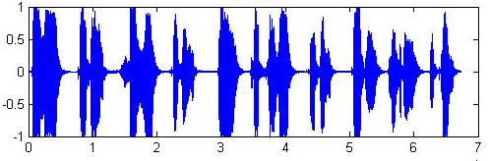 | 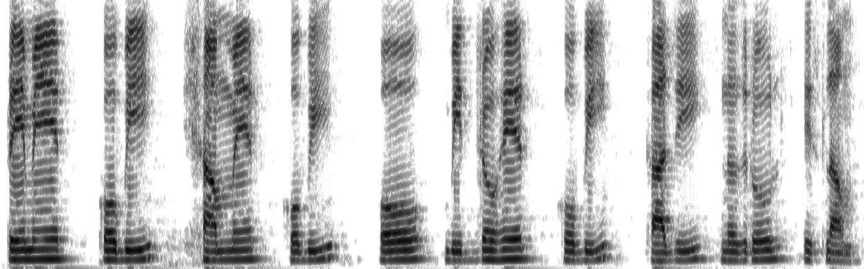
Binary Image using OTSU Method | Blocking Black Area | Segmentation
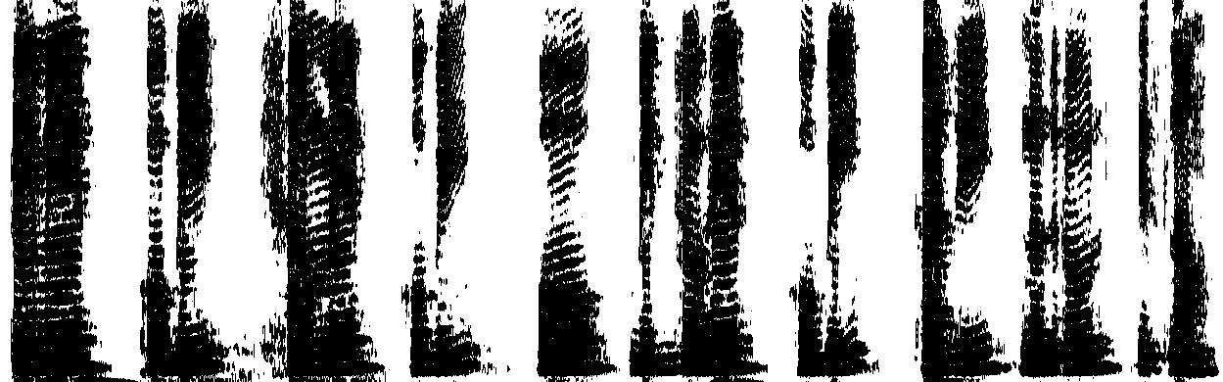 | 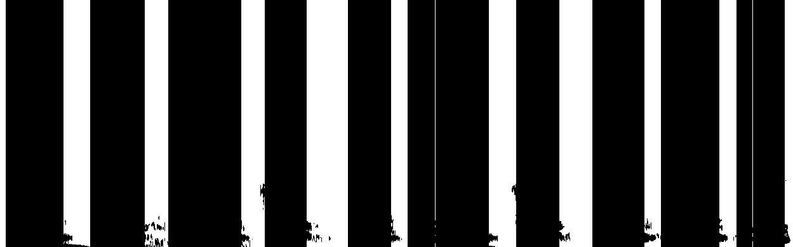 | 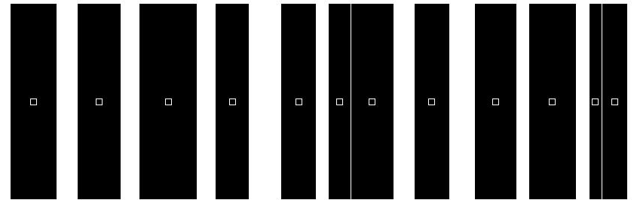12
Binary Image using K-MEANS Clustering
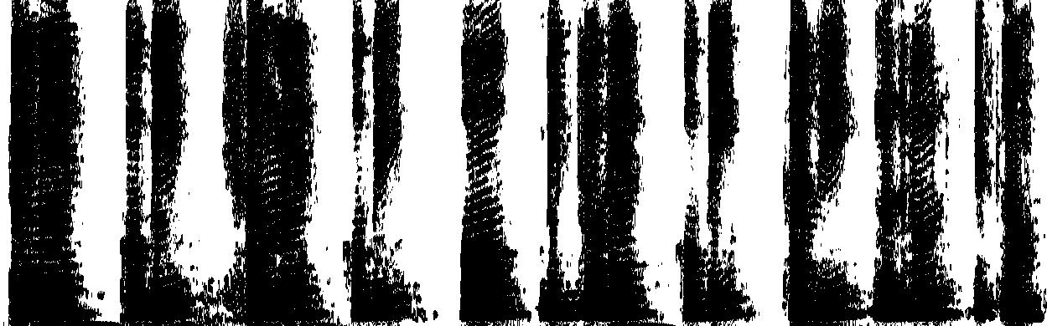 |  | 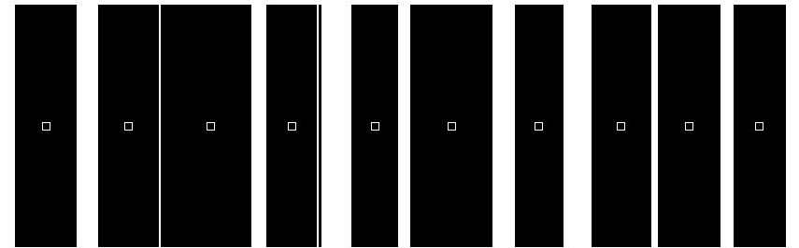10
Binary Image using FCM Clustering
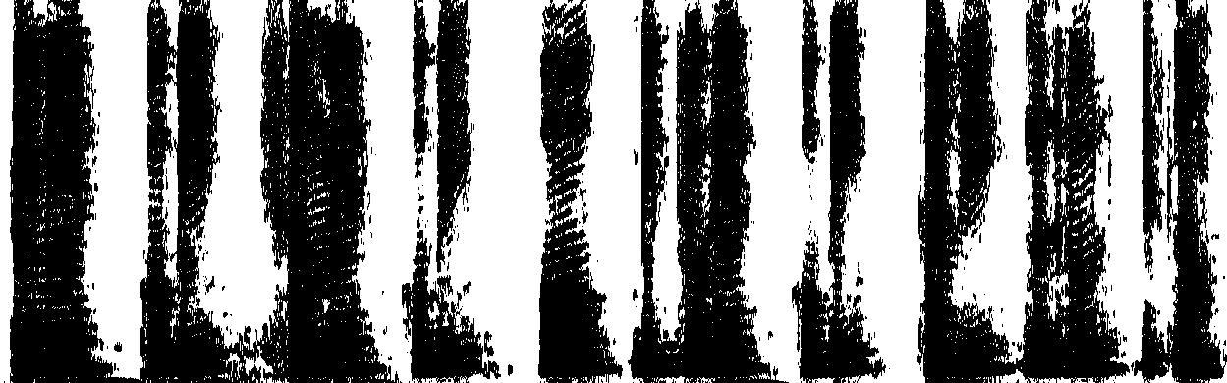 |  | 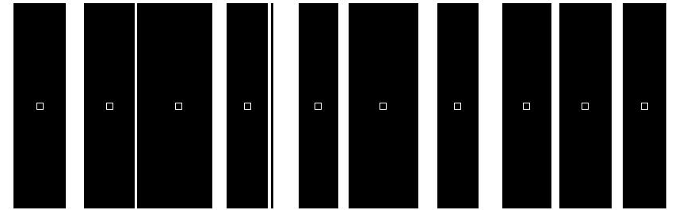10

3-class FCM clustering Example
Consider the following 6x6 pixel grayscale image.
Original Image | The image matrix | The matrix of gray intensity
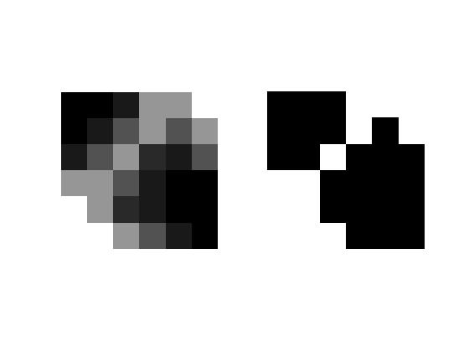 | M = [ 0 0 25 150 150 255  0 25 82 150 82 150  25 82 150 41 25 82  150 150 82 25 0 0  255 150 41 25 0 0  255 255 150 82 25 0 ] | I = [ 0 0 0.0980 0.5882 0.5882 1.0000  0 0.0980 0.3216 0.5882 0.3216 0.5882  0.0980 0.3216 0.5882 0.1608 0.0980 0.3216  0.5882 0.5882 0.3216 0.0980 0 0  1.0000 0.5882 0.1608 0.0980 0 0  1.0000 1.0000 0.5882 0.3216 0.0980 0 ]

Clustering of pixel intensity

  PX.  NO. | GRAY INTESITY | MS VALUE ASSOCIATED WITH CLASS#1 | MS VALUE ASSOCIATED WITH CLASS#2 | MS VALUE ASSOCIATED WITH CLASS#3 | CLASS
  1 | 0 | 0.005663 | 0.975541 | 0.018795 | 2
  2 | 0 | 0.005663 | 0.975541 | 0.018795 | 2
  3 | 0.098039 | 0.000604 | 0.996978 | 0.002418 | 2
  4 | 0.588235 | 0.01003 | 0.00637 | 0.9836 | 3
  5 | 1 | 0.999926 | 0.000014 | 0.00006 | 1
  6 | 1 | 0.999926 | 0.000014 | 0.00006 | 1
  7 | 0 | 0.005663 | 0.975541 | 0.018795 | 2
  8 | 0.098039 | 0.000604 | 0.996978 | 0.002418 | 2
  9 | 0.321569 | 0.057101 | 0.431086 | 0.511813 | 3
  10 | 0.588235 | 0.01003 | 0.00637 | 0.9836 | 3
  11 | 0.588235 | 0.01003 | 0.00637 | 0.9836 | 3
  12 | 1 | 0.999926 | 0.000014 | 0.00006 | 1
  13 | 0.098039 | 0.000604 | 0.996978 | 0.002418 | 2
  14 | 0.321569 | 0.057101 | 0.431086 | 0.511813 | 3
  15 | 0.588235 | 0.01003 | 0.00637 | 0.9836 | 3
  16 | 0.321569 | 0.057101 | 0.431086 | 0.511813 | 3
  17 | 0.160784 | 0.009739 | 0.944659 | 0.045602 | 2
  18 | 0.588235 | 0.01003 | 0.00637 | 0.9836 | 3
  PX.  NO. | GRAY INTESITY | MS VALUE ASSOCIATED WITH CLASS#1 | MS VALUE ASSOCIATED WITH CLASS#2 | MS VALUE ASSOCIATED WITH CLASS#3 | CLASS
  19 | 0.588235 | 0.01003 | 0.00637 | 0.9836 | 3
  20 | 0.588235 | 0.01003 | 0.00637 | 0.9836 | 3
  21 | 0.160784 | 0.009739 | 0.944659 | 0.045602 | 2
  22 | 0.098039 | 0.000604 | 0.996978 | 0.002418 | 2
  23 | 0.098039 | 0.000604 | 0.996978 | 0.002418 | 2
  24 | 0.321569 | 0.057101 | 0.431086 | 0.511813 | 3
  25 | 0.588235 | 0.01003 | 0.00637 | 0.9836 | 3
  26 | 0.321569 | 0.057101 | 0.431086 | 0.511813 | 3
  27 | 0.098039 | 0.000604 | 0.996978 | 0.002418 | 2
  28 | 0 | 0.005663 | 0.975541 | 0.018795 | 2
  29 | 0 | 0.005663 | 0.975541 | 0.018795 | 2
  30 | 0.098039 | 0.000604 | 0.996978 | 0.002418 | 2
  31 | 1 | 0.999926 | 0.000014 | 0.00006 | 1
  32 | 0.588235 | 0.01003 | 0.00637 | 0.9836 | 3
  33 | 0.321569 | 0.057101 | 0.431086 | 0.511813 | 3
  34 | 0 | 0.005663 | 0.975541 | 0.018795 | 2
  35 | 0 | 0.005663 | 0.975541 | 0.018795 | 2
  36 | 0 | 0.005663 | 0.975541 | 0.018795 | 2

CLASS | CLASS#1 | CLASS#2 | CLASS#3
PIXEL NO. | 5,6,12,30 | 1,2,3,7,8,13,17,21,22,  23,27,28,29,30,34,35,36 | 4,9,10,11,14,15,16,18,  19,20,24,25,26,32,33,
TOTAL (36) | 4 | 17 | 15

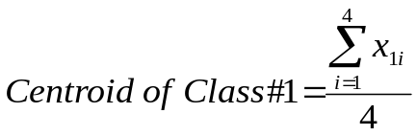= 0.996505
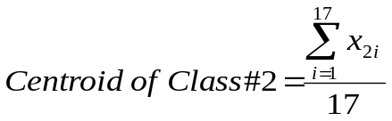= 0.075927
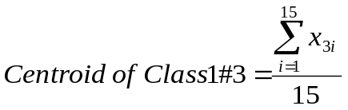= 0.547008
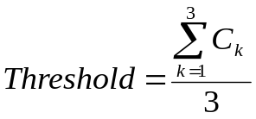= (0.996505+0.075927+0.547008)/3 = 0.539813

The Resulting Image

Original Image Thresholded Image
3-class K-Means clustering Example
Consider the following 6x6 pixel grayscale image.

Original Image | The image matrix | The matrix of gray intensity
 | M = [ 0 0 25 150 150 255  0 25 82 150 82 150  25 82 150 41 25 82  150 150 82 25 0 0  255 150 41 25 0 0  255 255 150 82 25 0 ] | I = [ 0 0 0.0980 0.5882 0.5882 1.0000  0 0.0980 0.3216 0.5882 0.3216 0.5882  0.0980 0.3216 0.5882 0.1608 0.0980 0.3216  0.5882 0.5882 0.3216 0.0980 0 0  1.0000 0.5882 0.1608 0.0980 0 0  1.0000 1.0000 0.5882 0.3216 0.0980 0 ]

Clustering of pixel intensity

  NO. | GRAY INTENSITY | CLASS NO.
  1 | 0 | 1
  2 | 0 | 1
  3 | 0.098039 | 1
  4 | 0.588235 | 3
  5 | 1 | 3
  6 | 1 | 3
  7 | 0 | 1
  8 | 0.098039 | 1
  9 | 0.321569 | 2
  NO. | GRAY INTENSITY | CLASS NO.
  10 | 0.588235 | 3
  11 | 0.588235 | 3
  12 | 1 | 3
  13 | 0.098039 | 1
  14 | 0.321569 | 2
  15 | 0.588235 | 3
  16 | 0.321569 | 2
  17 | 0.160784 | 1
  18 | 0.588235 | 3
  NO. | GRAY INTENSITY | CLASS NO.
  19 | 0.588235 | 3
  20 | 0.588235 | 3
  21 | 0.160784 | 1
  22 | 0.098039 | 1
  23 | 0.098039 | 1
  24 | 0.321569 | 2
  25 | 0.588235 | 3
  26 | 0.321569 | 2
  27 | 0.098039 | 1
  NO. | GRAY INTENSITY | CLASS NO.
  28 | 0 | 1
  29 | 0 | 1
  30 | 0.098039 | 1
  31 | 1 | 3
  32 | 0.588235 | 3
  33 | 0.321569 | 2
  34 | 0 | 1
  35 | 0 | 1
  36 | 0 | 1

CLASS | CLASS#1 | CLASS#2 | CLASS#3
PIXEL NO. | 1,2,3,7,8,13,17,21,22  23,27,28,29,30,34,35,36 | 9,14,16,24,26,33 | 4,5,6,10,11,12,15  18,19,20,25,31,32
TOTAL (36) | 17 | 6 | 13

= 0.059285
= 0.321569
= 0.714932
= (0.059285+0.321569+0.714932)/3 = 0.365262

The Resulting Image
Original Image Thresholded Image

M35
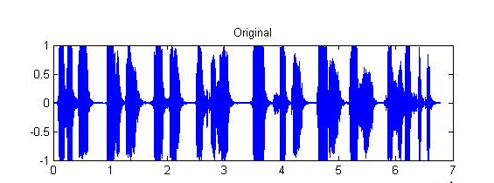
Binary Image using OTSU Method
Binary Image using K-MEANS Clustering
Binary Image using FCM Clustering

M45
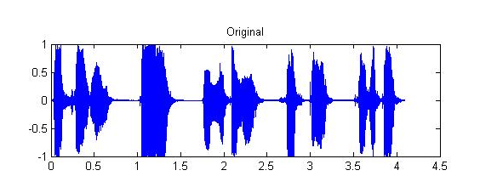
Binary Image using OTSU Method
Binary Image using K-MEANS Clustering
Binary Image using FCM Clustering

M55
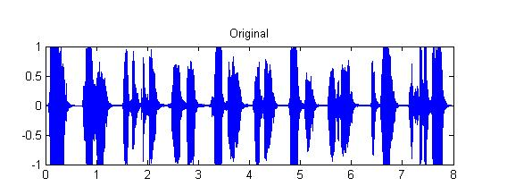
Binary Image using OTSU Method
Binary Image using K-MEANS Clustering
Binary Image using FCM Clustering

