

American International University-Bangladesh (AIUB)
Department of Computer Science
Faculty of Science & Technology (FST)

PROJECT TITLE
Semester: Fall 25-26

Group: |  | Section:
SL | Student Name | Student ID
16 | Yousuf Showrov | 23-54133-3
12 | Zubayeer Alam | 23-53942-3
38 | Hacin Mijbahur Rahman | 23-55589-3
17 | Naimul Hassan | 23-54173-3

Table of Contents

1. Project Proposal 03
1.1 Background to the Problem 03
1.2 Selection of Process Model 03
2. Software Requirements Specification (SRS) / PRD 04
2.1 Scopes and Features 04
2.2 User Story Table 05
2.3 Requirements Traceability Matrix 06
2.3.1 Functional Requirements 06
2.3.2 Non-Functional Requirements 06-07
3. Software Design 08
3.1 System Deisgn 09
3.2 UI Deisgn using Figma 10-13
4. Git Workflow xx
5. Software Testing 15-20
6. Conclusion 20

PROJECT PROPOSAL

Background to the Problem.
In the modern healthcare sector, managing patient records and hospital data efficiently is still a major challenge. Many hospitals and clinics continue to depend on outdated systems or even manual paperwork, which often leads to misplaced records, delays in diagnosis, and communication gaps between doctors and patients. Healthcare professionals struggle to access complete medical histories in real time, while patients find it difficult to track their reports, appointments, and prescriptions. Additionally, with the growing volume of data, there is an urgent need for intelligent systems that can analyze information and provide insights to improve patient care. Therefore, there is a clear need for a secure, user-friendly healthcare platform that can automate administrative work, ensure data accuracy, and allow doctors and patients to connect easily in one digital space.

Selection of Process Model: Agile Model
The Agile Model is an iterative and incremental software development approach that focuses on flexibility, continuous feedback, and customer collaboration. Instead of completing the entire system at once, the project is divided into small development cycles called iterations or sprints. Each sprint results in a working version of the software with added features.
In the Agile model, requirements can evolve throughout the development process based on user feedback, testing results, and changing needs. This model encourages close collaboration among team members and stakeholders, frequent testing, and continuous improvement.

Why Agile Model Was Chosen for AI Healthcare Project
The Agile Model was selected for the AI Healthcare project because the project contains multiple complex features such as AI-based doctor recommendation, appointment scheduling, video consultation, and prescription, which can be developed incrementally. Agile supports changing requirements, which is important for healthcare systems where user needs and system improvements evolve over time. Continuous testing in Agile helps ensure high reliability and accuracy, which is critical for healthcare applications. The model promotes team collaboration, making it suitable for group projects with multiple members. Early delivery of working features allows feedback from users (patients and doctors), improving system quality. Therefore, the Agile Model is a suitable and effective process model for developing the AI Healthcare system.

SOFTWARE REQUIREMENTS SPECIFICATIONS (SRS) / PRODUCT REQUIREMENTS DOCUMENT (PRD)

Scopes and Features
Scope
The AI Healthcare system is a web-based platform that connects patients with doctors using AI technology for better medical consultation and appointment management.
Main Features
For Patient
- Register and login
- Search and filter doctors
- Get AI-based doctor’s suggestion
- Book appointment
- Make online payment
- Join video consultation
- Receive e-prescription
- View doctor profile
- Rate and review doctors
For Doctor
- Create available schedule
- View patient details
- Conduct video consultation
- Generate e-prescription
- View revenue history
- View ratings
For Admin
- Manage doctors
- Manage patients
- Approve/modify schedules
- Monitor system activities

User Story Table
As a / An | I want to | So that | Acceptance Criteria
Patient | Register an account | I can access healthcare services | User can sign up using valid email and password
Patient | Log in to the system | I can use my dashboard securely | Valid credentials allow successful login
Patient | Search doctors | I can find suitable doctors | Doctors are listed based on search/filter
Patient | Filter doctors by specialization | I can find the right expert | Filter shows correct doctors
Patient | Enter my disease/symptoms | AI can analyze my condition | System accepts symptoms input
Patient | Get AI-based doctor suggestions | I can choose the best doctor | Top 3 relevant doctors are displayed
Patient | Select a doctor | I can proceed with consultation | Doctor profile opens successfully
Patient | Book an appointment | I can consult the doctor | Appointment is saved successfully
Patient | Make online payment | my appointment is confirmed | Payment success confirms booking
Patient | Join video consultation | I can talk to the doctor online | Video call starts at scheduled time
Patient | View e-prescription | I can follow treatment | Prescription is visible after consultation
Patient | Rate and review doctor | I can share feedback | Rating is saved and visible
Doctor | Create schedule | patients can book appointments | Schedule is published successfully
Doctor | View patient details | I can understand patient history | Patient data is accessible
Doctor | Conduct video consultation | I can treat patients remotely | Video call works properly
Doctor | Generate prescription | patients receive treatment | Prescription is stored and shared
Doctor | View revenue history | I can track my earnings | Revenue data is accurate
Doctor | View ratings | I can improve my service | Ratings are displayed correctly
Admin | Manage doctors | system stays organized | Admin can add/edit/remove doctors
Admin | Manage patients | system data remains valid | Admin can view/manage patients
Admin | Manage schedules | avoid conflicts | Schedule changes are updated

Requirements Traceability Matrix

Functional Requirements
Functional Requirement | Example Scenario
The system shall allow users to register and log in | A patient creates an account using email and password and logs in successfully
The system shall allow patients to search doctors | A patient search for doctors by name or specialization
The system shall provide AI-based doctor suggestions | After entering symptoms like “chest pain,” the system shows top 3 cardiologists
The system shall allow appointment booking | A patient selects a doctor and books an appointment slot
The system shall support online payment | Patient completes payment via card or mobile payment to confirm booking
The system shall enable video consultation | At appointment time, patient and doctor join a video call
The system shall generate and store prescriptions | Doctor creates a prescription after consultation and patient views it
The system shall allow patients to rate doctors | Patient gives a 5-star rating after consultation
The system shall allow doctors to create schedules | Doctor sets available time slots for the next week
The system shall allow doctors to view patient details | Doctor views patient’s medical history before consultation
The system shall allow admin to manage users | Admin approves or removes doctor accounts

Non-Functional Requirements
Performance Requirements
- Each web page of the AI Healthcare system shall load within 3 seconds over a standard broadband internet connection (≥1 Mbps).
- Doctor search and AI-based doctor recommendation results shall be generated within 5 seconds after symptom submission.
- Appointment booking confirmation shall be completed within 4 seconds after successful payment.
- Video consultation session initialization shall not exceed 10 seconds from the scheduled start time.

Availability Requirements
- The system should be at least 99.5% available on weekdays between 6:00 a.m. and 12:00 a.m. local time.
- The system shall maintain at least 99.9% availability during peak hours between 4:00 p.m. and 10:00 p.m. local time.
- Scheduled system maintenance should not exceed 2 hours per month.
Security Requirements
- User authentication requests shall be validated within 10 seconds.
- All patient medical data shall be encrypted using industry-standard encryption (AES-256).
- Unauthorized access attempts shall be detected and logged within 1 second.
Scalability Requirements
- The system shall support at least 500 concurrent users without performance degradation.
- The system shall handle at least 200 simultaneous appointment bookings during peak hours.
Reliability Requirements
- The video consultation service should have a call success rate of at least 98%.
- System failure recovery time shall not exceed 5 minutes after unexpected downtime.
Usability Requirements
- US-1: A first-time patient user shall be able to complete appointment booking within 3 minutes without external assistance.
- US-2: At least 90% of users shall be able to navigate core features without training.

SOFTWARE DESIGN

System Design

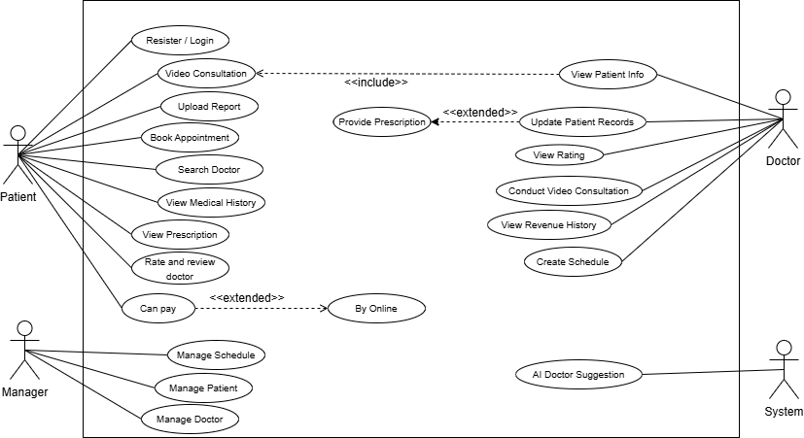
Use Case Diagram
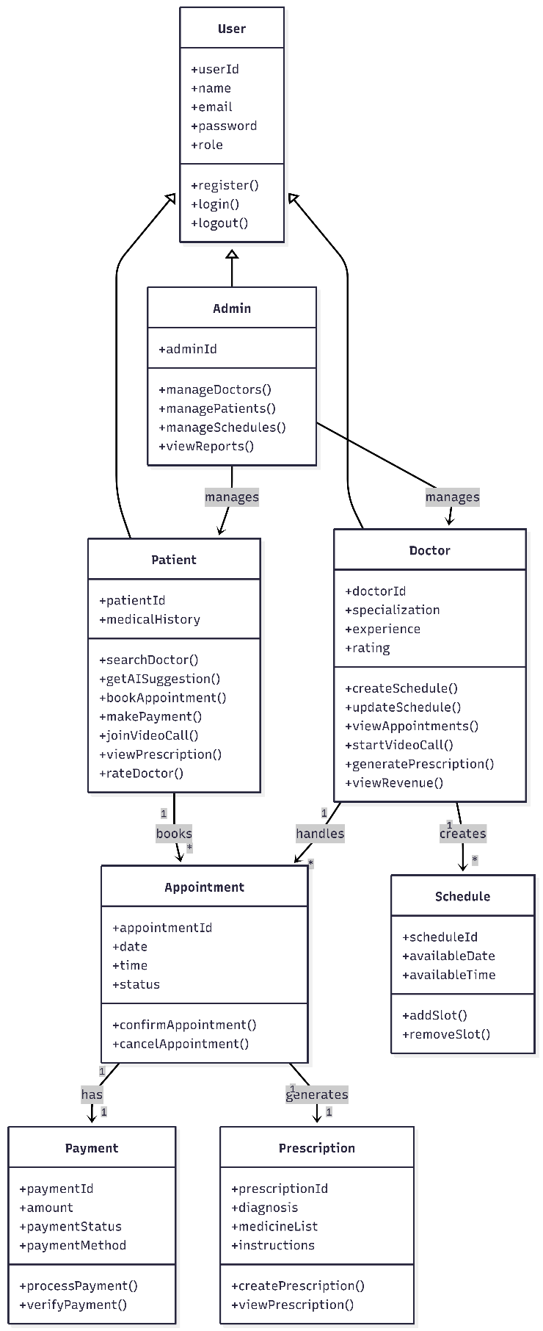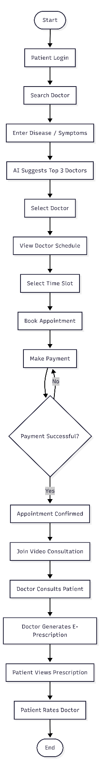
Class diagram Activity diagram

