CHAPTER 2 — Newton's Laws of Motion
Physics · Form 4 · MSCE · Malawian Science Books

Welcome to Chapter 2. Think about a minibus on the M1. The driver brakes hard at a police checkpoint. Everyone inside leans forward. Why? Nobody pushed them. Yet they moved.
Or think about a bicycle. You pedal, and you go. Stop pedalling, and you slow down. Why does motion need a push to keep going?
These questions — and every question about forces and motion — have the same answer. It was worked out by Isaac Newton over 300 years ago in three simple laws. In this chapter, you will understand them so clearly that you'll never need to memorise them again. You'll just see them in everyday life.

2.1 Newton's First Law of Motion
HAVE YOU EVER NOTICED…
When a minibus brakes suddenly, your body leans forward. When it accelerates, you lean backward. Nothing is pushing you. So why do you move?

THE BIG IDEA
An object at rest stays at rest, and an object in motion stays in motion at the same speed and direction, unless a net force acts on it. In other words: objects are lazy. They resist changes to their motion.

The real concept
Before Newton, most people believed that a moving object needed a continuous push to keep moving. That seems sensible — stop pedalling a bicycle, and you slow down.
But Newton realised something deeper: what stops the bicycle is friction (with the road and the air). If friction were removed, the bicycle would keep going forever at the same speed, in a straight line, without any push.
So motion doesn't need a push to continue. *Only a change in motion needs a force.* That's Newton's First Law.
The tendency of an object to resist changes in its motion is called inertia. More mass means more inertia. A lorry is harder to start, stop, or turn than a bicycle, because it has more inertia.
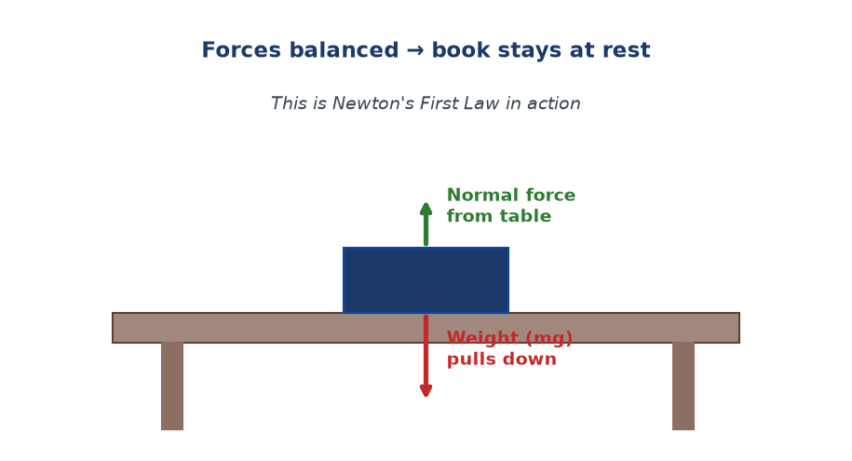
Figure 2.1 — A book resting on a table. Gravity pulls it down (weight). The table pushes it up (normal force). The forces cancel. So the book stays at rest — Newton's First Law in action.

Real-life picture: why you lean in a minibus
When the minibus brakes, the bus slows down — but you keep moving forward at your original speed, because no force has acted on you yet. Your body continues its motion. A moment later, your muscles and the seat catch up and slow you. That's why you lean forward.
When the bus starts moving, the bus speeds up — but you are still at rest. So relative to the bus, you slide backward. Again, this is inertia, not a mysterious force.
WHY STUDENTS FIND THIS DIFFICULT
- Many students believe motion requires a continuous force. It does not — only changes in motion need force.
- The word 'net' is often missed. If forces balance, the object behaves as if no force acted at all.
- Students sometimes think Newton's First Law only applies to objects at rest. It applies to objects in motion too — moving at constant velocity.

KEY POINTS — 2.1
- First Law: an object keeps doing what it was doing unless a net force acts.
- 'At rest' and 'moving at constant velocity' are both 'no change in motion.'
- Inertia = resistance to change in motion.
- More mass → more inertia.
- 'Net force' means the total of all forces — direction matters.

IF YOU REMEMBER ONE THING
Objects keep doing what they are doing — unless a net force acts. Motion does not need a push to continue; only change of motion does.

2.2 Mass and Inertia
HAVE YOU EVER NOTICED…
It's easy to kick an empty plastic bottle across the road. But try kicking a full 20-litre jerrycan of water. Same size. Very different result. Why?

THE BIG IDEA
Mass is the amount of matter in an object — and it is also a measure of inertia. More mass means the object resists changes to its motion more strongly.

Mass vs weight — do not confuse them
These two words get mixed up constantly. Let's fix that once and for all.
Property | Mass | Weight
What it is | Amount of matter | Force of gravity on the mass
Symbol | m | W (or mg)
SI unit | kilogram (kg) | newton (N)
Depends on gravity? | No — same everywhere | Yes — changes with g
On the Moon | Same as on Earth | About 1/6 of Earth's value
How to measure | Balance | Spring scale

So: mass is a property of the object itself; weight is a force that depends on where the object is. Your mass on Earth is the same as your mass on the Moon. But you would weigh much less on the Moon, because the Moon's gravity is weaker.
W = m g
where g = 9.8 m/s² on Earth (often rounded to 10 m/s² in MSCE calculations)
Everyday picture of inertia
- A loaded truck takes much longer to stop than an empty one. Same brakes, more inertia.
- When you shake a bottle of water, the water pushes back — inertia again.
- When you whack the bottom of a stack of books quickly, the bottom book flies out but the others stay roughly in place. Inertia.
- When you flick a coin off a card balanced on a glass, the coin drops into the glass. The card moves, the coin has inertia and stays over the glass.
WHY STUDENTS FIND THIS DIFFICULT
- Students use 'mass' and 'weight' as if they were the same word. They are not — one is matter (kg), the other is a force (N).
- Students think weight is fixed. It changes with gravity. Mass does not.
- Some say 'heavier things fall faster.' Not true in a vacuum — all objects fall with the same acceleration, because more weight comes with more inertia.

KEY POINTS — 2.2
- Mass = amount of matter (kg). Weight = force of gravity (N).
- W = mg (on Earth, g ≈ 9.8 m/s²).
- Mass is the same everywhere. Weight depends on g.
- Inertia grows with mass.

IF YOU REMEMBER ONE THING
Mass is matter (kg). Weight is force (N). W = mg. Mass never changes; weight does.

2.3 Momentum
HAVE YOU EVER NOTICED…
A slow-moving lorry can knock down a wall. A fast-moving cricket ball can break a window. Both have something in common — momentum. But the lorry has lots of mass; the cricket ball has lots of speed.

THE BIG IDEA
Momentum = mass × velocity. It measures how hard it is to stop a moving object. The heavier the object, or the faster it moves, the more momentum it has.

The concept
Momentum combines mass and velocity into one quantity. Two objects with the same momentum need the same effort to stop. A 2000 kg lorry moving at 1 m/s has the same momentum as a 2 kg brick moving at 1000 m/s. Both are hard to stop — just in different ways.
Because velocity is a vector, momentum is a vector too. Direction matters. This is why momentum is so useful in collisions: you add momenta as vectors, and the total is conserved.
p = m v
p = momentum (kg·m/s), m = mass (kg), v = velocity (m/s)
Momentum and Newton's Second Law
Newton originally stated his Second Law in terms of momentum, not acceleration. The clearest form is:
F = Δp / Δt
Force = rate of change of momentum
This is a much more powerful statement than F = ma, because it also handles cases where mass changes (a rocket burning fuel, a hose spraying water).
WHY STUDENTS FIND THIS DIFFICULT
- Forgetting momentum is a vector — direction matters. When two objects move in opposite directions, their momenta have opposite signs.
- Confusing mass with momentum. Mass is matter; momentum is matter moving.
- Forgetting to convert units (e.g. g to kg, km/h to m/s) before calculating.

KEY POINTS — 2.3
- p = mv. Unit: kg·m/s.
- Momentum is a vector — direction matters.
- Newton's Second Law in momentum form: F = Δp/Δt.
- Changing momentum faster requires a bigger force (that's why airbags work).

IF YOU REMEMBER ONE THING
Momentum = mass × velocity. Direction matters. Force is the rate of change of momentum.

2.4 Newton's Second Law of Motion
HAVE YOU EVER NOTICED…
Pushing a bicycle is easy. Pushing a car is hard. Same push. Different mass. Different acceleration.

THE BIG IDEA
The acceleration of an object is directly proportional to the net force on it, and inversely proportional to its mass. Bigger force → bigger acceleration. More mass → smaller acceleration.

The equation
F = m a
F = net force (N), m = mass (kg), a = acceleration (m/s²)
Rearranged:
a = F / m or m = F / a
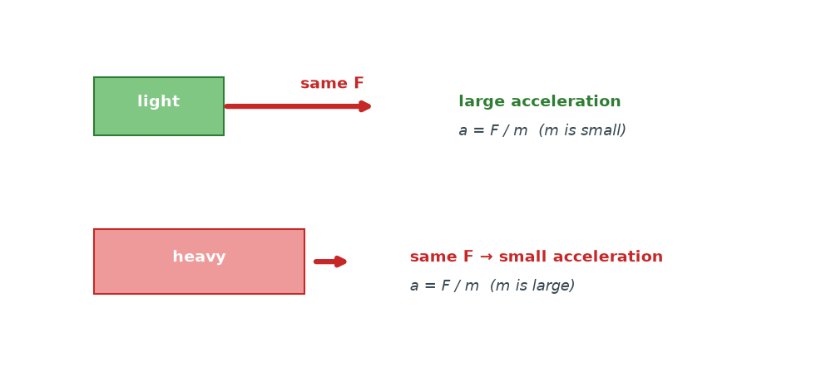
Figure 2.2 — Same force, two masses. The lighter cart accelerates more. The heavier cart accelerates less. This is Newton's Second Law — a = F/m.

What 'net force' means — free body diagrams
The F in F = ma is the net force — the sum of all forces acting on the object. This is why we draw free-body diagrams: pictures that show only the forces acting on the object, with their directions.
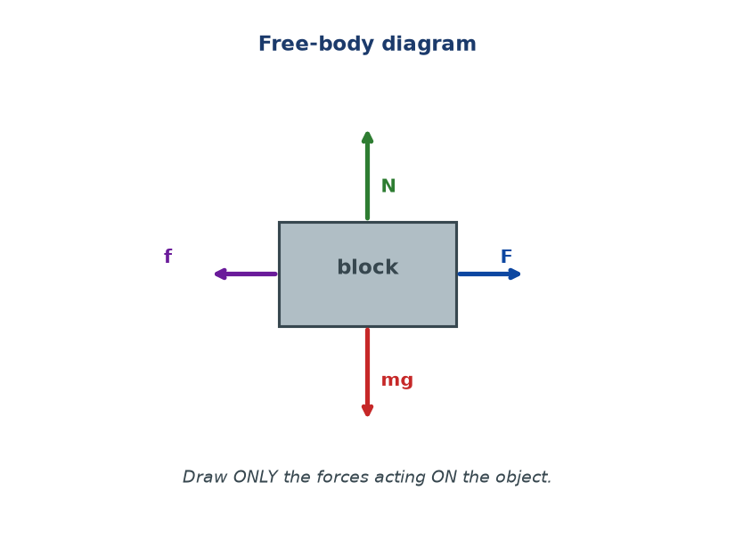
Figure 2.3 — A free-body diagram of a block on a surface. Four forces are shown: weight (mg), normal (N), friction (f), and applied force (F). The net force is the vector sum of all four.

Practical picture: airbags and seatbelts
Why does a car need airbags? Because of Newton's Second Law in the form F = Δp/Δt. When a car crashes, the passengers' momentum must go from a large value to zero. The force needed to do this is spread over the time of the impact. Airbags increase the impact time, so the force on the body is smaller. Same change in momentum, gentler deceleration. That's physics saving lives.
WHY STUDENTS FIND THIS DIFFICULT
- Using total force instead of net force. Every force must be summed with its direction (one direction positive, opposite negative).
- Thinking a big force always means big acceleration. Only if mass is small. A big force on a train gives a small acceleration.
- Forgetting that the equation is a vector equation. If forces oppose, they subtract.
- Confusing mass with weight when substituting into F = ma. Use mass (kg), not weight (N).

KEY POINTS — 2.4
- Second Law: F = ma.
- F is the net force — the vector sum of all forces on the object.
- Acceleration is in the same direction as the net force.
- F and a are proportional; F and m are inverse.
- Free-body diagrams help identify all forces correctly.

IF YOU REMEMBER ONE THING
F = ma. But F is the net force, and it points the same way as the acceleration.

2.5 Newton's Third Law of Motion
HAVE YOU EVER NOTICED…
When you push off from a wall while standing on a skateboard, you roll away from the wall. You pushed the wall — so why did you move? Because the wall pushed you back.

THE BIG IDEA
For every action, there is an equal and opposite reaction. Forces always come in pairs. If A pushes B, then B pushes A with the same size force but in the opposite direction.

The concept
Every force you have ever felt was one half of a pair. When you walk, your foot pushes backward on the ground, and the ground pushes forward on you — that's why you move. When you sit on a chair, your weight pushes down on the chair, and the chair pushes up on you.
*The pair acts on different objects.* This is the crucial point. The two forces are equal and opposite, but they never cancel out, because they act on different things.
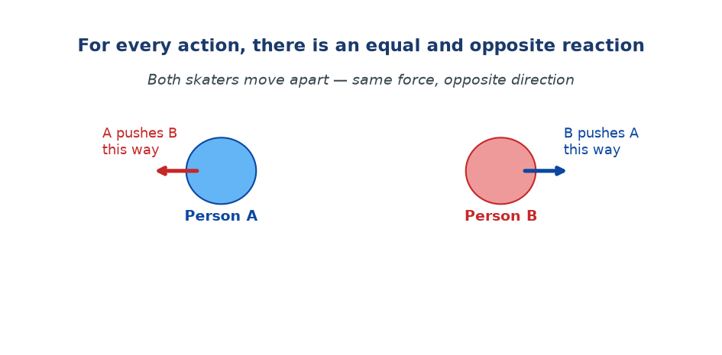
Figure 2.4 — Two skaters push each other. Person A pushes Person B one way; Person B pushes Person A the other way. Same force. Opposite direction. Both move apart.

Why you can walk
You push the ground backward with your foot. The ground pushes you forward. That forward push is the friction that lets you move. On ice, the ground cannot push back much — that's why you slip. This is Newton's Third Law explaining an everyday frustration.
WHY STUDENTS FIND THIS DIFFICULT
- Students think the forces cancel out. They do not — they act on different objects.
- Students confuse the Third Law pair with balanced forces. Balanced forces act on the same object; Third Law pairs act on two objects.
- Students think the reaction comes 'after' the action. Both happen at the same instant.

KEY POINTS — 2.5
- Third Law: action and reaction are equal in size, opposite in direction.
- The two forces act on different objects — never cancel.
- Both forces happen at the same instant.
- This law explains walking, swimming, rockets, recoil of guns.

IF YOU REMEMBER ONE THING
Every force has a partner — equal, opposite, acting on a different object. Forces never cancel unless they act on the same object.

2.6 Conservation of Linear Momentum
HAVE YOU EVER NOTICED…
When a gun fires, the bullet goes forward and the gun kicks backward. When a boat sails and you step off the front, the boat moves backward. These are not coincidences — they are the same law.

THE BIG IDEA
In any collision or explosion, the total momentum before equals the total momentum after — provided no external force acts. Momentum is conserved. It is never created or destroyed.

The equation
For two objects colliding:
m₁u₁ + m₂u₂ = m₁v₁ + m₂v₂
u = velocity before, v = velocity after
For two objects moving together after the collision (sticking):
m₁u₁ + m₂u₂ = (m₁ + m₂) v
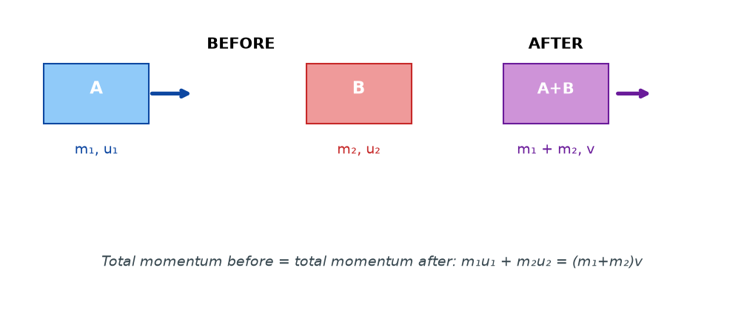
Figure 2.5 — Two carts collide and stick together. The total momentum before equals the total momentum after. Masses add; velocities combine.

Explosions too
In an explosion, the total momentum before is zero (nothing moving). So the total momentum after must also be zero. That means if one piece flies one way, another piece must fly the opposite way. That's why a gun recoils.
WHY STUDENTS FIND THIS DIFFICULT
- Forgetting that momentum has direction. Velocities to the right are positive; to the left are negative.
- Forgetting to convert units (g to kg, km/h to m/s).
- Using velocities after on both sides of the equation. Left side = before; right side = after.
- Not using a common sign convention.

KEY POINTS — 2.6
- Total momentum is conserved in collisions and explosions (no external force).
- m₁u₁ + m₂u₂ = m₁v₁ + m₂v₂ (two objects, before vs after).
- m₁u₁ + m₂u₂ = (m₁+m₂)v (objects sticking).
- Use a sign convention: right = +, left = −.

IF YOU REMEMBER ONE THING
Total momentum before = total momentum after (if no external force). Directions matter.

2.7 Collisions
HAVE YOU EVER NOTICED…
Drop a rubber ball — it bounces back high. Drop a lump of nsima — it doesn't bounce at all. Same drop, different behaviour. That's the difference between elastic and inelastic collisions.

THE BIG IDEA
Elastic collisions conserve kinetic energy (and momentum). Inelastic collisions conserve momentum only — some kinetic energy is lost to heat, sound, or deformation. In both, momentum is conserved.

Elastic vs inelastic
Property | Elastic collision | Inelastic collision
Momentum | Conserved | Conserved
Kinetic energy | Conserved | Not conserved (lost as heat, sound, deformation)
Objects after | Move separately | May stick together
Examples | Gas molecules, billiard balls (nearly) | Car crashes, bullet embedding in wood, nsima hitting the ground

Why does kinetic energy disappear in an inelastic collision? Because it is converted into other forms — heat (the ground and object warm slightly), sound (you hear the impact), and deformation (the object dents or squashes). Energy is not lost from the universe. It just changes form.
WHY STUDENTS FIND THIS DIFFICULT
- Saying 'energy is lost' in an inelastic collision — energy is not lost, it changes form.
- Assuming momentum is lost in inelastic collisions. It is not. Only kinetic energy is lost.
- Applying conservation of KE to every collision. Only elastic collisions conserve KE.

KEY POINTS — 2.7
- Elastic: momentum and KE both conserved.
- Inelastic: momentum conserved; KE not conserved (heat, sound, deformation).
- Objects that stick together after a collision → inelastic.
- Momentum is conserved in all collisions (no external force).

IF YOU REMEMBER ONE THING
Momentum is always conserved in collisions. Kinetic energy is conserved only in elastic collisions.

Worked Examples
Example 1 — Second Law (Easy)
Question. A force of 40 N acts on a 5 kg block on a frictionless surface. Find the acceleration.
Given: F = 40 N, m = 5 kg.
Find: a.
Principle. Newton's Second Law: F = ma.
Solution.
a = F / m = 40 / 5
a = 8 m/s²
Why this works: The bigger the force, the bigger the acceleration. The bigger the mass, the smaller the acceleration for the same force.
Common mistake: Using weight (N) instead of mass (kg). Always use mass.
Example 2 — Weight and mass (Easy–Medium)
Question. A student has a mass of 50 kg. Calculate her weight on Earth (g = 9.8 m/s²) and on the Moon (g = 1.6 m/s²).
Given: m = 50 kg; g_Earth = 9.8; g_Moon = 1.6.
Find: W on each.
Principle. W = mg.
Solution.
W_Earth = 50 × 9.8 = 490 N
W_Moon = 50 × 1.6 = 80 N
Why this works: Mass stays the same everywhere. Only g changes, so weight changes proportionally.
Common mistake: Saying 'she weighs 50 kg.' That's her mass. Her weight is 490 N on Earth.
Example 3 — Momentum (Medium)
Question. A 1200 kg car moves at 20 m/s. Calculate its momentum.
Given: m = 1200 kg, v = 20 m/s.
Find: p.
Principle. p = mv.
Solution.
p = 1200 × 20 = 24000 kg·m/s
Why this works: Momentum measures how much 'moving mass' the object has. Big mass × big speed = big momentum.
Common mistake: Forgetting units. Momentum's unit is kg·m/s, not just kg or m/s.
Example 4 — Conservation of momentum (MSCE)
Question. A 2 kg ball moving at 3 m/s to the right collides head-on with a stationary 1 kg ball. After the collision, the 2 kg ball moves at 1 m/s to the right. Find the velocity of the 1 kg ball after the collision.
Given: m₁ = 2, u₁ = 3; m₂ = 1, u₂ = 0; v₁ = 1. Right = positive.
Find: v₂.
Principle. Conservation of momentum: m₁u₁ + m₂u₂ = m₁v₁ + m₂v₂.
Solution.
(2)(3) + (1)(0) = (2)(1) + (1)(v₂)
6 = 2 + v₂
v₂ = 4 m/s to the right
Why this works: Momentum is conserved. Whatever the 2 kg ball loses, the 1 kg ball gains — in the same direction.
Common mistake: Forgetting the sign convention. If you'd written 'left = positive', you'd get the same magnitude but need to flip the direction.

Check Yourself
1. State Newton's First Law in your own words.
2. What is inertia? What property of an object determines how much inertia it has?
3. Distinguish between mass and weight.
4. A force of 60 N acts on a 12 kg object. Find its acceleration.
5. Calculate the weight of a 70 kg person on Earth (g = 9.8 m/s²).
6. Define momentum and give its SI unit.
7. State Newton's Third Law and give one everyday example.
8. Why does a gun recoil when fired?
9. A 3 kg ball moving at 4 m/s collides with a stationary 1 kg ball and sticks to it. Find their common velocity after impact.
10. In your own words, explain the difference between an elastic and an inelastic collision.

Exam-Style Questions (MSCE-style practice)
Q1. (a) State Newton's First Law of Motion.
(b) Explain, using the law, why a passenger in a bus leans forward when the bus brakes suddenly.
Q2. A force of 150 N acts on a 25 kg trolley.
(a) Calculate its acceleration.
(b) State what would happen to the acceleration if the same force acted on a 50 kg trolley.
Q3. A car of mass 1500 kg is travelling at 24 m/s.
(a) Calculate its momentum.
(b) The driver brakes and stops the car in 4 s. Calculate the average braking force.
Q4. A ball of mass 0.4 kg is moving at 6 m/s. It strikes a wall and rebounds at 4 m/s.
(a) Calculate the change in momentum of the ball.
(b) If the contact time with the wall is 0.05 s, calculate the average force.
Q5. (a) State the principle of conservation of momentum.
(b) A 5 kg trolley moving at 4 m/s collides with a 3 kg trolley at rest. After the collision, the two trolleys move together. Find their common velocity.
Q6. A rifle of mass 4 kg fires a bullet of mass 0.02 kg with a muzzle velocity of 500 m/s.
(a) Calculate the recoil velocity of the rifle.
(b) Explain why you used conservation of momentum, not conservation of kinetic energy.
Q7. A student says: "A heavier object always falls faster than a lighter one." Explain why this is wrong, using Newton's Second Law and the concept of inertia.
Q8. (a) Distinguish between elastic and inelastic collisions.
(b) Give one everyday example of each.
Q9. A 0.15 kg cricket ball moving at 30 m/s is caught by a fielder. The ball comes to rest in 0.3 s.
(a) Calculate the change in momentum of the ball.
(b) Calculate the average force the fielder applies.
Q10. A 60 kg student jumps from a stationary boat of mass 120 kg onto a jetty with a horizontal velocity of 2 m/s.
(a) Calculate the recoil velocity of the boat.
(b) Explain, in terms of Newton's Third Law, what is happening.

Full Worked Solutions
Check Yourself — Answers
1. An object stays at rest, or moves at constant velocity, unless a net force acts on it.
2. Inertia is the resistance to change in motion. It depends on mass.
3. Mass = amount of matter (kg); Weight = force of gravity on that mass (N). W = mg.
4. a = F/m = 60/12 = 5 m/s².
5. W = mg = 70 × 9.8 = 686 N.
6. Momentum = mass × velocity. Unit: kg·m/s.
7. For every action there is an equal and opposite reaction. Example: walking — foot pushes ground back, ground pushes foot forward.
8. Because of conservation of momentum. The bullet gains forward momentum; the gun must gain equal backward momentum.
9. (3)(4) + (1)(0) = (3+1)v → 12 = 4v → v = 3 m/s in the original direction.
10. Elastic: momentum and KE both conserved. Inelastic: momentum conserved, KE not conserved (some is converted to heat, sound, or deformation).

Exam-Style — Full Solutions
Q1. (a) An object at rest stays at rest, and an object in motion continues in a straight line at constant velocity, unless acted upon by a net force.
(b) When the bus brakes, the bus slows down. The passenger's body continues moving forward at the original velocity because of inertia. That is why the passenger leans forward.
Q2. (a) a = 150 / 25 = 6 m/s². (b) If mass doubles with the same force, acceleration halves → 3 m/s².
Q3. (a) p = 1500 × 24 = 36000 kg·m/s.
(b) F = Δp/Δt = 36000 / 4 = 9000 N.
Q4. (a) Take the initial direction as positive. Δp = m(v − u) = 0.4 × (−4 − 6) = −4 kg·m/s. Magnitude: 4 kg·m/s.
(b) F = Δp/Δt = 4 / 0.05 = 80 N (opposite to the initial motion).
Q5. (a) Total momentum before a collision equals total momentum after, provided no external force acts.
(b) (5)(4) + (3)(0) = (5+3)v → 20 = 8v → v = 2.5 m/s.
Q6. (a) 0 = (4)(v) + (0.02)(500) → 4v = −10 → v = −2.5 m/s (recoil, opposite to the bullet).
(b) Because energy is not conserved in a firing (chemical energy becomes heat, sound, KE). Momentum is conserved. Never use KE conservation unless the collision is elastic.
Q7. The gravitational force on a heavier object is bigger, but the inertia is also bigger, in the same proportion. So the acceleration comes out the same: a = F/m = mg/m = g. In a vacuum, all objects fall with the same acceleration g, regardless of mass.
Q8. (a) Elastic: both momentum and KE conserved. Inelastic: only momentum conserved.
(b) Elastic: gas molecules colliding. Inelastic: a car crash, a lump of nsima hitting the ground.
Q9. (a) Δp = m(v − u) = 0.15 × (0 − 30) = −4.5 kg·m/s.
(b) F = Δp/Δt = 4.5 / 0.3 = 15 N (opposite to the ball's motion).
Q10. (a) 0 = (60)(2) + (120)v → 120v = −120 → v = −1 m/s (boat moves backward).
(b) The student pushes the boat backward as she jumps forward. The boat pushes her forward. Equal and opposite — Newton's Third Law in action.

Common Mistakes
- Saying motion requires a continuous force. It does not — only change of motion needs force.
- Using weight instead of mass in F = ma. Always use kg.
- Using total force instead of net force in F = ma.
- Thinking action–reaction forces cancel. They act on different objects.
- Forgetting momentum has direction. Take right as + and left as −.
- Saying 'energy is lost' in an inelastic collision. Energy is converted, not lost.
- Using KE conservation in every collision. Only elastic collisions conserve KE.
- Forgetting to convert km/h to m/s (÷3.6) or g to kg (÷1000) before calculating.

EXAM TIP
MSCE reliably tests four things here: (1) F = ma calculations; (2) W = mg and the mass-vs-weight distinction; (3) momentum p = mv; (4) conservation of momentum in a collision.
For 'explain' questions, tie the answer back to a law: "Because of Newton's First Law, the passenger keeps moving forward..." — examiners love seeing the law named.
Always show the formula, then the substitution, then the answer with units. Three marks often come from three steps.
Watch for signs in momentum questions. Draw a small arrow to show which direction you're calling positive.

REMEMBER • First Law: no net force → no change of motion. Second Law: F = ma. Third Law: every force has an equal, opposite partner on another object. Momentum is always conserved in collisions.

Chapter 2 Test
SECTION A — Multiple Choice (5 marks)
1. Newton's First Law is also called the law of:
A. Acceleration B. Inertia C. Momentum D. Gravitation

2. Which quantity has the unit kg·m/s?
A. Force B. Mass C. Momentum D. Acceleration

3. A 4 kg object experiences a net force of 20 N. Its acceleration is:
A. 0.2 m/s² B. 5 m/s² C. 24 m/s² D. 80 m/s²

4. Which of the following is true of every collision (no external force)?
A. Kinetic energy is conserved B. Momentum is conserved C. Both are conserved D. Neither is conserved

5. Action and reaction forces:
A. Act on the same object and cancel B. Act on different objects and do not cancel C. Are unequal D. Only exist in explosions

SECTION B — Short Answers (10 marks)
6. State Newton's Second Law and write its equation. (2)
7. Distinguish between mass and weight. (2)
8. State the principle of conservation of momentum. (2)
9. Give one everyday example of Newton's Third Law. (1)
10. Explain, in terms of momentum, why airbags reduce injury in a car crash. (2)
11. Give one difference between elastic and inelastic collisions. (1)

SECTION C — Structured Questions (15 marks)
12. A 0.5 kg ball is kicked with a force of 20 N.
(a) Calculate the acceleration of the ball. (3)
(b) Calculate the ball's momentum if it reaches a velocity of 8 m/s. (3)

13. A 3 kg trolley moving at 5 m/s collides with a 2 kg trolley at rest. After the collision, they move together.
(a) Calculate their common velocity. (4)
(b) State whether the collision is elastic or inelastic, and explain. (2)

14. (a) State Newton's Third Law. (2)
(b) A rocket expels hot gas downward at high speed. Explain, using Newton's Third Law, why the rocket moves upward. (3)

END OF CHAPTER 2
Next chapter: Chapter 3 — Frictional Force.

