CHAPTER 3 — Frictional Force
Physics · Form 4 · MSCE · Malawian Science Books

Welcome to Chapter 3. Rub your hands together quickly. Feel the warmth? That warmth came from friction — the force that fights against sliding. Friction is what lets you walk without slipping, what stops a car when it brakes, and what wears out the soles of your shoes.
But friction is also the enemy: it wastes energy in engines, heats up machines, and slows down everything. And then there's its quieter cousin — viscosity — the friction inside fluids like water, oil, and air.
By the end of this chapter, you'll understand both, know how to calculate friction, and see why a feather and a coin fall at the same rate in a vacuum.

3.1 Coefficient of Solid Friction
HAVE YOU EVER NOTICED…
Pushing a heavy box across a cement floor is hard. Pushing the same box across a smooth tiled floor is easier. Same box, same push — but different surfaces. Why?

THE BIG IDEA
Friction is a force that opposes sliding between two surfaces. How strong it is depends on two things only: the nature of the two surfaces (how rough or smooth they are) and the normal force pressing them together.

The real concept
Even the smoothest-looking surface is rough at the microscopic level. When two surfaces are pressed together, tiny bumps on one surface lock into tiny dips on the other. To slide one across the other, those locks must be broken — and that takes force.
Friction acts along the surface, in the direction opposite to the motion (or attempted motion). It never acts perpendicular to the surface.
Two kinds of friction matter:
Type | When it acts | Size
Static friction | Object at rest, being pushed but not yet sliding | Grows with the applied force — up to a limit
Kinetic (sliding) friction | Object already sliding | Roughly constant; usually slightly less than maximum static friction

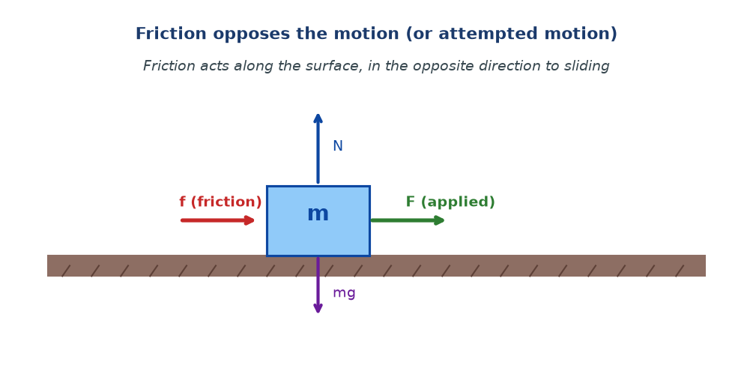
Figure 3.1 — A block on a surface. The applied force F tries to slide it. Friction f opposes, in the opposite direction along the surface. The weight mg is balanced by the normal force N.

The formula
f = μN
f = friction force (N), μ = coefficient of friction (no unit), N = normal force (N)
When does this apply? Only when the object is already sliding (kinetic friction), or at the limit just before sliding (maximum static friction). In between, static friction is smaller than μN and matches whatever applied force is needed to keep the object still.
On a horizontal surface with no other vertical forces, N = mg. So f = μmg. On a slope, or with other vertical forces, N changes, and f changes with it.
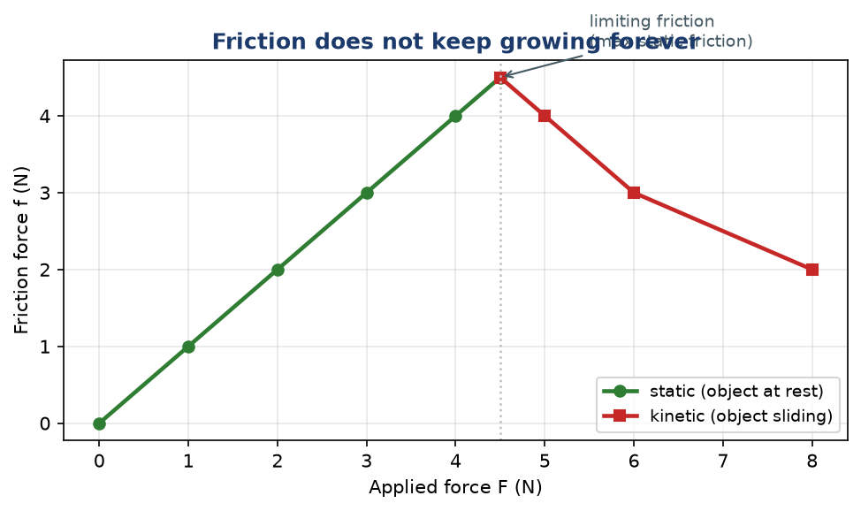
Figure 3.2 — How friction responds to an increasing applied force. While at rest, friction grows to match the push (green). At the limiting point, the object begins to slide, and friction drops slightly to a steady kinetic value (red).

Typical values of μ
Surfaces | μ (typical)
Rubber on dry concrete | 0.7 – 1.0
Wood on wood | 0.25 – 0.5
Steel on steel (dry) | 0.5 – 0.8
Steel on steel (lubricated) | 0.05 – 0.15
Ice on ice | 0.02 – 0.05
Teflon on steel | 0.04

Notice how much lubrication reduces μ. That is why engines have oil, why door hinges are greased, and why a bit of water on a tiled floor makes it dangerously slippery.
WHY STUDENTS FIND THIS DIFFICULT
- Confusing μ (coefficient of friction) with f (force of friction). μ is a property of the surfaces; f is the actual force. No units for μ; N for f.
- Using weight (mg) as the friction force instead of using μN. Friction is μ times the normal force, which equals mg only on a flat, horizontal surface.
- Thinking friction always equals μN. That's true only when sliding, or at the maximum static point. Otherwise static friction is smaller.
- Thinking friction is always bad. Without friction, you couldn't walk, drive, write, or even hold a pencil.

KEY POINTS — 3.1
- Friction opposes motion (or attempted motion), acting along the surface.
- f = μN. μ has no units; N is the normal force.
- On a horizontal surface without other vertical forces, N = mg.
- Static friction grows up to a limit; kinetic friction is roughly constant and slightly smaller.
- Lubrication reduces μ dramatically.
- Friction can be useful (walking) or wasteful (engine wear).

IF YOU REMEMBER ONE THING
f = μN. μ is the property of the surfaces; N is how hard they are pressed together.

3.2 Viscosity
HAVE YOU EVER NOTICED…
Honey pours slowly. Water pours fast. Cooking oil is somewhere in between. Why? They are all liquids, but they resist flowing in different ways.

THE BIG IDEA
Viscosity is the resistance of a fluid to flow. It's like friction, but inside a fluid. High viscosity = slow flow (honey, engine oil). Low viscosity = fast flow (water, petrol).

The real concept
A fluid is made of layers. When it flows, the layers slide past each other. Because of intermolecular forces between the molecules, one layer drags on the next. This dragging is viscosity.
Picture a stack of papers on a table. Slide the top sheet. It pulls the one below it a little. The one below pulls the one below that even less. The stack is a fluid, and the internal drag is viscosity.
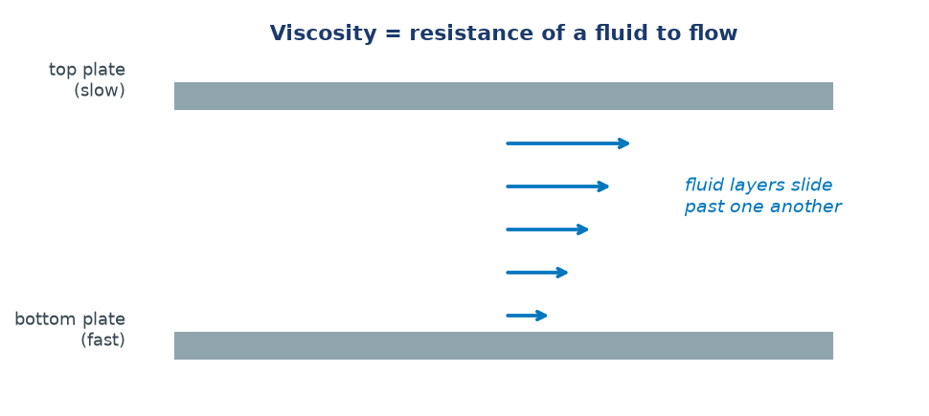
Figure 3.3 — Fluid between two plates. The faster layer drags on the slower layer. This internal drag is viscosity.

What affects viscosity
- Temperature. For most liquids, viscosity decreases as temperature rises. Warm honey flows faster than cold honey. Warm engine oil circulates more easily than cold oil.
- Nature of the liquid. Long molecules (like in oil and honey) get tangled easily, so they have high viscosity. Small molecules (water) slip past each other more easily, so they have low viscosity.
Note: For gases, viscosity increases with temperature. This is the opposite of liquids. Be careful in exam questions.
Terminal velocity — where viscosity shows up in motion
Drop a stone into a jar of honey. It starts slowly and settles into a steady speed. Why doesn't it keep accelerating? Because as it speeds up, the viscous drag (upward force from the fluid) increases. Eventually drag + upthrust = weight, so the net force is zero, and it falls at a constant speed. This steady speed is called terminal velocity.
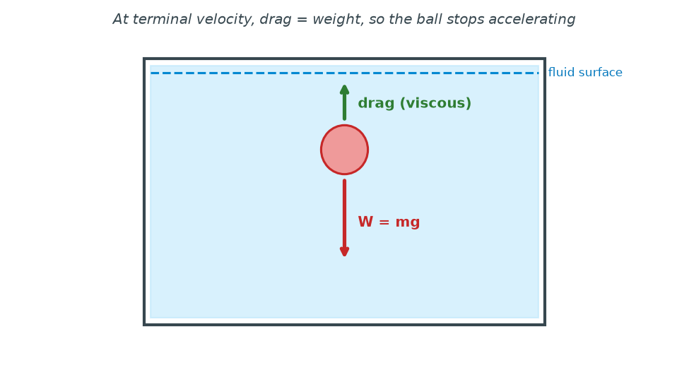
Figure 3.4 — A ball falling through a fluid. Weight pulls down. Viscous drag pushes up. At terminal velocity, the two balance and the ball falls at constant speed.

WHY STUDENTS FIND THIS DIFFICULT
- Confusing viscosity with density. Density is mass per volume; viscosity is resistance to flow. Honey has high viscosity but similar density to water.
- Thinking viscosity always decreases with temperature. True for liquids; false for gases.
- Thinking a falling object in a fluid keeps accelerating forever. It doesn't — terminal velocity kicks in when drag balances weight.
- Thinking terminal velocity = zero velocity. No — the object is moving at its fastest steady speed, not stopped.

KEY POINTS — 3.2
- Viscosity = fluid's resistance to flow.
- High viscosity → slow flow (honey). Low → fast flow (water).
- For liquids, viscosity decreases with temperature.
- For gases, viscosity increases with temperature.
- Terminal velocity: drag = weight → constant speed.

IF YOU REMEMBER ONE THING
Viscosity is friction inside a fluid. Liquids get thinner (less viscous) when hot; gases get thicker (more viscous).

3.3 Free Fall in Vacuum
HAVE YOU EVER NOTICED…
Drop a coin and a feather at the same time. The coin hits first. But if you could remove the air, they'd hit the ground at exactly the same instant. Sound impossible? It's one of the most beautiful facts in physics.

THE BIG IDEA
In a vacuum (no air resistance), all objects fall with the same acceleration, g, regardless of their mass. The reason: a heavier object has more gravitational pull, but also more inertia — the two cancel exactly.

The concept
On Earth, g ≈ 9.8 m/s². Every second a falling object in a vacuum gains 9.8 m/s of velocity.
Why doesn't a heavier object fall faster? Think about it this way:
a = F / m = (mg) / m = g
The force on the object is mg. The acceleration is force divided by mass. The mass cancels. So every object falls with the same acceleration g — a 1 kg stone and a 100 kg stone fall identically, if there's no air.
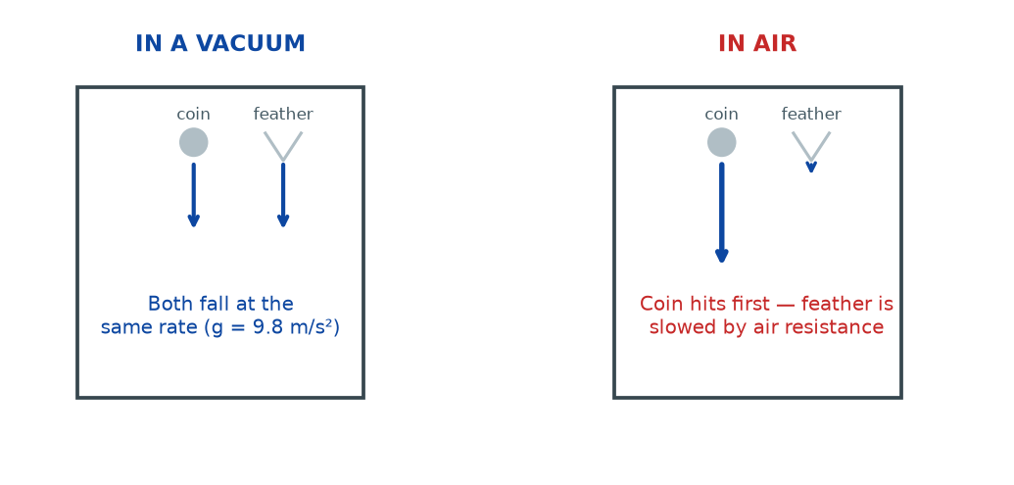
Figure 3.5 — Free fall in a vacuum vs in air. In a vacuum, coin and feather fall together. In air, the feather is slowed by air resistance, so the coin lands first.

Why real life looks different
In air, the feather is slowed by air resistance (a form of friction with air). Its weight is small, so the resistive force quickly balances it, and it drifts down slowly. The coin has much more weight, so air resistance is negligible until it's moving fast. That's why the coin lands first — not because it's heavier, but because it's less affected by air.
The classic demonstration
Take a long glass tube. Put a coin and a feather inside. Pump the air out. Turn it upside down. The coin and feather reach the bottom at the same time. Let the air back in and repeat — now the coin wins. This is how we prove free fall is independent of mass.
The equations of free fall
For an object dropped from rest and falling freely:
v = gt
h = ½ g t²
v² = 2 g h
where v = velocity (m/s), t = time (s), h = distance fallen (m), g = 9.8 m/s².
WHY STUDENTS FIND THIS DIFFICULT
- Believing heavier objects always fall faster. This is only true in air, and only because of air resistance — not because of gravity.
- Thinking g is different for different objects. g is the same for all objects at the same location.
- Confusing mass and weight. Two objects can have very different masses but the same acceleration in free fall.
- Forgetting that these equations apply only to objects dropped from rest with no air resistance.

KEY POINTS — 3.3
- In a vacuum, all objects fall with the same acceleration g = 9.8 m/s².
- Reason: a = mg/m = g. Mass cancels.
- In air, air resistance makes lighter objects fall slower.
- Free-fall equations: v = gt, h = ½gt², v² = 2gh.

IF YOU REMEMBER ONE THING
In a vacuum, everything falls at the same rate. Heavier things only seem faster because air holds them back less.

Worked Examples
Example 1 — Friction on a horizontal surface (Easy)
Question. A 20 kg box rests on a horizontal floor. The coefficient of friction between the box and the floor is 0.4. Find the friction force when the box is just about to slide.
Given: m = 20 kg, μ = 0.4, g = 9.8 m/s².
Find: f.
Principle. f = μN. On a horizontal surface, N = mg.
Solution.
N = mg = 20 × 9.8 = 196 N
f = μN = 0.4 × 196
f = 78.4 N
Why this works: The normal force equals weight on a flat floor. Then multiply by μ — the property of those two surfaces.
Common mistake: Using f = μmg without checking that N = mg. If there's another vertical force (a hand pushing down, or pulling up), N is not mg.
Example 2 — Coefficient from data (Medium)
Question. A 5 kg block is dragged across a table with a constant horizontal force of 30 N. It slides at constant velocity. Find μ.
Given: m = 5 kg, applied force = 30 N, constant velocity (so net force = 0).
Find: μ.
Principle. At constant velocity, friction equals the applied force: f = 30 N. Then μ = f / N.
Solution.
N = mg = 5 × 9.8 = 49 N
μ = f / N = 30 / 49
μ = 0.61 (no units)
Why this works: Constant velocity means no acceleration means no net force. So friction balances the applied force exactly.
Common mistake: Forgetting that constant velocity means net force is zero. Students sometimes try to use F = ma with a = 0 and get confused.
Example 3 — Free fall (Medium)
Question. A stone is dropped from the top of a building and hits the ground 3.0 s later. Find the height of the building and the stone's speed just before impact. (Ignore air resistance; g = 9.8 m/s².)
Given: t = 3.0 s, u = 0, g = 9.8 m/s².
Find: h and v.
Principle. Free-fall equations: h = ½gt² and v = gt.
Solution.
h = ½ × 9.8 × (3.0)² = 44.1 m
v = 9.8 × 3.0 = 29.4 m/s
Why this works: The object accelerates from rest at g, so both equations apply directly.
Common mistake: Using v = u + at with a = 10 and t = 3 to get 30 — that's fine if the question says g = 10. Always read what g value the question gives.
Example 4 — Terminal velocity reasoning (MSCE)
Question. Explain why a ball dropped into a tall cylinder of oil eventually falls at constant speed.
Given: Ball in oil. Initially at rest at the surface.
Find: Explanation.
Principle. Newton's Second Law plus viscosity.
Solution. At first, the only significant force is the ball's weight. So it accelerates downward. As speed increases, the viscous drag (upward) increases. The net downward force decreases, so acceleration decreases. Eventually the drag equals the weight, the net force becomes zero, and the ball falls at a constant terminal velocity.
At terminal velocity: drag + upthrust = weight, so net force = 0
Why this works: Acceleration depends on net force. As drag grows, net force shrinks, so acceleration shrinks. When both are zero, velocity stops changing.
Common mistake: Saying the ball 'stops.' It doesn't stop — it moves at a steady speed. That's the difference between terminal velocity and rest.

Check Yourself
1. Define friction and state two factors it depends on.
2. What is the SI unit of the coefficient of friction? Explain your answer.
3. Distinguish between static and kinetic friction.
4. A 10 kg block rests on a horizontal surface with μ = 0.3. Calculate the maximum static friction.
5. What is viscosity?
6. How does the viscosity of a liquid change with temperature?
7. What is terminal velocity?
8. Why do a coin and a feather fall at the same rate in a vacuum?
9. A stone is dropped from rest and falls for 2.5 s. Calculate the distance fallen and its final speed. (g = 9.8 m/s².)
10. In your own words, explain why a heavier object does not fall faster than a lighter one in a vacuum.

Exam-Style Questions (MSCE-style practice)
Q1. (a) Define the coefficient of friction between two surfaces.
(b) State the equation relating friction force, coefficient of friction, and normal force.
Q2. A 15 kg crate rests on a horizontal floor. The coefficient of static friction is 0.5. A student pushes the crate with a horizontal force of 60 N and it does not move.
(a) Calculate the maximum static friction.
(b) State and explain whether the crate will move if the student pushes with 80 N.
Q3. A block of mass 6 kg slides at constant velocity down a horizontal surface under a horizontal force of 25 N.
(a) Draw a free-body diagram of the block.
(b) Calculate the coefficient of kinetic friction.
Q4. (a) Explain, in terms of forces, why a skydiver reaches terminal velocity.
(b) Sketch a graph of velocity against time for a skydiver jumping from a plane.
Q5. A ball is dropped from the top of a tower 80 m high. Ignoring air resistance, calculate:
(a) the time taken to reach the ground,
(b) the velocity just before impact. (g = 10 m/s².)
Q6. Explain why the viscosity of cooking oil decreases when it is heated.
Q7. A glass tube containing a coin and a feather is sealed and the air is pumped out.
(a) Describe what is observed when the tube is turned upside down.
(b) Explain the observation using Newton's Second Law.
Q8. Two blocks, one 2 kg and one 6 kg, are dropped from the same height on the Moon (no atmosphere). Compare their times of fall. Explain your answer.
Q9. A 4 kg block is pushed with a horizontal force of 30 N along a rough horizontal surface with μ = 0.4.
(a) Calculate the friction force.
(b) Calculate the acceleration of the block.
Q10. (a) Explain why friction is described as a 'necessary evil'.
(b) Give two ways friction can be reduced in machines.

Full Worked Solutions
Check Yourself — Answers
1. Friction is a force that opposes sliding motion (or attempted sliding) between two surfaces. It depends on (i) the nature of the surfaces and (ii) the normal force between them.
2. No units. It is a ratio of two forces (f/N), so units cancel.
3. Static friction acts when the object is at rest; it grows with applied force up to a maximum. Kinetic friction acts when the object is sliding; it is roughly constant and slightly smaller than maximum static friction.
4. f = μN = μmg = 0.3 × 10 × 9.8 = 29.4 N.
5. Viscosity is a fluid's resistance to flow.
6. For liquids, viscosity decreases as temperature rises.
7. Terminal velocity is the constant speed reached by a falling object when drag balances weight.
8. In a vacuum, both have acceleration a = mg/m = g. Mass cancels, so acceleration is the same.
9. h = ½ × 9.8 × (2.5)² = 30.6 m; v = 9.8 × 2.5 = 24.5 m/s.
10. A heavier object has more weight (mg), but also more mass (m). The extra force is exactly offset by the extra inertia. So a = F/m = mg/m = g, the same for both.

Exam-Style — Full Solutions
Q1. (a) The coefficient of friction is the ratio of the friction force between two surfaces to the normal force pressing them together. It has no units.
(b) f = μN.
Q2. (a) f_max = μN = 0.5 × 15 × 9.8 = 73.5 N.
(b) Yes, the crate will move, because 80 N exceeds the maximum static friction (73.5 N). Once it starts, kinetic friction takes over (usually smaller than 73.5 N), so it continues to slide.
Q3. (a) Free-body diagram: weight downward, normal upward, applied force horizontally forward, friction horizontally backward.
(b) Constant velocity → friction = applied force = 25 N. N = 6 × 9.8 = 58.8 N. μ = 25 / 58.8 = 0.425.
Q4. (a) As the skydiver falls, air resistance increases with speed. Eventually it equals the weight, net force becomes zero, and the diver falls at a constant terminal velocity.
(b) Graph: velocity starts at 0, rises steeply, then levels off to a horizontal line (terminal velocity).
Q5. (a) h = ½gt² → 80 = ½ × 10 × t² → t² = 16 → t = 4 s.
(b) v = gt = 10 × 4 = 40 m/s.
Q6. Heating gives the oil molecules more kinetic energy, so they overcome intermolecular forces more easily and slide past each other more freely. Viscosity decreases.
Q7. (a) The coin and feather reach the bottom at the same time.
(b) Both experience the same acceleration a = g, because their weight and inertia cancel. With no air resistance, no other force acts.
Q8. Same time. On the Moon (no atmosphere), both fall with a = g_Moon, so they hit the surface together. The smaller g just makes the fall slower overall.
Q9. (a) f = μmg = 0.4 × 4 × 9.8 = 15.68 N.
(b) Net force = 30 − 15.68 = 14.32 N. a = F/m = 14.32/4 = 3.58 m/s².
Q10. (a) Friction is a 'necessary evil' because it wastes energy and causes wear (evil), yet without it you could not walk, drive, or hold objects (necessary).
(b) Lubrication (oil, grease), and using smooth materials or ball bearings.

Common Mistakes
- Using f = μmg when the surface is not horizontal or when there are other vertical forces.
- Giving μ a unit. It has none — it is a ratio of forces.
- Thinking friction always acts opposite to the object's velocity. In fact, static friction acts opposite to attempted motion.
- Confusing viscosity with density. Honey is viscous but not much denser than water.
- Saying a fall in a fluid 'stops' at terminal velocity. It moves at constant speed, not zero.
- Saying heavier objects always fall faster. Only true in air, and only because of air resistance.
- Forgetting to square the time in h = ½gt².
- Mixing up g = 9.8 with g = 10 (or another value) — always use the value the question gives you.

EXAM TIP
MSCE loves: (1) f = μN calculations; (2) free-fall calculations with v = gt or h = ½gt²; (3) explanation of terminal velocity.
For 'explain' questions, tie the answer to a net force of zero or a = mg/m = g. Those phrases earn the reasoning marks.
Always draw a free-body diagram when asked. Even if you don't fully solve the problem, the diagram earns marks.
If the surface is flat and horizontal, N = mg is almost always safe to assume — unless a question mentions a downward or upward external force.

REMEMBER • f = μN. Viscosity = fluid friction. In a vacuum, everything falls at g — heavier things only seem faster because air holds them back.

Chapter 3 Test
SECTION A — Multiple Choice (5 marks)
1. The coefficient of friction has units of:
A. N B. N/m C. No units D. kg

2. A 5 kg block is dragged at constant velocity across a horizontal surface with μ = 0.4. The friction force is about:
A. 2 N B. 5 N C. 20 N D. 50 N

3. Viscosity of a liquid ______ when heated.
A. increases B. decreases C. stays the same D. becomes zero

4. In a vacuum, a 1 kg stone and a 10 kg stone dropped from the same height:
A. Land at different times B. Land at the same time C. Only the 1 kg lands D. Neither lands

5. Terminal velocity is reached when:
A. The object stops B. Gravity is zero C. Drag balances weight D. Mass is zero

SECTION B — Short Answers (10 marks)
6. State the equation for the force of friction and define each symbol. (3)
7. Explain the difference between static and kinetic friction. (2)
8. What is viscosity? State how it changes with temperature for a liquid. (2)
9. A stone is dropped from rest. After 4 s, what is its speed? (g = 9.8 m/s².) (1)
10. Give one reason friction is useful and one reason it is a problem. (2)

SECTION C — Structured Questions (15 marks)
12. A 25 kg crate is pushed with a horizontal force of 80 N across a rough horizontal floor with μ = 0.25.
(a) Calculate the friction force on the crate. (3)
(b) Calculate the net force on the crate. (2)
(c) Calculate the acceleration of the crate. (2)

13. A stone is dropped from the top of a building 45 m high. (g = 10 m/s².)
(a) Calculate the time taken to reach the ground. (3)
(b) Calculate the speed just before impact. (2)

14. (a) Explain why a skydiver reaches terminal velocity. (3)

END OF CHAPTER 3
Next chapter: Chapter 4 — Hooke's Law.

