CHAPTER 4 — Hooke's Law
Physics · Form 4 · MSCE · Malawian Science Books

Welcome to Chapter 4. Stretch a rubber band. Pull it gently — it stretches, and when you let go, it snaps back. Pull it too hard — it stretches a lot, and this time it stays stretched. Two completely different behaviours, one simple rule.
That rule was discovered by Robert Hooke over 350 years ago. It tells us how springs, wires, and even bones bend when we pull on them. It explains why a mattress springs back, why a car has suspension, and why a bridge doesn't collapse under its own weight.
By the end of this chapter, you will understand force, extension, and the spring constant — and be able to calculate any one of them from the other two.

4.1 Effects of Force
HAVE YOU EVER NOTICED…
Knead nsima dough — it changes shape. Kick a football — it changes direction. Hang a bag from a hook — the hook bends a tiny bit. Forces do many different things to objects.

THE BIG IDEA
A force can do four things to an object: change its speed, change its direction, change its shape, or change its size. When a force changes shape or size, we call it deformation.

The four effects of force
Effect of force | Example
Changes the speed of an object | Kicking a stationary ball; braking a car
Changes the direction of motion | Hitting a tennis ball sideways
Changes the shape of an object | Kneading dough; bending a wire
Changes the size of an object | Stretching a spring; compressing a sponge

Elastic vs plastic deformation
When a force changes an object's shape or size, two things can happen:
Type of deformation | What happens | Example
Elastic | Object returns to its original shape/size when the force is removed | Rubber band, spring (gently stretched)
Plastic | Object stays permanently changed once the force is removed | Bending a paper clip too far, moulding clay

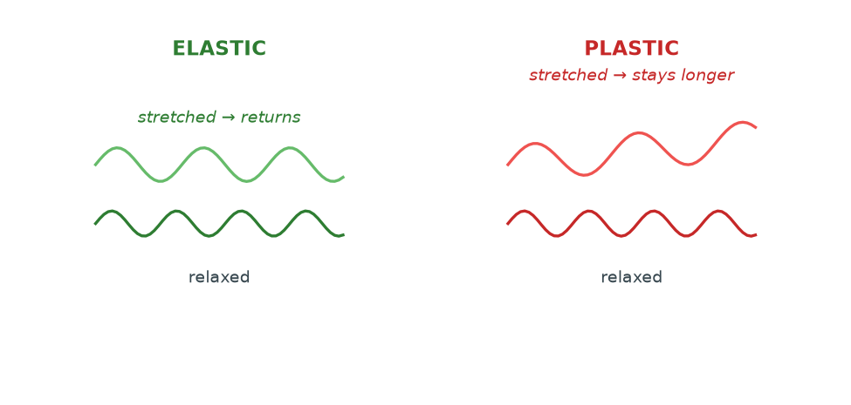
Figure 4.1 — Elastic deformation: the object springs back. Plastic deformation: the object stays deformed. A spring works only in the elastic region — beyond that, it is ruined.

For a spring, there is a limit — the elastic limit — beyond which plastic deformation sets in. Once a spring has been stretched past its elastic limit, it never returns to its original length. It is 'worn out.'
WHY STUDENTS FIND THIS DIFFICULT
- Thinking all deformation is elastic. Only some is. Push a spring too far, and it stays stretched.
- Confusing elastic limit with proportional limit. The proportional limit is where the graph stops being a straight line. The elastic limit is where the object stops returning to its original shape. They are close but not the same.
- Thinking a force only stretches. A force can also compress, bend, twist, or shear.

KEY POINTS — 4.1
- A force can change speed, direction, shape, or size.
- Elastic deformation: object returns to original shape.
- Plastic deformation: permanent change.
- The elastic limit is the point beyond which the object stays deformed.

IF YOU REMEMBER ONE THING
Stretch a spring gently — it returns. Stretch it too far — it doesn't. That 'too far' point is the elastic limit.

4.2 Stretching of Materials — Hooke's Law
HAVE YOU EVER NOTICED…
If you hang one small stone on a spring, it stretches a little. Hang two identical stones — it stretches twice as much. Three stones — three times as much. The spring is telling you something mathematical.

THE BIG IDEA
The extension of a spring is directly proportional to the force applied — provided the elastic limit is not exceeded. Double the force, double the extension. Triple the force, triple the extension.

The real concept
Hooke's Law is one of the simplest and most useful relationships in all of physics. It works for springs, wires, rubber bands (roughly), and even the bending of bones and bridges — as long as the deformation stays small.
What is happening at the atomic level? The atoms in the material are held together by bonds. Those bonds act like tiny springs. Pull on them, and they stretch. Pull harder, and they stretch more. Within limits, they behave in a perfectly linear way.
That's why the mathematics is so clean.
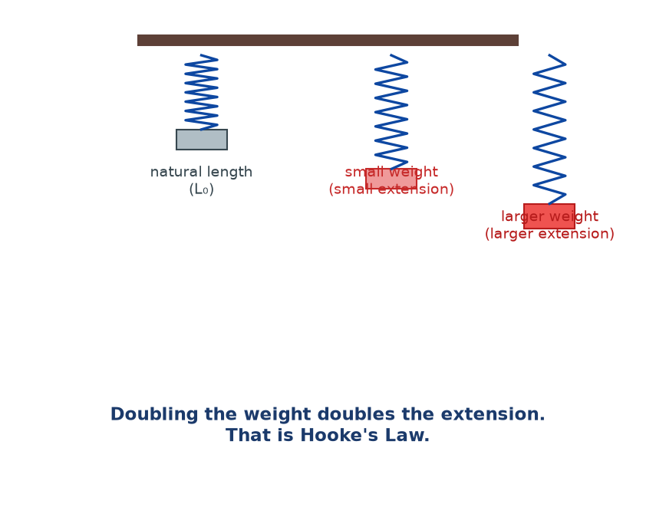
Figure 4.2 — The same spring loaded with increasing weights. Each time the weight doubles, the extension doubles. That is Hooke's Law in action.

The equation
F = k e
F = force (N), k = spring constant (N/m), e = extension (m)
Rearranged:
k = F / e or e = F / k
F is the force stretching the spring — usually the weight hung on it. k is a number that tells you how stiff the spring is. e is the extension — the extra length, not the total length.
Notice: e = new length − original length. Not just the new length. This is where students make marks-destroying errors.
Units
- F: newtons (N)
- e: metres (m)
- k: newtons per metre (N/m)
The force-extension graph
Plot F on the y-axis and e on the x-axis. Within the Hooke's Law region, you get a straight line through the origin. The gradient of that line is k.
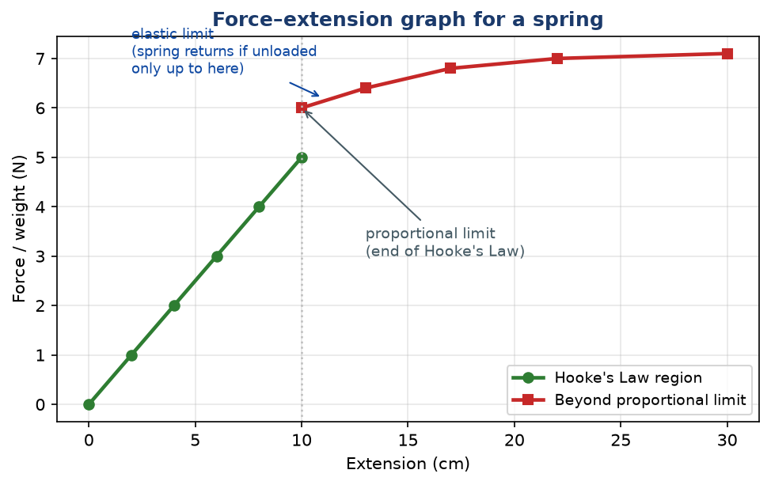
Figure 4.3 — The force–extension graph. Straight through the origin until the proportional limit, then it curves. The gradient of the straight part is the spring constant k.

The gradient of the linear portion gives k = F/e. Beyond the proportional limit, the graph curves — the spring is no longer obeying Hooke's Law.
WHY STUDENTS FIND THIS DIFFICULT
- Confusing extension with total length. Extension is the extra bit, not the whole spring.
- Forgetting that the force in F = ke is the weight (mg) of what's hanging on the spring, not the mass itself.
- Forgetting that Hooke's Law only applies within the elastic limit. Beyond that, the graph curves and the equation fails.
- Thinking k is a universal constant. It's not — each spring has its own k.
- Using grams instead of newtons. If the question gives mass, you must convert with W = mg.

KEY POINTS — 4.2
- Hooke's Law: F = ke.
- k is the spring constant (N/m) — how stiff the spring is.
- e is the extension — the extra length, not total length.
- Force-extension graph: straight line through origin, gradient = k.
- Only valid within the elastic limit.

IF YOU REMEMBER ONE THING
F = ke. Force, stiffness, and extension. Extension means the extra length, not the total length. Convert mass to weight before using F = ke.

4.3 Combination of Springs in Series and Parallel
HAVE YOU EVER NOTICED…
Hang two springs end-to-end and attach a weight — the weight stretches much further than with one spring. Hang the same two springs side by side — the weight stretches less. Same springs, different arrangement, different behaviour.

THE BIG IDEA
In series, springs stretch more — the combination is softer. In parallel, springs stretch less — the combination is stiffer. The rules look like the rules for resistors (but swapped!).

Springs in series
Two (or more) springs connected end to end. Each spring feels the same force, but the extensions add up.
e_total = e₁ + e₂ + …
Total extension is the sum of individual extensions
For two springs of constants k₁ and k₂ in series:
1 / k_total = 1 / k₁ + 1 / k₂
The combined spring constant is smaller than either spring. The combination is softer.
Springs in parallel
Two (or more) springs connected side by side, sharing the load. Each spring feels only part of the force, but they stretch by the same amount.
k_total = k₁ + k₂ + …
Combined spring constant is the sum
The combined spring constant is larger than either spring. The combination is stiffer.
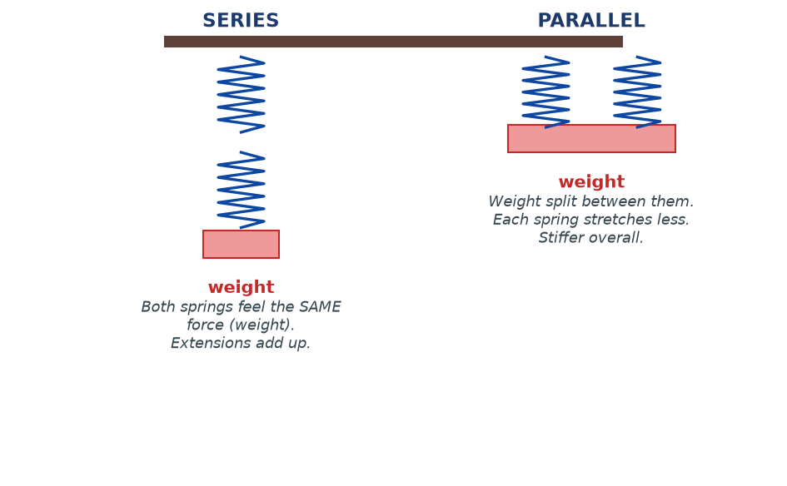
Figure 4.4 — Springs in series vs parallel. In series, extensions add and the combination is softer. In parallel, forces split and the combination is stiffer.

Arrangement | Force on each spring | Extension of each spring | Combined k
Series | Same for both | Adds | Smaller than either
Parallel | Splits between them | Same for both | Larger than either

WHY STUDENTS FIND THIS DIFFICULT
- Mixing up the series and parallel rules. Series adds extensions; parallel adds forces. This is the opposite of resistors.
- Forgetting that in series each spring feels the full weight, so it stretches more.
- Forgetting that in parallel each spring feels only part of the weight.
- Using the resistor formula for series springs. It's different! Series springs use 1/k = 1/k₁ + 1/k₂. Parallel springs use k = k₁ + k₂.

KEY POINTS — 4.3
- Series: 1/k_total = 1/k₁ + 1/k₂ + … (softer).
- Parallel: k_total = k₁ + k₂ + … (stiffer).
- Series → extensions add.
- Parallel → forces split.

IF YOU REMEMBER ONE THING
Series springs: weaker combined, extensions add. Parallel springs: stronger combined, forces split. The opposite of resistors.

4.4 Applications of Hooke's Law
HAVE YOU EVER NOTICED…
When you step on a scale at the clinic, a spring inside compresses and the needle points to your weight. When a car hits a bump, springs in the suspension compress and then stretch back. When you bounce on a mattress, dozens of small springs flex together.

THE BIG IDEA
Any device that uses a spring to measure, absorb, or restore force is using Hooke's Law. Springs are everywhere in engineering — because their behaviour is so predictable.

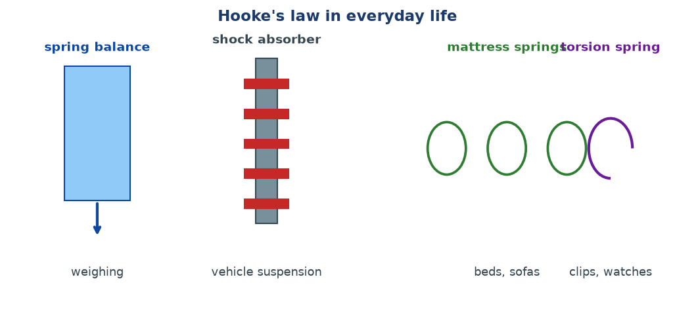
Figure 4.5 — Some everyday applications of Hooke's Law: spring balance for weighing, shock absorbers in cars, mattress springs, torsion springs in clips.

Real-life uses
- Spring balances / scales — used in clinics, markets, and science labs to measure weight. The extension of the spring tells you the force.
- Vehicle suspension — springs absorb bumps in the road, keeping passengers comfortable and the wheels on the ground.
- Mattresses and sofas — many small springs deform under your weight and return when you stand up.
- Torsion springs — used in clothes pegs, mousetraps, and clock mechanisms.
- Shock absorbers — combine springs with dampers to smooth out vibration.
- Newton meters — the classic school-lab instrument for measuring force.
Limitations — where Hooke's Law breaks down
Hooke's Law is only true up to the elastic limit. Beyond that:
- The spring stretches permanently (plastic deformation).
- The graph is no longer a straight line.
- The spring may snap.
Also, Hooke's Law describes small deformations. For very large forces, or very long stretches, more complicated behaviour emerges. In practice, engineers keep their designs well within the elastic region.
WHY STUDENTS FIND THIS DIFFICULT
- Thinking Hooke's Law is universal. It only applies to the elastic region of some materials.
- Assuming all materials obey Hooke's Law. Rubber, plastic, and biological tissues usually don't — they have complex, non-linear behaviour.
- Thinking k is a fundamental constant of nature. It is a property of a specific spring, wire, or object.

KEY POINTS — 4.4
- Hooke's Law powers spring balances, suspension systems, mattresses, and Newton meters.
- It only holds within the elastic limit.
- Engineers design within the elastic region.
- Materials like rubber don't obey Hooke's Law exactly.

IF YOU REMEMBER ONE THING
Hooke's Law is used everywhere springs are. But it only works up to the elastic limit. Beyond that, springs are ruined.

Worked Examples
Example 1 — Finding extension (Easy)
Question. A spring of spring constant 40 N/m is stretched by a force of 8 N. Find the extension.
Given: k = 40 N/m, F = 8 N.
Find: e.
Principle. Hooke's Law: F = ke.
Solution.
e = F / k = 8 / 40
e = 0.2 m = 20 cm
Why this works: A stiff spring (large k) stretches less for the same force. A soft spring (small k) stretches more.
Common mistake: Forgetting to convert cm to m before using F = ke. Always work in SI units.
Example 2 — Finding spring constant (Medium)
Question. A 500 g mass hanging from a spring causes it to extend by 5 cm. Find the spring constant. (g = 9.8 m/s².)
Given: m = 500 g = 0.5 kg, e = 5 cm = 0.05 m, g = 9.8 m/s².
Find: k.
Principle. The force on the spring is the weight of the hanging mass: F = mg. Then k = F/e.
Solution.
F = mg = 0.5 × 9.8 = 4.9 N
k = F / e = 4.9 / 0.05
k = 98 N/m
Why this works: The weight is the stretching force. Once you have F, Hooke's Law gives k directly.
Common mistake: Using mass (0.5 kg) directly as the force. Force is weight, not mass. Multiply by g first.
Example 3 — Series springs (Medium–Hard)
Question. Two springs with k₁ = 100 N/m and k₂ = 150 N/m are connected in series. Find the combined spring constant.
Given: k₁ = 100, k₂ = 150.
Find: k_total.
Principle. For series: 1/k_total = 1/k₁ + 1/k₂.
Solution.
1/k_total = 1/100 + 1/150 = 3/300 + 2/300 = 5/300
k_total = 300/5 = 60 N/m
Why this works: Springs in series act like a longer, softer spring, so k_total is smaller than either k.
Common mistake: Adding k₁ + k₂ for series. That's for parallel. For series, use reciprocals.
Example 4 — Interpreting a graph (MSCE)
Question. A student plots force against extension for a spring. The straight part of the graph passes through (0, 0) and (0.06 m, 12 N). Find the spring constant. Explain why the graph curves at higher extensions.
Given: Straight portion: e = 0.06 m, F = 12 N.
Find: k and explanation.
Principle. Gradient of F vs e graph = k.
Solution.
k = F / e = 12 / 0.06 = 200 N/m
Explanation of the curve: Beyond the proportional limit, the spring's internal structure begins to deform permanently. The relationship between force and extension stops being linear. Hooke's Law no longer applies.
Beyond the elastic limit, the spring never returns to its original length.
Why this works: The gradient of a straight-line graph is Δy/Δx. Here Δy = F and Δx = e, so the gradient is k.
Common mistake: Reading the total length of the spring instead of the extension. Always use e = new length − original length.

Check Yourself
1. State two effects a force can have on an object.
2. Distinguish between elastic and plastic deformation.
3. State Hooke's Law in words and as an equation.
4. What are the SI units of the spring constant?
5. A spring of constant 25 N/m is stretched by 0.4 m. Find the force applied.
6. A 2 kg mass hangs from a spring of constant 50 N/m. Find the extension. (g = 9.8 m/s².)
7. Two springs (k₁ = 60 N/m, k₂ = 30 N/m) are connected in parallel. Find the combined k.
8. Two identical springs of constant 20 N/m are connected in series. Find the combined k.
9. A force-extension graph for a spring is a straight line through the origin. What does its gradient represent?
10. In your own words, explain what happens to a spring when it is stretched past its elastic limit.

Exam-Style Questions (MSCE-style practice)
Q1. (a) State Hooke's Law.
(b) A spring has a natural length of 15 cm. When a 6 N force is hung on it, the length becomes 21 cm. Calculate the spring constant.
Q2. A student hangs masses on a spring and records the following data:
Mass (g): 0, 100, 200, 300, 400
Extension (cm): 0, 2.0, 4.0, 6.0, 8.0
(a) Plot a graph of force (N) against extension (m).
(b) From the graph, determine the spring constant.
(c) State whether the spring obeys Hooke's Law, and justify your answer. (g = 10 m/s².)
Q3. (a) Explain the difference between elastic and plastic deformation.
(b) Sketch a force-extension graph that shows both regions.
Q4. Two springs, k₁ = 200 N/m and k₂ = 300 N/m, are connected in series.
(a) Find the combined spring constant.
(b) Find the extension of the combination when a force of 12 N is applied.
(c) Find the extension of each spring individually, and check that they add to your answer in (b).
Q5. A spring of constant 80 N/m has a natural length of 30 cm. A 3 kg mass is hung on it. Calculate:
(a) the force on the spring (g = 9.8 m/s²),
(b) the extension,
(c) the new length of the spring.
Q6. Two springs of constant 150 N/m each are connected in parallel. Find the combined spring constant.
Q7. A student stretches a spring and notices the graph becomes curved at large extensions. Explain what has happened to the spring, and why the graph is no longer linear.
Q8. (a) State one use of Hooke's Law in everyday life.
(b) State one limitation of Hooke's Law.
Q9. A spring balance has a spring of k = 40 N/m. It is marked in newtons from 0 to 20 N.
(a) Find the maximum extension of the spring.
(b) The balance is taken to the Moon where g = 1.6 m/s². A mass of 5 kg is hung on it. What does the balance read?
Q10. Three identical springs, each with k = 90 N/m, are connected (i) all in series, (ii) all in parallel. Find the combined constant in each case.

Full Worked Solutions
Check Yourself — Answers
1. Any two: change speed, change direction, change shape, change size.
2. Elastic: returns to original shape/size. Plastic: stays permanently deformed.
3. The extension of a spring is directly proportional to the force applied, up to the elastic limit. F = ke.
4. N/m (newtons per metre).
5. F = ke = 25 × 0.4 = 10 N.
6. W = mg = 2 × 9.8 = 19.6 N. e = F/k = 19.6/50 = 0.392 m.
7. k = k₁ + k₂ = 60 + 30 = 90 N/m.
8. 1/k = 1/20 + 1/20 = 2/20 → k = 10 N/m.
9. The spring constant k (in N/m).
10. The spring undergoes plastic deformation — it stays permanently stretched and does not return to its original length when the force is removed.

Exam-Style — Full Solutions
Q1. (a) The extension of a spring is directly proportional to the applied force, provided the elastic limit is not exceeded.
(b) Extension e = 21 − 15 = 6 cm = 0.06 m. k = F/e = 6 / 0.06 = 100 N/m.
Q2. (a) Graph: straight line through the origin. Points: (0,0), (0.02, 1), (0.04, 2), (0.06, 3), (0.08, 4).
(b) Gradient = 4 / 0.08 = 50 N/m.
(c) Yes. The graph is a straight line through the origin.
Q3. (a) Elastic: returns to original shape when force removed. Plastic: stays deformed.
(b) Graph: straight line from origin, then curving off after the proportional limit.
Q4. (a) 1/k = 1/200 + 1/300 = 3/600 + 2/600 = 5/600 → k = 120 N/m.
(b) e = F/k = 12/120 = 0.10 m.
(c) e₁ = F/k₁ = 12/200 = 0.06 m; e₂ = F/k₂ = 12/300 = 0.04 m. Sum = 0.10 m ✓.
Q5. (a) F = mg = 3 × 9.8 = 29.4 N.
(b) e = F/k = 29.4 / 80 = 0.3675 m.
(c) New length = 0.30 + 0.3675 = 0.6675 m (≈ 66.75 cm).
Q6. k = 150 + 150 = 300 N/m.
Q7. The spring has gone past its proportional limit — it is now undergoing plastic deformation. The internal structure has been permanently altered, so the force-extension relation is no longer linear.
Q8. (a) Spring balance; car suspension; mattress springs.
(b) It only applies within the elastic limit. Beyond it, the spring is permanently deformed.
Q9. (a) e = F/k = 20/40 = 0.5 m.
(b) Weight of 5 kg on Moon = 5 × 1.6 = 8 N. Spring balance reads 8 N. (Note: the balance is calibrated on Earth to read in N directly, so it gives the true force.)
Q10. (i) Series: 1/k = 3 × (1/90) = 3/90 → k = 30 N/m.
(ii) Parallel: k = 3 × 90 = 270 N/m.

Common Mistakes
- Using total length instead of extension. Extension = new length − original length.
- Using mass instead of weight for F. Always multiply by g first.
- Forgetting to convert grams to kg and cm to m.
- Mixing up series and parallel formulas. Series: 1/k = 1/k₁ + 1/k₂. Parallel: k = k₁ + k₂.
- Thinking Hooke's Law applies everywhere. It only works up to the elastic limit.
- Saying the gradient of the F-e graph is 'the force.' It's k.
- Thinking k is a fixed property of any material. It depends on the specific spring.

EXAM TIP
MSCE exams regularly ask: (1) an F = ke calculation, sometimes with the mass given (convert to weight first!), (2) using a force-extension graph to find k from its gradient, (3) explaining elastic vs plastic deformation.
For graph questions: label axes, choose a straight portion, use gradient = Δy/Δx. Always state units.
For 'explain' questions, tie your answer to the elastic limit: 'Beyond the elastic limit, the spring is permanently deformed, so Hooke's Law no longer applies.'
Do NOT confuse extension (e) with length (L). Examiners deliberately test this.

REMEMBER • F = ke. Extension = extra length, not total length. Series adds extensions (softer); parallel splits forces (stiffer). Beyond the elastic limit, Hooke's Law fails.

Chapter 4 Test
SECTION A — Multiple Choice (5 marks)
1. Which is the SI unit of spring constant?
A. N B. N/m C. N·m D. m/N

2. A spring has k = 50 N/m and extends by 0.2 m. The force applied is:
A. 0.004 N B. 10 N C. 250 N D. 100 N

3. Two identical springs each with k = 100 N/m are connected in parallel. The combined k is:
A. 50 N/m B. 100 N/m C. 200 N/m D. 400 N/m

4. Hooke's Law applies:
A. Only to metals B. Only within the elastic limit C. To all materials forever D. Only to liquids

5. The gradient of a force-extension graph gives:
A. Extension B. Force C. Spring constant D. Mass

SECTION B — Short Answers (10 marks)
6. State Hooke's Law. (2)
7. Distinguish between elastic and plastic deformation. (2)
8. A spring of natural length 20 cm stretches to 26 cm under a force of 3 N. Find the extension and the spring constant. (3)
9. Give one real-life application of Hooke's Law. (1)
10. Two springs of constants 40 N/m and 60 N/m are connected in series. Find the combined constant. (2)

SECTION C — Structured Questions (15 marks)
12. A 400 g mass is hung on a spring of constant 32 N/m.
(a) Calculate the weight of the mass. (g = 9.8 m/s².) (2)
(b) Calculate the extension of the spring. (3)
(c) State the new length of the spring if its natural length is 25 cm. (1)

13. (a) A spring of k = 90 N/m is connected in series with a spring of k = 180 N/m. Find the combined k. (3)
(b) The combination is then stretched by a force of 20 N. Find the total extension. (2)

14. (a) Sketch a force-extension graph for a spring, marking the proportional limit. (3)
(b) Explain what happens to the spring beyond this point. (1)

END OF CHAPTER 4
Next chapter: Chapter 5 — Uniform Circular Motion.

