CHAPTER 5 — Uniform Circular Motion
Physics · Form 4 · MSCE · Malawian Science Books

Welcome to Chapter 5. Whirl a stone on a string around your head. Feel the pull on your finger. You are feeling the centripetal force — the force that keeps the stone going in a circle instead of flying off in a straight line.
The same force keeps the Moon in orbit around the Earth, keeps a car on the road at a sharp bend, and keeps water in a bucket when you swing it overhead. It is one of the most beautiful and useful ideas in mechanics.
By the end of this chapter, you'll know how to describe circular motion, how to calculate angular velocity, centripetal force, and centripetal acceleration — and how to explain all of it in terms of Newton's laws.

5.1 Illustrating Circular Motion
HAVE YOU EVER NOTICED…
When you whirl a stone on a string in a horizontal circle, the stone seems to want to fly outward. You feel a tug outward on your hand. But the string pulls inward. Which is right?

THE BIG IDEA
Uniform circular motion is motion in a circle at constant speed. The speed is constant, but the velocity is not — because the direction is always changing. And any change in velocity means acceleration.

The real concept
Speed and velocity are not the same thing. Speed is how fast. Velocity is how fast and in what direction. In circular motion, the object moves at constant speed but its direction keeps changing — so its velocity keeps changing.
Since acceleration is the rate of change of velocity, and velocity is changing, the object must be accelerating — even though its speed is constant. This acceleration is called centripetal acceleration (from the Latin for 'centre-seeking').
And by Newton's Second Law, an acceleration must come from a force. The force that causes centripetal acceleration is called centripetal force.
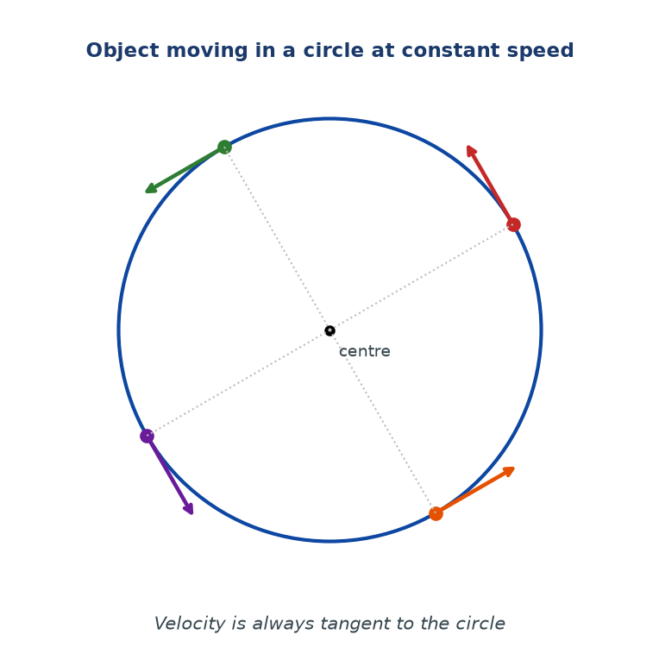
Figure 5.1 — An object moving in a circle at constant speed. At each point, its velocity is tangent to the circle. The velocity's direction keeps changing, so the object is accelerating.

Two simple rules to remember
Rule 1. In circular motion, velocity is always tangent to the circle. Never toward the centre, never away from the centre — always at right angles to the radius, along the direction of motion.
Rule 2. The centripetal force is always toward the centre of the circle. Never outward.
Common confusion: 'centrifugal force'
Many people talk about a centrifugal force pushing things outward. It feels that way when you're inside a turning car. But this 'force' is not real — it's the sensation of your body wanting to continue in a straight line (Newton's First Law) while the car turns. There is no outward force acting. The only real force is the inward centripetal force.
In MSCE, always use centripetal force, which points inward.
WHY STUDENTS FIND THIS DIFFICULT
- Thinking that constant speed means no acceleration. In circular motion, speed is constant but velocity changes — so acceleration is non-zero.
- Believing in 'centrifugal force' — an outward push. It does not exist. Only the inward force is real.
- Drawing velocity arrows pointing toward the centre. Velocity is tangent; the force is toward the centre.
- Confusing which direction the force acts. The force is toward the centre, the same direction as the acceleration.

KEY POINTS — 5.1
- Uniform circular motion: constant speed, changing direction.
- Velocity is always tangent to the circle.
- Acceleration and force are always toward the centre.
- There is no real outward force. The sensation of an outward push comes from inertia.

IF YOU REMEMBER ONE THING
In circular motion: velocity along the tangent, force toward the centre.

5.2 Angular Displacement and Angular Velocity
HAVE YOU EVER NOTICED…
A clock's second hand goes round the dial in 60 seconds. A wheel on a moving bicycle might go round many times a second. Both are rotating, but at very different rates. To describe how fast they rotate, we use angular quantities.

THE BIG IDEA
Angular displacement measures how far round a circle something has turned. Angular velocity measures how fast it turns — the angular displacement per second.

Angular displacement, θ
Imagine a line drawn from the centre of a circle to a moving object. As the object moves along the circle, this line rotates. The angle it sweeps out is the angular displacement, written θ.
The unit of angular displacement is the radian (rad). One full circle is 2π radians, which equals 360°.
θ = s / r
θ = angular displacement (rad); s = arc length (m); r = radius (m)
Because the radian is a ratio of two lengths, it has no units in the usual sense. But we still write 'rad' to be clear.
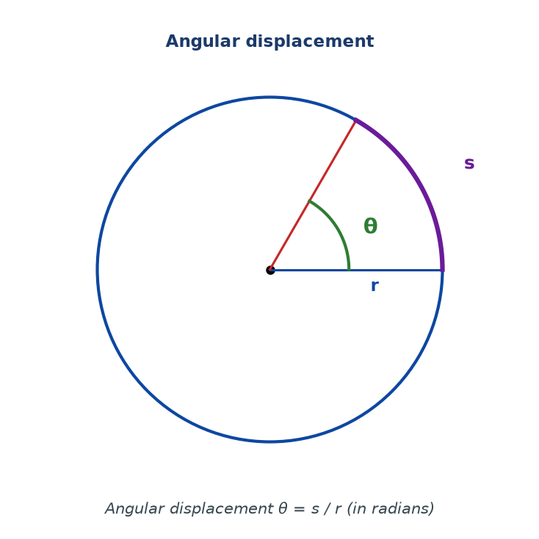
Figure 5.2 — Angular displacement θ is the angle swept at the centre. The arc length s along the circle and the radius r are related by θ = s / r.

Converting between radians and degrees
π rad = 180°
1 rad = 180° / π ≈ 57.3°
1° = π / 180 rad
Angular velocity, ω
Angular velocity is the rate of change of angular displacement. It is measured in radians per second (rad/s).
ω = θ / t
ω = angular velocity (rad/s); θ = angular displacement (rad); t = time (s)
For an object completing one full circle in time T (called the period):
ω = 2π / T
If the object completes f revolutions per second (its frequency), then T = 1/f, so:
ω = 2π f
Link between linear and angular quantities
The linear speed of an object moving in a circle is linked to its angular velocity by:
v = ω r
v = linear speed (m/s); ω = angular velocity (rad/s); r = radius (m)
WHY STUDENTS FIND THIS DIFFICULT
- Forgetting to use radians, not degrees, in formulas like v = ωr and ω = 2π/T. The formulas only work in radians.
- Confusing period (time for one full revolution) with frequency (number of revolutions per second). They are inverses of each other.
- Thinking angular velocity and linear speed are the same. On a rotating merry-go-round, everyone has the same ω but different v (because r is different).
- Forgetting that one full circle is 2π radians, not 360.

KEY POINTS — 5.2
- θ = s / r, measured in radians.
- ω = θ / t, measured in rad/s.
- ω = 2π / T = 2π f.
- v = ω r (linear speed = angular velocity × radius).
- Always use radians in these formulas, never degrees.
- One full circle: θ = 2π rad = 360°.

IF YOU REMEMBER ONE THING
Angle in radians, angular velocity in rad/s. v = ωr. Always radians, never degrees.

5.3 Circular Motion and Centripetal Force
HAVE YOU EVER NOTICED…
When a car turns a corner, the passengers slide sideways. When you swing a bucket of water overhead, the water stays in (if you swing it fast enough). What keeps things moving in a circle?

THE BIG IDEA
Centripetal force is the inward force that keeps an object moving in a circle. Without it, the object would continue in a straight line. It is not a new kind of force — it is provided by tension, gravity, friction, or a normal force, depending on the situation.

The equation
F = m v² / r
F = centripetal force (N); m = mass (kg); v = speed (m/s); r = radius (m)
Using v = ωr, an alternative form is:
F = m ω² r
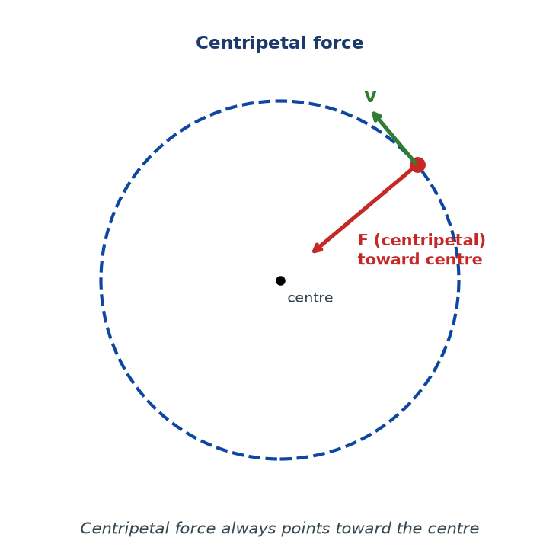
Figure 5.3 — An object moving in a circle at constant speed. The velocity (green) is tangent to the circle. The centripetal force (red) points toward the centre. The two are always at right angles.

What provides the centripetal force?
Situation | What provides the centripetal force
Stone whirled on a string | Tension in the string
Car going round a bend (flat road) | Friction between the tyres and the road
Car going round a banked bend | Friction plus the horizontal component of the normal force
Satellite orbiting the Earth | Gravity
Electron orbiting a nucleus | Electrostatic attraction
Water in a bucket swung overhead | Normal force from the bucket bottom (at the top of the swing)

Why the formula makes sense
Look at F = mv²/r. Notice what happens when you change each quantity:
- Bigger mass → need bigger force. A heavy car needs more grip to turn than a light one.
- Bigger speed → need much bigger force (because v is squared). Doubling speed quadruples the required force.
- Bigger radius → need smaller force. A gentle, wide turn is easier than a tight one.
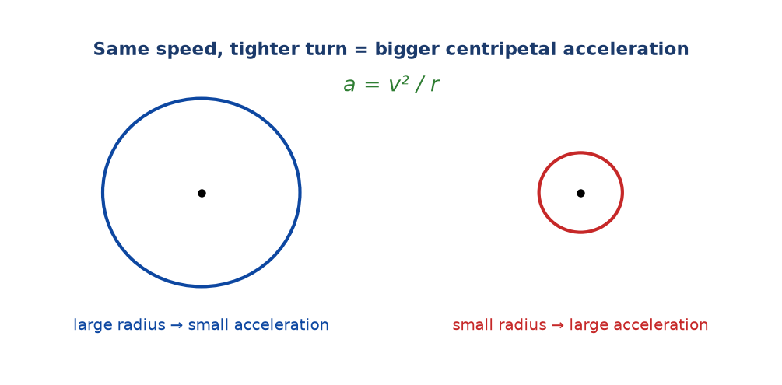
Figure 5.4 — Same speed, tighter turn = bigger required force. This is why sharp bends on roads are dangerous.

WHY STUDENTS FIND THIS DIFFICULT
- Calling centripetal force a 'new force'. It isn't — it's just the role played by an ordinary force (tension, gravity, friction, normal).
- Thinking there is also an outward 'centrifugal' force that balances it. There isn't. The outward sensation is inertia, not a force.
- Forgetting that centripetal force points toward the centre — never away from it.
- Using v in km/h instead of m/s. Always convert.
- Mixing up which force to use in F = mv²/r when the question is about a specific setup (e.g. a car on a bend — friction, not 'the engine').

KEY POINTS — 5.3
- Centripetal force: F = mv²/r, directed toward the centre.
- Also: F = mω²r.
- The force is provided by whatever happens to be pulling the object inward in that situation.
- Doubling v quadruples the required force (v is squared).
- There is no real outward force.

IF YOU REMEMBER ONE THING
Centripetal force = mv²/r, always toward the centre. It is not a new force — it is whatever force happens to be pointing inward.

5.4 Centripetal Acceleration
HAVE YOU EVER NOTICED…
When you take a sharp corner in a car, you feel pressed against the door. When you take a wide corner at the same speed, you barely feel anything. Same speed, different radius, different acceleration.

THE BIG IDEA
Centripetal acceleration is the acceleration toward the centre of a circle. It is caused by the centripetal force, and it is linked to that force by Newton's Second Law.

The equation
a = v² / r
a = centripetal acceleration (m/s²); v = speed (m/s); r = radius (m)
Alternative form using angular velocity:
a = ω² r
Connection to centripetal force
From Newton's Second Law, F = ma. If a = v²/r, then:
F = m a = m v² / r
So the same relationship we met in the last section comes straight out of Newton's Second Law. Centripetal force and centripetal acceleration are always in the same direction — toward the centre.
Figure 5.5 — Same speed, tighter circle → larger centripetal acceleration. That is why racing cars must slow down for tight bends.

Direction of centripetal acceleration
The acceleration is always perpendicular to the velocity and points toward the centre. Because it is perpendicular to velocity, it does not change the speed — only the direction. That is why the object moves at constant speed in a circle.
WHY STUDENTS FIND THIS DIFFICULT
- Thinking an acceleration must change speed. Centripetal acceleration changes direction only.
- Confusing linear acceleration (along the path) with centripetal acceleration (toward the centre).
- Forgetting that v is squared in a = v²/r. Doubling speed quadruples acceleration.
- Using r as diameter instead of radius.

KEY POINTS — 5.4
- a = v²/r = ω²r.
- Direction: toward the centre, perpendicular to velocity.
- It changes direction, not speed.
- Directly linked to force by F = ma.
- Speed is squared — so speed matters a lot.

IF YOU REMEMBER ONE THING
a = v²/r, always toward the centre. Same speed, smaller radius → bigger acceleration.

5.5 Applications of Uniform Circular Motion
HAVE YOU EVER NOTICED…
Cycle racers lean into corners. Cars bank on sharp bends. Astronauts float in space stations. None of it is magic — all of it is circular motion and centripetal force.

THE BIG IDEA
Circular motion and centripetal force are everywhere: road design, satellites, washing machines, blood centrifuges, and even the spin of the Earth itself. Understanding them helps us design safer vehicles, plan space missions, and separate materials in the lab.

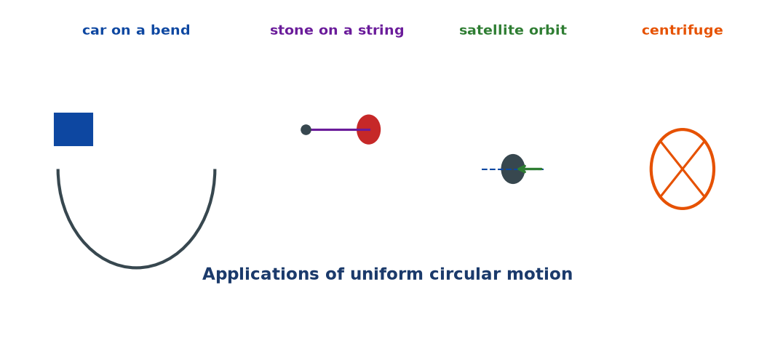
Figure 5.6 — Real-life applications: a car on a bend, a stone on a string, a satellite in orbit, and a laboratory centrifuge.

Why roads bank on bends
On a flat road, the only thing keeping a car turning is friction between the tyres and the road. If the car is too fast, or the road is wet, friction is not enough — the car slides straight off the bend.
Banking the road (tilting it) helps. The normal force from the road now has a horizontal component that also points toward the centre of the bend. This adds to friction, allowing the car to take the bend faster and more safely.
Satellites in orbit
A satellite stays in orbit because the gravitational pull of the Earth acts as the centripetal force. The satellite is in constant free fall toward the Earth — but it is also moving sideways so fast that it keeps missing the Earth. That is what an orbit is: falling while moving sideways.
Centrifuges
In hospitals and laboratories, a centrifuge spins samples at very high speed. Heavier particles (like red blood cells) need bigger centripetal force, so they move outward more strongly than lighter particles — the sample separates by density. This is how blood is separated into plasma and cells.
Other examples
- Washing machine spin cycle — water is driven off the clothes by the high-speed rotation.
- Carnival rides — the 'wall of death' uses centripetal force to keep riders pinned to the wall.
- Athletics hammer throw — the athlete spins the hammer and lets go; the hammer flies off along the tangent.
- Cyclone and hurricane formation — air spins around a low-pressure centre; the Coriolis effect and pressure gradient provide the centripetal force.
Limitations and safety
Circular motion can be dangerous. If the required centripetal force is not provided, objects fly off along a tangent. Cars skid on bends; passengers are thrown in sharp turns; riders in fast centrifuges can lose consciousness if the acceleration is too great. Engineers must design with a safety margin — for example, setting speed limits on bends based on the friction available, especially in the rain.
WHY STUDENTS FIND THIS DIFFICULT
- Saying 'centrifugal force pushes the water out of clothes'. There is no outward force. The clothes move outward because the drum pulls the water inward — and the water, not being pulled enough, goes off in a tangent.
- Confusing the role of gravity in orbit with 'no gravity'. There is still gravity — it is providing the centripetal force.
- Forgetting that banking helps because the normal force has a horizontal component. It's not just friction.

KEY POINTS — 5.5
- Cars on bends need friction (and banking helps) to provide centripetal force.
- Satellites orbit because gravity provides the centripetal force.
- Centrifuges separate materials by density.
- Without enough centripetal force, objects fly off along the tangent.

IF YOU REMEMBER ONE THING
Circular motion needs an inward force. In the real world, that force comes from friction, gravity, tension, or the normal force — never from a mysterious outward push.

Worked Examples
Example 1 — Angular velocity (Easy)
Question. A wheel makes 300 revolutions per minute. Find its angular velocity in rad/s.
Given: f = 300 rev/min = 5 rev/s.
Find: ω.
Principle. ω = 2πf.
Solution.
ω = 2 × π × 5 = 10π ≈ 31.4 rad/s
Why this works: Each revolution is 2π radians, and 5 revolutions happen per second, so the total angular displacement per second is 10π radians.
Common mistake: Forgetting to convert revolutions per minute to revolutions per second first. Always convert time to seconds.
Example 2 — Linear speed (Easy–Medium)
Question. A stone is whirled in a circle of radius 0.8 m with an angular velocity of 6 rad/s. Find its linear speed.
Given: r = 0.8 m, ω = 6 rad/s.
Find: v.
Principle. v = ωr.
Solution.
v = 6 × 0.8 = 4.8 m/s
Why this works: A point farther from the centre has to travel a longer path in the same time, so its linear speed is larger. That is why v = ωr.
Common mistake: Using degrees instead of radians. In v = ωr, ω must be in rad/s.
Example 3 — Centripetal force (Medium)
Question. A 0.5 kg stone is whirled in a horizontal circle of radius 1.2 m at 4 m/s. Find the tension in the string.
Given: m = 0.5 kg, v = 4 m/s, r = 1.2 m.
Find: T (tension = centripetal force).
Principle. F = mv²/r.
Solution.
F = (0.5 × 4²) / 1.2 = 8 / 1.2
F ≈ 6.67 N
Why this works: The tension in the string is the force pulling the stone toward the centre of the circle. Without it, the stone would fly off along the tangent.
Common mistake: Forgetting to square the speed. In F = mv²/r, v is squared — a very common slip.
Example 4 — Car on a bend (MSCE)
Question. A car of mass 1200 kg takes a bend of radius 80 m at 20 m/s on a flat road. (a) Find the centripetal force required. (b) The maximum friction force the road can provide is 4000 N. Will the car make it? (c) Suggest one way to make the bend safer.
Given: m = 1200 kg, v = 20 m/s, r = 80 m.
Find: (a) required F, (b) compare with max friction, (c) suggestion.
Principle. F = mv²/r; the car will slide if friction is less than required.
Solution.
F = (1200 × 20²) / 80 = (1200 × 400) / 80
F = 6000 N
(b) Required force (6000 N) > maximum friction (4000 N). So the car will not make it — it will skid off the bend.
(c) Banking the road adds a horizontal component of the normal force, increasing the effective centripetal force. Another option: reduce the speed limit.
Safe if friction ≥ mv²/r
Why this works: Friction must provide the inward force. If the required force exceeds the friction available, the car loses grip and slides off.
Common mistake: Using the car's mass in kg and speed in km/h. Always use SI: kg and m/s.

Check Yourself
1. Define uniform circular motion.
2. In what direction does the velocity point in circular motion?
3. In what direction does the centripetal force point?
4. Define angular displacement, θ, and give its SI unit.
5. Convert 90° to radians.
6. A wheel completes 1 revolution in 0.4 s. Find its angular velocity.
7. A point on the rim of a wheel of radius 0.5 m moves at 3 m/s. Find ω.
8. State the equation for centripetal force.
9. A 0.2 kg ball moves at 5 m/s in a circle of radius 0.4 m. Find the centripetal force.
10. Explain in your own words why there is no outward 'centrifugal' force.

Exam-Style Questions (MSCE-style practice)
Q1. (a) Define angular velocity and give its SI unit.
(b) A wheel of radius 0.4 m rotates at 30 rad/s. Find the linear speed of a point on the rim.
Q2. A stone of mass 0.3 kg is whirled on a string of length 0.6 m at a constant speed of 5 m/s in a horizontal circle.
(a) Calculate the centripetal force acting on the stone.
(b) State what provides this force.
(c) Explain what happens if the string breaks.
Q3. A car of mass 1000 kg travels round a bend of radius 50 m at 15 m/s.
(a) Calculate the centripetal force needed.
(b) The maximum friction force is 5000 N. Will the car skid? Explain.
Q4. (a) State two differences between angular velocity and linear velocity.
(b) A wheel rotates at 120 rpm. Calculate its angular velocity in rad/s.
Q5. A laboratory centrifuge has a rotor of radius 0.12 m spinning at 3000 revolutions per minute.
(a) Calculate the angular velocity.
(b) Calculate the centripetal acceleration at the rim.
(c) State the direction of this acceleration.
Q6. Explain, using Newton's First Law, why a passenger in a turning car feels pushed outward.
Q7. A satellite orbits the Earth at a radius of 6.7 × 10⁶ m. Its mass is 1000 kg and its speed is 7.7 × 10³ m/s.
(a) Calculate the centripetal force acting on the satellite.
(b) State what provides this force.
(c) Explain why the satellite does not fall to Earth.
Q8. (a) Explain why a road is banked on a sharp bend.
(b) A car of mass 800 kg goes round a banked bend of radius 40 m at 12 m/s. Find the required centripetal force.
Q9. A 0.05 kg ball is attached to a string of length 0.25 m and rotated at 4 revolutions per second.
(a) Find the angular velocity.
(b) Find the centripetal force.
Q10. (a) Define centripetal acceleration.
(b) Show that a = v²/r by combining F = ma and F = mv²/r.

Full Worked Solutions
Check Yourself — Answers
1. Motion in a circle at constant speed.
2. Tangent to the circle (along the direction of motion).
3. Toward the centre of the circle.
4. Angular displacement is the angle swept out at the centre of the circle; SI unit: radian (rad).
5. 90° = π/2 rad ≈ 1.57 rad.
6. ω = 2π / T = 2π / 0.4 = 5π ≈ 15.7 rad/s.
7. ω = v/r = 3 / 0.5 = 6 rad/s.
8. F = mv²/r.
9. F = (0.2 × 25) / 0.4 = 12.5 N.
10. There is no outward force. What feels like being 'pushed outward' is just inertia — your body wants to keep going straight while the car turns. The only real force is centripetal, pointing inward.

Exam-Style — Full Solutions
Q1. (a) Angular velocity is the rate of change of angular displacement. Unit: rad/s.
(b) v = ωr = 30 × 0.4 = 12 m/s.
Q2. (a) F = mv²/r = (0.3 × 25) / 0.6 = 12.5 N.
(b) The tension in the string.
(c) The stone flies off along the tangent to the circle at the point where it was when the string broke — by Newton's First Law, it continues in a straight line.
Q3. (a) F = (1000 × 15²) / 50 = (1000 × 225)/50 = 4500 N.
(b) No, it will not skid — the friction available (5000 N) is greater than required (4500 N). Margin = 500 N.
Q4. (a) Angular velocity is the rate of change of angle (rad/s) and is the same for all points on a rotating body; linear velocity is speed along the path (m/s) and depends on radius (v = ωr).
(b) f = 120/60 = 2 rev/s. ω = 2πf = 4π ≈ 12.57 rad/s.
Q5. (a) f = 3000/60 = 50 rev/s. ω = 2πf = 100π ≈ 314 rad/s.
(b) a = ω²r = (100π)² × 0.12 ≈ 98696 × 0.12 ≈ 1.18 × 10⁴ m/s² (about 1200 g).
(c) Toward the centre of the rotor.
Q6. When the car turns, the car accelerates toward the centre, but the passenger's body, by Newton's First Law, tends to continue in a straight line. Relative to the car, the passenger appears to be 'thrown outward'. There is no outward force — just inertia.
Q7. (a) F = mv²/r = (1000 × (7.7×10³)²) / (6.7×10⁶).
(7.7×10³)² = 5.929 × 10⁷. So F = (1000 × 5.929×10⁷) / (6.7×10⁶) ≈ 8.85 × 10³ N ≈ 8.85 kN.
(b) Earth's gravitational pull.
(c) The satellite is in free fall toward the Earth, but its high tangential speed means it keeps 'missing' the Earth. It falls around the Earth rather than into it.
Q8. (a) Banking makes the normal force from the road point slightly inward. The horizontal component of the normal force adds to friction in providing the required centripetal force, so the car can take the bend at higher speed safely.
(b) F = (800 × 12²) / 40 = (800 × 144)/40 = 2880 N.
Q9. (a) ω = 2πf = 2π × 4 = 8π ≈ 25.1 rad/s.
(b) v = ωr = 8π × 0.25 ≈ 6.28 m/s. F = mv²/r = (0.05 × 39.48) / 0.25 ≈ 7.9 N.
Q10. (a) Centripetal acceleration is the acceleration of a body moving in a circle, directed toward the centre, of magnitude v²/r.
(b) Newton's Second Law: F = ma. Centripetal force: F = mv²/r. Equating: ma = mv²/r. Divide both sides by m: a = v²/r. ∎

Common Mistakes
- Saying 'centrifugal force pushes outward'. There is no such force. Only inward centripetal force is real.
- Drawing velocity arrows pointing toward the centre. Velocity is tangent.
- Thinking constant speed means no acceleration. In circular motion, direction changes, so velocity changes, so there is acceleration.
- Forgetting that v is squared in F = mv²/r and a = v²/r.
- Using degrees in place of radians in v = ωr or ω = 2π/T.
- Using frequency in rpm instead of rev/s.
- Using diameter instead of radius.
- Forgetting to convert km/h to m/s (÷3.6).

EXAM TIP
MSCE loves: (1) F = mv²/r calculations; (2) angular velocity from rpm; (3) explaining why a passenger feels pushed outward (answer: inertia, not a real force); (4) why banking a road helps.
Always write the formula, substitute, and give units. Three steps, three marks.
When the question says 'state what provides the centripetal force', remember the answer depends on the setup: tension (string), friction (car on flat road), gravity (satellite), normal + friction (banked road).
Do not write 'centrifugal force' in MSCE unless the question uses it. Even then, be careful to explain it as inertia.

REMEMBER • Circular motion: velocity tangent, force toward centre. F = mv²/r, a = v²/r. No real outward force. v = ωr with ω in rad/s.

Chapter 5 Test
SECTION A — Multiple Choice (5 marks)
1. In uniform circular motion, the speed is ______ and the velocity is ______.
A. constant, constant B. changing, constant C. constant, changing D. changing, changing

2. The direction of centripetal acceleration is:
A. Along the tangent B. Away from the centre C. Toward the centre D. Vertically upward

3. If the speed of a stone whirled in a circle is doubled, the required centripetal force:
A. Doubles B. Halves C. Quadruples D. Stays the same

4. Angular velocity is measured in:
A. Degrees B. Radians C. Rad/s D. m/s

5. A car takes a sharp bend. The centripetal force is provided by:
A. Engine B. Friction C. Gravity D. Normal force only

SECTION B — Short Answers (10 marks)
6. Define angular velocity and give its SI unit. (2)
7. State the equation for centripetal force and define each symbol. (3)
8. A wheel makes 180 rpm. Find ω in rad/s. (2)
9. State one reason why roads are banked at bends. (1)
10. Explain why there is no outward 'centrifugal' force. (2)

SECTION C — Structured Questions (15 marks)
12. A 0.4 kg ball is swung in a horizontal circle of radius 0.9 m at 6 m/s.
(a) Find the centripetal acceleration. (3)
(b) Find the tension in the string. (3)
(c) State what happens if the string breaks. (1)

13. A 1500 kg car takes a bend of radius 60 m at 18 m/s on a flat road.
(a) Find the required centripetal force. (3)
(b) The maximum friction available is 7000 N. Will the car skid? (1)
(c) Suggest how the bend could be made safer. (1)

14. A centrifuge rotor of radius 0.15 m spins at 2400 rpm.
(a) Find the angular velocity. (2)
(b) Find the centripetal acceleration at the rim. (1)

END OF CHAPTER 5
Next chapter: Chapter 6 — Moments of Forces.

