CHAPTER 6 — Moments of Forces
Physics · Form 4 · MSCE · Malawian Science Books

Welcome to Chapter 6. Push a door near the hinge — it's hard to move. Push it near the handle — easy. Same door, same push, very different result. Why? Because what matters isn't just the force — it's where you apply it.
This idea is called the moment of a force. It explains why a long spanner loosens a stubborn bolt, why a wheelbarrow makes carrying bricks easier, and why a see-saw balances when it does.
By the end of this chapter, you'll be able to calculate moments, use the principle of moments to solve balance problems, and understand couples and centres of mass.

6.1 Moment of a Force
HAVE YOU EVER NOTICED…
You can open a tight bottle cap with a metal spoon. The longer the handle, the easier. Same force — but much bigger effect because the handle is longer. That's the moment of a force in action.

THE BIG IDEA
The moment of a force is the turning effect of that force about a pivot. It depends on two things: the size of the force, and how far from the pivot it acts. Bigger force, or bigger distance → bigger turning effect.

The real concept
When you push a door at the handle, you rotate it about its hinges. The hinges are the pivot. The push you apply is the force. The distance from the hinge to where you push is the perpendicular distance.
The turning effect — the moment — is the product of the force and this distance. Push harder, or push farther from the pivot, and you get a bigger moment. Simple.
Important: the distance must be perpendicular to the line of action of the force. Not the length of the spanner, not the length of the door — the perpendicular distance from the pivot to the line of the force.
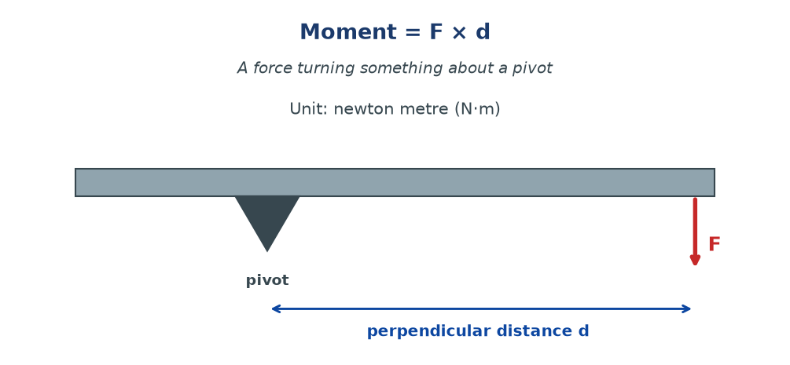
Figure 6.1 — A force F applied to a beam at a perpendicular distance d from the pivot. The moment is M = F × d. Push farther from the pivot → bigger moment → easier turning.

The equation
M = F × d
M = moment (N·m); F = force (N); d = perpendicular distance from pivot to force line (m)
Units: newton-metre (N·m). Not to be confused with a joule, even though both are N·m. They measure different things — a moment is a turning effect, energy is work.
Direction of a moment
A moment can turn something clockwise (CW) or anticlockwise (ACW). We use signs to keep track:
- Anticlockwise: usually positive (+)
- Clockwise: usually negative (−)
This sign convention is important when we use the principle of moments later.
WHY STUDENTS FIND THIS DIFFICULT
- Using the slanted distance instead of the perpendicular distance to the force line. Always drop a perpendicular from the pivot to the force.
- Confusing the pivot with where the force is applied. The pivot is fixed; the force moves.
- Forgetting the units — a moment is in N·m, not J, even though the units look the same.
- Ignoring direction. Moments are clockwise or anticlockwise — you must state which, or use signs.

KEY POINTS — 6.1
- Moment = F × d (perpendicular distance).
- Unit: newton-metre (N·m).
- Bigger force, or bigger d → bigger moment.
- Clockwise and anticlockwise moments have opposite signs.
- Distance must be perpendicular to the force.

IF YOU REMEMBER ONE THING
Moment = force × perpendicular distance. Push farther from the pivot, and it turns more easily.

6.2 The Principle of Moments
HAVE YOU EVER NOTICED…
On a see-saw, a small child far from the pivot can balance a bigger child sitting close to the pivot. Something about the distances must matter — and it does.

THE BIG IDEA
For an object in equilibrium (balanced), the total clockwise moment about any point equals the total anticlockwise moment about that same point. If they are not equal, the object rotates.

The real concept
A see-saw is a perfect example. The pivot is in the middle. If a 30 kg child sits 2 m from the pivot on the left, they create an anticlockwise moment. For the see-saw to balance, a heavier child (say 40 kg) must sit closer to the pivot on the right — enough to make the clockwise moment match.
The general condition for equilibrium is:
Σ clockwise moments = Σ anticlockwise moments
about the same pivot
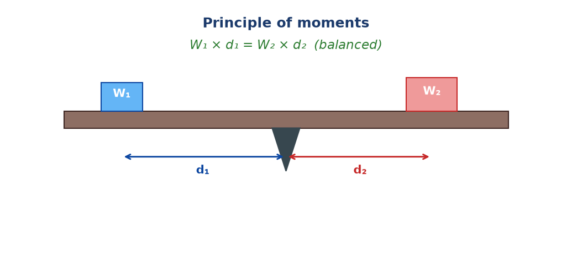
Figure 6.2 — A see-saw balanced. The anticlockwise moment from the left weight equals the clockwise moment from the right weight. W₁ × d₁ = W₂ × d₂.

Solving balance problems — a recipe
1. Identify the pivot (usually given).
2. Identify all forces and the perpendicular distance of each from the pivot.
3. Decide a sign convention: for example, anticlockwise = +, clockwise = −.
4. Write: sum of clockwise = sum of anticlockwise.
5. Solve for the unknown.
6. Check by substituting back.
Common setup: beam with several loads
When a beam carries several weights, each weight has its own moment. The beam will balance if the anticlockwise total equals the clockwise total. Extra care is needed to correctly identify each distance from the pivot.
WHY STUDENTS FIND THIS DIFFICULT
- Using the wrong pivot. Always use the pivot the question refers to, or choose one that eliminates an unknown.
- Forgetting which forces act clockwise and which anticlockwise. Draw small curved arrows showing the direction.
- Using the beam's full length instead of the distance from the pivot to the force.
- Forgetting the beam's own weight. If the beam is uniform, its weight acts at its midpoint — the centre of mass.
- Using mass instead of weight. Always convert mass to weight using W = mg before calculating moments.

KEY POINTS — 6.2
- Equilibrium: total CW moments = total ACW moments.
- The pivot must be the same for both sides.
- Use perpendicular distances, not beam lengths.
- Beam's own weight acts at the centre of mass (midpoint for a uniform beam).
- Convert mass to weight first: W = mg.

IF YOU REMEMBER ONE THING
Balanced means CW moment = ACW moment. Only about the same pivot. Only with perpendicular distances. Convert mass to weight first.

6.3 Couple
HAVE YOU EVER NOTICED…
Turn a steering wheel. You push up with one hand and down with the other. Two forces, equal size, opposite directions. The wheel spins — but the car doesn't move sideways. That's a couple.

THE BIG IDEA
A couple is two equal, opposite, parallel forces that don't act along the same line. It produces pure rotation — no movement of the object as a whole.

The real concept
Two equal and opposite forces that act along the same line cancel completely — the object doesn't move or rotate. But if they act along different parallel lines, they still cancel in terms of net force (so no linear motion), yet they create a turning effect — a rotation.
That's what a couple does. Pure rotation.
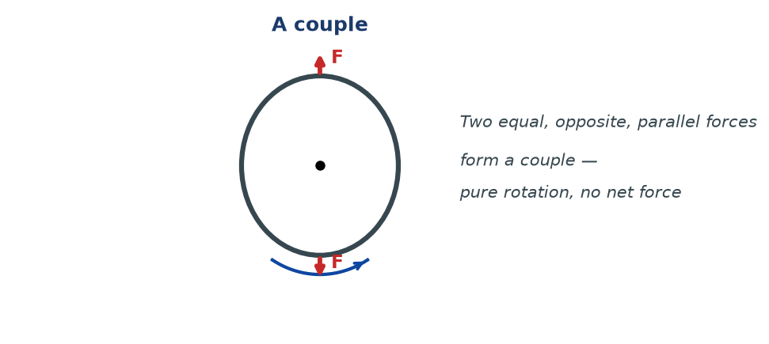
Figure 6.3 — A couple. Two equal and opposite parallel forces act on a body (here, a steering wheel). The net force is zero, but the turning effect is not — the body rotates.

Moment of a couple
The moment of a couple depends on one of the forces and the perpendicular distance between them:
M = F × d
F = one of the forces (N); d = perpendicular distance between the two lines of action (m)
Notice: the moment is the same about any point — that is a special property of couples. You don't need to choose a pivot.
Examples of couples
- Turning a steering wheel — one hand pushes up, one pushes down.
- Turning a tap — fingers push on opposite sides.
- Using a screwdriver — the handle twists one way, the blade resists.
- Turning a key in a lock.
- Twisting a lid off a jar with two hands.
WHY STUDENTS FIND THIS DIFFICULT
- Confusing a couple with two equal and opposite forces acting along the same line. That cancels completely — no rotation.
- Thinking the moment of a couple depends on the pivot. It doesn't — the moment is the same about every point.
- Forgetting that a couple produces rotation without any movement of the body as a whole (no net force).

KEY POINTS — 6.3
- Couple: two equal, opposite, parallel forces not in the same line.
- Produces pure rotation, no translation.
- Moment of a couple: M = Fd, where d is the perpendicular distance between the forces.
- Moment is the same about any point.

IF YOU REMEMBER ONE THING
A couple is two equal, opposite forces that don't line up. The net force is zero, but the turning effect is not.

6.4 Centre of Mass of a Body
HAVE YOU EVER NOTICED…
Balance a broom on one finger. It works — but only at one particular point. That point is the broom's centre of mass. Balance it anywhere else, and it topples.

THE BIG IDEA
The centre of mass of a body is the point at which the entire weight of the body appears to act. It is also the point about which the body balances.

The real concept
Every object is made of tiny pieces of matter. Each piece has weight. When you look at the whole object, all those tiny weights together behave as if they act at one single point — the centre of mass.
If you support the object at this point, it stays balanced. If you support it elsewhere, the weight creates a moment about the support and the object topples.
Where is the centre of mass?
- Uniform rod: at its midpoint.
- Uniform rectangular sheet: where the diagonals meet.
- Uniform circular disc: at its centre.
- Uniform sphere: at its centre.
- Irregular shape: found by experiment (see 6.5).
Stability
An object is stable if its centre of mass lies above its base of support. The lower the centre of mass, and the wider the base, the more stable the object.
- A bus is stable because its base is wide.
- A tall thin bottle is unstable — its base is narrow, and a small tilt moves the centre of mass outside the base.
- Loaded lorries are more stable when heavy goods are placed low — the centre of mass drops.
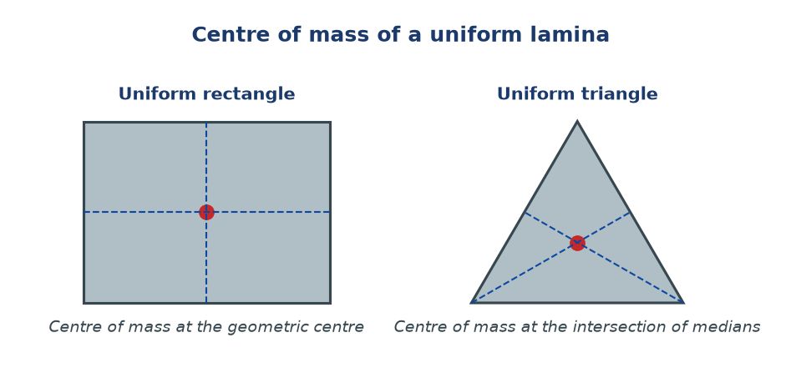
Figure 6.4 — Centre of mass of uniform shapes. For a rectangle, it is at the geometric centre. For a triangle, at the intersection of the medians.

WHY STUDENTS FIND THIS DIFFICULT
- Thinking the centre of mass is always inside the object. It can be outside — think of a horseshoe or a ring.
- Confusing centre of mass with centre of gravity. On Earth, they are at the same point. On a different planet, they would still be at the same point, but the weight would be different.
- Thinking heavy objects always have lower centre of mass. Not necessarily — a tall thin lamp post has a lower centre of mass than a small wide book, but only if the post is short.

KEY POINTS — 6.1
- Centre of mass: point where all weight seems to act.
- Uniform rod: midpoint. Rectangle: geometric centre. Triangle: intersection of medians.
- Object is stable if its centre of mass is above its base.
- Lower centre of mass + wider base = more stable.

IF YOU REMEMBER ONE THING
The centre of mass is where all the weight acts. Balance there, and the object stays put.

6.5 Centre of Mass of a Lamina
HAVE YOU EVER NOTICED…
Cut out a shape from cardboard. It never balances on your fingertip unless you find the exact right spot. Finding that spot is what this section is about — for flat shapes (laminas).

THE BIG IDEA
A lamina is a flat, thin shape. Its centre of mass can be found by experiment (the plumb-line method) or by calculation (for regular shapes).

Experimental method: the plumb-line
1. Make a small hole near one corner of the lamina.
2. Hang the lamina freely from a pin through the hole.
3. Hang a plumb-line from the same pin.
4. Draw a line along the plumb-line on the lamina.
5. Repeat from a different hole.
6. The intersection of the two lines is the centre of mass.
Why does this work? Because when the lamina hangs freely, its weight acts at its centre of mass. For it to be in equilibrium, that point must lie directly below the pivot — on the plumb-line. Two such lines are enough to locate the point.
Calculated method for regular shapes
- Rectangle or square: at the intersection of the diagonals.
- Circle or disc: at the centre.
- Triangle: at the intersection of the three medians (each median joins a vertex to the midpoint of the opposite side).
- Parallelogram: where the diagonals meet.
Figure 6.5 — The centre of mass of a rectangle (centre), a triangle (intersection of medians), and other regular shapes.

For irregular laminas
If the shape is irregular — like a map of Malawi, or a cut-out of a fish — no formula applies. You must use the plumb-line method. That is why it is the most important experimental technique in this section.
WHY STUDENTS FIND THIS DIFFICULT
- Thinking you can find the centre of mass by eye. For an irregular shape, you can't — you must use the plumb-line method.
- Confusing the median of a triangle with the altitude. The median joins a vertex to the midpoint of the opposite side; the altitude is perpendicular to a side.
- Drawing the plumb-line wrong — it must hang from the same pivot as the lamina.

KEY POINTS — 6.5
- Plumb-line method: two lines from two different holes → intersection is CoM.
- Rectangle: diagonals cross. Triangle: medians cross. Circle: centre.
- Irregular shapes: only the plumb-line method works.

IF YOU REMEMBER ONE THING
Hang the lamina from two points. Draw the plumb-line each time. Where they cross is the centre of mass.

6.6 Applications of Moment of a Force
HAVE YOU EVER NOTICED…
A wheelbarrow carries heavy bricks with less effort. A crowbar lifts a heavy lid. A fishing rod reaches far out. They all use moments — deliberately — to make work easier.

THE BIG IDEA
Moments are used everywhere in tools and machines. Whenever you need to make something easier to turn, lift, or hold, you lengthen the distance from the pivot to the force — and the same effort achieves much more.

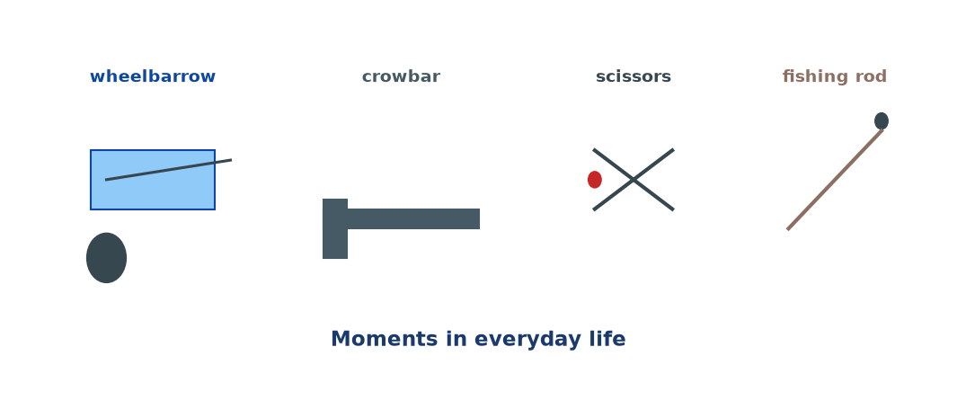
Figure 6.6 — Applications of moments: a wheelbarrow (load close to pivot), a crowbar (long lever for big moment), scissors (blades close to pivot), and a fishing rod (long rod multiplies the reach).

Tools that use moments
- Wheelbarrow: heavy load sits close to the wheel; effort applied at the far handles. The long effort distance magnifies the small applied force.
- Crowbar: a small push at the long end lifts a heavy object close to the pivot.
- Scissors: long handles and short blades — small hand force produces a large cutting force at the blades.
- Spanner: a long spanner loosens a tight bolt with less effort than a short one.
- Fishing rod: the long rod lets a small hand movement bring in a distant fish.
- Bicycle brake levers: long levers give a strong braking effect with a light squeeze.
Applications of centre of mass and stability
- Loaded lorries: heavy goods are placed low, to lower the centre of mass and keep the lorry stable on curves.
- Racing cars: designed with a very low centre of mass, so they corner without rolling.
- Tall buildings: designed with wide foundations to keep the centre of mass well above the base.
- Footballers: bend their knees to lower their centre of mass and turn more quickly.
- Carrying loads on the head (a Malawian tradition): the load stays balanced because the centre of mass of the load is directly above the person's centre of mass.
WHY STUDENTS FIND THIS DIFFICULT
- Thinking a bigger force always wins. What matters is the moment, not just the force.
- Forgetting that the distance must be measured from the pivot, not from anywhere on the object.
- Confusing stability (about centre of mass) with moment (about forces).

KEY POINTS — 6.6
- Tools use long effort arms to magnify small forces.
- Low centre of mass + wide base → stability.
- Carrying loads on the head stays stable because CoM is directly above the person's CoM.
- Moments explain levers, spanners, crowbars, and much more.

IF YOU REMEMBER ONE THING
Every lever, spanner, or wheelbarrow is using moments to multiply your effort. Long arm = big moment = easy work.

Worked Examples
Example 1 — Simple moment (Easy)
Question. A force of 20 N is applied perpendicular to a spanner, 0.3 m from the nut. Calculate the moment.
Given: F = 20 N, d = 0.3 m.
Find: M.
Principle. M = F × d.
Solution.
M = 20 × 0.3
M = 6 N·m
Why this works: Both force and distance are directly proportional to moment, so multiply.
Common mistake: Forgetting to keep the distance perpendicular. If the force is at an angle, use only the perpendicular component.
Example 2 — Principle of moments (Medium)
Question. A uniform metre rule is pivoted at the 50 cm mark. A 4 N weight hangs at the 20 cm mark. Where must a 6 N weight hang to balance the rule?
Given: 4 N at 30 cm from pivot (left); 6 N at distance x from pivot (right). Rule is uniform, so its weight acts at the pivot and creates no moment.
Find: x.
Principle. CW moments = ACW moments.
Solution.
4 N × 0.30 m = 6 N × x
1.2 = 6x
x = 0.20 m = 20 cm from the pivot
So the 6 N weight hangs at the 70 cm mark.
Why this works: For the rule to balance, the turning effects on both sides must match.
Common mistake: Using the ends of the rule as reference instead of the pivot. Always use distances from the pivot.
Example 3 — Beam with its own weight (Medium–Hard)
Question. A uniform beam of length 4.0 m and mass 20 kg rests on two supports, A at one end and B 3.0 m away. A 30 kg mass is placed on the beam 2.0 m from A. Find the reaction forces at A and B. (g = 9.8 m/s².)
Given: Beam mass 20 kg (weight 196 N, acts at 2.0 m from A, its centre). Load 30 kg (294 N) at 2.0 m from A. Supports A (at 0 m) and B (at 3.0 m).
Find: R_A and R_B.
Principle. Take moments about A. Sum of CW = sum of ACW. Then use vertical equilibrium: R_A + R_B = total weight.
Solution. Total weight = 196 + 294 = 490 N.
Take moments about A:
ACW (about A): none
CW (about A): 196 × 2.0 + 294 × 2.0 = 392 + 588 = 980 N·m
Also CW: R_B × 3.0
So R_B × 3.0 = 980 → R_B ≈ 327 N
R_A = 490 − 327 = 163 N
Why this works: Taking moments about A eliminates R_A from the equation, letting us solve for R_B directly. Then vertical equilibrium gives R_A.
Common mistake: Forgetting the beam's own weight. A uniform beam always has its weight acting at its midpoint.
Example 4 — Couple (MSCE)
Question. A steering wheel has two equal and opposite forces of 25 N applied tangentially, on opposite sides of the wheel. The wheel diameter is 0.36 m. Calculate the moment of the couple.
Given: F = 25 N each; diameter = 0.36 m.
Find: moment of the couple.
Principle. M = F × d, where d is the perpendicular distance between the two forces. For a wheel, this is the diameter, not the radius.
Solution.
M = F × d = 25 × 0.36
M = 9 N·m
Why this works: The two forces are on opposite sides of the wheel, so the perpendicular distance between them is the full diameter.
Common mistake: Using the radius instead of the diameter. The distance between the lines of action of the two forces is what matters — for a wheel, that's the diameter.

Check Yourself
1. Define the moment of a force and give its SI unit.
2. What is the perpendicular distance?
3. A force of 30 N acts 0.4 m from a pivot. Find the moment.
4. State the principle of moments.
5. A see-saw is pivoted at its centre. A 20 kg child sits 2 m from the pivot. Where should a 40 kg child sit to balance? (g = 9.8 m/s².)
6. What is a couple? Give one example.
7. Find the moment of a couple of forces 15 N separated by 0.5 m.
8. Define the centre of mass of a body.
9. Where is the centre of mass of a uniform circular disc?
10. Explain, in your own words, why a plumb-line is used to find the centre of mass of an irregular lamina.

Exam-Style Questions (MSCE-style practice)
Q1. (a) State the principle of moments.
(b) A uniform metre rule is pivoted at its 40 cm mark. A 2 N weight is hung at the 10 cm mark, and a 3 N weight at the 100 cm mark. Is the rule balanced? Show your working.
Q2. A force of 50 N is applied to a wrench at a distance of 0.25 m from the bolt. Calculate the moment.
Q3. Two children, one of mass 25 kg and the other of mass 40 kg, sit on a see-saw. The 25 kg child sits 1.8 m from the pivot. Where must the 40 kg child sit to balance the see-saw? (g = 9.8 m/s².)
Q4. (a) Define a couple and give its moment formula.
(b) A bicycle brake lever is 12 cm long from pivot to hand. The brake cable is attached 3 cm from the pivot. The rider pulls with a force of 40 N. Calculate the tension in the cable.
Q5. A uniform plank of length 3.0 m and mass 12 kg is supported at both ends. A 40 kg mass is placed 1.0 m from the left end. Find the reactions at the two supports. (g = 9.8 m/s².)
Q6. (a) Define the centre of mass.
(b) Explain how the plumb-line method can be used to find the centre of mass of an irregular lamina.
Q7. A lever is used to lift a 200 N rock. The rock is 0.20 m from the pivot. The person pushes with a force at 1.2 m from the pivot. What force must be applied?
Q8. A uniform beam of mass 30 kg and length 5.0 m is pivoted 1.0 m from its left end. A 50 kg load is hung from the left end. What load must be hung from the right end to balance the beam? (g = 9.8 m/s².)
Q9. Explain why a loaded lorry is more stable when its heavy goods are placed low.
Q10. A uniform rod of length 1.2 m and mass 1.5 kg is suspended from one end. What horizontal force applied at the other end will keep it in equilibrium at 30° to the vertical? (g = 9.8 m/s².)

Full Worked Solutions
Check Yourself — Answers
1. The turning effect of a force about a pivot. Unit: N·m.
2. The shortest distance from the pivot to the line of action of the force.
3. M = 30 × 0.4 = 12 N·m.
4. For a body in equilibrium, total clockwise moments = total anticlockwise moments about the same point.
5. Let x be the distance. 20 × 2 = 40 × x → x = 1.0 m. So the 40 kg child sits 1 m from the pivot.
6. A couple is two equal, opposite, parallel forces not acting along the same line. Example: turning a steering wheel.
7. M = Fd = 15 × 0.5 = 7.5 N·m.
8. The point at which the entire weight of the body appears to act.
9. At the centre of the disc.
10. Because when the lamina hangs freely, its weight acts at the centre of mass. For equilibrium, this point lies directly below the pivot. Two such lines intersect at the centre of mass.

Exam-Style — Full Solutions
Q1. (a) For a body in equilibrium, sum of CW moments = sum of ACW moments about the same point.
(b) Distances from the 40 cm pivot: 2 N at 30 cm to the left; 3 N at 60 cm to the right.
ACW: 2 × 0.30 = 0.60 N·m. CW: 3 × 0.60 = 1.80 N·m. They are not equal → the rule is not balanced — it will rotate clockwise.
Q2. M = 50 × 0.25 = 12.5 N·m.
Q3. Balance: 25g × 1.8 = 40g × x → 45 = 40x → x = 1.125 m from the pivot. (g cancels.)
Q4. (a) A couple is two equal, opposite parallel forces not along the same line. M = Fd.
(b) Moments about the pivot: 40 N × 0.12 m = T × 0.03 m → 4.8 = 0.03T → T = 160 N.
Q5. Beam weight = 12 × 9.8 = 117.6 N, acting at 1.5 m from left (midpoint). Load = 40 × 9.8 = 392 N, at 1.0 m from left. Total = 509.6 N.
Take moments about the left end: 117.6 × 1.5 + 392 × 1.0 = R_right × 3.0
= 176.4 + 392 = 568.4 = 3 R_right → R_right = 189.5 N.
R_left = 509.6 − 189.5 = 320.1 N.
Q6. (a) The point at which the entire weight of the body appears to act.
(b) Suspend the lamina freely from a pin through a hole near one corner. Hang a plumb-line from the same pin, and mark the vertical line on the lamina. Repeat from another hole. The intersection of the two lines is the centre of mass.
Q7. Moments about the pivot: 200 × 0.20 = F × 1.2 → 40 = 1.2F → F ≈ 33.3 N.
Q8. Beam weight = 30 × 9.8 = 294 N, acting at 2.5 m from left end = 1.5 m from pivot (right side). Load 1: 50 × 9.8 = 490 N, at left end = 1.0 m from pivot (left side).
Let right load have weight W, acting at 4.0 m from pivot (right side, since right end is 4 m from pivot at 1 m).
CW moments (about pivot): beam (294 × 1.5) + W × 4.0 = 441 + 4W.
ACW moments: 490 × 1.0 = 490.
For balance: 490 = 441 + 4W → 4W = 49 → W = 12.25 N → mass = 1.25 kg.
Q9. Placing goods low lowers the lorry's centre of mass. This makes it harder for the centre of mass to move beyond the base during a turn or tilt, so the lorry is more stable.
Q10. Rod centre of mass at 0.6 m from the pivot (its midpoint). Weight W = 1.5 × 9.8 = 14.7 N.
For the rod at 30° to the vertical, the moment arm of W about the pivot is 0.6 × sin(30°) = 0.30 m.
Moment of W: 14.7 × 0.30 = 4.41 N·m.
Force F applied horizontally at the other end, at perpendicular distance 1.2 × cos(30°) = 1.039 m from pivot.
Moment of F: F × 1.039.
Equilibrium: 1.039 F = 4.41 → F ≈ 4.24 N.

Common Mistakes
- Using the length of the beam instead of the perpendicular distance from the pivot.
- Forgetting the beam's own weight. A uniform beam's weight acts at its midpoint.
- Using mass instead of weight in moment calculations. Convert: W = mg.
- Mixing up clockwise and anticlockwise. Draw small curved arrows on your diagram.
- Using the same pivot for CW and ACW moments — this is essential and often forgotten.
- Confusing the radius and diameter for a wheel-based couple. The distance between the two force lines is the diameter.
- Thinking a bigger force always wins. What matters is force × distance.
- Forgetting that the centre of mass of a uniform triangle is at the intersection of the medians, not at the centre of the bounding box.
- Saying the centre of mass must be inside the object. For a ring or horseshoe, it can be outside.

EXAM TIP
MSCE regularly tests: (1) the principle of moments on a beam or see-saw; (2) finding an unknown force or distance; (3) couples on wheels; (4) centre of mass and stability.
Always draw a clear diagram with pivot marked, all forces labelled, and distances measured from the pivot.
Choose a pivot that eliminates an unknown — usually a support you don't need. That simplifies the equation.
Show the equation 'CW moments = ACW moments' explicitly. Examiners give method marks for this line.
For questions on stability, remember: lower CoM + wider base = more stable. This is a favourite one-liner.

REMEMBER • Moment = force × perpendicular distance from pivot. Balance: CW = ACW. Couple: M = Fd. Centre of mass: where all the weight acts.

Chapter 6 Test
SECTION A — Multiple Choice (5 marks)
1. The moment of a force is measured in:
A. N B. N·m C. N/m D. m

2. The perpendicular distance for a moment is:
A. The length of the lever B. The length of the object C. The shortest distance from the pivot to the line of action of the force D. Any horizontal distance

3. Two equal, opposite, parallel forces that don't act along the same line form:
A. A resultant force B. A couple C. A pivot D. A moment arm

4. The centre of mass of a uniform triangle lies at:
A. Its centre B. A vertex C. The intersection of the medians D. The midpoint of the longest side

5. An object is most stable when its:
A. Centre of mass is high, base narrow B. Centre of mass is low, base wide C. Centre of mass is outside the object D. Base is a point

SECTION B — Short Answers (10 marks)
6. Define the moment of a force and give its SI unit. (2)
7. State the principle of moments. (2)
8. What is a couple? Give one everyday example. (2)
9. A force of 24 N acts 0.15 m from a pivot. Calculate the moment. (2)
10. Why does a uniform beam's own weight not appear in the moment equation when the beam is pivoted at its centre? (2)

SECTION C — Structured Questions (15 marks)
12. A uniform metre rule is pivoted at the 30 cm mark. A 5 N weight hangs at the 10 cm mark.
(a) Find the moment of the 5 N weight about the pivot. (3)
(b) Where must a 4 N weight be placed to balance the rule? (4)

13. (a) A bicycle brake lever is 10 cm long, and the brake cable is attached 2 cm from the pivot. The rider squeezes with 30 N.
(i) Calculate the moment applied by the hand. (2)
(ii) Calculate the tension in the brake cable. (3)

14. (a) Define the centre of mass of a lamina. (1)
(b) Describe the plumb-line method for finding it. (2)

END OF CHAPTER 6
Next chapter: Chapter 7 — Magnetism.

