CHAPTER 7 — Magnetism
Physics · Form 4 · MSCE · Malawian Science Books

Welcome to Chapter 7. Every fridge door, every speaker, every motor, every compass in a Malawi classroom — all rely on magnets. Magnetic forces are invisible, but their effects are everywhere.
Why does iron get pulled toward a magnet but copper doesn't? Why does a magnet lose its strength if you heat it or drop it? And why does a piece of iron itself become a magnet when you stroke it with another magnet?
By the end of this chapter, you will know the answers to all three — and you'll be able to explain magnetic materials, magnetisation, demagnetisation, and the domain theory that ties everything together.

7.1 Magnetisation
HAVE YOU EVER NOTICED…
If you stroke a steel pin with a magnet in one direction, over and over, the pin becomes a magnet itself. It can pick up other pins. You just made a magnet — without any electricity.

THE BIG IDEA
Magnetisation is the process of making a material behave as a magnet. It works on magnetic materials (iron, steel, cobalt, nickel) by lining up the 'domains' inside them so that their magnetic effects add up instead of cancelling.

The real concept
Not all materials can be magnetised. Only magnetic materials — iron, cobalt, nickel, and some alloys like steel — can be turned into magnets. Copper, aluminium, wood, plastic, and glass cannot.
Among magnetic materials, some magnetise easily (soft iron) and some hold their magnetism for a long time (hard steel). This difference matters for making electromagnets vs permanent magnets.
The process itself works because magnetic materials are made of tiny regions called domains — and each domain behaves like a small magnet. When the domains are randomly oriented, the material as a whole is not magnetic. When they are lined up, the material becomes a magnet.
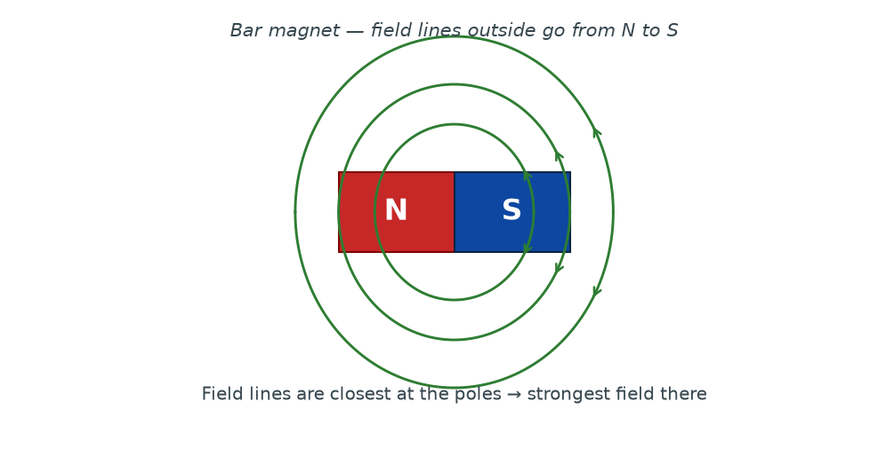
Figure 7.1 — A bar magnet with its field lines. Outside the magnet, field lines go from the North pole to the South pole. The field is strongest at the poles, where the lines are closest together.

The law of magnetic poles
The single most important rule of magnetism:
Like poles repel; unlike poles attract.
N repels N, S repels S; N attracts S
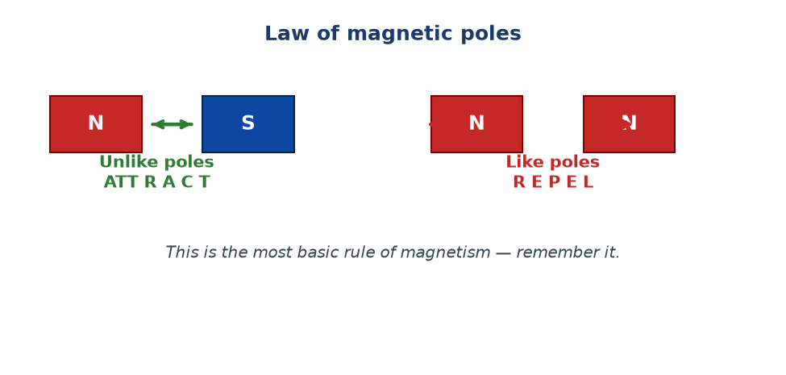
Figure 7.2 — The law of magnetic poles. Two North poles (or two South poles) push apart. A North and a South pole pull together. This is a favourite MSCE question.

How to magnetise a material
There are two common methods in school physics:
1. Stroking method. Stroke the steel bar repeatedly with one pole of a permanent magnet, always in the same direction. The steel bar becomes magnetised.
2. Electrical method (solenoid). Place the steel bar inside a coil of wire and pass a direct current through the coil. The current aligns the domains, and the steel bar becomes magnetised. This is the method used to make strong permanent magnets in industry.
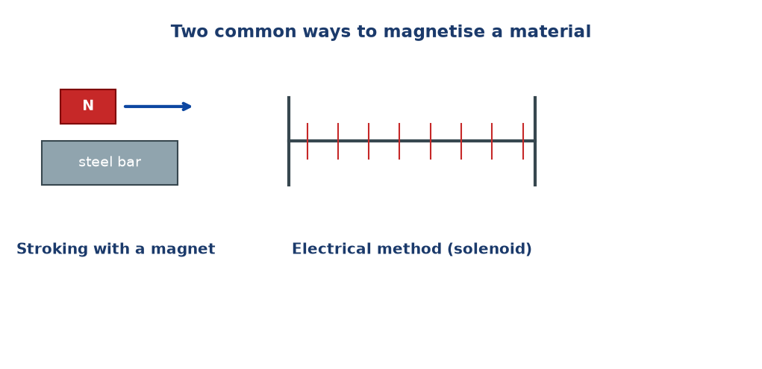
Figure 7.3 — Two common ways to magnetise a steel bar: stroking with a permanent magnet, or placing it in a current-carrying solenoid.

Categories of magnetic materials
Category | Examples | Behaviour
Ferromagnetic | Iron, cobalt, nickel, steel | Strongly attracted to magnets; can be magnetised strongly
Paramagnetic | Aluminium, platinum | Very weakly attracted to magnets
Diamagnetic | Copper, water, wood, glass | Very weakly repelled by magnets
Non-magnetic | Plastic, paper, air | Not noticeably affected by magnets

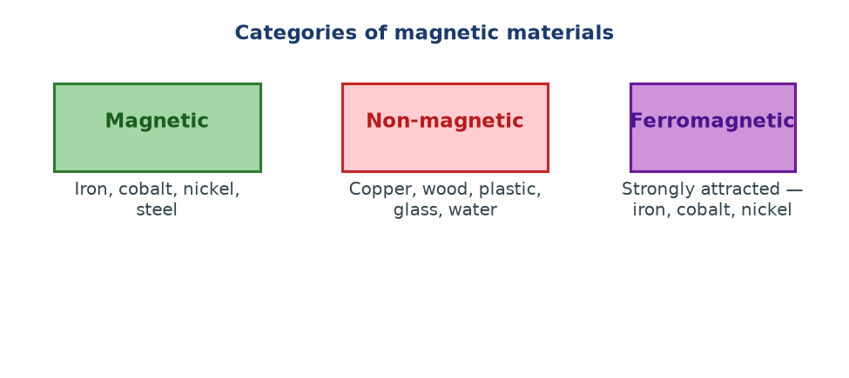
Figure 7.4 — Categories of magnetic materials. Ferromagnetic materials (iron, cobalt, nickel) are the ones we use to make permanent magnets.

WHY STUDENTS FIND THIS DIFFICULT
- Thinking all metals are magnetic. They are not — copper, aluminium, and lead are not magnetic.
- Confusing soft iron (magnetises easily, loses magnetism easily — good for electromagnets) with hard steel (magnetises less easily, keeps its magnetism — good for permanent magnets).
- Thinking a magnet has 'more force' at its middle. The magnetic force is strongest at the poles and weakest in the middle.
- Believing that cutting a magnet destroys it. If you cut a magnet in half, each piece is a complete magnet with its own N and S poles.

KEY POINTS — 7.1
- Magnetisation: making a material behave like a magnet.
- Only magnetic materials (Fe, Co, Ni, steel) can be magnetised.
- Law of poles: like repel, unlike attract.
- Two methods: stroking, and electrical (solenoid).
- Field is strongest at the poles.
- Cutting a magnet gives two smaller magnets, each with its own N and S.

IF YOU REMEMBER ONE THING
Like poles repel, unlike attract. Only iron, cobalt, nickel, and steel can be magnetised.

7.2 Demagnetisation
HAVE YOU EVER NOTICED…
Drop a magnet on a hard floor, or heat it in a fire, and it becomes weaker. Sometimes it stops being a magnet entirely. Magnets can lose their strength.

THE BIG IDEA
Demagnetisation is the loss of magnetic strength. It happens when the aligned domains inside the material are disturbed — by heating, hammering, or dropping — and become randomly oriented again.

The real concept
A magnet is a magnet because its domains are lined up. If something shakes those domains out of alignment, the material loses its magnetism. Anything that violently disturbs the internal structure of the material works:
- Heating — above a certain temperature (called the Curie temperature), the thermal vibration is strong enough to randomise the domains. For iron, the Curie temperature is about 770 °C.
- Hammering — mechanical shocks jostle the domains out of alignment.
- Dropping onto a hard surface — same effect as hammering.
- Using an alternating current (AC) in a coil — slowly withdrawing a magnet from an AC coil demagnetises it, because the current reverses direction many times a second, flipping the domain alignment back and forth and leaving them randomly oriented.
How to keep a magnet strong
- Store magnets in pairs with unlike poles together (N against S), often with a soft iron 'keeper' across the ends.
- Avoid dropping them.
- Avoid heating them.
- Do not hammer or bend them.
WHY STUDENTS FIND THIS DIFFICULT
- Thinking magnets last forever. They don't — they can weaken over time, especially with rough handling.
- Confusing demagnetisation with 'destroying' the magnet. The material is still there; only its domain alignment is lost.
- Thinking any small knock will demagnetise a magnet. Only significant shocks or high temperatures do.
- Forgetting that alternating current demagnetises, while direct current magnetises.

KEY POINTS — 7.2
- Demagnetisation: loss of magnetism.
- Causes: heating, hammering, dropping, AC current in a coil.
- Reason: domains become randomly oriented again.
- Direct current magnetises; alternating current demagnetises.
- Store magnets carefully to preserve their strength.

IF YOU REMEMBER ONE THING
Heat it, hit it, or drop it — and the magnet weakens. Domains fall out of alignment.

7.3 Domain Theory of Magnetism
HAVE YOU EVER NOTICED…
An unmagnetised iron nail is not a magnet. Yet after you stroke it with a magnet, it becomes one. Where did the magnetism come from? The answer is inside the iron itself.

THE BIG IDEA
A magnetic material is made of small regions called domains. Each domain behaves like a tiny magnet. In an unmagnetised material the domains point in random directions — their effects cancel. In a magnet, they all point the same way — their effects add up.

The real concept
Imagine a classroom of students, each holding a small magnet. If everyone points their magnet in a different direction, the overall magnetic effect is nothing. But if all the students line up their magnets in the same direction, the room becomes strongly magnetic.
That is exactly what domains are. In a piece of iron, there are millions of domains. In an unmagnetised iron bar, they are randomly oriented — cancelling each other out. In a magnetised iron bar, most domains point the same way — their magnetic fields add up to produce a strong magnet.
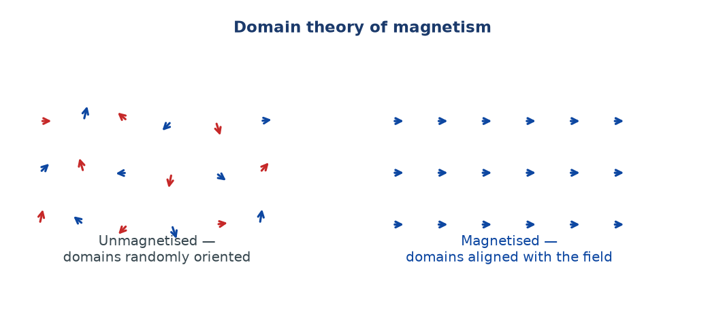
Figure 7.5 — Domain theory of magnetism. Unmagnetised (left): domains are randomly oriented, so their fields cancel. Magnetised (right): domains are aligned, so their fields add up.

Explaining magnetisation and demagnetisation
Magnetisation: Stroking with a magnet, or placing the iron in a solenoid, gives the domains enough energy to rotate into alignment with the applied field. The more domains that align, the stronger the magnet.
Demagnetisation: Heating, hammering, or dropping gives the domains enough thermal or mechanical energy to break alignment and return to random orientations. The magnetism is lost.
Why iron and steel behave differently
- Soft iron: domains align easily (magnetises strongly) but return to random orientation easily too (loses magnetism easily). Perfect for electromagnets — where you need the magnetism to switch on and off.
- Hard steel: domains align less easily but stay aligned. Once magnetised, it stays magnetised. Perfect for permanent magnets.
Material | Magnetises | Holds magnetism | Best used for
Soft iron | Easily | Poorly | Electromagnets
Hard steel | With difficulty | Well | Permanent magnets

Why cutting a magnet gives two magnets
If you cut a bar magnet in half, you might expect to get a North piece and a South piece. You don't. You get two smaller magnets, each with its own North and South. This is because domains are everywhere in the material — every piece of magnetic material, no matter how small, has both N and S ends once magnetised.
WHY STUDENTS FIND THIS DIFFICULT
- Thinking a magnet has 'free' North and South poles that can be separated. They can't — every magnet, however small, has both.
- Saying the domains 'melt' during demagnetisation. They don't melt — they just re-orient randomly.
- Confusing the domain theory with atoms. Domains are made of many atoms; each atom has its own tiny magnetic moment.
- Thinking all iron is magnetic. Iron is ferromagnetic — it becomes magnetic when domains align — but a piece of iron is not automatically magnetised.

KEY POINTS — 7.3
- Domains are small regions inside a magnetic material; each behaves like a tiny magnet.
- Unmagnetised: domains random. Magnetised: domains aligned.
- Magnetisation aligns domains. Demagnetisation randomises them.
- Soft iron: easy to magnetise, easy to demagnetise → electromagnets.
- Hard steel: hard to magnetise, holds it → permanent magnets.
- Cutting a magnet gives two smaller magnets.

IF YOU REMEMBER ONE THING
A magnet is a magnet because its domains are lined up. Randomise the domains, and the magnetism goes.

Worked Examples
Example 1 — The law of poles (Easy)
Question. A bar magnet is brought near a second bar magnet. The North pole of the first is brought close to the North pole of the second. Describe what happens and state the law involved.
Given: Two North poles brought close.
Find: Description and law.
Principle. Law of magnetic poles.
Solution. The two North poles repel each other — the magnets push apart.
Like poles repel.
Why this works: Magnetic poles obey the same rule as electric charges: similar poles push apart, opposite poles pull together.
Common mistake: Saying they attract. That would be true if one were North and the other South.
Example 2 — Identifying poles (Medium)
Question. A bar magnet is suspended freely and comes to rest with one end pointing North. Explain why, and identify the pole at each end.
Given: Bar magnet suspended freely.
Find: Explanation and identification.
Principle. The Earth acts like a giant magnet. The end of a freely suspended magnet that points to geographic North is called the North-seeking pole — the 'North pole' of the magnet.
Solution. The Earth itself has a magnetic field, roughly aligned with its axis. The suspended magnet aligns with this field. The end that points North is the magnet's North pole (N). The end that points South is its South pole (S).
Freely suspended magnet → N pole points geographic North.
Why this works: The magnetic field of the Earth exerts a torque on the suspended magnet, rotating it until it aligns with the field.
Common mistake: Confusing the magnet's N pole with the Earth's magnetic pole. Strictly, the Earth's magnetic pole near the geographic North is actually a magnetic South pole — but MSCE accepts 'the N pole of the compass points North'.
Example 3 — Magnetisation and demagnetisation (Medium)
Question. A student strokes a steel nail with a bar magnet 30 times in one direction. The nail becomes magnetised. The student then drops the nail on the floor several times and finds it has lost its magnetism. Explain both observations using domain theory.
Given: Stroking → magnetisation; dropping → loss.
Find: Explanation.
Principle. Domain theory of magnetism.
Solution. Stroking: The magnetic field of the stroking magnet gives energy to the domains in the steel, rotating them into alignment with the field. The more strokes, the more domains align. The nail becomes a magnet.
Dropping: Each impact shakes the domains. If the shocks are strong enough, the domains fall back into random orientations. The net magnetic effect cancels, and the nail loses its magnetism.
Stroking aligns domains; dropping randomises them.
Why this works: Domains need energy to align and energy to lose alignment. Strokes provide alignment energy; shocks provide disordering energy.
Common mistake: Saying 'the magnetism is used up'. Magnetism is not used up — the domain alignment is disturbed.
Example 4 — Soft iron vs steel (MSCE)
Question. A student is asked to make an electromagnet. Should the core be made of soft iron or hard steel? Give two reasons.
Given: Electromagnet core choice.
Find: Choice and two reasons.
Principle. Soft iron magnetises and demagnetises easily.
Solution. Use soft iron.
Reason 1. Soft iron has a high permeability — it magnetises strongly with a small current, giving a powerful electromagnet.
Reason 2. Soft iron demagnetises easily when the current is switched off — the electromagnet can be turned off.
Electromagnet → soft iron core. Permanent magnet → hard steel.
Why this works: An electromagnet must switch on and off. Hard steel would stay magnetised after the current was switched off, which defeats the purpose.
Common mistake: Choosing hard steel because 'it's stronger'. Stronger for a permanent magnet, yes — but wrong for an electromagnet.

Check Yourself
1. State the law of magnetic poles.
2. Name three magnetic materials.
3. Describe two methods of magnetising a steel bar.
4. Give two ways a magnet can be demagnetised.
5. What is a magnetic domain?
6. Explain, using domains, why an unmagnetised iron nail does not attract other iron nails.
7. Why does a magnet become weaker when heated?
8. Why is soft iron used in electromagnets, and hard steel in permanent magnets?
9. If you cut a bar magnet in half, what do you get?
10. Where is the magnetic field of a bar magnet strongest?

Exam-Style Questions (MSCE-style practice)
Q1. (a) State the law of magnetic poles.
(b) Two bar magnets are placed with their North poles facing each other. Describe what happens and explain why.
Q2. (a) Describe the domain theory of magnetism.
(b) Use it to explain why a piece of iron becomes magnetised when stroked with a magnet.
Q3. A student heats a magnet strongly using a Bunsen burner. After cooling, the magnet is much weaker.
(a) Name this process.
(b) Explain, using domain theory, why heating reduces the magnet's strength.
Q4. Give one example each of:
(a) a magnetic material,
(b) a non-magnetic material.
Q5. (a) Explain why soft iron is preferred over steel for the core of an electromagnet.
(b) Explain why steel is preferred over soft iron for a permanent magnet.
Q6. Sketch the magnetic field pattern around a bar magnet. Label the poles, and show the direction of the field lines.
Q7. A bar magnet is suspended freely and comes to rest pointing North-South.
(a) Explain why this happens.
(b) Identify which end of the magnet is the North pole.
Q8. Explain why dropping a magnet repeatedly weakens it.
Q9. (a) What happens if you cut a bar magnet into two pieces?
(b) Explain this in terms of domains.
Q10. A student finds that a piece of iron and a piece of copper behave differently when brought near a magnet.
(a) State the difference you would observe.
(b) Explain the difference in terms of magnetic properties.

Full Worked Solutions
Check Yourself — Answers
1. Like poles repel; unlike poles attract.
2. Any three: iron, cobalt, nickel, steel.
3. (i) Stroking with one pole of a permanent magnet, always in the same direction. (ii) Placing inside a solenoid carrying direct current.
4. (i) Heating. (ii) Hammering or dropping.
5. A small region inside a magnetic material in which all the atoms are aligned, behaving like a tiny magnet.
6. Its domains are randomly oriented, so their magnetic effects cancel. There is no net magnetic field to attract other iron.
7. Heating increases atomic vibration, which randomises the domain orientations, reducing the net magnetic effect.
8. Soft iron magnetises and demagnetises easily → good for on/off electromagnets. Hard steel is hard to magnetise but retains magnetism → good for permanent magnets.
9. Two smaller magnets, each with its own North and South poles.
10. At the poles.

Exam-Style — Full Solutions
Q1. (a) Like poles repel; unlike poles attract.
(b) They repel each other. The two North poles are like poles, so they exert equal and opposite repulsive forces on each other and the magnets move apart.
Q2. (a) A magnetic material is made of many small regions called domains. Each domain behaves like a tiny magnet. In an unmagnetised material, the domains are randomly oriented, so their magnetic effects cancel. In a magnetised material, most domains are aligned in the same direction, so their fields add up to give a net magnetic field.
(b) Stroking with a magnet applies a magnetic field to the iron. This field gives energy to the domains, rotating them into alignment with the stroking field. The more strokes, the more domains align, and the stronger the magnet becomes.
Q3. (a) Demagnetisation.
(b) Heating causes the atoms (and therefore the domains) to vibrate strongly. The thermal energy randomises the alignment of the domains, so their magnetic effects cancel. The magnet's overall strength drops.
Q4. (a) Iron (or cobalt, nickel, steel).
(b) Copper (or wood, plastic, glass, aluminium).
Q5. (a) Soft iron magnetises easily and demagnetises easily. This allows the electromagnet to be switched on and off.
(b) Steel is harder to magnetise but retains its magnetism well once it has been magnetised, so it makes a strong permanent magnet.
Q6. Field lines emerge from the North pole and enter the South pole, curving outward and being densest near the poles. Inside the magnet, field lines go from S to N. Direction is from N to S outside.
Q7. (a) The Earth's magnetic field exerts a torque on the suspended magnet, rotating it until it aligns with the field (which runs roughly North-South).
(b) The end pointing North is the magnet's North pole.
Q8. Each impact shakes the crystal structure of the magnet. This mechanical shock gives energy to the domains, allowing some of them to return to random orientations. The net magnetisation decreases.
Q9. (a) Two smaller bar magnets, each with its own N and S poles.
(b) Domains are distributed throughout the material. Whichever way you cut it, each piece still contains many aligned domains, so each piece has its own N and S ends.
Q10. (a) The iron is attracted to the magnet (and may itself become magnetised), while the copper is not attracted at all.
(b) Iron is ferromagnetic — its domains can align with the external field, producing attraction. Copper is non-magnetic — its domains (if any) do not respond to the field in a way that produces measurable attraction.

Common Mistakes
- Thinking all metals are magnetic. Only iron, cobalt, nickel, and steel are.
- Saying 'opposite poles repel'. It's the opposite — unlike poles attract.
- Believing that cutting a magnet gives a separate N and S piece. It gives two smaller magnets.
- Confusing soft iron (electromagnets) with hard steel (permanent magnets).
- Saying the domains 'melt' or 'break'. They only re-orient.
- Saying a magnet becomes weaker because 'the magnetism runs out'. The magnetism isn't used up — the alignment is lost.
- Confusing magnetisation with electrification. They are entirely different processes.

EXAM TIP
MSCE regularly tests: (1) the law of magnetic poles; (2) methods of magnetisation and demagnetisation; (3) the domain theory of magnetism; (4) distinguishing soft iron and hard steel for different uses.
For 'explain using domains' questions, always structure your answer as: (i) what domains are, (ii) what alignment does, (iii) how the alignment is changed by the process in question.
Draw clear field-line diagrams — arrows pointing N to S outside the magnet, denser lines at the poles.
For comparison questions (soft iron vs steel), always link the choice to the purpose: electromagnets need on/off behaviour; permanent magnets need lasting magnetism.

REMEMBER • Like poles repel, unlike attract. Domains aligned = magnet. Random = not a magnet. Soft iron for electromagnets, hard steel for permanent magnets.

Chapter 7 Test
SECTION A — Multiple Choice (5 marks)
1. Which of the following is NOT magnetic?
A. Iron B. Cobalt C. Copper D. Nickel

2. Like poles of two magnets will:
A. Attract B. Repel C. Stay still D. Rotate

3. A material magnetised by placing it in a solenoid uses:
A. Alternating current B. Direct current C. No current D. Heat

4. The magnetic field of a bar magnet is strongest:
A. At the centre B. At the poles C. Everywhere equally D. Outside the magnet only

5. Which material would you use for the core of an electromagnet?
A. Steel B. Soft iron C. Aluminium D. Copper

SECTION B — Short Answers (10 marks)
6. State the law of magnetic poles. (2)
7. Name two methods of magnetisation. (2)
8. Name two ways a magnet can be demagnetised. (2)
9. What is a magnetic domain? (2)
10. Explain why soft iron is preferred over steel for the core of an electromagnet. (2)

SECTION C — Structured Questions (15 marks)
12. (a) Draw a labelled diagram of the magnetic field around a bar magnet. Include the direction of field lines and the position of the poles. (4)
(b) Explain why the field is strongest at the poles. (2)

13. (a) A steel bar is stroked repeatedly with one pole of a bar magnet, always in the same direction. Explain, using domain theory, how the bar becomes magnetised. (4)
(b) The bar is then dropped on the ground several times. Explain why the bar loses most of its magnetism. (3)

14. (a) Explain why a magnet's magnetism is lost when it is heated strongly. (2)

END OF CHAPTER 7
Next chapter: Chapter 8 — Electromagnetism.

