CHAPTER 8 — Electromagnetism
Physics · Form 4 · MSCE · Malawian Science Books

Welcome to Chapter 8. In Chapter 7 we learned that magnets create magnetic fields. Now comes the surprising part: electric currents also create magnetic fields. And the reverse is true too — magnetic fields can push on currents, producing motion.
This two-way connection between electricity and magnetism is called electromagnetism. It powers electric motors, loudspeakers, loud generators, and the transformers that bring electricity to your home.
By the end of this chapter, you'll know how to find the direction of magnetic fields, how to build and use electromagnets, and how the motor effect makes a current-carrying wire move inside a magnetic field.

8.1 Magnetic Field due to a Straight Current-Carrying Conductor
HAVE YOU EVER NOTICED…
Place a compass near a wire carrying a current, and the needle deflects. Switch the current off, and the needle returns to point North. The current has created a magnetic field around the wire.

THE BIG IDEA
A straight wire carrying a current produces a circular magnetic field around itself. The field is strongest near the wire and gets weaker as you move away. Reverse the current, and the field reverses direction.

The real concept
When a current flows, the moving charges inside the wire create a magnetic field. Because the charges are moving along the wire, the field wraps around it in concentric circles — like the rings you'd see if you sliced the space around the wire and dropped iron filings on it.
The field's strength depends on two things:
- The current. Bigger current → stronger field.
- The distance from the wire. Closer to the wire → stronger field.
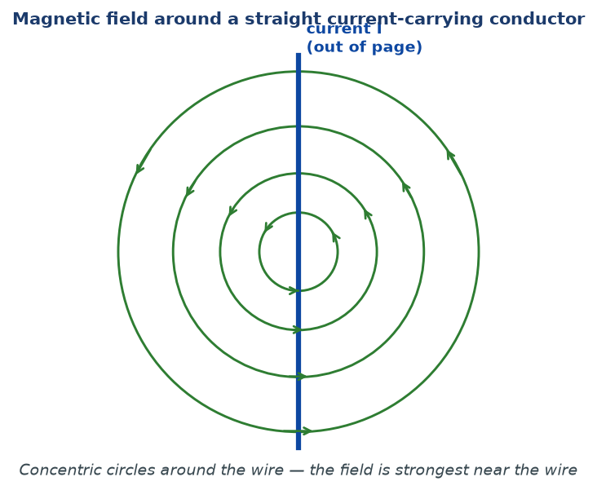
Figure 8.1 — The magnetic field around a straight current-carrying wire. The field lines are concentric circles. The field is strongest near the wire and weakest far away.

WHY STUDENTS FIND THIS DIFFICULT
- Thinking the field lines go along the wire. They go around it.
- Not realising the field depends on both the current and the distance. Both matter.
- Forgetting that reversing the current reverses the field direction. This is tested often.

KEY POINTS — 8.1
- A current-carrying wire has a magnetic field around it.
- The field lines are concentric circles centred on the wire.
- Field strongest near the wire, weaker farther away.
- Reversing the current reverses the field.

IF YOU REMEMBER ONE THING
Current in a wire → magnetic field around the wire. It's circular, and it reverses when the current reverses.

8.2 Direction of the Magnetic Field
HAVE YOU EVER NOTICED…
If you hold a wire and reverse the current, the compass deflects the other way. To know which way the field goes, physicists use a simple trick with the right hand.

THE BIG IDEA
The right-hand grip rule: point the thumb of your right hand along the direction of the current, and your curled fingers point in the direction of the magnetic field.

Using the right-hand grip rule
1. Hold your right hand as if you were gripping the wire.
2. Point your thumb in the direction of the current (the direction in which positive charge flows — from + to −).
3. Your curled fingers now indicate the direction of the magnetic field lines around the wire.
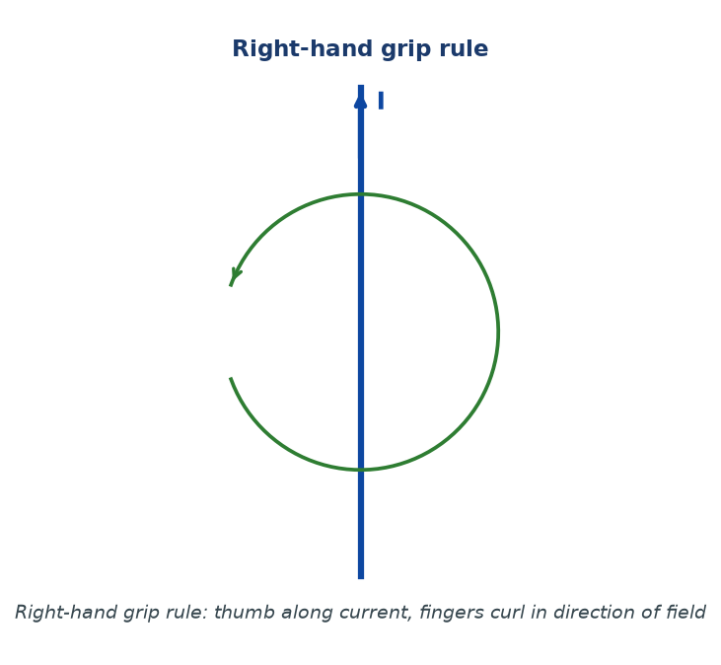
Figure 8.2 — The right-hand grip rule. Thumb along current, fingers curl in the direction of the magnetic field.

Reversing the current
If you reverse the current — switch the terminals of the battery — the field reverses too. So the compass needle that deflected left will now deflect right. This is a very common exam question.
WHY STUDENTS FIND THIS DIFFICULT
- Using the left hand by mistake. This chapter's grip rule uses the right hand; Fleming's left-hand rule is used later.
- Forgetting to point the thumb in the direction of conventional current (+ to −), not electron flow.
- Turning the hand the wrong way. Practice: grip an imaginary wire, thumb along current.

KEY POINTS — 8.2
- Right-hand grip rule gives field direction.
- Thumb = current, fingers = field.
- Reverse current → reverse field.
- Applies to any straight current-carrying conductor.

IF YOU REMEMBER ONE THING
Right hand: thumb along current, fingers curl the way the field goes. Reverse the current, the field flips.

8.3 Magnetic Field due to a Solenoid
HAVE YOU EVER NOTICED…
Wrap a wire into a tight coil and pass a current — the coil becomes a magnet. The more turns, the stronger. This is a solenoid.

THE BIG IDEA
A solenoid is a long coil of wire. When current flows through it, the field inside is strong and uniform, and outside it behaves like a bar magnet — with a North pole at one end and a South pole at the other.

Field pattern
- Inside the solenoid: field lines are straight, parallel, and equally spaced — uniform field.
- Outside: field lines curve from one end to the other, like a bar magnet.
- Poles: the end where field lines emerge (outside) is the North pole; the end where they enter is the South pole.
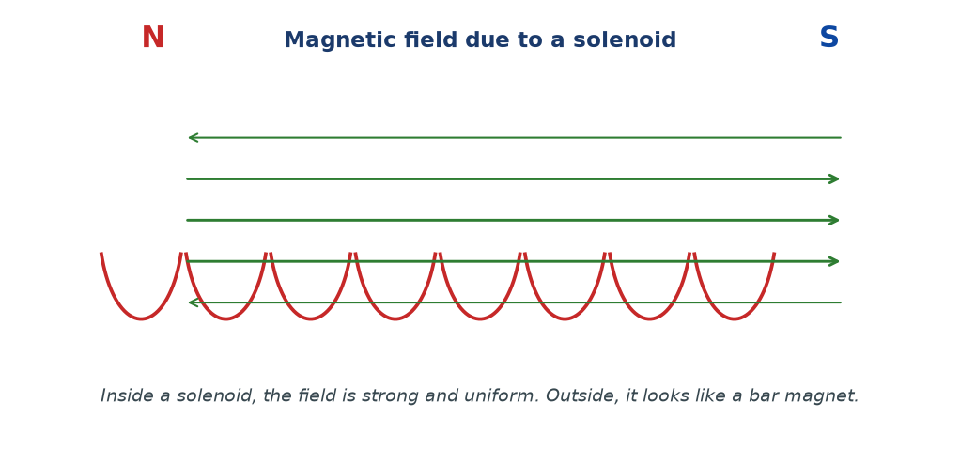
Figure 8.3 — The magnetic field inside a solenoid is strong and uniform. Outside, it looks like a bar magnet, with N at one end and S at the other.

Factors affecting field strength
- Current — bigger current → stronger field.
- Number of turns per unit length — more turns → stronger field.
- Core material — inserting soft iron hugely increases the field, because the iron becomes magnetised and adds its own field.
The N-S direction of a solenoid
To find which end is North, use the right-hand grip rule for solenoids:
1. Curl the fingers of your right hand along the direction of the current in the coils.
2. Your thumb points to the North pole of the solenoid.
WHY STUDENTS FIND THIS DIFFICULT
- Confusing the field inside the solenoid (uniform) with the field outside (curved, like a bar magnet).
- Saying 'the solenoid has no poles'. It has two — North at one end, South at the other.
- Forgetting that soft iron inside the solenoid massively increases the field strength.
- Mixing up the grip rule for solenoids (fingers along current, thumb → North) with the grip rule for straight wires (thumb along current, fingers curl).

KEY POINTS — 8.3
- Solenoid = coil of wire.
- Inside: uniform field. Outside: like a bar magnet.
- N pole = where field lines emerge; S pole = where they enter.
- Field strength increases with current, turns per unit length, and iron core.
- Right-hand grip rule for solenoids: fingers along current, thumb = North pole.

IF YOU REMEMBER ONE THING
Solenoid = electromagnet with a strong uniform inside field and a bar-magnet-like outside field.

8.4 Simple Electromagnets
HAVE YOU EVER NOTICED…
The doorbell rings. A crane lifts scrap metal and then drops it. A relay switches on a large motor with a tiny signal. All these use electromagnets — magnets you can turn on and off.

THE BIG IDEA
An electromagnet is a magnet made using an electric current. It can be switched on and off, and its strength can be controlled. Typically, it is a solenoid with a soft iron core.

Real concept
A current in a coil creates a magnetic field. If we put a soft iron bar inside the coil, the iron becomes magnetised and massively increases the field. But when the current stops, the soft iron quickly demagnetises — so the electromagnet is off.
This is why soft iron (not steel) is used for the core. Steel would stay magnetised after the current is switched off, which is not what we want for a switchable magnet.
Strength of an electromagnet
The strength of an electromagnet increases if you:
- Increase the current in the coil.
- Increase the number of turns in the coil.
- Insert a soft iron core.
- Reduce the length of the coil for the same number of turns (i.e. pack the turns more densely).
Uses of electromagnets
- Electric bell — the electromagnet pulls a hammer that strikes the bell.
- Relay — a small current in one circuit switches on a much larger current in another.
- Loudspeaker — the electromagnet interacts with a permanent magnet to move a cone and produce sound.
- Lifting cranes in scrapyards — the electromagnet picks up and drops iron scrap.
- Electric motors — the electromagnet in the rotor is switched on and off by a commutator.
WHY STUDENTS FIND THIS DIFFICULT
- Thinking any coil makes an electromagnet. Without a current, there's no magnet — just wire.
- Using steel instead of soft iron for the core. Soft iron is essential for switchability.
- Forgetting that the current must flow. An electromagnet without a current does nothing.
- Confusing permanent magnets with electromagnets. Permanent magnets can't be switched off.

KEY POINTS — 8.4
- Electromagnet = solenoid + soft iron core + current.
- Switchable on and off.
- Strength ∝ current, ∝ turns, ∝ soft iron core.
- Uses: bell, relay, loudspeaker, crane, motor.

IF YOU REMEMBER ONE THING
Electromagnet = coil + soft iron + current. Switch on to attract, switch off to release.

8.5 Force on a Current-Carrying Conductor in a Magnetic Field
HAVE YOU EVER NOTICED…
If you place a wire carrying a current between the poles of a strong magnet, the wire jumps. Something pushed it. That something is the motor effect.

THE BIG IDEA
A current-carrying conductor in a magnetic field experiences a force. The force is maximum when the current is perpendicular to the field, and zero when they are parallel. This is the basis of every electric motor.

The equation
F = B I L
F = force (N); B = magnetic field strength (T); I = current (A); L = length of conductor in the field (m)
Units: B is measured in tesla (T). Also 1 T = 1 N/(A·m).
Condition: the conductor must be perpendicular to the field. If it is at an angle θ to the field, then F = BIL sin θ.
Fleming's left-hand rule
Hold your left hand with the thumb, first finger, and second finger all mutually at right angles:
- First finger = direction of the magnetic Field (N → S).
- Second finger = direction of the Current (+ to −).
- Thumb = direction of the Force (motion).
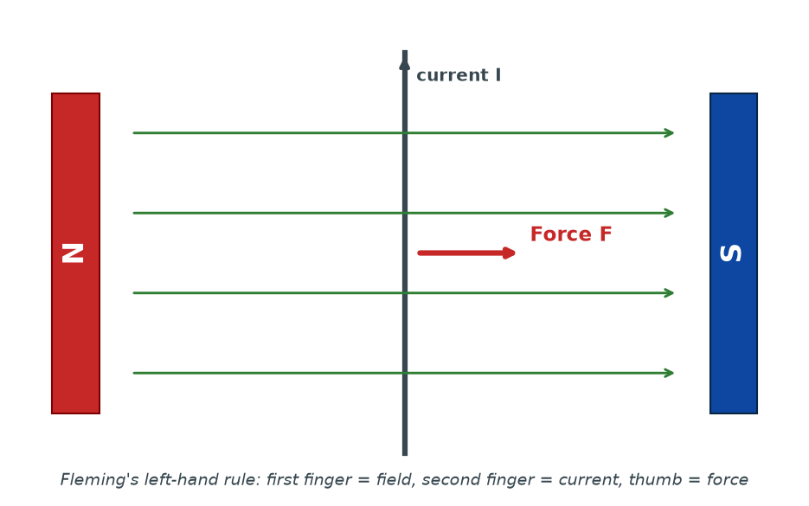
Figure 8.4 — The motor effect. A current-carrying wire inside a magnetic field experiences a force. Use Fleming's left-hand rule to find its direction.

Direction of the force
Because there are three quantities involved (field, current, force), it's easy to get confused. Fleming's left-hand rule solves this:
- Thumb and first two fingers at right angles.
- First finger along the field, second along the current, thumb points in the direction of the force.
WHY STUDENTS FIND THIS DIFFICULT
- Using the right hand instead of the left. Field-current-force uses the left hand (Fleming's Left = Force).
- Forgetting to have all three at right angles.
- Confusing this with the right-hand grip rule of Section 8.2 — they're different rules for different purposes.
- Using current in mA or length in cm without converting to A and m.

KEY POINTS — 8.5
- F = BIL (when current ⟂ field).
- Force is perpendicular to both current and field.
- Fleming's left-hand rule gives direction.
- Maximum force when current ⟂ field; zero when parallel.
- This is the basis of every electric motor.

IF YOU REMEMBER ONE THING
F = BIL. Left hand: Field, Current, force. All perpendicular.

8.6 Applications of the Motor Effect
HAVE YOU EVER NOTICED…
Fans, blenders, water pumps, DVD players, electric drills, washing machines — all use the same basic principle. A current in a magnetic field produces rotation.

THE BIG IDEA
The motor effect turns electrical energy into kinetic energy. Any device that converts current to motion relies on it — from the smallest fan to the largest industrial motor.

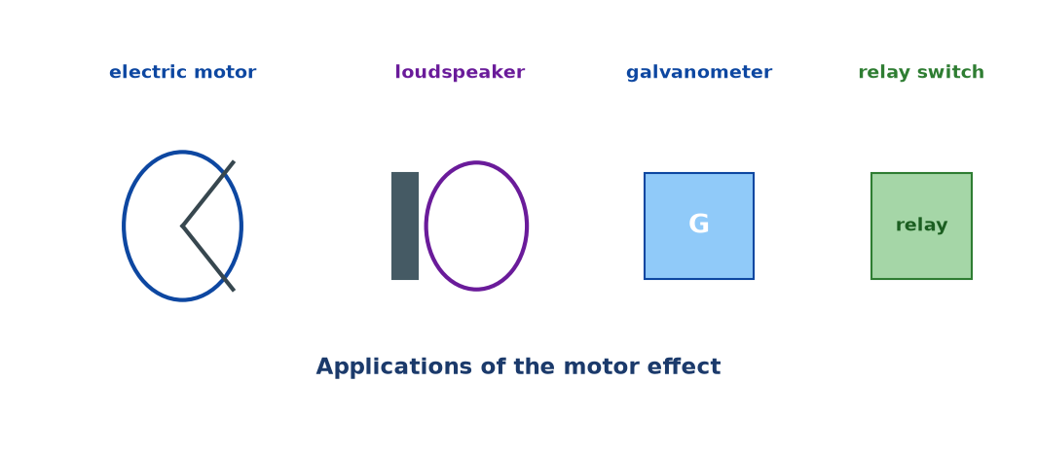
Figure 8.5 — Applications of the motor effect: electric motor, loudspeaker, galvanometer, relay switch.

How a simple DC motor works
1. A rectangular coil of wire is placed between the poles of a magnet.
2. Current flows through the coil.
3. By the motor effect, each side of the coil experiences a force.
4. Because the two sides carry current in opposite directions, the forces are also opposite — creating a couple that rotates the coil.
5. A split-ring commutator reverses the current in the coil every half turn, so the coil keeps rotating in the same direction.
The loudspeaker
A loudspeaker has a coil of wire attached to a cone. The coil sits in the field of a permanent magnet. When an alternating current (the audio signal) flows through the coil, the force on the coil alternates, making the cone vibrate and producing sound.
The moving-coil galvanometer
A moving-coil galvanometer is a device for measuring small currents. The current flows through a coil suspended in a magnetic field. The coil experiences a couple and rotates, against a restoring spring. The angle of rotation gives the current reading.
The relay
A relay uses a small current to switch on a much larger current. A small electromagnet pulls a soft-iron armature; the armature closes a contact in a second circuit, allowing a large current to flow. Relays are essential in cars, industrial control systems, and older telephone exchanges.
WHY STUDENTS FIND THIS DIFFICULT
- Forgetting the commutator's role. Without it, the coil would stop after half a turn because the forces would reverse.
- Confusing the field direction inside the motor with the current direction. They are perpendicular.
- Thinking loudspeakers use a permanent magnet to produce the sound. The sound comes from the vibrating cone; the magnet provides the field.

KEY POINTS — 8.6
- Motor: current in field → forces → couple → rotation.
- Commutator keeps the rotation going in one direction.
- Loudspeaker: varying current → varying force → cone vibrates → sound.
- Galvanometer: current in field → deflection → measurement.
- Relay: small current controls large current via an electromagnet.

IF YOU REMEMBER ONE THING
The motor effect converts electricity into motion. Motors, speakers, galvanometers, relays — all the same physics.

Worked Examples
Example 1 — Force on a conductor (Easy)
Question. A straight wire of length 0.20 m carries a current of 5.0 A perpendicular to a uniform magnetic field of strength 0.40 T. Find the force on the wire.
Given: B = 0.40 T, I = 5.0 A, L = 0.20 m.
Find: F.
Principle. F = BIL.
Solution.
F = 0.40 × 5.0 × 0.20
F = 0.40 N
Why this works: Force is proportional to all three: field strength, current, and the length of wire inside the field.
Common mistake: Forgetting to convert length from cm to m. Always work in SI units.
Example 2 — Finding the current (Medium)
Question. A wire of length 0.30 m is placed perpendicular to a magnetic field of 0.50 T. A force of 0.15 N acts on the wire. Find the current.
Given: B = 0.50 T, L = 0.30 m, F = 0.15 N.
Find: I.
Principle. F = BIL, so I = F / (BL).
Solution.
I = 0.15 / (0.50 × 0.30) = 0.15 / 0.15
I = 1.0 A
Why this works: Rearrange the same equation. Units work out: N / (T·m) = N / (N/(A·m) · m) = A.
Common mistake: Forgetting the brackets and computing 0.15/0.50 × 0.30, which gives 0.09 — wrong.
Example 3 — Angle to field (Medium–Hard)
Question. A wire of length 0.40 m carries 3.0 A and is placed at 30° to a magnetic field of 0.25 T. Find the force on the wire.
Given: B = 0.25 T, I = 3.0 A, L = 0.40 m, θ = 30°.
Find: F.
Principle. F = BIL sin θ.
Solution.
F = 0.25 × 3.0 × 0.40 × sin 30°
F = 0.30 × 0.5
F = 0.15 N
Why this works: Only the component of current perpendicular to the field produces force — hence the sin θ factor.
Common mistake: Forgetting the sin θ when the wire is not perpendicular. If θ = 90°, sin θ = 1 and the simple F = BIL applies.
Example 4 — Motor reasoning (MSCE)
Question. Explain the role of the split-ring commutator in a simple DC motor.
Given: A DC motor with a rotating coil.
Find: Explanation.
Principle. Motor effect + couple + rotation.
Solution. The current in the coil flows in one direction for half a turn. After half a turn, the coil reaches a position where the forces on its two sides would reverse direction and push it back — stopping the motor. The commutator reverses the current just at the moment the coil passes the vertical position, so the forces continue to push the coil in the same direction. The result is continuous rotation.
Commutator reverses current every half-turn → continuous rotation.
Why this works: The direction of the force depends on the direction of the current. By reversing the current at exactly the right moment, the force direction stays the same relative to the coil's motion.
Common mistake: Saying the commutator 'increases the current'. It doesn't — it reverses it.

Check Yourself
1. Describe the shape of the magnetic field around a straight current-carrying wire.
2. State the right-hand grip rule.
3. What happens to the field if the current is reversed?
4. Draw the field pattern of a solenoid.
5. State two ways to increase the strength of an electromagnet.
6. What is the motor effect?
7. State Fleming's left-hand rule.
8. A wire of length 0.15 m carries a current of 4.0 A in a field of 0.60 T. Find the force on the wire.
9. Explain the role of the split-ring commutator in a DC motor.
10. Give one everyday use of an electromagnet.

Exam-Style Questions (MSCE-style practice)
Q1. (a) Describe the magnetic field pattern around a long straight current-carrying wire.
(b) Explain how you would determine the direction of the field.
Q2. (a) State two ways of increasing the strength of an electromagnet.
(b) Give two reasons why soft iron is preferred to steel as the core of an electromagnet.
Q3. A straight conductor of length 0.25 m is placed perpendicular to a uniform magnetic field of 0.80 T. The current through it is 2.0 A.
(a) Calculate the force on the conductor.
(b) State what happens to the force if the current is doubled.
Q4. (a) Draw the magnetic field pattern inside and outside a current-carrying solenoid.
(b) Label the North and South poles on your diagram.
Q5. A wire of length 0.30 m carrying a current of 6.0 A is placed at 90° to a magnetic field. A force of 0.72 N acts on it.
(a) Calculate the magnetic field strength.
(b) State the equation you used.
Q6. (a) Explain the motor effect.
(b) State Fleming's left-hand rule.
(c) Describe one everyday application.
Q7. (a) Explain how a simple DC motor works.
(b) What is the role of the split-ring commutator?
Q8. The field inside a solenoid is uniform. Explain what 'uniform' means in this context, and how it differs from the field around a straight wire.
Q9. A copper wire of length 0.50 m carries a current of 2.5 A perpendicular to a magnetic field of 0.30 T.
(a) Calculate the force on the wire.
(b) If the wire is rotated so that it makes 45° with the field, calculate the new force.
Q10. (a) State one use of an electromagnet in a relay.
(b) Explain how the relay uses a small current to control a large current.

Full Worked Solutions
Check Yourself — Answers
1. Concentric circles centred on the wire, strongest close to the wire, weakening with distance.
2. Point the right thumb along the direction of the current, and the curled fingers show the direction of the field.
3. The field also reverses direction.
4. Straight parallel field lines inside; curved (bar-magnet-like) lines outside; N at one end, S at the other.
5. Any two: increase current; increase number of turns; insert a soft iron core.
6. The force experienced by a current-carrying conductor placed in a magnetic field.
7. First finger = field, second finger = current, thumb = force; all at right angles using the left hand.
8. F = BIL = 0.60 × 4.0 × 0.15 = 0.36 N.
9. It reverses the current in the coil every half turn, so that the forces continue to rotate the coil in the same direction instead of stopping it.
10. Electric bell (or loudspeaker, relay, motor, crane).

Exam-Style — Full Solutions
Q1. (a) The field consists of concentric circles around the wire, in a plane perpendicular to it. The field is strongest near the wire and weakens as distance increases.
(b) Use the right-hand grip rule: point the thumb of the right hand along the current; the curled fingers show the direction of the magnetic field.
Q2. (a) Increase the current; increase the number of turns.
(b) Soft iron magnetises easily, producing a strong field with a small current; and demagnetises easily, so the electromagnet can be turned off quickly.
Q3. (a) F = BIL = 0.80 × 2.0 × 0.25 = 0.40 N.
(b) The force doubles to 0.80 N, because F ∝ I.
Q4. (a)-(b) Straight parallel lines inside; curved lines outside from N to S; N at the end where lines emerge; S at the end where lines enter.
Q5. (a) B = F / (IL) = 0.72 / (6.0 × 0.30) = 0.72 / 1.8 = 0.40 T.
(b) F = BIL.
Q6. (a) A current-carrying conductor in a magnetic field experiences a force (perpendicular to both the field and the current).
(b) Left hand: first finger along the field, second finger along the current, thumb points along the force.
(c) Electric motor (or loudspeaker, galvanometer).
Q7. (a) A rectangular coil in a magnetic field carries current. The two opposite sides carry current in opposite directions, so they experience opposite forces → a couple that rotates the coil.
(b) It reverses the current every half turn, so the coil continues to rotate in the same direction.
Q8. 'Uniform' means the field has the same strength and direction at every point inside the solenoid. Around a straight wire, the field strength decreases with distance, so the field is not uniform.
Q9. (a) F = BIL = 0.30 × 2.5 × 0.50 = 0.375 N.
(b) F = BIL sin θ = 0.375 × sin 45° ≈ 0.375 × 0.707 ≈ 0.265 N.
Q10. (a) A relay uses a small electromagnet to close a contact in a second circuit.
(b) A small current through the electromagnet coil pulls a soft-iron armature. The armature closes a contact in a second circuit, allowing a much larger current to flow. In this way, a small current controls a large one.

Common Mistakes
- Using the left hand for the right-hand grip rule, or the right hand for Fleming's left-hand rule. Keep them separate.
- Thinking the field lines around a straight wire are along the wire. They go around it.
- Forgetting that F = BIL applies only when the current is perpendicular to the field.
- Not converting length to metres, or current to amperes.
- Saying the commutator increases the current. It reverses it.
- Confusing the field inside a solenoid (uniform) with the field outside (bar-magnet-like).
- Using hard steel for electromagnet cores. Soft iron is always correct for switchable magnets.

EXAM TIP
MSCE regularly tests: (1) the right-hand grip rule (direction of field); (2) the motor effect and F = BIL; (3) Fleming's left-hand rule; (4) applications of electromagnets and motors.
For direction questions, always state which hand and which finger means what. Even if your direction is wrong, the method gains marks.
For F = BIL, always show the formula, the substitution, and the units. Three steps, three marks.
Remember the motor effect requires the current to be perpendicular to the field. If the question says 'parallel', the force is zero.
For explanation questions on the commutator, use the phrase 'reverses the current every half turn' — that is the mark the examiner is looking for.

REMEMBER • Right-hand grip: thumb along current, fingers curl field. Left-hand rule: Field, Current, Force. F = BIL. Commutator reverses current each half-turn.

Chapter 8 Test
SECTION A — Multiple Choice (5 marks)
1. The magnetic field around a straight current-carrying wire consists of:
A. Straight lines along the wire B. Concentric circles around the wire C. Random lines D. Nothing

2. The right-hand grip rule is used to find:
A. The current B. The voltage C. The direction of the magnetic field D. The mass of the wire

3. The unit of magnetic field strength is the:
A. Newton B. Tesla C. Ampere D. Volt

4. Fleming's left-hand rule involves:
A. Field, current, and voltage B. Field, current, and force C. Current, voltage, and resistance D. Only field

5. In a DC motor, the split-ring commutator:
A. Increases the current B. Decreases the current C. Reverses the current each half-turn D. Cuts the current off

SECTION B — Short Answers (10 marks)
6. State the right-hand grip rule. (2)
7. Explain the motor effect. (2)
8. State two ways of increasing the strength of an electromagnet. (2)
9. A wire of length 0.25 m carries a current of 3.0 A in a magnetic field of 0.40 T. Calculate the force on the wire. (2)
10. Give one application of an electromagnet and briefly explain how it works. (2)

SECTION C — Structured Questions (15 marks)
12. (a) Draw and label the magnetic field pattern around a long straight current-carrying wire. (3)
(b) Explain how the direction of the field can be determined. (2)
(c) State what happens if the current is reversed. (1)

13. A straight conductor of length 0.20 m is placed perpendicular to a magnetic field of 0.50 T. The current through it is 4.0 A.
(a) Calculate the force acting on the conductor. (3)
(b) State two ways the force could be increased. (2)

14. (a) Describe how a simple DC motor works. (3)
(b) Explain the role of the commutator. (1)

END OF CHAPTER 8
Next chapter: Chapter 9 — Electromagnetic Induction.

