CHAPTER 1 — Thermal Expansion
Physics · Form 4 · MSCE · Malawian Science Books

Almost everything gets bigger when it is heated and smaller when it is cooled. Bridges are built with gaps. Railway lines are laid with gaps. Hot water can crack a cold glass. In this chapter we learn why this happens — at the level of the atoms themselves — and how to calculate it precisely.

1.1 Definition of Temperature
THE BIG IDEA
Temperature is a measure of the average kinetic energy of the particles in a substance. Hotter objects have particles that are, on average, moving and vibrating faster.

The real concept
Every substance is made of atoms or molecules. Even in a solid block of iron that looks completely still, the atoms are vibrating about their fixed positions. In a liquid or gas, the particles are moving even more freely.
The faster the particles move on average, the hotter the substance feels. Temperature does not measure the total energy of all the particles — that is called internal energy or heat content. Temperature measures the average energy per particle.
Two objects in contact reach thermal equilibrium when they have the same temperature. Heat then flows from the hotter object to the cooler one until they are equal.
SI unit: kelvin (K). Everyday unit: degree Celsius (°C).
T(K) = T(°C) + 273
Absolute zero (0 K = −273 °C) is the temperature at which particles have minimum possible kinetic energy.
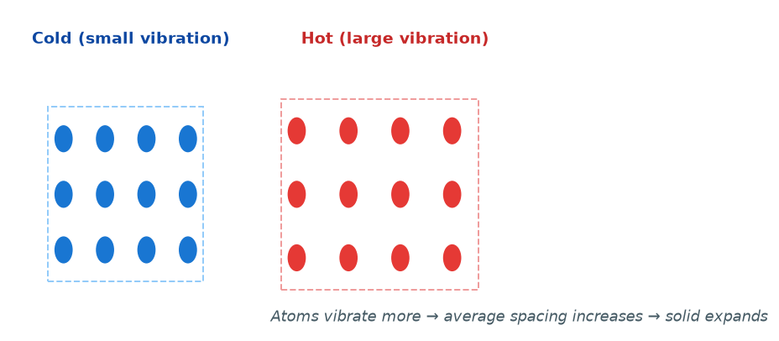
Figure 1.1 — At higher temperature, atoms vibrate with larger amplitude. Their average separation increases, so the solid expands.

WHY STUDENTS FIND THIS DIFFICULT
- Students say "temperature is heat". Temperature and heat are different: temperature is average particle energy; heat is total energy transferred.
- Students think cold objects have "no energy." Every object above 0 K has moving particles.
- Students forget to convert °C to K in gas calculations. Temperature in the gas laws must always be in kelvin.

KEY POINTS — 1.1
- Temperature measures average kinetic energy of particles.
- SI unit: kelvin (K).
- T(K) = T(°C) + 273.
- Heat flows from hot to cold until thermal equilibrium.
- Absolute zero = 0 K = −273 °C.

1.2 Thermal Expansion in Solids, Liquids and Gases
THE BIG IDEA
When a substance is heated, its particles vibrate more, so the average distance between them increases. The substance expands. Solids expand only a little. Liquids expand more. Gases expand the most.

Why expansion happens — at the atomic level
In a solid, each atom sits in a potential "well" created by its neighbours. At low temperature, the atom vibrates near the bottom of the well. As temperature rises, it vibrates with more energy, and because the well is asymmetric (it curves more sharply on the compressed side than the expanded side), the atom's average position drifts slightly outward. Neighbouring atoms do the same. The whole solid grows by a tiny fraction.
This is why expansion is very small in solids — the shift is only a fraction of an atomic spacing. But over a long bridge, or a long rail, even a tiny fraction adds up to a real gap.
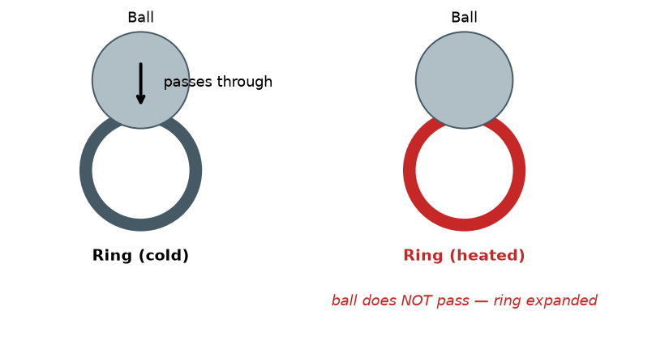
Figure 1.2 — The ball-and-ring experiment. Cold, the metal ball just passes through the ring. When the ring is heated, it expands, and the ball no longer fits. The metal itself has grown.

The three types of expansion
Linear expansion (1D)
The change in length of a rod:
ΔL = L₀ α ΔT
where ΔL = change in length (m), L₀ = original length (m), α = coefficient of linear expansion (K⁻¹), ΔT = temperature change (K or °C).
New length:
L = L₀ (1 + α ΔT)
Area expansion (2D)
ΔA = A₀ β ΔT , β = 2α
Volume expansion (3D)
ΔV = V₀ γ ΔT , γ = 3α
Note on applicability: α is approximately constant only for small temperature changes. For large changes, α varies slightly with temperature. MSCE questions assume α is constant.
Material | α (×10⁻⁶ K⁻¹) | Behaviour
Invar (iron–nickel alloy) | 1.2 | Very low expansion — used in watches, thermostats
Pyrex glass | 3.2 | Low expansion — used in cooking dishes
Iron | 12 | Common metal
Concrete | 12 | Matches iron — good for reinforced concrete
Copper | 17 | Wires, pipes
Brass | 19 | Higher than iron — used in bimetallic strips
Aluminium | 23 | High expansion — window frames need gaps

Liquids
Liquids have no fixed shape, so only volume expansion applies. Typically γ(liquid) is around 10× larger than γ(solid). That is why a liquid thermometer works — the liquid rises visibly up the tube when heated.
Gases
Gases expand far more than solids or liquids. The gas laws describe this:
V / T = constant (at constant pressure — Charles's law)
Gases expand by a factor of about 1/273 of their volume at 0 °C for every 1 °C rise — much larger than any solid or liquid.
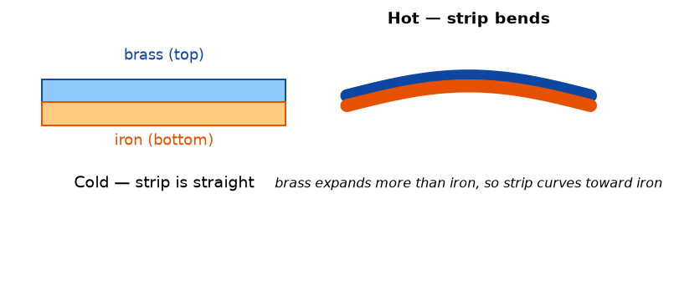
Figure 1.3 — A bimetallic strip. Brass expands more than iron, so when heated the strip curves toward the iron side. This is the basis of many thermostats and fire alarms.

WHY STUDENTS FIND THIS DIFFICULT
- Confusing α (linear, 1D) with β (area, 2D) and γ (volume, 3D). The relationships are β = 2α, γ = 3α — not β = α or γ = α.
- Thinking all solids expand by the same amount. They do not — the material's α matters, and α differs from metal to metal.
- Using Celsius when K is required. In ΔT, °C and K give the same numerical value, because a change of 1 °C equals a change of 1 K. But if temperature is used as T (not ΔT), convert to K.
- Forgetting the sign. Expansion: ΔT > 0 → ΔL > 0. Contraction: ΔT < 0 → ΔL < 0.
- Mixing up which quantity is "original" (L₀, A₀, V₀) and which is "change" (ΔL, ΔA, ΔV).

KEY POINTS — 1.2
- Expansion happens because heated particles vibrate more and their average separation increases.
- Solids expand least. Liquids expand more. Gases expand most.
- Linear: ΔL = L₀ α ΔT.
- Area: ΔA = A₀ β ΔT with β = 2α.
- Volume: ΔV = V₀ γ ΔT with γ = 3α.
- α is material-specific (not universal).
- The rules apply for small ΔT.

1.3 Anomalous Expansion of Water
THE BIG IDEA
Water does not behave like other liquids. Between 0 °C and 4 °C, water contracts when heated, and expands when cooled. Its volume is minimum (and density maximum) at exactly 4 °C. This unusual behaviour has huge consequences for life in lakes and rivers.

The real concept
Most liquids expand steadily as they get warmer. Water is different. From 0 °C to 4 °C, water contracts as it warms. Above 4 °C, it behaves normally and expands. Because of this, water has its maximum density at 4 °C.
Why does this happen? Water molecules are held together by hydrogen bonds. In ice, the hydrogen bonds form an open, hexagonal lattice — which is why ice is less dense than water and floats. As ice melts, some of that open structure collapses, so liquid water at 0 °C is denser than ice. As the temperature rises from 0 °C to 4 °C, the structure keeps collapsing — the water contracts. Above 4 °C, normal thermal expansion takes over, and the water begins to expand again.
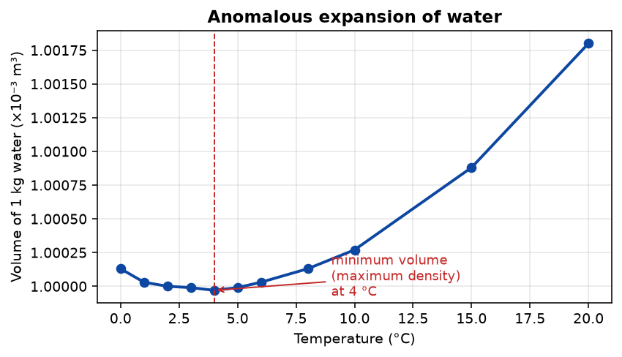
Figure 1.4 — The volume of 1 kg of water versus temperature. The minimum (maximum density) is at 4 °C. Between 0 °C and 4 °C, warming causes contraction.

Consequences for nature
- Ice floats. Ice at 0 °C is less dense than water at 0 °C.
- Lakes freeze from the top. As water cools in a Malawian cold season (or in temperate countries in winter), the surface reaches 4 °C and sinks, because it is denser. Colder water (below 4 °C) is less dense and floats on top. Eventually the top freezes, but the deeper layers stay at about 4 °C — liquid, life-sustaining.
- Fish survive. Because the bottom stays liquid at ~4 °C, aquatic life survives under the ice.
- Water pipes burst in cold weather. If water in a pipe cools to 0 °C and freezes, it expands — unlike most substances, freezing water grows in volume. That expansion bursts pipes.
WHY STUDENTS FIND THIS DIFFICULT
- Saying "water expands when heated." This is wrong between 0 °C and 4 °C.
- Confusing density and volume. Water's density is maximum at 4 °C. Its volume is minimum at 4 °C. These describe the same fact.
- Thinking ice floats because it is "lighter" (vague). Ice floats because it is less dense than water — a specific comparison of mass per volume.
- Claiming this anomaly is universal for all liquids. It is specific to water (and a few other substances, but mainly water).

KEY POINTS — 1.3
- Water is densest at 4 °C.
- From 0 °C to 4 °C, water contracts as it warms (anomalous).
- Above 4 °C, water expands normally.
- Ice is less dense than water, so it floats.
- Lakes freeze from the top; the water below stays liquid at ~4 °C.
- Water expands on freezing — this bursts pipes.

1.4 Applications of Thermal Expansion
THE BIG IDEA
Engineers and scientists use thermal expansion deliberately in some places (thermostats, thermometers) and allow for it in others (bridges, rails, pipes). Ignoring expansion causes real, expensive failures.

Where expansion is used
- Bimetallic strips — two metals with different α bonded together. Heating bends the strip; this opens or closes a switch. Used in thermostats, electric irons, fire alarms, ovens.
- Liquid-in-glass thermometers — the liquid expands visibly when heated; the rise is calibrated to give temperature.
- Fitting metal tyres on cart wheels (traditional Malawi) — the iron rim is heated, expands, slips over the wooden wheel, and grips tightly when it cools.
- Rivets — heated rivets are hammered into plates; on cooling they contract and clamp the plates tightly.
- Thermal expansion of gases — used in hot-air balloons and in the carburettor of small engines.
Where expansion must be allowed for
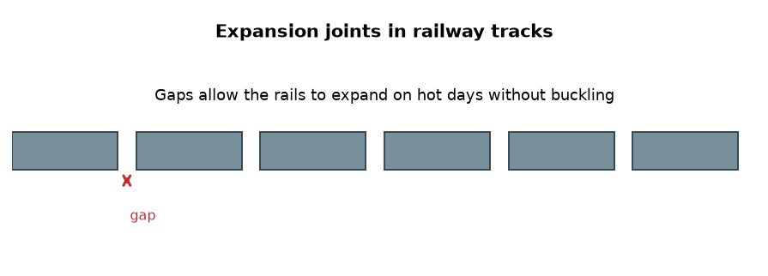
Figure 1.5 — Expansion joints in railway tracks. On a hot day, the steel rails expand. Without a gap, the rails would buckle and derail trains.

- Railway lines — small gaps between sections allow expansion.
- Bridges — one end rests on rollers so the deck can expand freely.
- Concrete roads — expansion joints are cut at intervals.
- Metal pipes — U-shaped bends allow for expansion along the pipe.
- Glassware — Pyrex is used for cooking and lab glass because its low α means it will not crack with sudden temperature change.
- Electric power lines — hung with a slight sag in summer so they do not snap when they contract in cold weather.
WHY STUDENTS FIND THIS DIFFICULT
- Thinking engineers want expansion. They do not — they allow for it. The design aim is usually to prevent the effects of expansion, not to encourage them.
- Confusing a thermostat with a thermometer. A thermometer measures temperature; a thermostat uses expansion to control temperature by switching a circuit on or off.
- Saying "Pyrex is stronger." Pyrex is not necessarily stronger — it has a low coefficient of expansion, so it resists thermal shock.

KEY POINTS — 1.4
- Bimetallic strips use unequal expansion of two metals — basis of thermostats.
- Liquid thermometers use expansion of a liquid.
- Rails, bridges, roads, and pipes are designed with gaps or bends to allow expansion.
- Pyrex has low α → resists cracking under sudden temperature change.
- Power lines sag in summer to allow for winter contraction.

Worked Examples
Example 1 — Linear expansion (Easy)
Question. A steel railway rail is 20.0 m long at 15 °C. On a hot day, it reaches 45 °C. The coefficient of linear expansion of steel is 12 × 10⁻⁶ K⁻¹. Find the change in length.
Given: L₀ = 20.0 m, ΔT = 45 − 15 = 30 °C (which equals 30 K), α = 12 × 10⁻⁶ K⁻¹.
Find: ΔL.
Principle. Linear expansion: ΔL = L₀ α ΔT.
Solution.
ΔL = (20.0)(12 × 10⁻⁶)(30)
ΔL = 7.2 × 10⁻³ m = 7.2 mm
Why this works: Because α is small, the change in length is a small fraction of the original length. Multiplying L₀ by α gives the fractional expansion per degree, and ΔT scales it.
Common mistake: Forgetting to convert °C to K. Here it does not matter, because ΔT in °C = ΔT in K. But if a question gives absolute temperatures, convert to K.
Example 2 — Volume expansion of a liquid (Medium)
Question. A glass beaker holds 500 cm³ of mercury at 20 °C. The mercury is heated to 120 °C. The coefficient of volume expansion of mercury is 1.8 × 10⁻⁴ K⁻¹. Find the increase in volume of the mercury.
Given: V₀ = 500 cm³ = 5.00 × 10⁻⁴ m³, ΔT = 100 K, γ = 1.8 × 10⁻⁴ K⁻¹.
Find: ΔV.
Principle. Volume expansion: ΔV = V₀ γ ΔT.
Solution.
ΔV = (5.00 × 10⁻⁴)(1.8 × 10⁻⁴)(100)
ΔV = 9.0 × 10⁻⁶ m³ = 9.0 cm³
Why this works: γ is much larger for liquids than for solids. Mercury's high γ is what makes it useful in thermometers.
Common mistake: Using α instead of γ. For liquids, only volume expansion applies (liquids have no fixed length or area).
Example 3 — Anomalous expansion reasoning (MSCE)
Question. A bottle of water is tightly sealed and placed in a freezer. The bottle bursts. Explain why, using the concept of thermal expansion.
Given: Water is sealed, then cooled to freezing.
Find: Explanation of why the bottle bursts.
Principle. Water is anomalous: unlike most substances, water expands on freezing.
Solution. Water at room temperature has a density of about 1000 kg/m³. When it freezes, its molecules form an open, hexagonal lattice held by hydrogen bonds. This structure occupies more volume than liquid water — the density drops to about 917 kg/m³. Because the bottle is sealed, this extra volume cannot escape, and the pressure inside rises until the bottle bursts.
ρ_ice < ρ_water ⇒ V_ice > V_water (for the same mass)
Why this works: Freezing water grows by about 9 % in volume. A sealed, rigid container cannot accommodate this, so it breaks.
Common mistake: Writing "water expands when heated" — this is true above 4 °C, but freezing is a different phenomenon: water expands on cooling from 4 °C to 0 °C, and again on freezing.
Example 4 — Bimetallic strip reasoning (MSCE)
Question. A bimetallic strip is made of brass (α = 19 × 10⁻⁶ K⁻¹) and iron (α = 12 × 10⁻⁶ K⁻¹). Brass is on top, iron on the bottom. The strip is heated. Which way does it bend, and why?
Given: α_brass > α_iron. Brass on top.
Find: Direction of bending.
Principle. For the same ΔT, the metal with larger α expands more.
Solution. Brass expands more than iron. Because they are bonded, the longer side (brass) must curve around the shorter side (iron). The strip bends toward the iron — that is, it curves downward if iron is underneath.
α_brass > α_iron ⇒ strip bends toward iron side
Why this works: The two metals were the same length when cold. On heating, brass becomes longer than iron. Bonded together, brass is on the outside of the bend, iron on the inside.
Common mistake: Saying "it bends toward brass." Think: the larger-expansion metal ends up on the outside curve. So the strip bends away from brass.

Check Yourself
1. Define temperature in terms of the motion of particles.
2. Convert 27 °C to kelvin.
3. Write down the equation for linear expansion and define each symbol with its unit.
4. State the relationship between α, β, and γ.
5. A metal rod is 2.00 m long at 20 °C. It is heated to 220 °C. If α = 12 × 10⁻⁶ K⁻¹, find its increase in length.
6. Why does water have its maximum density at 4 °C?
7. Explain why lakes in cold climates freeze from the top.
8. Give two everyday applications of thermal expansion.
9. Why do railway lines have small gaps between sections?
10. Pyrex is used for cooking dishes. Explain why.

Exam-Style Questions (MSCE-style practice)
Q1. (a) State what is meant by the coefficient of linear expansion of a material.
(b) A metal bar of length 1.50 m at 25 °C is heated to 225 °C. Its length increases by 3.6 mm. Calculate α.
Q2. A copper pipe has length 12.0 m at 20 °C. Copper has α = 17 × 10⁻⁶ K⁻¹.
(a) Calculate the length of the pipe at 120 °C.
(b) Explain why engineers install U-bends in long pipelines.
Q3. Explain, using molecular reasoning, why solids expand when heated.
Q4. (a) Sketch a graph of volume against temperature for 1 kg of water between 0 °C and 20 °C, marking the temperature of maximum density.
(b) Explain the shape of the graph between 0 °C and 4 °C.
Q5. A bimetallic strip is used in an electric iron. The metals are brass (α = 19 × 10⁻⁶ K⁻¹) and iron (α = 12 × 10⁻⁶ K⁻¹).
(a) Which metal expands more when heated?
(b) Explain how the strip can switch the iron off when it becomes too hot.
Q6. A glass bottle is filled to the brim with water at 20 °C and placed in a freezer. The bottle cracks.
(a) Explain why the water expands when it freezes.
(b) State one other everyday consequence of this behaviour.
Q7. The coefficient of volume expansion of a liquid is 5.0 × 10⁻⁴ K⁻¹. A container holds 2.0 × 10⁻³ m³ of the liquid at 15 °C. Calculate the increase in volume when it is heated to 65 °C.
Q8. (a) State two properties a material should have to be suitable for use in a thermometer.
(b) Explain why mercury is used in many thermometers, but water is not.
Q9. A brass rod has length L₀ at 0 °C. Show that when it is heated by ΔT, its new length is given by L = L₀(1 + αΔT).
Q10. Give two ways in which thermal expansion can cause damage to structures, and two ways engineers prevent this damage.

Full Worked Solutions
Check Yourself — Answers
1. Temperature is the measure of the average kinetic energy of particles in a substance.
2. T = 27 + 273 = 300 K.
3. ΔL = L₀ α ΔT; ΔL = change in length (m); L₀ = original length (m); α = coefficient of linear expansion (K⁻¹); ΔT = temperature change (K).
4. β = 2α and γ = 3α.
5. ΔL = (2.00)(12 × 10⁻⁶)(200) = 4.80 × 10⁻³ m = 4.8 mm.
6. Because of hydrogen bonding, water's molecular arrangement changes between 0 °C and 4 °C, allowing contraction. Above 4 °C, normal thermal expansion dominates.
7. Water is densest at 4 °C. As the surface cools below 4 °C, the colder (less dense) water floats on top and freezes, while the deeper water remains at ~4 °C and stays liquid.
8. Any two: bimetallic thermostat; liquid-in-glass thermometer; heat-shrink metal tyre rims; rivet clamping.
9. So the steel can expand on hot days without buckling.
10. Pyrex has a very low coefficient of expansion, so it resists cracking under sudden temperature change (thermal shock).

Exam-Style — Full Solutions
Q1. (a) The fractional increase in length per unit rise in temperature.
(b) ΔL = 3.6 mm = 3.6 × 10⁻³ m; ΔT = 200 K.
α = ΔL / (L₀ ΔT) = (3.6 × 10⁻³) / (1.50 × 200) = 1.2 × 10⁻⁵ K⁻¹.
Q2. (a) ΔL = (12.0)(17 × 10⁻⁶)(100) = 2.04 × 10⁻² m. L = 12.0 + 0.0204 = 12.02 m.
(b) U-bends absorb the expansion without putting stress on pipe joints or on the pipe itself.
Q3. When heated, particles vibrate with larger amplitude. Because the interatomic potential well is asymmetric, the average separation of neighbouring atoms increases — the solid expands.
Q4. (a) Graph: volume decreases from 0 °C to 4 °C, reaching minimum at 4 °C; then increases from 4 °C to 20 °C. Mark 4 °C as the minimum.
(b) Between 0 °C and 4 °C, hydrogen bonds are still rearranging and the open structure of ice continues to collapse, so the water contracts. Above 4 °C, the structure is fully collapsed and normal thermal expansion begins to dominate.
Q5. (a) Brass.
(b) When the iron is hot, the bimetallic strip bends away from its contact. This opens the circuit and cuts off current to the heating element. As it cools, the strip straightens and re-makes the contact, switching the iron back on.
Q6. (a) On freezing, water molecules form an open hexagonal lattice held by hydrogen bonds. This structure occupies more volume than liquid water — density falls from ~1000 kg/m³ to ~917 kg/m³.
(b) Burst water pipes in cold weather; rocks fractured by freezing water in cracks (frost shattering).
Q7. ΔV = (2.0 × 10⁻³)(5.0 × 10⁻⁴)(50) = 5.0 × 10⁻⁵ m³.
Q8. (a) Any two: uniform expansion over the temperature range; visible change; non-toxic; does not stick to glass; wide liquid range.
(b) Mercury expands uniformly, does not wet glass, and is opaque and easy to read. Water has an anomalous expansion between 0 °C and 4 °C, so its readings are not linear there.
Q9. ΔL = L₀ α ΔT. So new length L = L₀ + ΔL = L₀ + L₀ α ΔT = L₀(1 + α ΔT). ∎
Q10. Damage: (i) railway lines buckle in heat; (ii) concrete roads crack. Prevention: (i) leave expansion gaps between rail sections; (ii) cut expansion joints into concrete roads.

Common Mistakes
- Confusing temperature (average kinetic energy per particle) with heat (total energy transferred).
- Using α when the question is about volume, or γ when the question is about length.
- Forgetting that β = 2α and γ = 3α.
- Forgetting that ΔT in °C is numerically equal to ΔT in K — so no conversion is needed for ΔT. But if the question gives absolute T, convert to K.
- Writing "water expands when heated" without the qualification "above 4 °C."
- Saying ice is "lighter." Say less dense — that is the physically correct statement.
- Saying a bimetallic strip "bends toward the brass." It bends toward the metal with smaller α (the iron).
- Mixing up thermometer (measures T) and thermostat (controls T).

EXAM TIP
MSCE repeatedly asks for: (1) ΔL calculation with α given; (2) explanation of anomalous expansion of water; (3) explanation of a bimetallic strip.
For "explain why" questions, write a cause-and-effect sentence. Example: "Because heated particles vibrate with greater amplitude, their average separation increases, so the metal expands."
Always state units in your final answer. Marks are lost for missing units even when the number is correct.
Read carefully: if a question says "volume" or "cube", use γ = 3α. If it says "length" or "rod", use α.

REMEMBER • Heated particles vibrate more → average separation increases → the substance expands. Water is anomalous: densest at 4 °C.

Chapter 1 Test
SECTION A — Multiple Choice (5 marks)
1. Which of these expands by the largest fraction when heated by the same amount?
A. Solid iron B. Liquid mercury C. Gas (constant pressure) D. Water at 2 °C

2. The coefficient of area expansion β is related to α by:
A. β = α B. β = 2α C. β = 3α D. β = α/2

3. Water has maximum density at:
A. 0 °C B. 4 °C C. 100 °C D. −4 °C

4. A bimetallic strip with brass on top and iron underneath is heated. It bends:
A. Upward (toward brass) B. Downward (toward iron) C. It stays straight D. It curls into a circle

5. A railway line has gaps between sections to allow for:
A. Contraction in winter only B. Expansion in summer only C. Both expansion and contraction D. Cleaning

SECTION B — Short Answers (10 marks)
6. Define temperature. (2)
7. State the relationship between γ and α. (1)
8. Explain why water is anomalous between 0 °C and 4 °C. (2)
9. Give one reason why mercury is used in thermometers. (1)
10. A metal rod of length 1.00 m expands by 1.2 mm when heated by 100 °C. Calculate α. (2)
11. State two everyday applications of thermal expansion. (2)

SECTION C — Structured Questions (15 marks)
12. (a) A steel bridge is 200 m long at 15 °C. The coefficient of linear expansion of steel is 12 × 10⁻⁶ K⁻¹. Calculate the change in length when the temperature rises to 45 °C. (3)
(b) Explain why one end of the bridge rests on rollers. (2)

13. (a) Sketch a graph of volume against temperature for 1 kg of water from 0 °C to 20 °C. (3)
(b) State the temperature at which the volume is minimum. (1)
(c) Explain why lakes freeze from the top, using this property of water. (3)

14. (a) A bimetallic strip is made of brass (α = 19 × 10⁻⁶ K⁻¹) and iron (α = 12 × 10⁻⁶ K⁻¹). It is heated.
(i) State which metal expands more. (1)
(ii) Explain the direction of bending. (2)

END OF CHAPTER 1
Next chapter: Chapter 2 — Newton's Laws of Motion.

