Section Ⅰ Use of English

**Directions:**

Read the following text. Choose the best word(s) for each numbered blank and mark A, B, C or D on the ANSWER SHEET. (10 points)

Even if families don’t sit down to eat together as frequently as before, millions of Britons will nonetheless have got a share this weekend of one of that nation’s great traditions:the Sunday roast. 1 a cold winter’s day, few culinary pleasures can 2 it. Yet as we report now, the food police are determined that this 3 should be rendered yet another guilty pleasure 4 to damage our health.

The Food Standards Authority (FSA) has 5 a public warning about the risks of a compound called acrylamide that forms in some foods cooked 6 high temperatures. This means that people should 7 crisping their roast potatoes, reject thin- crust pizzas and only 8 toast their bread.But where is the evidence to support such alarmist advice? 9 studies have shown that acrylamide can cause neurological damage in mice, there is no 10 evidence that it causes cancer in humans.

Scientists say the compound is 11 to cause cancer but have no hard scientific proof 12 the precautionary principle, it could be argued that it is 13 to follow the FSA advice. 14 , it was rumoured that smoking caused cancer for years before the evidence was found to prove a 15 .

Doubtless a piece of boiled beef can always be 16 up on Sunday alongside some steamed vegetables, without the Yorkshire pudding and no wine. But would life be worth living? 17 , the FSA says it is not telling people to cut out roast foods 18 ,but to reduce their lifetime intake. However, their 19 risks coming a cross as being pushy and overprotective.Constant health scares just 20 with one listening.

1. [A] In [B] Towards [C] On [D]Till

2. [A] match [B] express [C] satisfy [D] influence

3. [A] patience [B] enjoyment [C] surprise [D] concern

4. [A] intensified [B] privileged [C] compelled [D] guaranteed

5. [A] issued [B] received [C] ignored [D] cancelled

6. [A] under [B] at [C] for [D] by

7. [A] forget [B] regret [C] finish [D] avoid

8. [A] partially [B] regularly [C] easily [D] initially

9. [A] Unless [B] Since [C] If [D] While

10.[A] secondary [B] external [C] conclusive [D] negative

11.[A] insufficient [B] bound [C] likely [D] slow

12.[A] On the basis of [B] At the cost of [C] In addition to [D] In contrast to

13.[A] interesting [B] advisable [C] urgent [D] fortunate

14.[A] As usual [B] In particular [C] By definition [D] After all

15.[A] resemblance [B] combination [C] connection [D] pattern

16.[A] made [B] served [C] saved [D] used

17.[A] To be fair [B] For instance [C] To be brief [D] In general

18.[A] reluctantly [B] entirely [C] gradually [D] carefully

19.[A] promise [B] experience [C]campaign [D] competition

20.[A] follow up [B] pick up [C]open up [D] end up

SectionⅡ Reading Comprehension

**Part A Directions:**

Read the following four texts. Answer the questions after each text by choosing A, B,

C or D. Mark your answers on the ANSWER SHEET. (40 points)

**Text 1**

**A gro~~u~~p of Labour MPs, among them Yvette Cooper, are bringing in the new year with a call to institute a UK "town of culture" award. The proposal is that it should sit alongside the existing city of culture title, which was held by Hull in 2017,** **and has been awarded to Coventry for 2021. Cooper and her colleagues argue that the success of the crown for Hull, where it brought in 位20m of investment and an avalanche of arts, ought not to be confined to cities. Britain’s towns, it is true, are not**

**prevented from ~~ap~~plying, but they generally lack the resources to put together a bid to beat their bigger competitors. A town of culture award could, it is argued, become an**

**annual event, attracting funding ~~a~~nd creating jobs.**

**Some might see the proposal as a booby prize for the fact that Britain 1s no**

**longer able to apply for the much more prestigious title of E~~u~~ropean capital of culture, a sought-after award bagged by Glasgow in 1990 and Liverpool in 2008. A cynic might specul~~a~~te that the UK is on the verge of disappearing into an endless fever of self-celebration in its despe~~ra~~tion to reinvent itself for the post-Brexit world: after town of culture, who knows what will follow-village of culture? Suburb of cultu~~r~~e?**

**H~~a~~mlet of culture?**

**It is also wise to recall that such titles are not a cure-all. A badly run "year of culture" washes in and washes out of a place like the tide, bringing prominence for a spell but leaving no lasting benefits to the comm~~u~~nity. The really successful holders of such titles are those that do a great deal more than fill hotel bedrooms** **and bring in high-profile arts events and good press for a year. They transform the aspirations of the people ~~w~~ho live there; they nudge the self-image of the city into a bolder** **and more optimistic light. It is h~~a~~rd to get right, and requires a remarkable degree of vision, as well as cooperation between city authorities, the priv~~a~~te sector, commu~~n~~ity groups and cultural org~~a~~nis~~a~~tions. But it can be done: Glasgow's ye~~a~~r as Europe~~a~~n c~~ap~~ital of culture can certainly be seen as one of a co~~m~~plex series of factors that have turned the city into the powerhouse of art, music and theatre that it remains today.**

**A "town of culture" could be not just about the arts but abo~~u~~t hono~~u~~ring a to~~w~~n’s peculiarities—helping sustain its high street, s~~u~~pporting local facilities and above all celebrating its people. Jeremy Wright, the culture secretary, should welcome this positive, hope-filled proposal, and turn it into action.**

**21. Cooper and her colleagues argue th~~a~~t a "town of culture" ~~awa~~rd could**

**[A] consolidate the town-city ties in Britain.**

**[BJ promote cooperation-among Britain’s towns.**

**[CJ increase the economic strength of Britain’s towns.**

**[DJ focus Britain’s limited resources on cultural events.**

**22. According to P~~a~~rag~~ra~~ph 2, the proposal might be reg~~a~~rded by some as**

**[A] a sensible co~~m~~promise.**

**[BJ a self-deceiving attempt.**

**[CJ an eye-catching bonus.**

**[DJ an inaccessible target.**

**23. The author suggests that a title holder is successful only if it**

**[A] endeavours to maintain its image.**

**[B] meets the aspiration of its people.**

**[C] brings its local arts to prominence.**

**[DJ commits to its long-term growth.**

**24. Glasgow is mentioned in Paragraph 3 to present**

**[A] a contrasting case.**

**[B] a su~~p~~porting example.**

**[C] a background story.**

**[D] a related topic.**

**25. What is the author’s attitude tow~~a~~rds the proposal?**

**[A] Skeptical.**

**[B] Objective.**

**[C] Favourable.**

**[D] Critical.**

**Text2**

**Scientific publishing has long been a licence to print money. Scientists need journals in which to publish their research, so they will supply the articles witho~~u~~t monetary reward. Other scientists perform the specialised work of peer review also for free, because it is a central element in the acquisition of status and the production of scientific knowledge.**

**With the content of papers secured for free, the p~~u~~blisher needs only find a market for its journal. Until this century, ~~u~~niversity libraries were not very price sensitive. Scientific publishers routinely report profit margins approaching 40% on their operations at a time when the rest ofthe p~~u~~blishing industry is in an existential crisis.**

**The Dutch gi~~an~~t Elsevier, which claims to publish 25% of the scientific papers produced in the world, made profits of more than 砂OOm last year, while UK universities alone spent more than £210m in 2016 to enable researchers to access their own publicly funded research; both figures seem to rise unstoppably despite increasingly desperate efforts to change them.**

**The most drastic, an thoroughly illegal, reaction has been the emergence of Sci-Hub, a kind of global photocopier for scientific papers, set ~~u~~p in 2012, which now claims to offer access to every paywalled article published since 2015. The success of Sci-Hub, which relies on researchers passing on copies they have themselves legally accessed, shows the legal ecosystem has lost legitimacy among its users and m~~u~~st be transformed so that it works for all participants.**

**In Britain the move tow~~ar~~ds open access publishing has been driven by funding bodies. In some wa~~y~~s it has been very successful. More than half of all British scientific research is now published under open access terms: either freely available from the moment of publication, or paywalled for a year or more so that the p~~u~~blishers can make a profit before being placed on general release.**

**Yet the new system has not yet worked out any cheaper for the ~~u~~niversities. Publishers have responded to the demand that they make their product free to readers**

**by charging their w**门**ters fees to cover the costs of prep ring an article. These range**

**from around 眨00 to $5,000, and apparently the work gets more expensive the more that publishers do it. A report last year pointed out that the costs both of subscriptions**

**and of these "article preparation costs" had been steadily rising at a rate above inflation.**

**In some ways the scie~~n~~tific publishing model resembles the economy of the**

**social i~~n~~ternet: labour is provided free in exchange for the hope of status, while huge profits are made by a few big** 伍**ms who run the market places. In both cases, we need a rebalancing of power.**

26. Scientific publishing is seen as "a licence to print money" p~~a~~rtly because

[A] its funding has e~~n~~joyed a steady increase.

[B] its marketing strategy has been successful.

[C] its payment for peer review is reduced.

[D] its content acq~~u~~isition costs nothing.

27. According to Paragraphs 2 and 3, scientific p~~u~~blishers Elsevier have

[A] thrived mainly on ~~u~~niversity libraries.

[B] gone through an existential crisis.

[C] revived the publishing industry.

[D] financed researchers generously.

28. How does the author feel about the success of Sci-H~~u~~b?

[A] Relieved.

[B] Puzzled.

[C] Concerned.

[D] Encouraged.

29. It can be learned from Paragraphs 5 and 6 that open access terms

[A] allow publishers some room to make money.

[B] render publishing much easier for scientists.

[C] reduce the cost of publication substantially.

[D] free universities from financial burdens.

30. Which of the following characterizes the scientific p~~u~~blishing model?

[A] Trial subscription is offered.

[B] Labour triumphs over status.

[C] Costs are well controlled.

[D] The few feed on the many.

**Text3**

**Progressives often su~~p~~port diversity mandates as a path to e~~q~~uality and a w~~a~~y to level the playing field. But all too often such policies are an insincere form of virtue-signaling that benefits only the most privileged and does little to help average people.**

**A pair of bills sponsored by Massachusetts state Senator Jason Lewis and House Speaker Pro Te~~mp~~ore Patricia Haddad, to ensure "gender parity" on bo~~ar~~ds and commissions, provide a case in point.**

**Haddad and Lewis are concerned that more than half the state-government boards are less than 40 percent female. In order to ensure that elite women have more such opportunities, they have proposed i~~mp~~osing government quotas. If the bills become law, state boards and commissions will be req~~u~~ired to set aside 50 percent of board seats for women by 2022.**

**The bills are similar to a measure recently adopted in Califomia, which last year became the first state to require gender quotas for private companies. In signing the**

**measure, California Governor Jerry Brown admitted that the la~~w~~, which e~~x~~pressly classifies people on the basis of sex, is probably unconstitutional.**

**The US Su~~p~~reme Court frowns on sex-based classifications unless they ~~ar~~e**

**designed to address an "important" policy interest, Beca~~u~~se the California la~~w~~ applies to all boards, even where there is no history of prior discrimination, courts are likely to rule that the law violates the constitutional guarantee of"equal protection".**

**But are such government mandates even necessary? Female participation on corporate boards may not currently mirror the percentage of women in the general population, but so what?**

**The number of women on corporate boards has been steadily increasing without government interference. According to a study by Catalyst, between 2010 and 2015 the share of women on the boards of global corporations increased by 54 percent.**

**Requiring companies to make gender the primary ~~q~~ualification for bo~~ar~~d membership will inevitably lead to less experienced private sector boards. That is exactly what happened when Norway adopted a nationwide corporate gender quota.**

**Writing in The New Republic, Alice Lee notes that increasing the number of opportunities for board membership without increasing the pool of qualified women to serve on such boards has led to a "golden skirt" phenomenon, where the same elite women scoop ~~u~~p multiple seats on a variety of boards.**

**Next time somebody pushes corporate quotas as a way to promote gender e~~q~~uity, remember that such policies are largely self-serving measures that make their sponsors feelgood b~~u~~t do little to help a~~v~~erage women.**

31.The ~~a~~uthor believes that the bills ~~s~~ponsored by Lewis and Haddad will

[A] help little to reduce gender bias.

[B] pose a threat to the state gove~~rnm~~ent.

[C] raise women's position in politics.

[D] greatly broaden career options.

32. Which of the following is true of the Califormia measure?

[A] It has irritated private business owners.

[B] It is welcomed by the S~~u~~preme Court.

[C] It m~~a~~y go against the Constitution.

[D] It will settle the prior controversies.

33. The author mentions the study by Catalyst to illust~~ra~~te

[A] the harm from arbitrary board decision.

[B] the i四ortance of constitutional guarantees.

[C] the press~~u~~re on women in global corporations.

[D] the needlessness of government interventions.

34. Norway's adoption of a nation~~w~~ide corporate gender q~~u~~ota has led to

[A] the underestimation of elite women's role.

[B] the objection to female participation on boards.

[C] the entry of ~~u~~nqualified candidates into the board.

[D] the growing tension between labor and manageme~~n~~t.

35. Which of the following c~~an~~ be inferred from the text?

[A] Women's need in emplo~~y~~ment should be considered.

[B] Feasibility should be a prime concern in policymaking.

[C] Everyone should try h~~ar~~d to promote social justice.

[D] Major social issues should be the focus of legislation.

**Text4**

**Last Thursday, the French Senate passed a digital services tax, which would i~~mp~~ose an entirely new t~~a~~x on large multinationals th~~a~~t provide digital services to consumers or users in France. Digital services include everything from providing a platform for selling goods and services online to targeting advertising based on user data, and the tax applies to gross revenue from such services. Many French politicians and media outlets have referred to this as a " GAFA tax," meaning that it is designed to ~~ap~~ply primarily to companies such as Google, A~~p~~ple, Fac~~e~~book and Amazo~~n~~**—**in other words, multinational tech companies based in the United States.**

**The digital services tax now awaits the signature of Preside~~n~~t Emm~~an~~uel Macron, who has expressed support for the measure, and it could go into effect within the next**

**few weeks. But it has already sparked significant controversy, with the United States**

**trade representative opening an investigation into whether the tax discriminates against**

**American companies, which in tum could lead to trade sanctions against France.**

**The French tax is not just a unilateral move by one co~~u~~ntry in need of revenue.**

**Instead, the digital services tax is part of a much larger trend, with countries over the past few years proposing or putting in place an alphabet sou~~p~~ of new i~~n~~ternational t~~ax~~ provisions. They h~~a~~ve included Britain’s DPT. (diverted profits tax), Australia’s MAAL (multmational anti-avoidance law), and India’s SEP (significant economic presence) test, to name but a few. At the same time, the Europe~~an~~ Union, Spain, Britain and several other countries h~~a~~ve all seriously co~~ntemp~~lated digital services taxes.**

**These unilateral developments differ in their specifics, b~~u~~t they are all designed to tax multinationals on income and reven~~u~~e that countries believe they should have a right to tax, even if international tax rules do not grant them that right. In other words, they all share a view that the i~~n~~ternational tax system has failed to keep u~~p~~ with the current economy.**

**In response to these many unilateral measures, the Organization for Economic Cooperation and Development (OECD) is currently working with 131 co~~u~~ntries to reach a consensus by the end of 2020 on an international solution. Both France and the U~~n~~ited States ~~are in~~volved in the organization's work, but France's digital services tax and the American response raise questions about what the future holds for the international tax system.**

**F~~ran~~ce’s planned tax is a clear warning: Unless a broad consensus can be reached on reforming the i~~n~~ternational tax system, other nations ~~ar~~e likely to follow suit, and American companies will face a cascade of different taxes from dozens of nations that will prove burdensome and costly.**

36.The French Senate has passed a bill to

[A] regulate digital services platforms.

[B] protect French companies" interests.

[C] impose a levy on tech multinationals.

[D] curb the influence of advertising.

37. It can be learned from Paragraph 2 that the digital services tax

[A] may trigger countermeasures against France.

[B] is apt to arouse criticism at home and abroad.

[C] a1ms to ease mtemat10nal trade tensions.

[D] will prompt the tech giants to quit France.

38. The countries adopting the unilateral measures share the opinion that

[A] redistribution of tech giants'revenue must be ensured.

[B] the current international tax system needs upgrading.

[C] tech multinationals'monopoly should be prevented.

[D] all countries ought to enjoy equal taxing rights.

39. It can be learned from Paragraph 5 that the OECD's current work

[A] is being resisted by US companies.

[B] needs to be readjusted i~~mm~~ediately.

[C] is faced with uncertain prospects.

[D] needs to in involve more co~~u~~ntries.

40. Which of the following might be the best title for this text?

[A] France Is Confronted with Trade Sanctions

[B] France leads the ch~~ar~~ge on Digital Tax

[C] France Says " NO" to Tech Multinationals

[D] France Demands a Role in the Digital Econo~~m~~y

**Part B**

**Directions:**

**Read the following text and ~~an~~swer the ~~q~~uestions by choosing the most suit~~able~~**

**s~~u~~bheading from the list A-G for each of the numbered paragraphs (41-45). There** **are**

**two extra subheadings. Mark your answers on the ANSWER SHEET. (10 points)**

**[A] Eye fixations are brief**

**[B] Too much eye contact is instinctively felt to be rude**

**[C] Eye contact can be a friendly social signal**

**[D] Personality can affect how a person reacts to eye contact**

**[E] Biological factors behind eye contact ~~ar~~e being i~~n~~vestigated**

**[F] Most people are not comfortable holding eye contact with strangers**

**[G] Eye co~~n~~tact can also be aggressive.**

**In a social situation, eye contact with another person can show that you are paying attention in a friendly way. But it can also be antagonistic such as when a political candidate tu~~rn~~s toward their competitor during a debate and makes eye co~~n~~tact that signals hostility.Here's what hard science reveals about eye contact:**

巳

**We know that a typical infant will instinctively gaze i~~n~~to its mother's eyes, ~~an~~d she will look back. This mutual gaze is a major part of the attachment between mother and child. In adulthood, looking someone else in a pleasant way can be a complimentary sign of paying attention. It can catch someone's attention in a crowded room, "Eye contact and smile" c~~an~~ signal availability and confidence, a common-sense notion supported in studies by psychologist Monica Moore.**

尸

**Neuroscientist Bonnie Auyeu~~n~~g found that the hormone oxytocin increased the**

**amount of eye contact from men toward the interviewer during a brief interview ~~w~~hen**

**the direction of their gaze was recorded. This was also found in high-functioning men**

**with some autistic spectrum sy~~mp~~toms, who may tend to avoid eye co~~n~~tact. Specific**

**brain regions th~~a~~t re~~s~~pond during direct gaze ~~ar~~e being ex~~p~~lored by other researches, using advanced methods of brain scanning.**

巳

**With the use of eye-tracking technology, Julia Minson of the Harvard Kenned****y School of Government concluded that eye contact can signal very different kinds of messages, depending on the situation. While eye contact may be a sign of connection or trust in friendly situations, it's more likely to be associated with dominance or i~~n~~timidation in adversarial situ~~a~~tions. "Whether you're a politician or a parent, it might be helpful to keep in mind that trying to maintain eye contact may backfire if you're trying to con~~v~~ince someone who has a different set of beliefs than you,"said Minson.**

巳

**When we look at a face or a picture, our eyes pause on one spot at a time, often on the eyes or mouth. These pauses typically occur at about three per second, and the eyes then ju~~mp~~ to another spot, u~~n~~til several important points in the image are registered like a series of snapshots. How the whole image is then assembled and perceived is still a mystery although it is the subject of current research.**

巳

**In people who score high in a test of neuroticism, a personality dimension associated with self-consciousness and anxiety, eye contact triggered more activity associated with avoidance,according to the Finnish researcher Jari Hietanen and colleagues "Our findings indicate that people do not only feel different when they are the centre of attention but that their brain reactions also differ." A more direct finding is that people who scored highly for negative emotions like anxiety looked at others for shorter periods of time and reported more comfortable feelings when others did not look directly at them.**

**Part C Directions:**

**Read the following text carefully and then translate the underlined segments into Chinese. Your translation should be written neatly on the ANSWER SHEET. (10 points)**

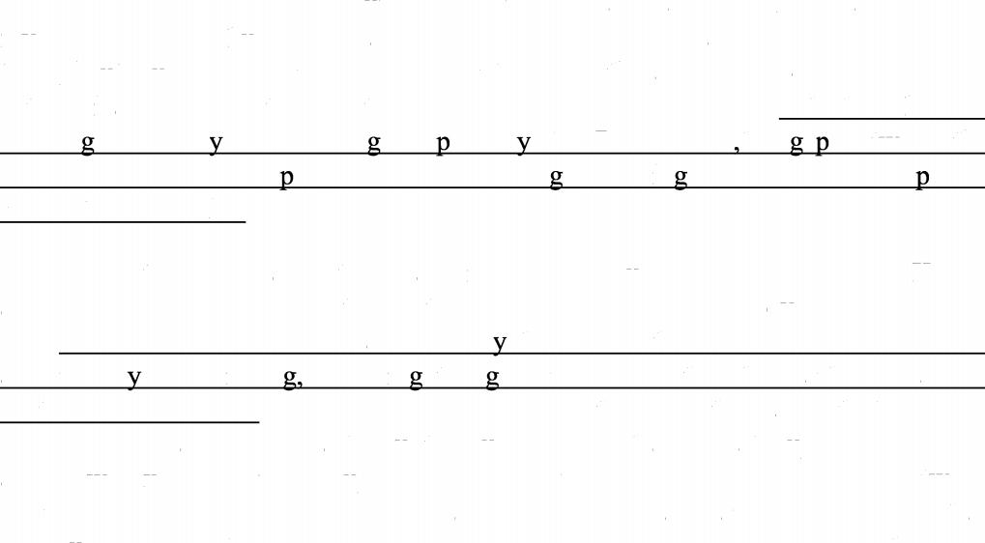**Following the explosion of creativity in Florence during the 14th century known as the Renaissance, the modern world saw a departure from what it had once known. It turned from God and the authority of the Roman Catholic Church and instead favoured a more humanistic approach to being. Renaissance ideas had spread throughout Europe well into the 17th century,with the arts and sciences flourishing extraordinarily among those with a more logical disposition. (46) with the Church’s teachin s and wa s of thinkin ecli sed b the Renaissance the a between the Medieval and modern eriods had been brid ed leadin to new and unex lored intellectual territories.**

**During the Renaissance, the great minds of Nicolaus Copernicus, Johannes Kepler and Galileo Galilei demonstrated the power of scientific study and discovery.**

**(47) Before each of their revelations man thinkers at the time had sustained more ancient wa s of thinkin includin the eocentric view that the Earth was at the centre of our universe. Copernicus theorized in 1543 that all of the planets that we knew of revolved not around the Earth, but the Sun, a system that was later upheld by Galileo at his own expense. Offering up such a theory during a time of high tension between scientific and religious minds was branded as heresy and any such heretics that continued to spread these lies were to be punished by imprisonment or even death.**

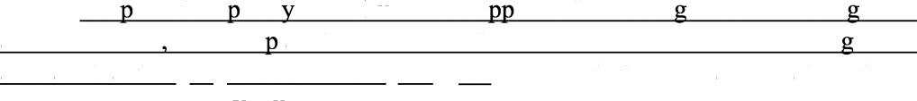**(48) Des ite attem ts b the Church to su ress. this new eneration of lo icians and rationalists more ex lanations for how the universe functioned were bein made at a rate that the 卫eo卫le could no longer ignore.It was with these great revelations that a new kind of philosophy founded in reason was born.**

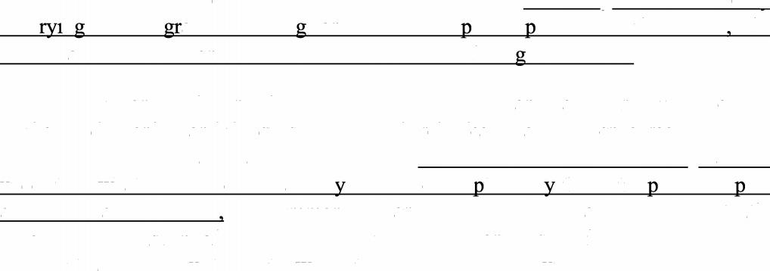**The Church’s long-standing dogma was losing the great battle for truth to rationalists and scientists. This very fact embodied the new ways of thinking that swept through Europe during most of 17th century. (49) As many took on the duty of t ·n to inte ate reasonin and scientific hiloso hies into the world the Renaissance was over and it was time for a new era - the A e of Reason.**

**The 17th and 18th centuries were times of radical change and curiosity, Scientific method, reductionism and the questioning of Church ideals was to be encouraged, as were ideas of liberty, tolerance and progress. (50) Such actions to seek knowledge and to understand what information we alread knew were ca tured b the Latin hrase6sa ere aude’or 6dare to know’after Immanuel Kant used it in his essay An Answer to the Question: What is Enlightenment?. It was the purpose and responsibility of great minds to go forth and seek out the truth, which they believed to be founded in knowledge.**

**Section III Writing**

**Part A**

**51. Directions:**

**The Students Union of your university has assigned you to inform the international students about an upcoming singing contest. White a notice in about 100 words.**

**Write your answer on the ANSWER SHEET.**

**Do not use your own name in the notice. (10 points)**

**Part B**

**52. Directions:**

**Write an essay of 160-200 words based on the picture below. In your essay, you should**

**1) describe the picture briefly,**

**2) interpret the implied meaning, and**

**3) give your comments.**

**You should write neatly on the ANSWER SHEET. (20 points)**

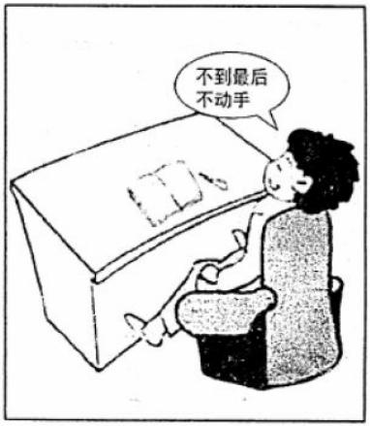

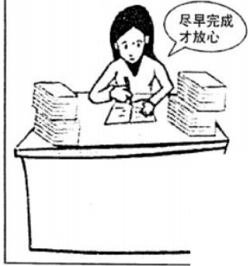

I I

.

习惯