MINORITY FUNDING

“The Commerce Center for Minority Businesses”

By Marc Kramer

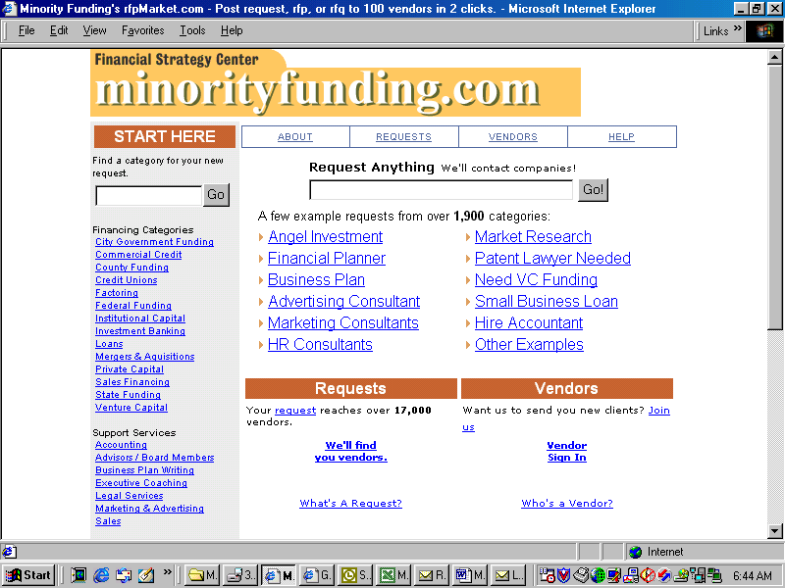

519 Baintree Run

Downingtown, Pa. 19335

610-873-6978

TABLE OF CONTENTS

Executive Summary 3
Objectives 7

Market 8

Revenue Streams 10

Content Description 11

Marketing Site 14

Sales 15

Retention 16

Competition 18

Management 28

Technology 34

Launch Plan 35

Financials 36

EXECUTIVE SUMMARY

Problem:

The five minority business groups, as classified by the Census Bureau and Small Business Administration, are African American, Asian American, Indian, Hispanic, and Native American Indian. Currently, there is no online financial/business exchange for minority business executives to:

- Raise capital to start and run a business
- Buy and sell exclusively to minority businesses
- Find minority service providers
- Buy and sell services/products to each other

According to the Federal Reserve, every bank has Community Reinvestment Act (CRA) requirements to meet. Banks by law are required to loan a percentage of dollars equal to the percentage of dollars in their banking region.

Minority-owned companies that focus on getting contracts from Fortune 1000 companies and government entities must sell their businesses to another minority owner who will maintain a 30% or greater interest in the company to qualify as minority-owned business.

According to Bill Larson, director of minority purchasing for Ford Motor Company ($8 billion a year with minority vendors) and a member of the Detroit Chapter of the National Minority Supplier Development Council, there is no destination website for minority companies to find funding. The NMSDC network includes a national office in New York and 39 regional councils across the country and certifies 15,000 minority businesses for its 3,500 corporate members whose minority purchases exceeded $41 billion in one year.

Facts:

- Minority-owned businesses represent only 11% of total businesses, 6% of gross receipts -- and 3 to 4% of total corporate purchases.
- 20% is the growth rate of minority businesses, according to the Small Business Administration.
- $500 billion is the amount of revenue minority firms generate per year, according to the U.S. Census Bureau.
- There are over 1 million minority-owned businesses in the United States.
- 3,000 African-American businesses have $1 million or more in sales, according to the U.S. Census Bureau.
- 9,200 Hispanic-American businesses have $1 million or more in sales, according to the U.S. Census Bureau.
- 12,517 Asian-American businesses have $1 million or more in sales, according to the U.S. Census Bureau.
Company Description:

Minorityfunding.com is the first business exchange to assist minorities in:

- Finding capital (banking, factoring, government, private and institutional capital)
- Finding potential buyers of their businesses
- Finding minority service providers to provide services and products
- Training their employees to improve productivity, increasing their chances of success

Competition:

Currently no destination site provides minorities with access to private individuals and institutions that provide working capital or to an exchange to buy and sell businesses, products, and services. There are four major competitors in the area of assistance in finding financing and they are:

Categories | DataMerge | OffRoadCapital | Vcapital | Garage | Minorityfunding
Button for minority funding | N | N | Y | N | Y
Funding Categories
City government funding | N | N | N | N | Y
Commercial banking | N | N | N | N | Y
County funding | N | N | N | N | Y
Credit unions | N | N | N | N | Y
Factoring (funding) | Y | Y | Y | N | Y
Federal funding | N | N | N | N | Y
Institutional capital | N | Y | Y | Y | Y
Investment banking | N | N | N | N | Y
Leasing | N | N | N | N | Y
Private capital | N | Y | Y | Y | Y
Savings and loans | N | N | N | N | Y
State funding | N | N | N | N | Y
Venture capital | N | Y | Y | Y | Y
Businesses For Sale
Business-to-consumer | N | N | N | N | Y
Business-to-business | N | N | N | N | Y
Support Services
Accounting | N | N | Y | Y | Y
Board members | N | Y | N | N | Y
Business plan | N | Y | Y | Y | Y
Employment opportunities | N | N | Y | Y | Y
Executive coaching | N | N | N | Y | Y
Legal | N | N | Y | Y | Y
Marketing | N | N | Y | N | Y
Online training | N | N | N | N | Y
Sales | N | N | Y | N | Y

Competitive Advantages:

- First to market with a dedicated B2B site for minority entrepreneurs to raise capital and business and sell businesses
- Minorityfunding.com is narrowly focused
- Our management team has strong regional and national contacts
- Largest and most comprehensive database of minority-owned businesses

Marketing:

Our marketing will be targeting two groups:

Group A: Presidents, Vice Presidents of sales and marketing, CFOs, and minority purchasing managers, banks, venture capitalists, factoring companies, accounting, law, and investment banking firms.

Group B: Non-profit chamber and trade association leaders, government officials, economic development organizations, media, and university business schools.

Our primary use of marketing dollars will be for direct mail, broadcast permission e-mail, print advertising, trade shows, and public relations.

Management:

The management team has over 150 years of business operations and marketing experience

- Acting Chairman-Betsy Cohen, former chairman/CEO of Jefferson Bank, a $2 billion in asset regional bank in Philadelphia
- Board Member- Thad Fortin is President of Haas Corporation, one of the leading outsource chemical management service firms in the United States.
- President/COO- Marc Kramer is the former president of Mixed Media Works, which was acquired by US Interactives and ran seven startups and four turnarounds.
- Vice President of Marketing- Eugene Principato is a 25-year marketing veteran.
- CIO- Randy Feldman has 15 years of management information experience and is currently the CIO of ECRI, a 300-person medical device testing company with offices worldwide.
- Vice President of Finance- Martin Egan, vice president of Thebancorp.com.
- Vice President of Content- Gail Jones has over 20 years of editorial experience with companies such as The Vanguard Group and AstraZeneca.

We are in the process of recruiting minorities to the Board of Directors and will recruit minorities for key management positions. Any service such as advertising, executive recruiting, marketing, website development, hosting, etc., will be outsourced to minority-owned companies.

Sales Process:

To support our marketing effort, we will have one sales person per each minority in each of the top eight cities in the United States. Those sales people will be heavily involved with the ethnic group they are working with. We will launch in New York, Philadelphia, Miami, and Los Angeles in our first year.

Revenue:

 | Yr1 | Yr2 | Yr3 | Yr4 |  | Yr5
Revenue
Placement Fees | $ 312,500 | $ 1,800,000 | $ 5,184,000 | $ 14,929,920 |  | $ 32,248,627
Business Sales | $ - | $ 2,750,000 | $ 6,050,000 | $ 13,310,000 |  | $ 29,282,000
Business Sales Listing Fee | $ - | $ 600,000 | $ 990,000 | $ 1,633,500 |  | $ 2,695,275
Online Training | $ 280,000 | $ 1,108,800 | $ 4,024,944 | $ 14,610,547 |  | $ 53,036,285
Books | $ 280,000 | $ 616,000 | $ 1,355,200 | $ 2,981,440 |  | $ 6,559,168
Employment Opportunities | $ 252,000 | $ 609,840 | $ 1,475,813 | $ 3,571,467 |  | $ 8,642,950
Conferences | $ - | $ 1,320,000 | $ 3,267,000 | $ 8,085,825 |  | $ 20,012,417
Service Fees | $ 870,000 | $ 1,914,000 | $ 4,210,800 | $ 9,263,760 |  | $ 20,380,272
Sponsorship | $ 144,000 | $ 316,800 | $ 696,960 | $ 1,533,312 |  | $ 3,373,286
Total | $ 2,138,500 | $11,035,440 | $ 27,254,717 | $ 69,919,771 |  | $ 176,230,280
Total Expenses | $ 3,883,172 | $11,579,248 | $ 22,677,226 |  | $ 49,764,606 | $ 121,384,005
Pretax Profit/Loss | $ (1,744,672) | $ (543,808) | $ 4,577,491 |  | $ 20,155,164 | $ 54,846,275

Minorityfunding.com has nine sources of revenue. None of its revenue sources requires the company to build distribution centers and take possession of products.

Capital Needs:

Minorityfunding.com is looking for $5 million in start-up capital. We have corporate and private commitments totaling $750,000.

Exit Strategy:

We believe this company has a tremendous chance to be successful and reach an IPO because of its niche and current competition.

OBJECTIVES:

Objectives for two groups of years are as follows:

Years 1-2:

- Financial transactions—Over 700 in the first two years members (a minimum of four users per corporation)
- Public members--100 members (a minimum of four users per institution)
- Revenue—nearly $10 million by Year 2

Years 3-5:

- Financial transactions-Over 6,000 by Year 5
- Year 3--Profitable
- Revenue—Over $170 million by Year 5
- Profits—40% plus pretax profit margins

MARKET:

Small Business Usage:

The number of small businesses with a Web presence has nearly doubled since 1998, and the coming years will see an even more dramatic increase, according to a nationwide survey of companies with fewer than 100 employees by International Communications Research commissioned by Prodigy Biz Corp., a subsidiary of Prodigy Communications Corp.

The research found that approximately one-third of small businesses currently have a Web presence. Research by International Data Corp. (IDC) found that 19% of small businesses were online one year ago. The Prodigy study also found that 40% more small businesses (approximately 2.1 million) without websites expect to be on the Internet within an average of the next eight months.

Despite perceived geographical barriers, 90% of small businesses anticipate benefiting from the Internet. When asked how the Internet would be used, small business respondents said their primary uses would be promoting to prospects (69%), followed by e-commerce (57%), and providing better customer service (48%). Other top responses included competing with other businesses (46%) and communicating with employees (11%). Nearly 75% of small business owners claim cost is not a barrier to setting up a website.

Forty-four percent of small business owners claim they do not have enough staff for, and 41% report they do not have time to, maintain a website. Overall, the study showed the likelihood of having an Internet presence declines significantly with the overall size of the company. Only 25% of companies with fewer than 10 employees have an Internet presence. By contrast, half of those with 10 or more employees have taken advantage of this opportunity.

"Small businesses no longer have to spend hours toiling over their site design and updates," said Rick Miller, senior analyst of Internet strategies at Cahners In-Stat. "A website will be mandatory for any business in the 21st century, no matter what their size."

Primary Market:

The NMSDC Network, which includes 39 affiliated regional councils, matches more than 15,000 certified minority-owned businesses (Black, Hispanic, Asian, and Native American) with its more than 3,500 corporate members, including America's top publicly owned, privately owned, and foreign-owned companies, as well as universities, hospitals, and other major buying institutions.

Minorities represent 26% of the population of the United States, but minority businesses represent only 11% of total businesses, 6% of gross receipts -- and 3 to 4% of total corporate purchases.

Percentage of minorities online, according to Cyber Dialogue

- African Americans- 35%
- Asians- 7 %
- Hispanics- 25%
- Indians- 45%
- Native American Indians- 30%

Market Interviews:

We interviewed the following minority purchasing managers to see if there was a need for a minority vendor website:

- Karl Brockenborough, Vice President for Financial Affairs for Cheyney University
- Bill Larson, Purchasing Manager for Ford Motor Company and Member of the Detroit Chapter Board of the National Minority Supplier Development Council
- Ramon Moya, Director of Minority Purchasing for Bell Atlantic
- Bill Pebble, Purchasing Manager for ADC Telecommunications

Through interviews, we have learned the following:

- There is no online or offline source for minority-owned businesses to find all the sources that will provide financing to minority-owned businesses.
- There is no website where corporations can go to find detailed information on minority vendors, although plans to put the NMSDC database online are being discussed. That database, according to those we interviewed, only provides names and contact information for certified companies. It does not provide detailed information about their revenue, past clients, or references.
- There is no website that aggregates minority opportunities.
- There is no website that provides minority-owned businesses a way to find other minority-owned businesses with which to partner and with which to buy and sell products and services.

REVENUE STREAMS:

Minorityfunding.com will have 9 sources of revenue.

Placement Fees: We will develop an investment capital matching service that will match minority-owned companies looking for capital with private investors, venture capitalists, investment banks, and commercial banks. We will have an agreement among Minorityfunding and participating companies that want financing and investment banking firms that might handle certain transactions. We will charge half percent to half a percent for capital raised. Fifty percent will be taken in capital stock on a case-by-case basis and 50 % in cash. In most cases the banks will pay the fee directly to Minorityfunding.

Business Sales: We will partner with a business broker to offer this service. We will take split a 10% commission with a national business brokerage company.

Business Listing Fee: Companies will be able to list their businesses they want to sell. We will charge them $1,200 a year to list their companies.

Contract Opportunities: We will offer members the opportunity to enter proposals and respond to proposals. Each vendor will sign a contract with Minorityfunding.com to pay 10% of each consulting opportunity as a marketing fee.

Online Training: We will partner with an accredited university to offer business training and seminars. We will charge our partner a 10% commission on gross sales.

Conferences: We will list conferences and provide online processing capabilities. We will list conferences for $500 and charge 5% commission to the conference for each person that signs up through our service.

Bookstore: We will offer books through a partnership with Amazon. The books will be selected by and for culture and demographics. We will earn a 10% gross commission on each book sold.

Employment Recruiting: We will offer a service that allows companies who want to recruit minority students and professionals to advertise for them on our website. We will charge a placement fee of $100 and 5% commission on people who are hired.

Sponsorship: Companies will be able to sponsor sections and run banner advertisements that will link to their websites or to their corporate information on Minorityfunding.com’s website, or to a specific offer. The average sponsorship will cost $2,000 a month.

CONTENT DESCRIPTION:

The way we have constructed the website content should put us at the top of any minority vendor or minority business search conducted, according to interviews with Lycos and Excite search engine managers, that relies on a combination of the following:

- Title tags
- Meta tags
- Human editors
- Links to our site

The website includes the following sections:

Company: There will be background information on the company and names and contact information for sales, customer service, and editorial.

Membership: There will be a one-page description of each member. Companies who decide to become members will fill out an online form that provides the following:

- Name
- Address
- Telephone
- Fax
- E-mail address
- Website address
- Top corporate officer’s names
- Revenue size
- Client references
- Certifications

Investment Capital: We will provide minority companies with access to bankers, private investors, venture capitalists, and investment bankers. Companies will put in what type of capital needs they have, what structure they would like the investment to be, and, using rfpMarket software, we will send those leads to interested financial parties.

Business For Sale: We will list descriptions of businesses without providing names. The companies for sale will be broken down by category.

Minority Vendor Categories: Purchasing departments and corporate management will be able to access a password-protected database that will allow them to find the type of vendor they want by size, years of experience, and geography.

Contract Opportunities: Companies will be able to post vendor needs and we will use software developed by rfpMarket.com that sends proposals to companies that are tagged in our database who are interested in specific opportunities. For example, if a company is looking for a website, the proposal will be sent only to Web developers.

Online Training: We will partner with a major business university such as the Wharton School and offer online courses in the following disciplines:

- Human Resources
- Management
- Marketing
- Sales

Books: We will partner with Amazon to offer books specifically targeted to small-to-medium-sized businesses and will select books focused on minority business interests in the following areas:

- Computers
- Customer Service
- Management
- Marketing
- Public Relations
- Raising Capital
- Sales

Employment Opportunities: We will partner with an online minority-recruiting firm such as Minorityjobsbank or Minorityrecruiter to assist members in finding employees for the following types of positions:

- Accounting
- Advertising
- Computer Sciences
- Engineering
- Human Resources
- Legal
- Marketing
- Public Relations
- Software Development
- Websites

Business News: We will provide news on minority-owned businesses that span minorities. There will be six types of business news/interviews that we will provide:

- CEO Interviews--Each week we will interview a different CEO about the challenges and opportunities they are dealing with.
- Company/News--We will post press releases of all of our members on a daily basis similar to what Venturewire.com does.
- Human Resources--We will have human resource professionals, executive recruiters, and compensation specialists write and be interviewed about recruiting and retaining personnel.
- Financial--We will have investment bankers, venture capitalists, and bankers write about and be interviewed on how to finance companies.
- Marketing--We will have marketing professionals write about and be interviewed about marketing and branding strategies.
- Sales--We will have sales professionals write about and be interviewed about sales.

Events: There are regional, national, and minority-focused business events. We will work with event planners and list events and take enrollment online. We will store the users contact information, so the next time they decide to go to an event they won’t have to type in their contact information. They will only have to enter a credit card number.

MARKETING SITE:

Marketing for our site is not very complicated because we have specific target users of the site. Our strategy includes all forms of marketing, except television and radio.

Target Users:

- Minority Vendors: We will buy mailing lists that contain names of presidents, vice presidents of marketing, vice presidents of sales, and sales people.
- Private Sector Members: We will target minority purchasing managers and minority human resource recruiters, and minority and non-minority accounting, banking, legal, investment banking, marketing, advertising, and product-oriented companies.
- Public Sector: We will target minority-purchasing managers for local, state, and federal governments, school districts, and colleges and universities.
- Students: We will target business, computer science, science, marketing, and English undergraduates and graduate students.
- Trade Associations and Chambers: We will join, sponsor, and make mailings to national and regional trade associations/chamber leaders and their members.

Building Visibility Tools:

Direct Mail: We will buy traditional mailing lists and e-mail above publications.

Direct E-mail: We will purchase permission mailing list from Bigfoot.com, one of the leading direct e-mail companies in the United States.
- Print Advertising: We will run quarter-page advertisements in newspapers like The Philadelphia Tribune, Asian News, Hispanic News and third of a page advertisements in publications such as Black Entrepreneur, Purchasing Manager Today and with the National Council of Minority Suppliers. We will also look at purchasing advertisements in national magazines such as The Wall Street Journal, USA Today, Business Week, Forbes, and Fortune by region.
- Public Relations: We will send press releases to minority publications, radio and television stations, and to targeted public and private sector members.
- Partner Promotion: We will work with our sponsors and business partners to send out direct mail pieces and to have links from their websites to our site.
- Affiliate Programs: We will develop relationships with minority-oriented chambers of commerce and trade associations to promote the site in return for revenue that is derived from those who enter our site through their websites.
- Events: We will run events with chambers of commerce and trade associations to promote the site and attend trade shows sponsored by these partners.

SALES:

Our sales strategy is multifaceted. Our product and service offering varies from sponsorships to sales partnerships to memberships. Therefore we will implement a variety of sales tactics.

Memberships--In order to develop a large user group we will give membership away for free for at least one year and consider charging a subscription fee after we see how customers are using the site.

Sponsorship Sales--We will have a team of experienced advertising sales people, who will come from minority publications, to sell sponsorship and banner advertising. Banks and insurance agencies have targeted budgets to promote products to minority companies.

New Product Show Sales--We will hire people that have Fortune 500 sales experience and large contact databases to encourage companies to promote their products through our site.

Contract Opportunities--We will send out broadcast e-mail pieces and link people to the section of the site that will allow them to enter proposals and respond to proposals. We will limit and screen the number of service providers and charge them an annual fee, plus a percentage of each proposal that they win.

Online Training--We will send direct mail and e-mail to promote our educational offering and then allow our partners to handle sales leads.

Surveys--We will send direct mail and e-mail to promote our in-house surveys and we will have sales people responsible for contacting companies to promote our custom survey capabilities.

Books--We will do broadcast e-mail to promote our bookstore.

Travel--We will do broadcast e-mail to promote our travel program.

Employment Opportunities--We will do broadcast e-mail to promote our Employment Opportunities section and allow our partners to take leads we receive and convert them into sales.

Events--We will have sales people who will contact trade associations, chambers of commerce, and companies to promote their events through our membership and encourage members to sign up for events online.

RETENTION:

Our long-term success will be based on our ability to retain users. We have a retention plan for each target group:

Members:
In order to encourage buyers to submit requests, we plan to do the following:

Management Interface: Minorityfunding.com has built a management interface to help users easily manage contacting and rejecting vendors, making sure users have a positive experience.

Follow-Up Phone Calls: We will follow up with a percentage of our users to make sure they are satisfied.

Focus Groups: We will conduct focus groups each quarter to stay in contact with buyers and to find out how we can improve our service.

Sweepstakes: Each month we will give away a one-week vacation. Each time a buyer enters a request, he or she will have an additional chance to win. For example, if they enter six requests in a month; they will have six chances to win in that particular month.

Market Research: We will provide buyers with information about what products and services are most bought through our service and what is the range and average of those prices.

Advisory Board: We will create an advisory board made up of 12 of our users. This group will be charged with advising on how to improve our content and services and what new services and categories we should be adding. The board will be changed every two years.

Market Research: We will provide members with monthly statistics on traffic, advertising, and revenue earned.

Ongoing Analysis: We will provide ongoing analysis and feedback to help members earn more revenue.

User Retention:

Focus on Requests: Management believes that to retain users we need to get more requests. Therefore we have to focus on getting corporations and public entities that target providing minority vendors opportunities to join.

Education: We try to educate vendors to help them focus their efforts and write good replies.

Focus Groups: We will conduct semiannual online and offline focus groups to determine how we can improve the process.

Winner Information: We will post information on which companies had won contracts. Vendors need to know that the system works.

COMPETITION:

There are four potential competitors. None of the competitors is focused on minority businesses. As you saw in the spreadsheet in the executive summary, none focus on the following:

- Local, state and county funding
- Access to service providers
- Providing a forum to buy and sell businesses

Garage.com

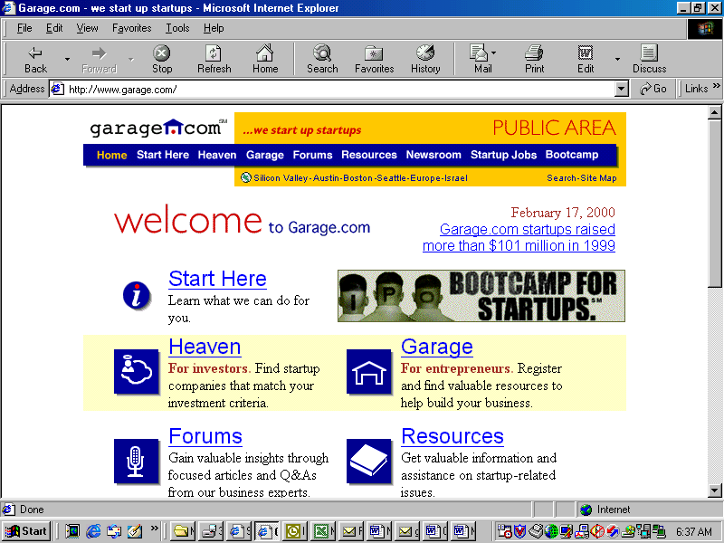

Mission: Garage.com helps entrepreneurs and investors build great businesses. This website claims to differ from typical venture capital firms that raise money from external sources and then invest the funds in various investment opportunities. At Garage.com, conversely, each member investor makes an independent investment decision and each entrepreneur chooses the investor with whom they wish to partner.

The funds are transferred directly from the investor to the entrepreneur and the two parties negotiate valuation, equity investment, and operational participation, without the involvement of Garage.com. Rather than compete with venture capital firms, this website helps them get together with start-up companies. Also, since the average Garage.com entrepreneur is a start-up business seeking from $1 to 2 million in seed funding, venture capital firms are not usually interested in these opportunities. Garage.com finds “angels” for these average entrepreneurs. The targeted users of this website are both entrepreneurs seeking seed-level money and the independent investor seeking to become involved with this type of start-up business. The message to the targeted user is relatively simple – this is the place to find the “angels” needed to get start-up businesses off the ground.

Functionality: This website is very easy to navigate. The homepage is arranged with a menu at the top of the page and the same links, in large print, in the center of the page. The links include the following:

- “Start Here” - Learn what this site can do for the user.
- “Forums” – Gain valuable insights through focused article and Q&As from business experts.
- “Newsroom” – Browse stories, opinions, and articles of interest to high tech investors and entrepreneurs.
- “Garage” – Find valuable resources to build businesses (for entrepreneurs).
- “Resources” – Get valuable information and assistance on startup-related issues.
- “Startup Jobs” – Look for select jobs in the high tech industry.
- “Bootcamp” – Learn the fundamentals of taking a company from startup to IPO in this two-day seminar.

There are small banner advertisements for the site sponsors near the bottom of the page along with the site’s disclosure statement. There are two links at the bottom of the page to “Contact Us” and “Privacy Policy.” The transition from page to page is fast without any delays. Many of the areas are repetitive and there are areas available only to members. No special programming or software is required to use this website and everything appears to function as designed.

User Benefit: The goal of Garage.com is to benefit two groups of users: entrepreneurs and investors. Assisting entrepreneurs in obtaining seed-level financing is the primary objective of this website. Garage.com strives to compress the entrepreneurs’ “time-to-money” via mentoring and a high-quality investment network, allowing them to focus more time on building their businesses. This site also provides member entrepreneurs with expert advice, research and reference materials, and topical forums to help them launch and grow their start-up businesses. For investors, Garage.com will identify and provide pre-screened, high-quality investment opportunities that match the individual investor’s identified areas of interest. All information is presented in a standard format to help investors analyze and evaluate companies quickly. Additionally, member investors have access to a broad community of investors focused on the cutting edge of high technology, enabling them to work together as they identify and qualify investment opportunities.

Owner Benefit: When a company is accepted into the Garage.com portfolio, the company compensates Garage.com, through a broker/dealer, when the company receives funding. The broker/dealer receives a small percentage of the new money raised. Investors are charged an annual membership fee. Both member companies and investors are given a 90-day, free, no obligation trial. Garage.com also has small banner advertisements on several of the pages, providing another revenue stream.

Strengths/Weaknesses: Garage.com’s objective is to bring start-up businesses together with investors interested in these types of companies. This site is able to differentiate itself from other venture capital sites by focusing on seed-level companies. The functionality of this website is much more logical and the site is easier to use than the other sites reviewed. The “bootcamp” feature is unique and could prove to be very useful to beginners in these areas of interest. A cost to entrepreneurs and investors is mentioned but not specified. The site presents a great deal of information arranged to make access easy but there is quite a bit of repetition. The forums provide useful information but also function as vehicles for advertisements.

VCapital.com

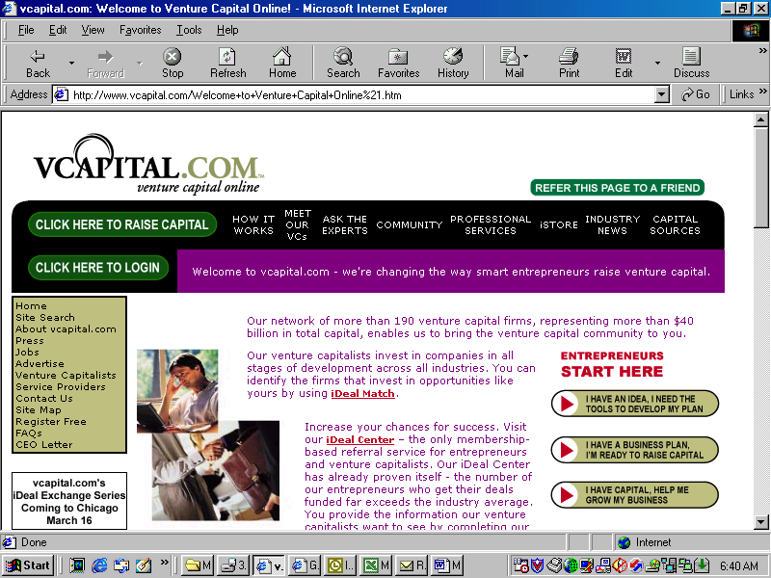

Mission: Vcapital.com was developed in response to the perceived need of businesses to raise capital. This website was designed by venture capitalists and capital-backed entrepreneurs who understand the frustrations of raising capital. The founders and operators of this site have been on the “other side.” They started out looking for capital and know what it’s like to be turned down or just ignored. The Vcapital.com network consists of leading professional venture capital providers and professional service providers. The founding venture capitalists represent a diverse cross-section of the venture capital community, consisting of law firms, accounting firms, and others experienced in this arena. The goal of this website is to assist the businesses in searching for the right venture capitalists, preparing an appropriate presentation, providing advice in an honest and timely manner, and providing referrals to targeted venture capitalists. The targeted users of this website are business owners looking for capital to improve or expand their businesses. There are also opportunities for capitalists searching for the appropriate vehicle in which to invest. The message to the targeted user is that this is the place to find the assistance they need to connect with venture capitalists ready to supply the funds needed to take their business to the next level.

Functionality: This website is set up to present information on Vcapital.com in a way that is logical and makes it easy to find the desired areas of the site. Menus are set up at the top of the page and down the left margin. These menus provide links to the different areas of the site, including how Vcapital.com works, introductions to the individual venture capitalists, an area to ask questions of the experts, the various communities, professional services, the “istore,” and industry news. The vertical menu presents links to a site search engine, site map, the different types of information on the site and the individuals involved with Vcapital.com. The home page contains much press release/marketing information, along with a number of advertisements. A great deal of information is presented on this website, spread out over many pages. The pages on the site are easy to access and move between, and the site functions quickly. The site map presents all the links and is the easiest way to navigate Vcapital.com. The whole site works like a large database of information that the user cannot interact with or sort. This site simply presents the information on Vcapital.com and provides an area to request information or assistance from the professional capitalists involved with it.

User Benefit: VCapital.com is a website devoted to bringing business owners looking for venture capital together with the professional venture capitalists who can help them. The targeted users of this website benefit through the use of the services provided. The first step is the search function that helps entrepreneurs determine which venture capitalists to target. The search is followed by assistance with their business plan presentation. In addition to assisting with business plan presentation, the professionals also review the information in the plan and provide honest and timely feedback. The final step in this process is submitting the business plan to venture capitalists. The professionals at Vcapital.com use their connections with others in the industry to get the business plan reviewed instead of just added to the pile. This site also offers information and assistance with business-related issues, such as human resources, marketing, and sales.

Owner Benefit: The owners of this website benefit a number of different ways. The first is by introducing venture capital professionals and service providers to opportunities associated with businesses looking for assistance. Several revenue streams are available to Vcapital.com. The most obvious of these are from advertising and from charging commissions on deals consummated through the website. The success or failure of this site should be relatively easy to determine. If Vcapital.com is able to deliver venture capitalists willing to provide the needed money at competitive costs to the business owner, users will continue to come here for the assistance they need.

Strengths/Weaknesses: Vcapital.com offers a large quantity of information that is logically arranged and easy to access. In addition to providing access to professional venture capitalists looking for good investment opportunities, this site offers advice on business plan content and presentation, followed up by referrals to venture capitalists. Advertising is used to raise revenues and a commission is charged to connect the business owner to the capital providers. While there is much information on this website, it is spread over many pages and quite a few of the links are repetitive. Financial charges to the site users are not very well explained and the commission fees are not easy to find.

DataMerge.com

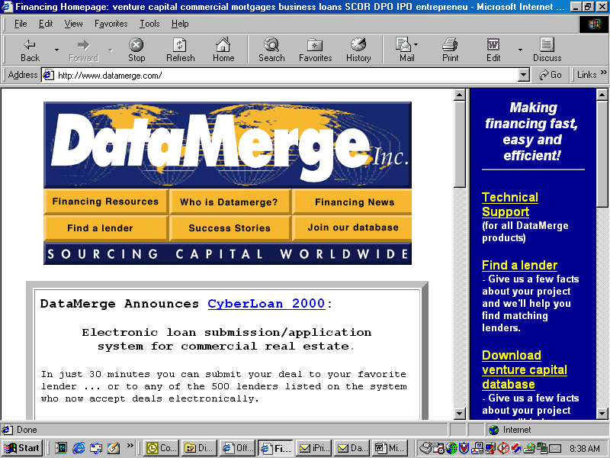

Mission: DataMerge.com provides financing sources and financing “how to” programs to business owners, commercial real estate finance professionals, and finance consultants, both within the United States and internationally. This website began as a proprietary in-house databank for a Denver law firm. The company CEO saw an opportunity to market this database to other businesses and the public to allow access to the alternative funding sources the firm had developed over time. Since its startup, DataMerge.com has grown from simply offering its database to marketing a complete line of business financing tools. DataMerge.com sells all its products through its home office in Denver. Customers buy direct by telephone. Other distribution methods include cross-marketing programs with trade associations and software publishers to sell their products, and individual dealer agreements. The message to the targeted users is that DataMerge.com is offering the expertise and access to funding that the user needs, and this is the best place to meet those needs.

Functionality: This is a difficult site to use. Most of the pages use frames. These frames move independently and the control bars take up a lot of room on the screen. Some of the frames on the homepage overlap and there is no way to see all of the information presented. There is a menu in the upper left frame that includes links to “Financing Resources,” “Who Is DataMerge?” “Financing News,” “Find A Lender,” “Success Stories,” and “Join Our Database.” The center of the homepage allows electronic submission of loan application information for commercial real estate. There are also short blurbs on the products offered on this website. There is a table presenting DataMerge.com products. The table is organized into three columns: Product name, Type, and Description. Once the user gets past the pages with frames, the site functions quickly when switching pages and presenting different pages of information. There is no specialized programming or software required. Basically, this website is an advertisement for DataMerge rather than an actual forum for conducting business.

User Benefit: User benefits have to be separated into two categories. The first is benefits from using the products developed and marketed by DataMerge. The second is the benefits from using the DataMerge.com website. DataMerge presents a number of business financing tools. The most important of these products is the Financing Sources Databank. This database features thousands of active financiers across the country, allowing business people to reach beyond their local contacts and geographical barriers in their search for capital. A second product is a manual and software program on raising capital through SCOR (Small Corporate Offering Registration). There are several other software programs available, each dealing with topics relating to business development. These include business plan guides, cash flow analyzers, mortgage planners, marketing kits, etc. The benefit of the actual website is mostly limited to reviewing information on the products offered and the company itself. An area on the home page leads the user to expect selected portions of the venture capital database, based on project facts submitted from the site, to be available over the Internet.

Owner Benefit: This website serves as an advertisement for DataMerge. It presents information related to the company and its products in an easy-to-understand format. DataMerge.com appears to have taken a first, small step in putting some of its products online with the offering of sections of its venture capital database to interested users. There is no advertising apparent on DataMerge.com and, as the products aren’t sold online, no direct revenue stream from the web-site. With Internet use growing at a rapid pace, even a website devoted to simply presenting information on the products and company is a valuable forum for getting news on the company out to the targeted users.

Strengths/Weaknesses: This website presents information on DataMerge in a direct manner that is easy to understand and use. The owners of the site have begun experimenting with online transactions in addition to the marketing efforts already well established on the site. The weakness is that the products aren’t available on-line and while a contact is given to order the products by telephone, costs are not provided on the website. A final drawback is the use of frames on the home page. The frames are not centered correctly and some of the information is obscured by overlaps.
OffroadCapital.com

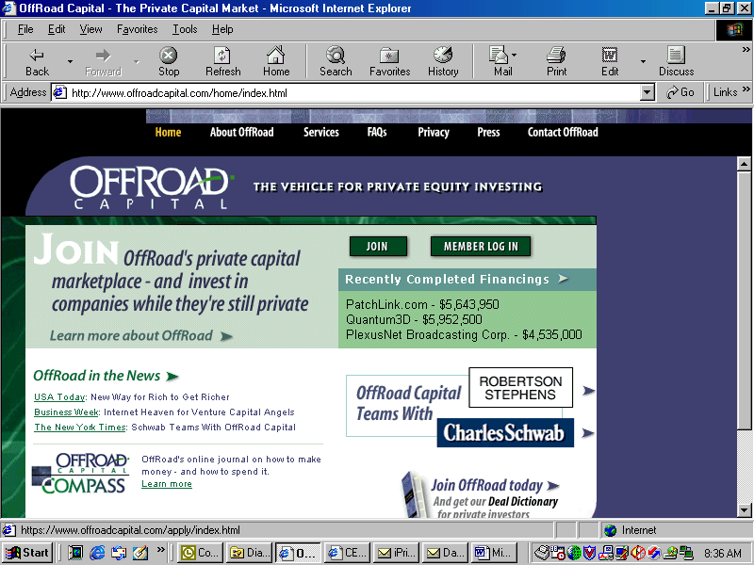

Mission: “Log in to Offroadcapital’s private capital marketplace – and invest in companies while they’re still private.” Offroadcapital.com is a financial services company that uses the Internet to create a private capital marketplace. By combining the discipline of the public stock market with the efficiency and global reach of online technology, Offroadcapital.com brings together high net-worth individuals wanting access to private equity investment opportunities with established, privately owned companies that need financing in the $3 million to $15 million range. Offroadcapital.com is in the business of arranging equity capital for companies seeking to grow through internal expansion, pursue an acquisition, recapitalize its balance sheet, or facilitate an ownership transition, including management buyouts. This website targets three audiences: individual investors, financial advisors, and businesses. The message to these targets is that Offroadcapital.com is the place to find the funding in this difficult capital range because it is a level that doesn’t attract the attention of traditional investment banks. A second reason to use this website is that Offroadcapital.com has a captive, widely distributed network of investors ready to participate in private equity investment opportunities.

Functionality: Offroadcapital.com contains a lot of information. This website doesn’t have the large number of pages that some of its competitors do, but there is still repetition with some of the links. The home page for this website is very simple. There is a menu at the top of the page with links to “About Offroadcapital,” “Services,” “FAQs,” “Privacy,” “Press,” and “Contact Offroadcapital.” A little bit of information is summarized on this page and each summary links to another section of the site. There are also links to join the site and for members to log in. The “Offroadcapital teams with” section presents small banners for teaming partners. These banners appear to function as small advertisements for the teaming partner. The transition from page to page is fast and no special programming or software is required. Many of the links take the user to the same place over and over again as they search for specific information.

User Benefit: Prior to the creation of private capital marketplaces, financing in the $3 million to $15 million range was difficult to obtain and access to private equity investment opportunities was scarce. Offroadcapital.com brings together business owners and investors in an efficient, orderly, and controlled marketplace. This website claims its marketplace is characterized by several significant innovations:

- Standardized on-line ordering mechanisms that present information in a consistent format for easy evaluation and comparison.
- An “Offroadcapital Show” for each investment opportunity, which supports the free flow of information between company principals and investors through a series of interactive on-line meetings and e-mail exchanges.
- Market pricing of securities, based on the level of interest expressed by investors after performing their own due diligence.
- Standardized terms and conditions for each of the five available deal structures.
- Mandated quarterly and annual performance reporting throughout the life of the investment.

Offroadcapital.com functions as a financial intermediary for the business owner and the investor. Their assistance is arranged into six distinct phases:

  - Assessing the business’ needs
  - Understanding the business
  - Preparing the offering
  - Building investor interest
  - Closing the transaction
  - Providing on-going support.

Owner Benefit: The purpose of Offroadcapital.com is to bring together businesses looking for funding and investors looking for private equity investment opportunities. The owners of the site do much more than just bring the two parties together and most likely realize some financial reward for their efforts. The percentage or fee charged could not be located on the website. Another potential revenue stream are the small advertising banners for the site’s teaming partners. Offroadcapital claims to be able to produce investors in the $3 million to $5 million range.

Strengths/Weaknesses: The strength of Offroadcapital.com is that it is very easy to understand what it is trying to accomplish. The site is looking for business owners and investors in a very specific niche, one in which it is difficult to find funding. If, as the site claims, this level of funding is overlooked by mainstream financial vehicles, users should be lining up to join this site. The most glaring weakness of Offroadcapital.com is that it doesn’t explain the ways in which they benefit financially; meaning the basis or amount of their fee is not discussed. Additionally, there doesn’t appear to be any way to conduct these transactions on-line, reducing this website to a simple advertisement.

MINORITYFUNDING.COM’S COMPETITIVE ADVANTAGE:

We have three competitive advantages:

- We are first to market with our type of concept.
- We are narrowly focused.
- Our marketing professionals are minorities and have strong ties to their communities.
- No one has a minority business database that is as extensive as ours.

MANAGEMENT:

Acting Chairman: Chairman-Betsy Z. Cohen

Betsy is the founder of Jefferson Bank, and served as the Chairman and Chief Executive Officer of JeffBanks, Inc. for the past 25 years. JeffBanks, Inc., a publicly held company recently merged with New Jersey-based Hudson United Bancorp. At the time of the merger, JeffBanks was a $2 billion asset commercial bank. Mrs. Cohen is currently Chairman of Resource Asset Investment Trust (Amex: RAS) as well as a Board of Director for Aetna Corporation. In addition to her extensive accomplishments as Chairman of JeffBanks, Mrs. Cohen has won numerous awards for her outstanding leadership as well as many philanthropic awards.

Board Member: Thad Fortin
Thad began his career in 1981 as Operations Manager with the Haas Corporation, a specialty chemical manufacturer in Philadelphia, Pennsylvania. In 1999, he was promoted to CEO.
In 1985, Thad assumed sales responsibilities for the new mid-West territory. Within three years, this territory became Haas' largest region. In 1988, Thad started Haas of Canada and Haas of Mexico. These companies represent more than 40% of total Haas sales.
In 1990, Thad was promoted to Executive Vice-President, where his duties included complete responsibility for the automotive market. In 1996, Thad was named President of Haas Corporation. In this role, Thad is extremely active in all aspects of Haas's chemical management programs.
He also sits on the Board of two companies, Omnikem and Sun & Earth. Thad is a graduate of the Haverford School (1977) and Ithaca College (B.S., 1981).
President/CEO: Marc Kramer
Marc is a former partner at USWeb, the world’s largest Internet consulting firm. Prior to that he was President of Mixed Media Works, an interactive company that produced such websites for Rosenbluth International and CoreStates Bank among others.

Before joining MMW, Marc started the Eastern Technology Council, the second-largest business technology council in the United States, with over 1,000 corporate members. Marc has also served as interim president/CEO of Business Philadelphia and Seven Arts, two large regional magazines.

Marc has received such awards as the Inc. Magazine Entrepreneur of the Year, American Electronics Association Spirit of America Award and was, for three years in a row, named one of the Top Five Business Leaders Under Age 40 in the Philadelphia region by the Philadelphia Jaycees.

Marc’s first book, Power Networking, was published by the Tribune Company in the fall of 1997. His second book, Small Business Turnaround, published by Adams Media, came out in the fall of 1999.

He is a trustee of Cheyney University, the oldest African-American University in the United States. Marc has a Master’s degree in Management from Penn State University and a B.S. in journalism from West Virginia University.

Vice President of Marketing: Eugene M. Principato

Gene has been managing sales, products, and profitability in the banking, financial services, health care and information services industries for over 20 years. In the banking industry, he was a Vice President for Retail Deposit Products departments at Maryland National Bank (Baltimore, MD) and Riggs National Bank (Washington, DC) in the late 1980s and early 1990s. Since that time, he has owned and operated a successful marketing consulting business serving the financial services and health care industries.

Gene’s strength is his ability to find creative and cost-effective ways to increase sales and profits. He has successfully identified new market opportunities, developed strategic marketing plans, introduced new products and services, and managed existing products to higher levels of profitability. He has also developed and overseen the implementation of marketing and sales programs for a variety of new businesses. Gene’s unique background combines strong analytical, communication, and management skills.

Gene earned an M.B.A. from George Washington University, an M.S. from Georgetown University, and an undergraduate degree from The University of Pennsylvania. He has also taught graduate-level marketing courses at The Johns Hopkins University.
Vice President of Technology: Randy Feldman

Randy directs all technology operations as CIO at ECRI, an international non-profit corporation headquartered in Plymouth Meeting, PA. Managing five service departments totaling over 50 personnel, he has designed and implemented a complete technology revolution within ECRI. The result was a 25% increase in its annual revenues to over $23 million in 1999. His management and continual hands-on work resulted in the recent completion of a new Internet presence, which promises to provide the basis for greater growth in its membership, by providing Web access to its highly regarded services and publications.

A graduate of Bucknell University and Penn State University, Randy previously managed and supported the Technical Services at the Vanguard Group as their Senior Analyst and Consultant. While at Vanguard, he led the transitions of most of its information technologies, the creation of its online services and support of its changing infrastructure. Before that, Randy was the Network Operations Manager at US Healthcare during its peak growth years and when it became number 1 on the list of the fastest growing companies in the country.

Vice President of Content: Gail S. Jones

Gail has 20 years of experience in publications management, marketing support, editing, and writing for a broad range of industries including pharmaceutical (AstraZeneca, L.P.), environmental (Roy F. Weston, Inc.), scientific (VWR Scientific Products), financial (The Vanguard Group) and computer-related (Aydin Computer Systems, Keystone Computer Associates, and Ketron, Inc.). She has performed report administration, document coordination, and information research.

Gail’s strength is her knowledge, accuracy, and attention to detail. Her background of editing both promotional and technical copy gives her great flexibility and competence. Her B.A. is in Communication from the University of Central Florida.

TECHNOLOGY:

Objectives
- Automation of all components
- Scalable back office management
- Scalable website

Existing Technology
- Fully functioning website
- Application to import new vendors
- Application to manage RFPs / vendors
- Application to pre-register vendors
- Application to manage site traffic and event logging
- Simple Partnering Program Implementation
- Banner Ad Back Office Management
- E-Commerce linking implemented
- Tools and products used to build application
- Microsoft SQL SERVER for database
- Internet Information Server (IIS) as Web server with Front Page extensions
- Microsoft SMTP for CDONTS emailing
- Active Server Pages (ASP) for serving Web pages and gluing to database
- Active Data Object (ADO) for executing queries against the database
- ASP contained embedded SQL for majority of the application with some stored procedures for making ADO calls to the database
- CyberCash for credit checking
- Visual InterDev for building the application
- Source Safe for source code control

Site Scalability
The following servers will help us scale the site as it grows:
- 2 Database servers with replication capabilities running on separate NT servers with 4 CPUs each
- 2 IIS servers with load balancing capabilities running on separate NT servers with 4 CPUs each
- 1 Microsoft Proxy Server on a separate 2 CPU NT Server
- ADO with connection pooling enabled for better database I/O
- MSMQ for bank wire instructions for processing and managing cash transactions

LAUNCH PLAN:

Month | Action Item
1 | Developing the content strategy and implementation plan for each city
1 | Developing Minorityfunding.com home page
1 | Developing Minorityfunding.com home page
1 | Interviewing advertising/sales personnel
2 | Interviewing advertising/sales personnel
2 | Developing relationships with regional Minorityfunding.com organizations
2 | Developing Home page for Minorityfunding.com com
2 | Developing Minorityfunding.com website
2 | Interviewing editorial personnel
3 | Developing Minorityfunding.com website
3 | Extending offers to advertising/sales personnel
3 | Extending offers to editorial personnel
4 | Developing the editorial content
4 | Developing Minorityfunding.com website
4 | Preparing marketing materials and developing marketing plan
5 | Approving marketing plan
6 | Approaching advertising agencies and companies who buy direct
7 | Promote site through PR, direct e-mail, and direct mail
7 | Approaching advertising agencies and companies who buy direct
7 | Signing 100 members a month
8 | Promote site through PR, direct e-mail, and direct mail
8 | Signing 100 members a month
8 | Closing on two to four advertisers
9 | Closing on two to four advertisers
9 | Promote site through PR, direct e-mail, and direct mail
9 | Signing 100 members a month
10 | Closing on four to six advertisers
10 | Signing 100 members a month
11 | Closing on six to eight advertisers
11 | Signing 100 members a month
12 | Closing on six to eight advertisers
12 | Signing 100 members a month

Financials:

 | Yr1 | Yr2 | Yr3 | Yr4 | Yr5
Revenue
Placement Fees | $ 312,500 | $ 1,800,000 | $ 5,184,000 | $ 14,929,920 | $ 32,248,627
Business Sales | $ - | $ 2,750,000 | $ 6,050,000 | $ 13,310,000 | $ 29,282,000
Business Sales Listing Fee | $ - | $ 600,000 | $ 990,000 | $ 1,633,500 | $ 2,695,275
Online Training | $ 280,000 | $ 1,108,800 | $ 4,024,944 | $ 14,610,547 | $ 53,036,285
Books | $ 280,000 | $ 616,000 | $ 1,355,200 | $ 2,981,440 | $ 6,559,168
Employment Opportunities | $ 252,000 | $ 609,840 | $ 1,475,813 | $ 3,571,467 | $ 8,642,950
Conferences | $ - | $ 1,320,000 | $ 3,267,000 | $ 8,085,825 | $ 20,012,417
Service Fees | $ 870,000 | $ 1,914,000 | $ 4,210,800 | $ 9,263,760 | $ 20,380,272
Sponsorship | $ 144,000 | $ 316,800 | $ 696,960 | $ 1,533,312 | $ 3,373,286
Total | $ 2,138,500 | $11,035,440 | $ 27,254,717 | $ 69,919,771 | $ 176,230,280
Expenses
Salaries | $ 1,487,500 | $ 3,233,250 | $ 4,987,081 | $ 8,179,149 | $ 14,369,881
Taxes & Benefits | $ 446,250 | $ 969,975 | $ 1,496,124 | $ 2,453,745 | $ 4,310,964
Travel | $ 331,429 | $ 364,571 | $ 401,029 | $ 441,131 | $ 485,245
Telephone | $ 49,714 | $ 126,990 | $ 204,696 | $ 344,034 | $ 607,112
Rent/Utilities | $ 87,000 | $ 222,233 | $ 358,219 | $ 602,059 | $ 1,062,446
Marketing Support | $ 215,000 | $ 519,900 | $ 695,010 | $ 1,021,665 | $ 1,667,259
Online Training Partner Fees | $ 224,000 | $ 887,040 | $ 3,219,955 | $ 11,688,437 | $ 42,429,028
Book Partner Fees | $ 252,000 | $ 554,400 | $ 1,219,680 | $ 2,683,296 | $ 5,903,251
Business Supplies | $ 16,571 | $ 42,330 | $ 68,232 | $ 114,678 | $ 202,371
Business Technology | $ 49,714 | $ 126,990 | $ 204,696 | $ 344,034 | $ 607,112
Business Sales | $ - | $ 2,612,500 | $ 5,747,500 | $ 12,644,500 | $ 27,817,900
Conferences | $ - | $ 1,188,000 | $ 2,940,300 | $ 7,277,243 | $ 18,011,175
Business Equipment | $ 49,714 | $ 126,990 | $ 204,696 | $ 344,034 | $ 607,112
Technology | $ 376,000 | $ 96,000 | $ 125,100 | $ 167,805 | $ 230,870
Professional Services | $ 220,000 | $ 270,000 | $ 333,000 | $ 413,100 | $ 515,970
Business Insurance | $ 2,139 | $ 11,035 | $ 27,255 | $ 69,920 | $ 176,230
Miscellaneous | $ 76,141 | $ 227,044 | $ 444,651 | $ 975,777 | $ 2,380,079
Total Expenses | $ 3,883,172 | $11,579,248 | $ 22,677,226 | $ 49,764,606 | $ 121,384,005
Pretax Profit/Loss | $ (1,744,672) | $ (543,808) | $ 4,577,491 | $ 20,155,164 | $ 54,846,275
 |  |  | Minorityfunding.com
Minority Member Potential | 25,000 | 30,000 | 36,000 | 43,200 | 51,840
Corporate Potential | 3,500 | 3,500 | 3,500 | 3,500 | 3,500
Revenue | Yr1 | Yr2 | Yr3 | Yr4 | Yr5
Member Revenue | 0 | 0 | 0 | 0 | 0
Minority vendors | 0 | 0 | 0 | 0 | 0
No. of members | 2,500 | 5,000 | 10,000 | 20,000 | 40,000
Price per membership | 0 | 0 | 0 | 0 | 0
Corporate | 0 | 0 | 0 | 0 | 0
No. of members | 200 | 400 | 800 | 1,600 | 3,200
Price per membership | 0 | 0 | 0 | 0 | 0
Public/NonProfit | 0 | 0 | 0 | 0 | 0
No. of members | 100 | 200 | 400 | 800 | 1,600
Price per membership | 0 | 0 | 0 | 0 | 0
Revenue
Placement Fees | $ 312,500 | $ 1,800,000 | $ 5,184,000 | $ 14,929,920 | $ 32,248,627
No. of Deals | 125 | 600 | 1,440 | 3,456 | 6,221
Ave Deal | 500,000 | 600,000 | 720,000 | 864,000 | 1,036,800
Referral fee | 0.005 | 0.005 | 0.005 | 0.005 | 0.005
Online Training | $ 280,000 | $ 1,108,800 | $ 4,024,944 | $ 14,610,547 | $ 53,036,285
No. of Corporate members | 2,800 | 5,600 | 11,200 | 22,400 | 44,800
Percent buying courses | 0.05 | 0.08 | 0.11 | 0.17 | 0.25
No. of Courses | 2.0 | 2.4 | 2.6 | 2.9 | 3.2
Charge per course | 1,000 | 1,100 | 1,210 | 1,331 | 1,464
Books | $ 280,000 | $ 616,000 | $ 1,355,200 | $ 2,981,440 | $ 6,559,168
No. of Users | 2,800 | 5,600 | 11,200 | 22,400 | 44,800
No. of Books | 4 | 4 | 4 | 4 | 4
Ave. Price Per Book | 25 | 28 | 30 | 33 | 37
Employment Opportunities | $ 252,000 | $ 609,840 | $ 1,475,813 | $ 3,571,467 | $ 8,642,950
No. of Companies | 140 | 280 | 560 | 1,120 | 2,240
Ave. of number of ads | 12 | 13 | 15 | 16 | 18
Cost per Advertisement | 150 | 165 | 182 | 200 | 220
Business Sales | $ - | $ 2,750,000 | $ 6,050,000 | $ 13,310,000 | $ 29,282,000
No. of Companies for sale | 0 | 50 | 100 | 200 | 400
Average sale price | 500,000 | 550,000 | 605,000 | 665,500 | 732,050
Percent sold | 0.10 | 0.10 | 0.10 | 0.10 | 0.10
Business Sales Listing Fee | $ - | $ 600,000 | $ 990,000 | $ 1,633,500 | $ 2,695,275
No. Companies for sale | 0 | 500 | 750 | 1,125 | 1,688
Charge per listing per year | 0 | 1,200 | 1,320 | 1,452 | 1,597
Conferences | $ - | $ 1,320,000 | $ 3,267,000 | $ 8,085,825 | $ 20,012,417
No. of Conferences | 0 | 4 | 6 | 9 | 14
Average Number of Attendees | 200 | 300 | 450 | 675 | 1,013
Average Attendance of Fee | 1,000 | 1,100 | 1,210 | 1,331 | 1,464
Service Finder's Fees | $ 870,000 | $ 1,914,000 | $ 4,210,800 | $ 9,263,760 | $ 20,380,272
No. of companies | 2,500 | 5,000 | 10,000 | 20,000 | 40,000
No. of Service providers | 100 | 200 | 400 | 800 | 1,600
Membership fee | 1,200 | 1,320 | 1,452 | 1,597 | 1,757
Percent of co's providing projects | 0.10 | 0.10 | 0.10 | 0.10 | 0.10
Average project | 30,000 | 33,000 | 36,300 | 39,930 | 43,923
Minorityvendors fee | 0.10 | 0.10 | 0.10 | 0.10 | 0.10
Sponsorships | $ 144,000 | $ 316,800 | $ 696,960 | $ 1,533,312 | $ 3,373,286
No. of Sponsors | 6 | 12 | 24 | 48 | 96
Average fee per month | 2,000 | 2,200 | 2,420 | 2,662 | 2,928
No. of months | 12 | 12 | 12 | 12 | 12
Expenses
Management Salaries | $ 632,500 | $ 959,500 | $ 1,073,600 | $ 1,202,922 | $ 1,349,787
Chairman/CEO | 1 | 1 | 1 | 1 | 1
annual salary | 175,000 | 192,500 | 211,750 | 232,925 | 256,218
President/COO | 1 | 1 | 1 | 1 | 1
annual salary | 150,000 | 165,000 | 181,500 | 199,650 | 219,615
Vp Of Marketing | 1 | 1 | 1 | 1 | 1
annual salary | 62,500 | 125,000 | 137,500 | 151,250 | 166,375
VP of Finance | 0 | 1 | 1 | 1 | 1
annual salary | 62,500 | 125,000 | 137,500 | 151,250 | 166,375
VP Of Sales | 0 | 1 | 1 | 1 | 1
annual salary | 62,500 | 68,750 | 75,625 | 83,188 | 91,506
VP of Content | 1 | 1 | 1 | 1 | 1
annual salary | 70,000 | 77,000 | 84,700 | 93,170 | 102,487
VP of Banking Relationships | 1 | 1 | 1 | 1 | 1
annual salary | 100,000 | 110,000 | 121,000 | 133,100 | 146,410
VP of Technology | 1 | 1 | 1 | 1 | 1
annual salary | 75,000 | 150,000 | 165,000 | 181,500 | 199,650
Sales managers | 40,000 | 132,000 | 290,400 | 638,880 | 1,405,536
No. of managers | 1 | 2 | 3 | 7 | 14
Average annual salary | 70,000 | 77,000 | 84,700 | 93,170 | 102,487
Marketing Directors | $ 55,000 | $ 302,500 | $ 332,750 | $ 366,025 | $ 402,628
annual salary | 55,000 | 60,500 | 66,550 | 73,205 | 80,526
number of people | 1 | 5 | 5 | 5 | 5
Sales Executives | $ 220,000 | $ 726,000 | $ 1,597,200 | $ 3,513,840 | $ 7,730,448
annual salary | 55,000 | 60,500 | 66,550 | 73,205 | 80,526
number of people | 4 | 12 | 24 | 48 | 96
Content Managers | $ 100,000 | $ 157,500 | $ 259,875 | $ 428,794 | $ 707,510
annual salary | 50,000 | 52,500 | 57,750 | 63,525 | 69,878
number of people | 2 | 3 | 5 | 7 | 10
Customer Service | $ 60,000 | $ 94,500 | $ 148,838 | $ 234,419 | $ 369,210
annual salary | 30,000 | 31,500 | 33,075 | 34,729 | 36,465
No. of client service people | 2 | 3 | 5 | 7 | 10
Web Site Personnel | $ 30,000 | $ 476,250 | $ 860,919 | $ 1,328,420 | $ 1,892,328
Programmers | 0 | 6 | 10 | 14 | 18
Annual Salary | 65,000 | 71,500 | 78,650 | 86,515 | 95,167
Clerical Assistance | 1 | 2 | 2 | 3 | 5
Annual Salary | 30,000 | 31,500 | 33,075 | 34,729 | 35,423
Total People | 17 | 40 | 62 | 99 | 166
Taxes & Benefits(% salary) | 30% | 30% | 30% | 30% | 30%
Travel | $ 331,429 | $ 364,571 | $ 401,029 | $ 441,131 | $ 485,245
No. of Employees | 17 | 40 | 62 | 99 | 166
Average travel expense | $ 20,000 | $ 21,000 | $ 22,050 | $ 23,153 | $ 24,310
Telephone | $ 49,714 | $ 126,990 | $ 204,696 | $ 344,034 | $ 607,112
No. of Employees | 17 | 40 | 62 | 99 | 166
Tele(per/person/per yr) | $ 3,000 | $ 3,150 | $ 3,308 | $ 3,473 | $ 3,647
Rent/Utilities | $ 87,000 | $ 222,233 | $ 358,219 | $ 602,059 | $ 1,062,446
No. of Employees | 17 | 40 | 62 | 99 | 166
cost per sq foot | 21 | 22 | 23 | 24 | 26
Sq. Ft / person | 250 | 250 | 250 | 250 | 250
Total Marketing Support | $ 215,000 | $ 519,900 | $ 695,010 | $ 1,021,665 | $ 1,667,259
Direct Mail (postcards) | $ 37,000 | $ 78,300 | $ 165,750 | $ 350,979 | $ 743,445
#letters | 100,000 | 200,000 | 400,000 | 800,000 | 1,600,000
cost per mailing | 0.31 | 0.33 | 0.34 | 0.36 | 0.38
cost per name | 0.06 | 0.06 | 0.06 | 0.06 | 0.06
cost per post card | 1.00 | 1.10 | 1.21 | 1.33 | 1.46
Direct E-mail | $ 18,000 | $ 39,600 | $ 79,860 | $ 167,706 | $ 360,169
No. of mailings | 6 | 12 | 12 | 12 | 12
Setup fee | 500 | 550 | 605 | 666 | 732
No. of lists | 5 | 5 | 5 | 5 | 5
Cost per e-mail | 0.03 | 0.03 | 0.04 | 0.04 | 0.04
No. of mailings | 100,000 | 200,000 | 400,000 | 800,000 | 1,600,000
Public Relations | $ 60,000 | $ 72,000 | $ 86,400 | $ 103,680 | $ 124,416
No. of months | 6 | 12 | 12 | 12 | 12
Fee per month | 10,000 | 11,000 | 12,100 | 13,310 | 14,641
Print Advertising | $ 100,000 | $ 330,000 | $ 363,000 | $ 399,300 | $ 439,230
No. of Ads | 20 | 60 | 60 | 60 | 60
Cost per ad | 5,000 | 5,500 | 6,050 | 6,655 | 7,321
Sponsorships | $ - | $ 99,000 | $ 145,200 | $ 199,650 | $ 263,538
No. of Markets | 0 | 6 | 8 | 10 | 12
Budget Per Market | 15,000 | 16,500 | 18,150 | 19,965 | 21,962
Online Training | $ 224,000 | $ 887,040 | $ 3,219,955 | $ 11,688,437 | $ 42,429,028
Revenue | 280,000 | 1,108,800 | 4,024,944 | 14,610,547 | 53,036,285
Fee to partner | 0.80 | 0.80 | 0.80 | 0.80 | 0.80
Books | $ 252,000 | $ 554,400 | $ 1,219,680 | $ 2,683,296 | $ 5,903,251
Revenue | 280,000 | 616,000 | 1,355,200 | 2,981,440 | 6,559,168
Fee to partner | 0.90 | 0.90 | 0.90 | 0.90 | 0.90
Business Sales | $ - | $ 2,612,500 | $ 5,747,500 | $ 12,644,500 | $ 27,817,900
Revenue | 0 | 2,750,000 | 6,050,000 | 13,310,000 | 29,282,000
Fee to seller | 0.95 | 0.95 | 0.95 | 0.95 | 0.95
Conferences | $ - | $ 1,188,000 | $ 2,940,300 | $ 7,277,243 | $ 18,011,175
Revenue | 0 | 1,320,000 | 3,267,000 | 8,085,825 | 20,012,417
Fee to Conferences | 0.90 | 0.90 | 0.90 | 0.90 | 0.90
Bus. Sup.(pp per yr) | $ 16,571 | $ 42,330 | $ 68,232 | $ 114,678 | $ 202,371
Employees | 17 | 40 | 62 | 99 | 166
Cost for Supplies | $ 1,000 | $ 1,050 | $ 1,103 | $ 1,158 | $ 1,216
Bus. Equip.(pp per yr) | $ 49,714 | $ 126,990 | $ 204,696 | $ 344,034 | $ 607,112
Employees | 17 | 40 | 62 | 99 | 166
Cost of Supplies | $ 3,000 | $ 3,150 | $ 3,308 | $ 3,473 | $ 3,647
Technology | $ 376,000 | $ 96,000 | $ 125,100 | $ 167,805 | $ 230,870
Web Site Development/Maintenance | 300,000 | 360,000 | 432,000 | 518,400 | 622,080
Hosting | 36,000 | 54,000 | 81,000 | 121,500 | 182,250
Sql Server & Misc | 5,000 | 5,250 | 5,513 | 5,788 | 6,078
Equipment | 35,000 | 36,750 | 38,588 | 40,517 | 42,543
Prof. Srv. (legal,acct,hr) | $ 220,000 | $ 270,000 | $ 333,000 | $ 413,100 | $ 515,970
Legal | 50,000 | 60,000 | 72,000 | 86,400 | 103,680
Accounting | 20,000 | 30,000 | 45,000 | 67,500 | 101,250
Human Resources | 50,000 | 60,000 | 72,000 | 86,400 | 103,680
IT | 100,000 | 120,000 | 144,000 | 172,800 | 207,360
Business Insurance | $ 2,139 | $ 11,035 | $ 27,255 | $ 69,920 | $ 176,230
Miscellaneous | $ 76,141 | $ 227,044 | $ 444,651 | $ 975,777 | $ 2,380,079

Income:

All income revenue is based on first year’s experience and what management believes current and future partnerships will bring.

Investment Capital- Based on percentages given by Eloan and Capital.com.

Business Sales- Based on what Sun Belt Business Owners charges.

Online Training- Based on what Phoenix, the top online education company, would pay a partner.

Books- Based on what Amazon pays partners.

Employment Opportunities- Based on what Minorities Job Bank charges.

Conferences- Based figures provided by Association of Executive Directors.

Service Fees- Based on average rfpMarket’s contract size.

Sponsorship: Based on 1 cent per visitor per month.

Expenses:

Management Salaries: Based on figures supplied by executive recruiting firms on what start-up Internet companies are paying on average.

Taxes and Benefits: Based on a Coopers Price Waterhouse study on what companies pay on average to employees.

Travel: Based on figures supplied by AAA.

Telephone: Based on figures supplied by public relations department of Bell Atlantic.

Telephone 800 Service: Based on figures provided by AT&T small business services.

Rent & Utilities: Based on figures supplied by Building Owners and Managers Association.

Direct Mail: Based on figures provided by Direct Marketing Association.

Magazine Ads: Based on contacting and reviewing advertising press kits.

Public Relations: Based on contacting small and medium-sized public relations firms.

Business Supplies: Based on figures supplied by Staples public relations department.

Business Equipment: Based on figures supplied by Staples public relations department.

Technology Hosting: Based on speaking with Digger and Bee.Net.

Professional Services: Based on contacting professional service firms.

Business Insurance: Figures based on figures supplied by New England Financial.

