VIT-AP UNIVERSITY
School of Computer Science and Engineering
B.Tech CSE and Specializations — Capstone Project
Review 1 Project Report
ResQTwin — AI-Driven Digital Twin for Urban Flood Emergency Response
Project Title | ResQTwin — AI-Driven Digital Twin for Urban Flood Emergency Response
Semester | Fall Semester 2026-27
Guide | Sandipan Maiti
Team Members | Mohammed Intekhab Khan (23BCE8654)  Raghav Bohora (23BCE8648)  Shivanshu Pauskar (23BCE8662)  Druthi Sai Medampudi (23BCE8666)

1. Introduction

1.1 Background
Urban flooding is a complex disaster-management problem in which rainfall intensity, water levels, terrain, drainage, land use, infrastructure and human exposure interact over space and time. Modern remote sensing and machine-learning methods can provide rapid flood extent estimation, while digital-twin concepts can combine heterogeneous data to represent the evolving state of a city. However, prediction alone is not sufficient for emergency response.
Recent research shows that uncertainty is present throughout the flood-modelling pipeline. The 2026 systematic review by Idowu and Alfahid identifies fragmented uncertainty workflows and calls for end-to-end probabilistic pipelines that integrate heterogeneous data, quantify uncertainty across stages, and communicate actionable risk information.
ResQTwin therefore focuses on Chennai as a single mandatory case study for urban flooding and aims to connect AI-based flood prediction, Sentinel-1 satellite flood segmentation, geospatial impact analysis and human-centered emergency decision support.

1.2 Motivation
Existing flood systems often emphasize predicting where or when flooding may occur. Emergency users also need to know how reliable the prediction is, what factors contributed to it, what areas or roads may be affected, and what alternative actions are available. Tran et al. (2026) argue that many flood early-warning systems remain prediction-centric and provide limited support for uncertainty interpretation, risk communication and real-world response.
The motivation for ResQTwin is not to claim that uncertainty estimation itself is new. Instead, the project investigates whether uncertainty can be carried from multi-source AI predictions through flood mapping and impact assessment into understandable, decision-oriented recommendations.

1.3 Objective
The primary objective of ResQTwin is to develop a prototype AI-driven digital twin framework for Chennai urban flood response that combines multi-source environmental data, satellite-based flood segmentation, uncertainty estimation and geospatial impact analysis to produce explainable and human-centered emergency decision support.
Specific objectives are to: (i) develop a flood-risk prediction component using environmental and geographical inputs, (ii) develop and evaluate Sentinel-1 SAR flood segmentation, (iii) quantify and propagate prediction uncertainty, (iv) identify potential impacts on roads, population and critical facilities, and (v) communicate recommendations together with confidence, limitations and alternatives.

1.4 Scope
The current scope is intentionally limited to Chennai and urban flooding so that the team can build and evaluate an end-to-end prototype within the capstone timeline. Additional cities or disaster types are optional future extensions and are not required for the core contribution.
The project does not require custom hardware or IoT sensors. It is designed as a software-based system using publicly available and academically appropriate datasets and APIs. Closed-loop real-time updating is an optional future enhancement rather than a primary research contribution.

2. Related Work and Baseline
The literature review was conducted to identify what is already established in flood prediction, remote-sensing segmentation, digital twins, uncertainty quantification and decision support. The comparison is focused on the research gap addressed by ResQTwin rather than claiming that individual techniques are novel.

2.1 Idowu and Alfahid (2026) — Uncertainty Quantification in Flood Modelling
The 2026 systematic review identifies eight open problems in flood-model uncertainty quantification, including uncertainty propagation, incomplete representation of uncertainties, data integration, spatial and temporal variability, and extreme-event uncertainty. It emphasizes that current workflows are fragmented and calls for seamless end-to-end probabilistic pipelines and actionable risk communication.

2.2 Manyaka et al. (2026) — Remote Sensing and Machine Learning for Flood Modelling
This systematic review examines ML and remote sensing flood-modelling research from 2010–2025. It reports extensive use of Sentinel-1/2, Landsat and MODIS, but identifies gaps including uncertainty quantification, standardized benchmarking and reproducibility. It recommends uncertainty-aware methods and transparent deployment.

2.3 Tran et al. (2026) — FEWS-DM
Tran et al. propose a flood early-warning decision-making framework coupling physical science, human science and decision science. The paper identifies limited uncertainty interpretation, risk communication and real-world response support in many systems, and emphasizes human-centered design and end-to-end uncertainty management.

2.4 Inyang and Taghikhah (2025) — Digital Twin-Based Disaster Decision Support
This systematic review examines digital-twin decision-support systems for natural disaster management, including data collection, computational approaches and emergency decision tasks. It identifies research gaps and future directions for AI-assisted digital twins in disaster management.

2.5 Comparison and Identified Gap
Approach | Flood Prediction /  Mapping | Uncertainty | Digital Twin /  DSS | Gap Addressed by ResQTwin
Idowu & Alfahid (2026) | ✓ | ✓ | Partial | End-to-end uncertainty pipeline
Manyaka et al. (2026) | ✓ | Gap identified | — | Uncertainty-aware RS/ML workflow
Tran et al. (2026) | ✓ | ✓ | ✓ | Human-centered uncertainty communication
Inyang & Taghikhah (2025) | ✓ | Not central | ✓ | Uncertainty-aware DT decision support
Typical flood segmentation studies | ✓ | Often limited | — | Move beyond segmentation to decisions
Table 1: Comparison of existing research directions against the target ResQTwin contribution.
Across these works, uncertainty-aware flood modelling, remote-sensing segmentation and digital-twin decision support are each established research directions. The specific gap targeted by ResQTwin is their integration: uncertainty from heterogeneous inputs and AI models should be represented, communicated and propagated into spatial impact analysis and emergency decisions rather than being reported only at the prediction stage.

2.6 Research Gap Addressed by ResQTwin
- End-to-end uncertainty: carry uncertainty from environmental/AI inputs through flood prediction and segmentation into impact assessment and decision support.
- Decision-aware uncertainty communication: translate model confidence and limitations into understandable information for emergency users.
- Multi-source integration: combine rainfall, water levels, weather, Sentinel-1 SAR and geospatial context rather than relying on one prediction source.
- Chennai-focused validation: evaluate transfer/generalization to a defined urban case study instead of presenting only generic benchmark results.
- Reproducible evaluation: report predictive and segmentation metrics together with uncertainty/calibration behaviour and failure cases.

3. Proposed System
ResQTwin is proposed as a software-based AI-driven digital twin for Chennai urban flood emergency response. The system will ingest heterogeneous environmental, satellite and geospatial information, generate flood-risk and flood-extent predictions, estimate uncertainty, assess potential impacts, and present human-centered decision support.
The system is organized as separate modules so that each team's work can be developed independently and integrated through defined interfaces. The AI/Satellite module handles flood-risk modelling and Sentinel-1 segmentation; backend/data engineering manages data pipelines and APIs; the geospatial module manages roads, facilities and exposure; and the frontend presents the digital-twin state and recommendations.

3.1 System Architecture
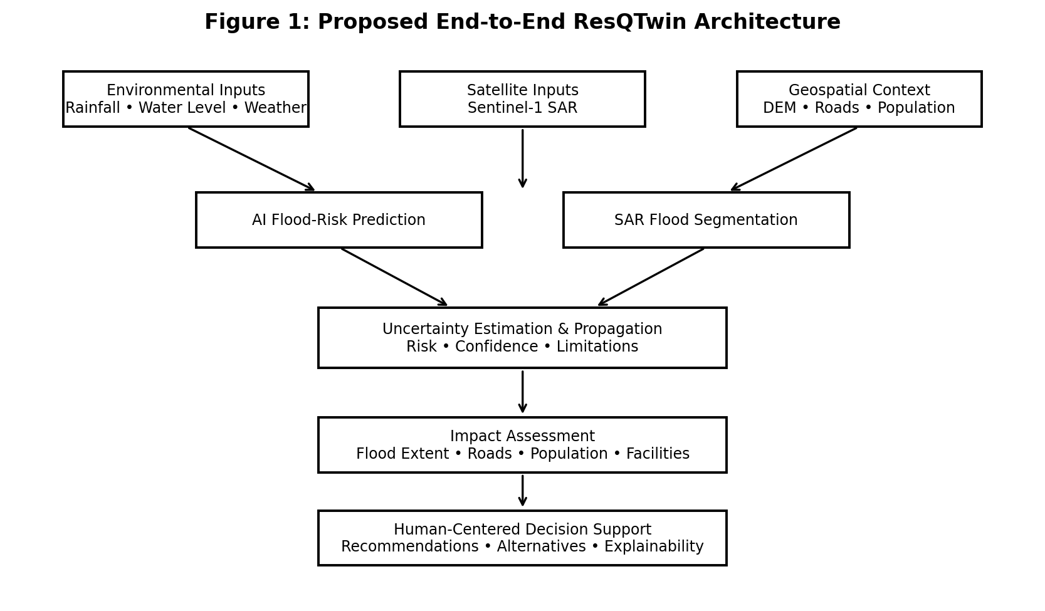
Figure 1: End-to-end ResQTwin architecture. Multi-source observations feed AI flood prediction and Sentinel-1 segmentation. Uncertainty is estimated and propagated into flood-impact analysis and then communicated through human-centered decision support.

3.2 Key Contributions
- Uncertainty-aware flood intelligence: predictions are accompanied by confidence/uncertainty information rather than presented as deterministic facts.
- Uncertainty propagation: investigate how uncertainty at upstream prediction stages should affect downstream impact assessment and recommendations.
- Human-centered emergency support: present what is happening, why a recommendation is made, how confident the system is, what alternatives exist and when human verification is required.
- Satellite computer vision: use Sentinel-1 SAR data for flood segmentation and evaluate transfer from the Sen1Floods11 benchmark to Chennai imagery.
- City-scale geospatial integration: connect flood extent with roads, population and critical facilities to make predictions operationally meaningful.
- Research-grade evaluation: evaluate predictive performance, segmentation quality, uncertainty quality/calibration and failure cases rather than relying on a single accuracy score.
3.3 Expected Outcome
For a given Chennai scenario, the completed prototype is expected to provide a digital representation of flood risk and potential impact. Outputs should include flood-risk predictions, satellite-derived flood extent where imagery is available, uncertainty/confidence information, affected-road and exposure information, and an understandable emergency recommendation.
A representative final output is expected to communicate predicted flood risk, confidence level, major contributing factors, affected or potentially affected areas, safer alternatives where supported by the geospatial module, and limitations such as missing observations or unavailable satellite coverage. The system is intended as decision support and will not replace official emergency authorities or warnings.

3.4 Review 1 Progress and Work Completed
Area | Work Completed | Status
Project foundation | Scope fixed to Chennai urban flooding; roles and module boundaries established. | Completed
Git/GitHub | Repository initialized; main branch created; individual feature-branch workflow established; feature/intekhab-ai pushed. | Completed
Repository structure | AI, backend, geospatial, frontend, data, scripts, tests and documentation structure created. | Completed
Research direction | Primary focus fixed as end-to-end uncertainty-aware flood-to-decision; secondary focus as human-centered uncertainty communication. | Completed
Satellite dataset | Sen1Floods11 v1.1 subset downloaded locally: 446 VV/VH chips and 446 matching masks. | Completed
Dataset verification | 252 train, 89 validation, 90 test and 15 Bolivia holdout samples verified; labels and image-mask pairing checked. | Completed
Initial inspection | Rasterio-based read-only inspection script created and committed as 'Add Sen1Floods11 dataset inspection'. | Completed
Model training | Not started; baseline and uncertainty methods will be selected after preprocessing verification. | Planned
Table 2: Review 1 progress summary.

3.5 Immediate Next Steps
- Verify Sentinel-1 VV/VH value distributions, NaN/no-data behaviour and valid-pixel ranges.
- Finalize normalization and masking rules without leaking information from validation/test data into training.
- Create a reusable PyTorch dataset/data-loader pipeline for Sen1Floods11.
- Train a simple deterministic segmentation baseline such as U-Net and establish IoU, Dice/F1, precision and recall.
- Select and implement a justified uncertainty-estimation method after baseline behaviour is understood.
- Acquire and preprocess Chennai Sentinel-1 scenes for transfer/generalization evaluation.
- Begin integration with the team's backend and geospatial modules.

4. Key References
Idowu, J. A., & Alfahid, A. (2026). Open problems in uncertainty quantification for flood modelling: A systematic review. Environmental Modelling & Software, 196, 106799. https://doi.org/10.1016/j.envsoft.2025.106799
Tran, V. N., Huan, X., Antar, A. D., et al. (2026). Reimagining How Flood Warnings Can Inform Decision-Making and Community Actions. Earth's Future, 14(6), e2026EF008857. https://doi.org/10.1029/2026EF008857
Manyaka, N., Shoko, C., Gxokwe, S., & Dube, T. (2026). Integrating remote sensing and machine learning for flood modelling: A systematic literature review. Physics and Chemistry of the Earth, Parts A/B/C, 143, 104315. https://doi.org/10.1016/j.pce.2026.104315
Inyang, S., & Taghikhah, F. R. (2025). Digital twin-based decision support systems for natural disaster management: A systematic review of current trends and approaches. Science Talks, 13, 100406. https://doi.org/10.1016/j.sctalk.2024.100406
Cloud to Street. Sen1Floods11: Global flood detection from Sentinel-1 SAR imagery. Dataset and repository documentation. https://github.com/cloudtostreet/Sen1Floods11
Copernicus. Sentinel Earth observation data and Sentinel-1 mission documentation. https://www.copernicus.eu/

Review 1 Summary
At Review 1, ResQTwin has completed its problem definition, Chennai case-study selection, research-gap framing, team work allocation, repository setup, primary satellite dataset acquisition and initial dataset verification. The project has deliberately not started model training yet. The next phase will establish a reproducible preprocessing and baseline-modelling pipeline, after which uncertainty estimation and Chennai transfer experiments will be introduced.
The project is positioned as an applied AI/ML research prototype whose main contribution is the integration of uncertainty-aware flood intelligence with human-centered emergency decision support. Recent literature supports the need for end-to-end probabilistic flood workflows and decision-oriented uncertainty communication.

