Michael Osei

Lab 1 – COSC 4478

Question 1 – Python

Q7.

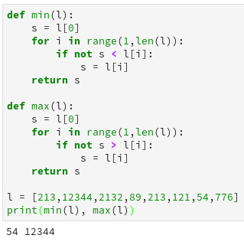

For strings lexicographic orderings will be used to find the minimum and maximum in the list

Q8.

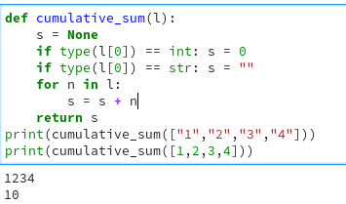

If the type is not checked the program will fail to run because integers cannot be added to a string.

Question 5 – Fourier Analysis

a.

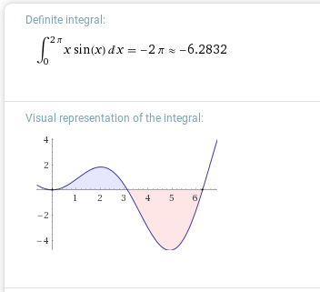  
b.

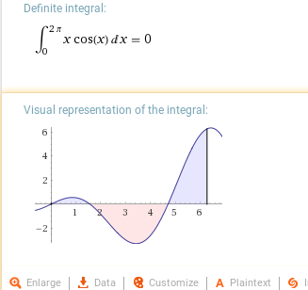

Question 7 – Fourier Analysis

A1 =

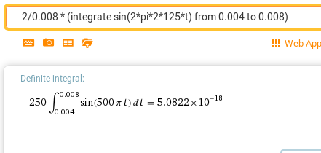

Question 8 – Fourier Analysis  
A1=

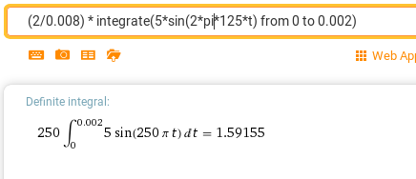

B1 =   
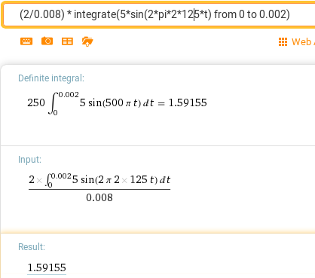

A2=   
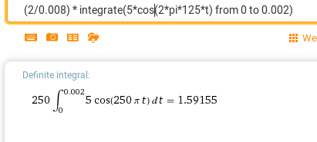  
B2 =

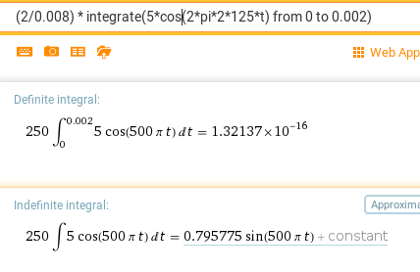

C =   
