TITLE - WrittenReport_Homework_Module4_MikeStrati_230627  
-------------------------------------------------------------------------------  
TASK - Written Report (15 points)

To receive all points, the written report presents a cohesive written analysis that:

1A - Summarizes the analysis (5 points)  
1B - Draws two correct conclusions or comparisons from the calculations (10 points)  
-------------------------------------------------------------------------------

-------------------------------------------------------------------------------

TASK 1A - Summarize the analysis

--------------------------------

Charter Schools outperform District Schools by every metric.

(Fig 1. Scores by School Type)

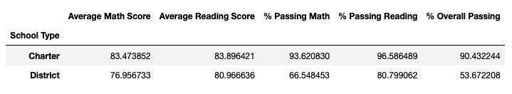

Larger Size Schools significantly underperform in every metric compared to Medium Size and Large Size Schools. (Fig 2. Scores by School Size)

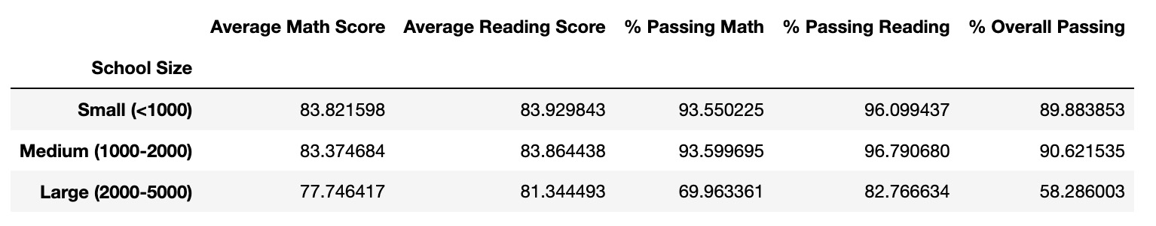

‘Scores by School Spending’ DataSet indicates that Lower Spending Ranges Per Student equates to Higher Test Scores. As well, Higher Spending Ranges Per Student equates to Lower Test Scores. (Fig 3. Scores by School Spending)

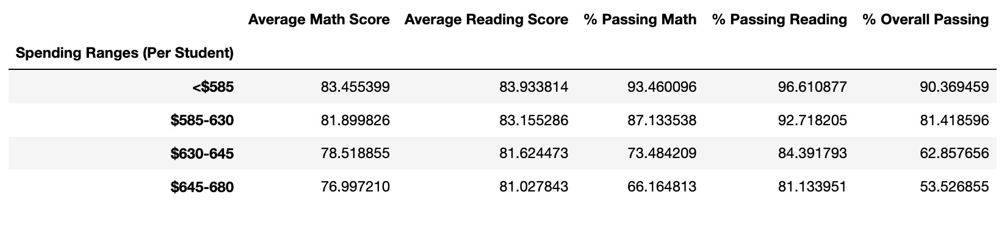

-------------------------------------------------------------------------------

-------------------------------------------------------------------------------

TASK 1B - Draws two correct conclusions or comparisons from the calculations

-----------------------------------------------------

Conclusion 1 - COMPARING PASSING-PERCENTAGE TO BUDGET

-----------------------------------------------------

Cabrera High School has the Highest Overall-Passing-Percentage at: 91.334769 %

Cabrera High School has the Third Lowest Per-Student-Budget at: $582.00

Rodriguez High School has the Lowest Overall-Passing-Percentage at: 52.988247 %

Rodriguez High School has the Highest Per-Student-Budget at: $655.00

Conclusion: Per-Student-Budget is no correlation to Overall-Passing-Percentage and in all but in the case of Thomas High School, Per-Student-Budget is often a direct indicator of lower Overall-Passing-Percentage.

(Fig 4. Below Chart sorted by Overall-Passing-Percentage, Lowest-to-Highest )

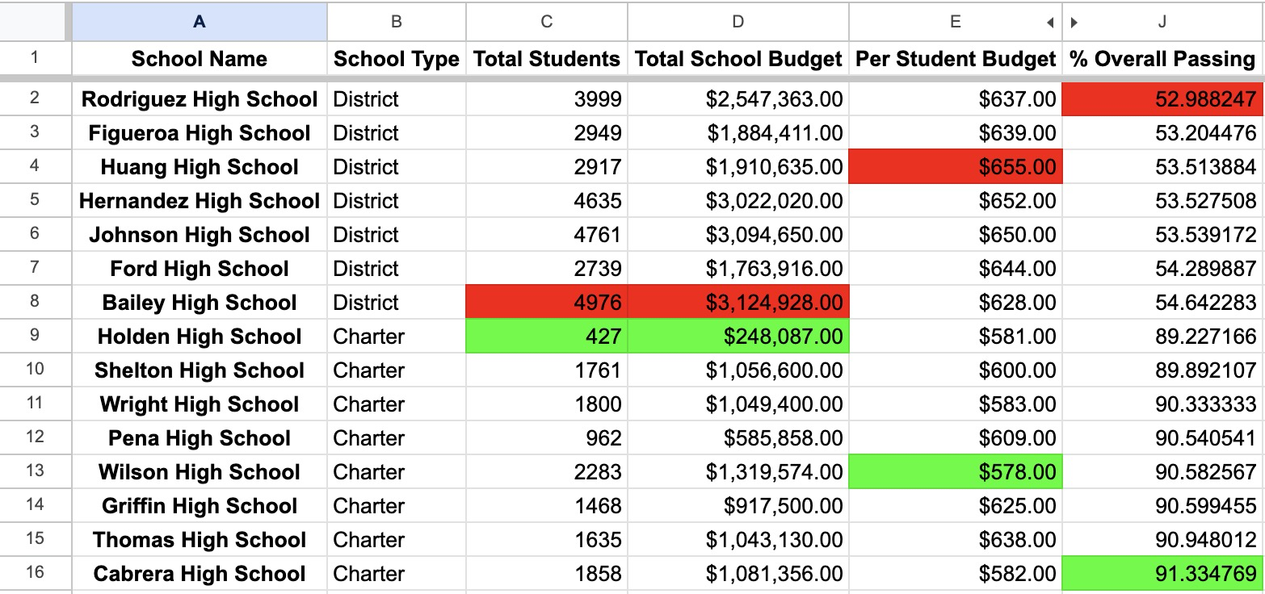

(Fig 5. Below Chart sorted by Per-Student-Budget, Lowest-to-Highest )

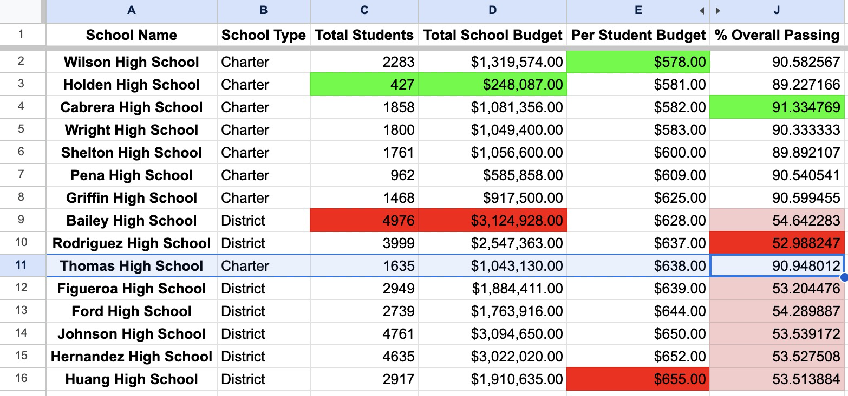

-------------------------------------------------------------------------------

-------------------------------------------------

Conclusion 2 - COMPARING TOTAL NUMBER OF STUDENTS

-------------------------------------------------

When sorting the School Summary DataSet for Total Number of Students, the 7 Schools where the Percentage of Overall Passing was less-than-60-Percent (I.E. Failing) also coincided with the Total Number of Students.

Conclusion: Better put, the 7 Schools with the Highest Total Number of Students Attending all had their Percentage of Overall Passing at less-than-60-Percent (I.E. Failing).

(Fig 6. Below Chart sorted by Total Students)

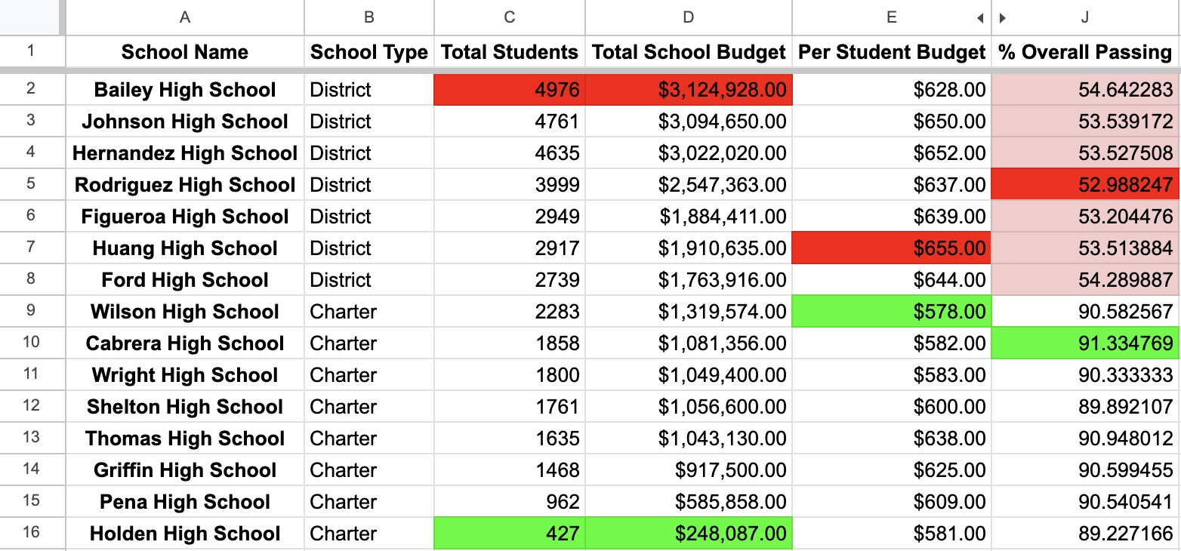

-------------------------------------------------------------------------------

-------------------------------------------------------------------------------

----------------------------------------------

Conclusion 3 - COMPARING MATH SCORES BY GRADE

----------------------------------------------

Conclusion: Holden High School has 2-out-of-4 Highest Math Scores by Grade ( Grade 9th & Grade 11th ). Other Districts can look to their Math Curriculum for advice.

(Fig 7. Below Chart sorted Alphabetically by School Name)

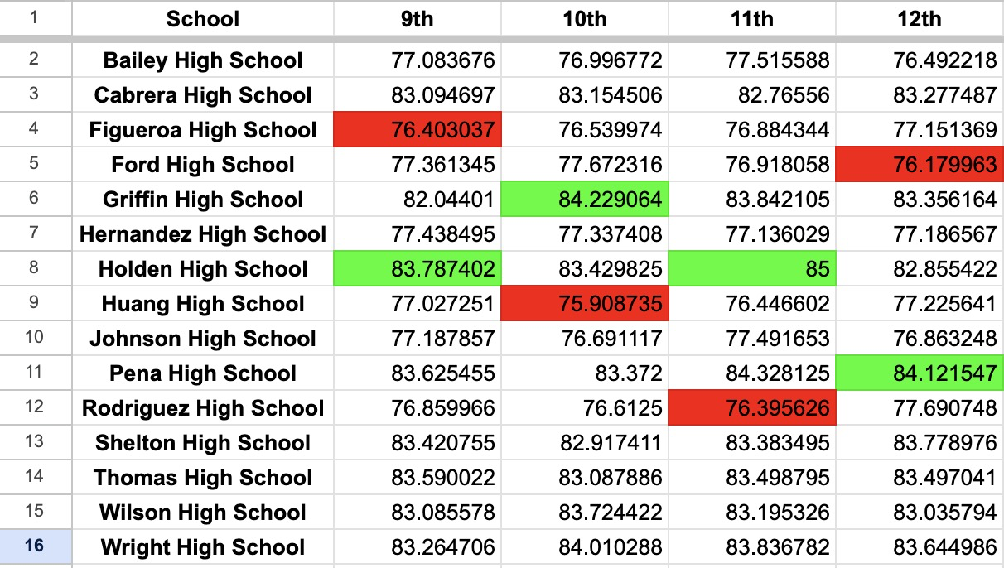

-------------------------------------------------------------------------------

----------------------------------------------

Conclusion 4 - COMPARING READING SCORES BY GRADE

----------------------------------------------

Conclusion: Ford High School shares 2-out-of-4 of the Lowest Reading Scores by Grade (Grade 9th & Grade 11th). Their Reading Curriculum could use examining.

Conclusion: Shelton High School has 2-out-of-4 Highest Reading Scores by Grade (Grade 9th & Grade 11th). Other Districts can look to their Reading Curriculum for advice.

(Fig 8. Below Chart sorted Alphabetically by School Name)



