Executive Summary: US Retail Sales Analysis (2010–2022)
Dataset: 9,048 monthly records across 58 business categories and 12 industries, U.S. Census retail sales data, Jan 2010–Dec 2022.

Key Findings

1. Automotive is the dominant revenue driver
Automotive leads all industries with a median sales value of $67,514 — nearly 1.5x the next closest industry (Food & Beverage, $47,532). Within the top 10 individual business categories by total revenue, four of the top four slots are automotive-related (Motor vehicle and parts dealers, Automobile dealers, New car dealers), together accounting for roughly 26% of total revenue across the entire dataset.
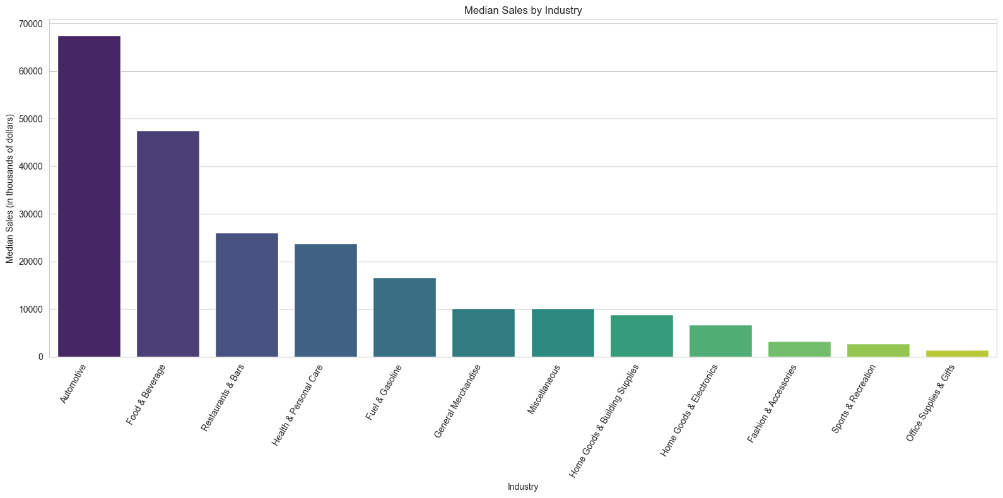
Figure 1. Median sales by industry — Automotive and Food & Beverage lead by a wide margin.
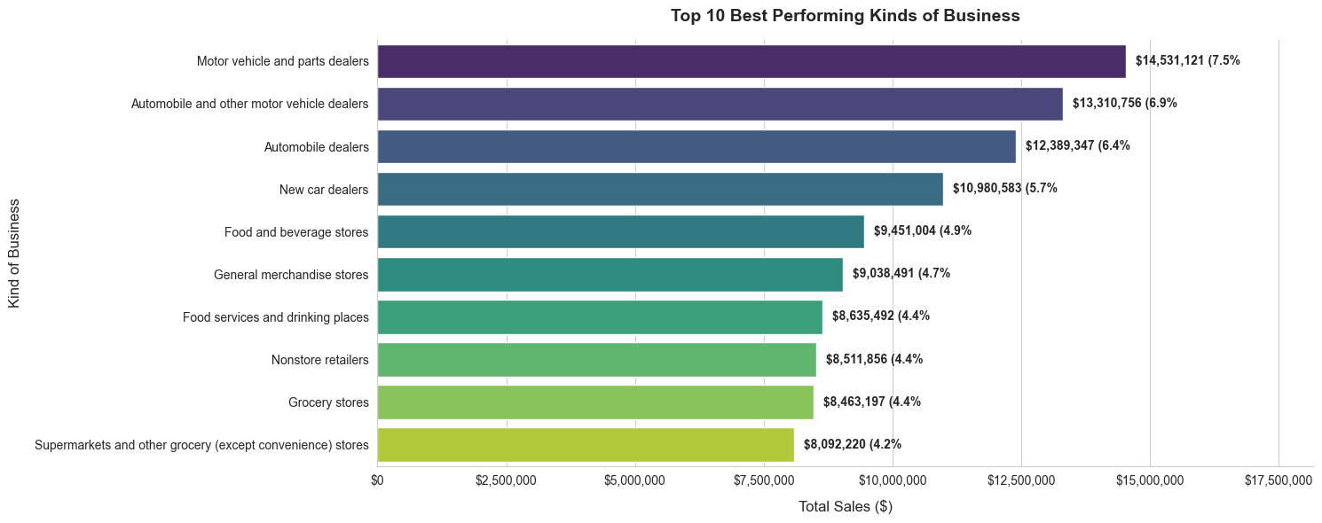
Figure 2. Top 10 kinds of business by total revenue generated, 2010–2022.

2. Food & Beverage is the most recession-resistant category
This industry shows a consistent, near-linear upward trend across all 12 years with virtually no decline during the 2020 COVID shock — rising from roughly $2.0M to over $3.2M in annual sales. It behaves like a defensive, non-discretionary spending category.

3. Restaurants & Bars were hit hardest by COVID, but recovered
Sales fell sharply in 2020 (to ~$1.8M, down from ~$2.2M pre-pandemic), consistent with lockdown restrictions. By 2022, the industry had recovered to ~$2.5M — exceeding pre-pandemic levels, though with far more year-to-year volatility than Food & Beverage or Automotive.

4. Automotive dipped briefly, then accelerated post-2020
Despite a modest early-2020 dip, Automotive rebounded sharply, reaching over $5.6M in total sales by 2022 — its strongest multi-year growth phase in the dataset.
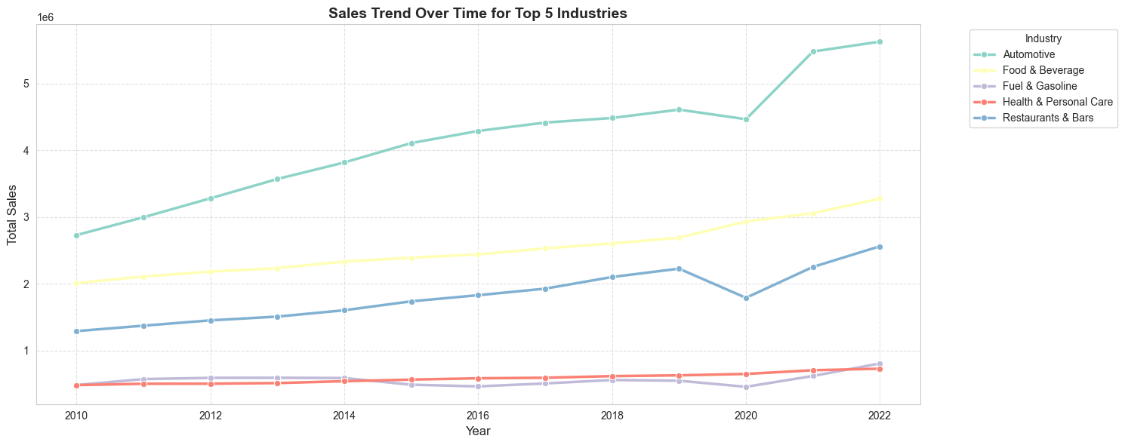
Figure 3. Total sales trend (2010–2022) for the top 5 industries, showing the 2020 dip and post-pandemic acceleration.

5. Clear seasonal patterns in General Merchandise & Home Goods/Electronics
Both categories consistently peak in Q4 in both 2020 and 2022 — a straightforward holiday-shopping effect that held steady even through the pandemic.

6. Quarterly peak timing shifted from 2020 to 2022
This signals a return to "normal" seasonal rhythms:
Industry | 2020 Peak | 2022 Peak
Automotive | Q3 | Q2
Food & Beverage | Q4 | Q4
Restaurants & Bars | Q1 (pre-lockdown) | Q3
Home Goods & Electronics | Q4 | Q4
General Merchandise | Q4 | Q4

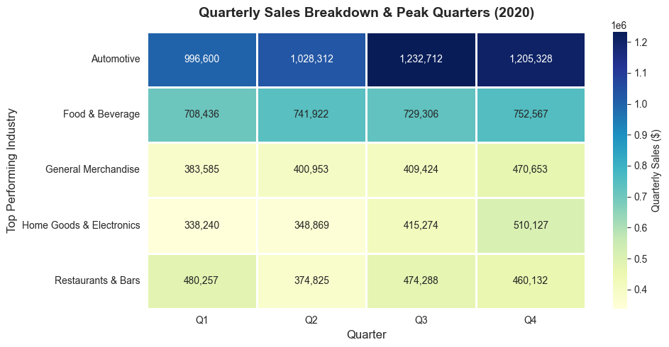
Figure 4. Quarterly sales breakdown and peak quarters by industry, 2020.
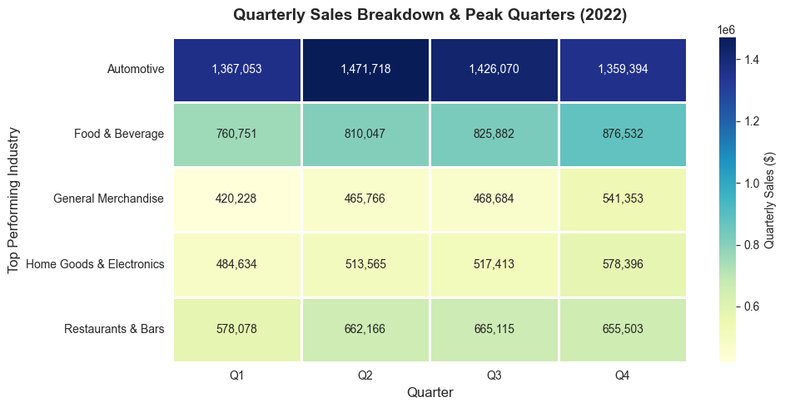
Figure 5. Quarterly sales breakdown and peak quarters by industry, 2022 — peaks shift back toward pre-pandemic timing.

7. Data quality note
261 of 9,048 sales records (~2.9%) were missing and imputed using the median — a reasonable choice given the right-skewed distribution of sales values, but worth flagging to stakeholders as an assumption baked into the figures above.

Recommended Strategies
- Prioritize capital and operational investment in Automotive. It's the single largest revenue contributor and showed the strongest post-2020 acceleration — the highest-leverage place to expand supply chain capacity and dealer inventory.
- Use Food & Beverage as a defensive anchor. Its stability through the 2020 shock makes it a natural hedge for the broader portfolio during future downturns or economic uncertainty.
- Build contingency flexibility into Restaurants & Hospitality. This segment is both high-growth and high-volatility — hybrid/delivery models and flexible staffing would reduce exposure to the next external shock.
- Align marketing and inventory cycles to Q4 for General Merchandise and Home Goods/Electronics, where the holiday effect is large and consistent year over year.
- Improve sales-data completeness at the source to reduce reliance on imputation in future reporting cycles.

