Contents

1. Audience Profile 2

2. Functionality and features 2

2.1. Features 2

2.2. Functionality 3

2.2.1. Q&A Forum 3

2.2.2. Web Playground 5

# Audience Profile

The website that I have created for this coursework, StudyTonight, is an online learning platform. It has been created to help students and other individuals who want to learn web design and development. The age of the most audience may range from 14 to 35.

The website is in English. Thus, the website can attract users from all over the world as long as they can speak English and have interest in learning Web development.

# Functionality and features

## Features

In the development of StudyTonight, I have used the following:

* HTML5
* CSS3
* JavaScript
* jQuery 3.3.1
* Twitter Bootstrap 4
* Ace.js

As the layout and overall design of the website have been developed using Bootstrap, it is completely responsive and keeps its design and beauty in mobile devices, tablets and desktops.

I have to mention that I got inspiration from the existing website, <https://studytonight.com>, in terms of look and design of the website. I also used the images and content of the website in the coursework in order to avoid dummy text and stock images, which would make the website unrealistic, and template-like.

The website is hosted using GitHub Pages. It is online at <https://mikado2710.github.io/>. I used this service as it makes it easy to host and maintain the website.

There is also a preloader used in the website, which encourages users to wait until the page is fully loaded.

One more interesting feature of the website is that it has a sign in box that pops up when Sign-in button is clicked on the navigation menu. However, as a functional sign in process includes database, and some back-end programming, it is not fully functional in the case of this coursework.

## Functionality

### Q&A Forum

One of the main functions of the website is its Question and Answer Forum. This page is at <https://mikado2710.github.io/forum.html>. On this page users can post their own questions regarding web development and programming and answer previously posted questions. As the website does not have any kind of back-end technologies to support, it uses Vanilla JavaScript to make this functionality possible.

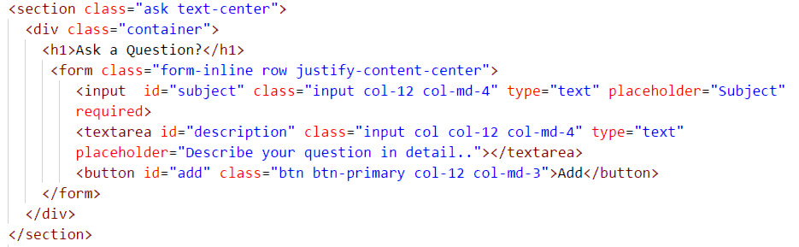

First, a simple form was created to get the inputs from a user. The user can write the subject of the question along with detailed description of it. When a user clicks Add button after completing the form, the following JavaScript code validates the user input, calls the addQuestion function and resets the form.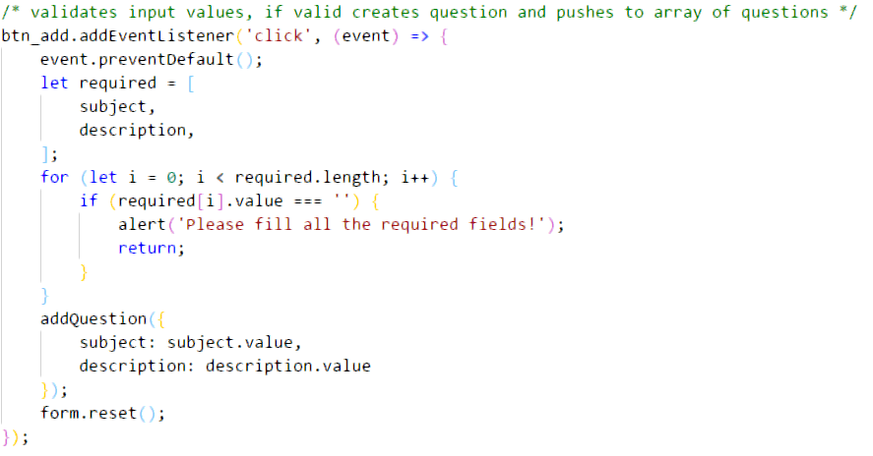

The addQuestion function pushes the question to the array of question where they are temporarily stored. It also creates all the html elements that are needed to add the question, sets required attributes and nests them properly.

The form also has an answer button in every question which pops up a modal answer form when pressed. The form has a textbox where user can enter his or her answer to the question. The form is submitted by pressing the Submit button, which also calls JavaScript.

Adding question functionality works very similar to adding question functionality in terms of how it is coded. It checks if the textbox in answer box is not empty, creates html elements, sets CSS, Bootstrap and other necessary attributes, and nests those elements in a particular order to display it on the website.

### Web Playground

Another important function of the website is that it has an online text editor built in a web page, <https://mikado2710.github.io/playground.html>. Users can write HTML, CSS and JavaScript codes in it to practice the web development skills that they developed.

In order to create this functionality, a JavaScript library called Ace.js was used. It is a great library which is used in a great number of websites to enable this functionality of creating an online text editor.

The JavaScript ready function is called when the Playground page is load. The ready function itself calls setupEditor and update. The setupEditor is an Ace.js function which configures the text editor. The update function takes the users input constantly and updates the iframe.

References

1. Studytonight, (2018). *Studytonight - Best place to Learn Coding Online.*[online] Studytonight. Available from: <https://studytonight.com> [Accessed at 8 November 2018].