FUR STEP 7
Administrative Security Record
Status: Approved | Approval date: 7 September 2026 | Scope: GitHub, Supabase and Vercel
Purpose. This record identifies the cloud services used to administer and operate FUR, their business purpose, administrative control, authorised devices, MFA status, general data categories, and the procedures governing access and updates.

1. Service and administrator register
Service | Business purpose | Administrator account label | MFA status
GitHub | Source control, documentation, review and automated workflows | mikael230776-crypto | Enabled and verified
Supabase | Backend database, authentication, storage and verification service | Account linked to mikael230776-crypto | Enabled and verified
Vercel | Website hosting, builds and production deployment | mikael230776-3734's projects | Enabled and verified

2. Authorised devices
- Mac laptop - administration of GitHub, Supabase and Vercel.
- Android phone - storage and generation of Google Authenticator codes.
Excluded identifiers: serial numbers, device IDs, passwords and authentication codes are not recorded.

3. General data categories
Service | FUR data stored or processed
GitHub | Source code, tests, technical documentation, configuration files, pull requests, issues, commit history and automated workflow results.
Supabase | FUR product/tag verification records, database records used by the verification service, and related timestamps and status information.
Vercel | Public website files, deployed application code, build/deployment logs, request logs, configuration metadata and protected environment variables.

4. Access-control procedure
- FUR administrator access is restricted to the owner by default.
- Administrator accounts must not be shared.
- Any future access must be approved by the owner for a named individual and limited to the minimum permissions required.
- MFA must be enabled before administrator access is granted.
- Only authorised devices recorded in the FUR security register may access administrator accounts.
- Access must be removed immediately when no longer required, when a person's role ends, or when a device is lost or compromised.
- Following suspected compromise, active sessions and access tokens must be revoked and affected credentials rotated.
- Recovery codes and authentication secrets must be stored privately and never placed in GitHub, documentation, screenshots, messages or support tickets.

5. Update procedure
- Update the FUR administration register whenever a service, administrator account, authorised device, MFA method or data category changes.
- Record the date, general description of the change, person approving it, and any sanitised evidence reference. Never record secret values.
- Review administrator access and authorised devices every three months and immediately after any security incident.
- Remove unused accounts, sessions, devices, access tokens and integrations promptly.
- Keep the Mac operating system, browser, Android phone and authenticator application supported and updated.
- Apply application and dependency updates through the normal GitHub review and testing process before deploying through Vercel.
- Review Supabase and Vercel security notices and configuration changes before applying them to production.
- Record recovery-code regeneration by date only; never record the codes in the administration register.

6. Security evidence
Evidence is limited to security status only. Images containing recovery codes were excluded. No QR code, OTP, password, email address, API key, token, environment-variable value or recovery code is included.

GitHub - 2FA enabled
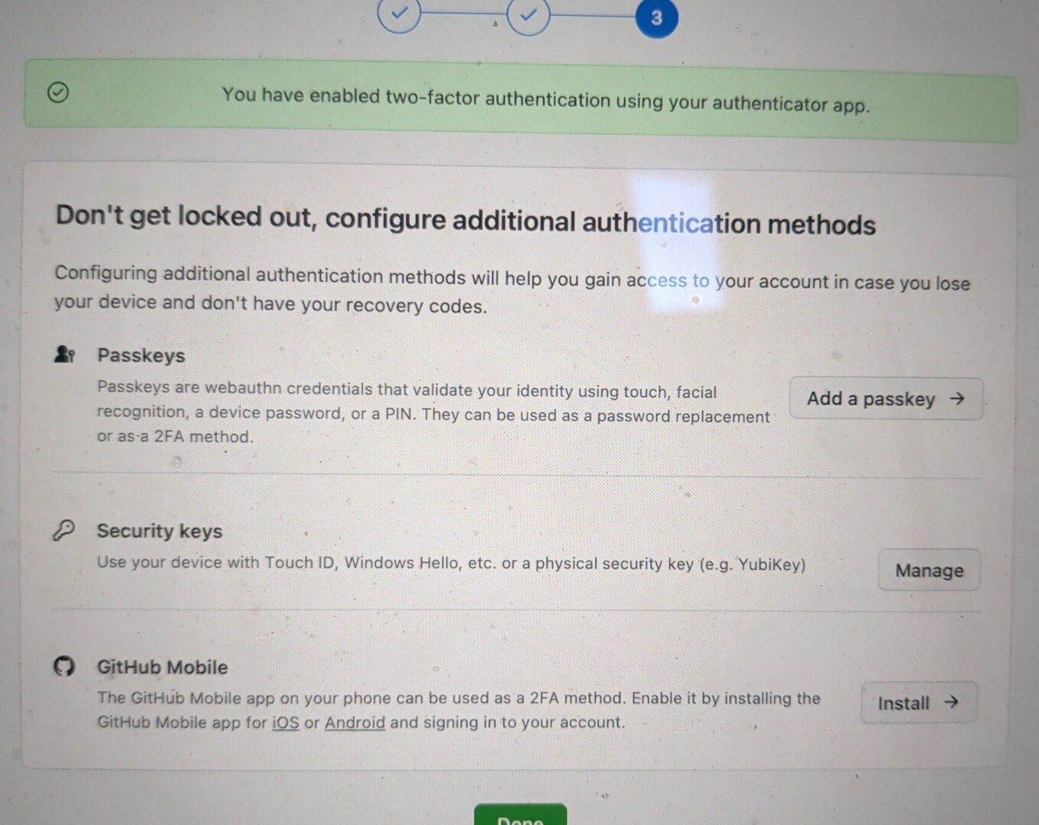
Figure 1. GitHub confirmation that two-factor authentication is enabled using an authenticator app.

Supabase - authenticator configured
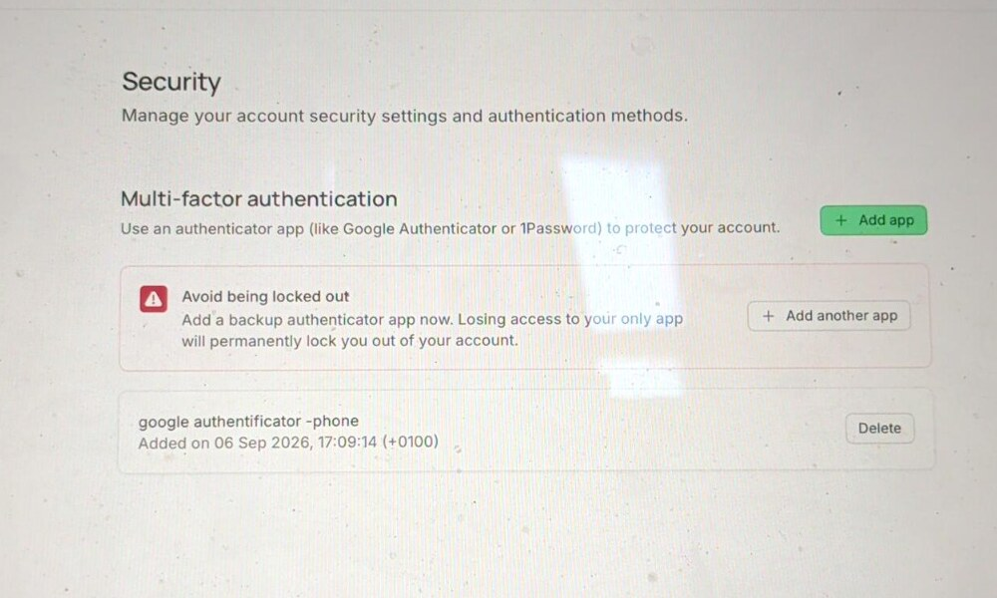
Figure 2. Supabase security page showing the configured authenticator label. No QR or code is shown.

Vercel - verification record
Verification method: successful fresh Vercel sign-in using an authenticator code on 6 September 2026.
Evidence limitation: no post-setup screenshot was retained; the completed security procedure was not repeated solely to obtain one.

7. Approval and control statement
This Step 7 record was reviewed and approved on 7 September 2026. It contains no active credentials. The GitHub recovery codes visible in earlier working images were invalidated and replaced; those images are excluded from this record.
Repository status: This review document is separate from the FUR repository. No repository, database or deployment change is made by creating it.

