Thesis:

A Timeline of Women’s Fertility/ Reproduction Throughout Her Lifetime

**Research Guiding Questions:**

* What are the current fertility trends? Are women having children later in life?
* What do women need to know about their fertility/ reproduction?
* What choices do women have to make?
* When do women need to make these choices?
* Are women being educated to make these choices?
* How do these choices differ for women around the world?
* Why is it important for women to be aware of choices surrounding their fertility/ reproduction?
* How should female sexual health be addressed within educational institutions? When?
* Does educating women about pre-pregnancy perpetuate patriarchal ideas about motherhood?
* What information do women need to have to make informed decisions about their own fertility/ reproduction (including the choice to not have children)?

**Audience:**

* General Audience:
  + May have previous knowledge about fertility and pre-pregnancy
  + Varying opinions on the topic and different misconceptions
  + Can be argued as both feminist and anti-feminist
  + Scientific/ factual vs. personal belief and opinions may come into play
  + Must be presented in a tone that is non-bias and does not tell women what choice they should make, rather what choices are available
  + People may be overwhelmed with different opinions being told to them (never one straight answer)
* Educators:
  + Already knowledge on the topic but want to see how it can be presented differently
  + Sexual health educators may want to incorporate fertility education into curriculum
  + May also be seen as “inappropriate” to teach young children
* Field Workers:
  + People who work with women/ study fertility and pre-pregnancy
  + Want help advocating the for the importance of accurate and accessible knowledge
  + Want to be able to clear misconceptions

**So What? Why is This Important?**

* Women are choosing to have kids later in life for various reasons
  + They should not feel pressured to give up career due to “biological clock”
  + They also should not have to go extensive fertility treatments because they waited to have kids at an older age (or have to find out they can no longer have kids at all)
  + Information = the ability to make decisions (including the decision to not be pregnant)
* There are so many varying opinions about fertility/ there is no “one” place to find information which makes seeking out information feel daunting
* Sexual education does not teach fertility or anything pre-pregnancy related (fear of encouraging teen pregnancy?)
* Issues regarding women’s fertility is drastically different for women in different parts of the world

**Goals:**

* To provide information in a way that feels helpful and empowering for women
* To create a tool that can be used for both educational and personal use
* To contextualize issues surrounding fertility by providing international examples and case studies

**Design:**

* Inviting
* Fun/ playful
* Timeline:
  + Split into age groups?
  + Specific to the age
* Hand drawings/ graphics
* Trustworthy information
* Colorful
* Interactive (move things around)
* Collage
* A little bit messy? (non sterile)

**Visualization:**

* Timeline (vertical or horizontal?)
* Ability to click and have pop ups (case studies/ stories)
* Ability to choose what age you want to see or scroll through the entire timeline
* Link to resources
* End with “larger picture” data visualization (quantitative) 🡪 second visualization?

**What Points will be Covered on the Timeline?**

* Puberty
* When to start fertility education (Age 9)
* Sexual Abuse
* Period
* Pap Test/ Gynecologist
* Virginity
* Birth Control
* Biologically the best age to reproduce (Age 19)
* Biologically the best age to have multiple children (Age 23)
* When America thinks you should have your first child (Age 25)
* The perfect age to have a baby according to the British (Age 26)
* The perfect age to have a baby according to the Dutch (Age 27)
* The age women begin to show a decline in fertility (Age 28)
* The “Most Fertile Age”
* The youngest girl ever pregnant
* Egg Freezing
* IVF
* Menopause

**Qualitative Sources:**

* The Zero Trimester: Pre-Pregnancy Care and The Politics of Reproductive Risk
  + “This book aims to highlight the historical, cultural and political underpinnings of pre-pregnancy care, embracing instead of eschewing all the nuances that come with such analysis”
  + Chapter 1: Someday, Now: Preconceiving Risk and Maternal Responsibility
    - If we put too much pressure on women about pre-pregnancy care it promotes the idea that women are just a “baby vessel”. (p. 2)
      * Problematic to think of women during a reproductive age as “mothers-in-waiting” 🡪 is that all they are?
      * “for any women of childbearing age, in the case of pregnancy health, someday is now”
    - the pre pregnancy model introduces a “zero trimester” = focus on the months or years prior to conception in which women are urged to prepare their bodies for a healthy pregnancy
    - As women wait longer to have kids and have less kids, they are extending this “pre-pregnancy phase”
    - Modern views of fertility = Ansley Coale “calculus of conscious choice” 🡪 with the availability of contraception and family planning techniques, women and couples are presumed to have the option to avoid pregnancies and to plan and space births according to their wishes
    - Greater emphasis on pre pregnancy care in the turn of the 21st century is about women’s increasing control over their fertility
    - The pre-pregnancy model can be “dangerous for women” but also is one that hinges on reproductive-justice notions of expanded health services for all women, regardless of if they become mothers
      * It Is neither wholly hostile to feminist progress nor the saving grace for women and babies in America

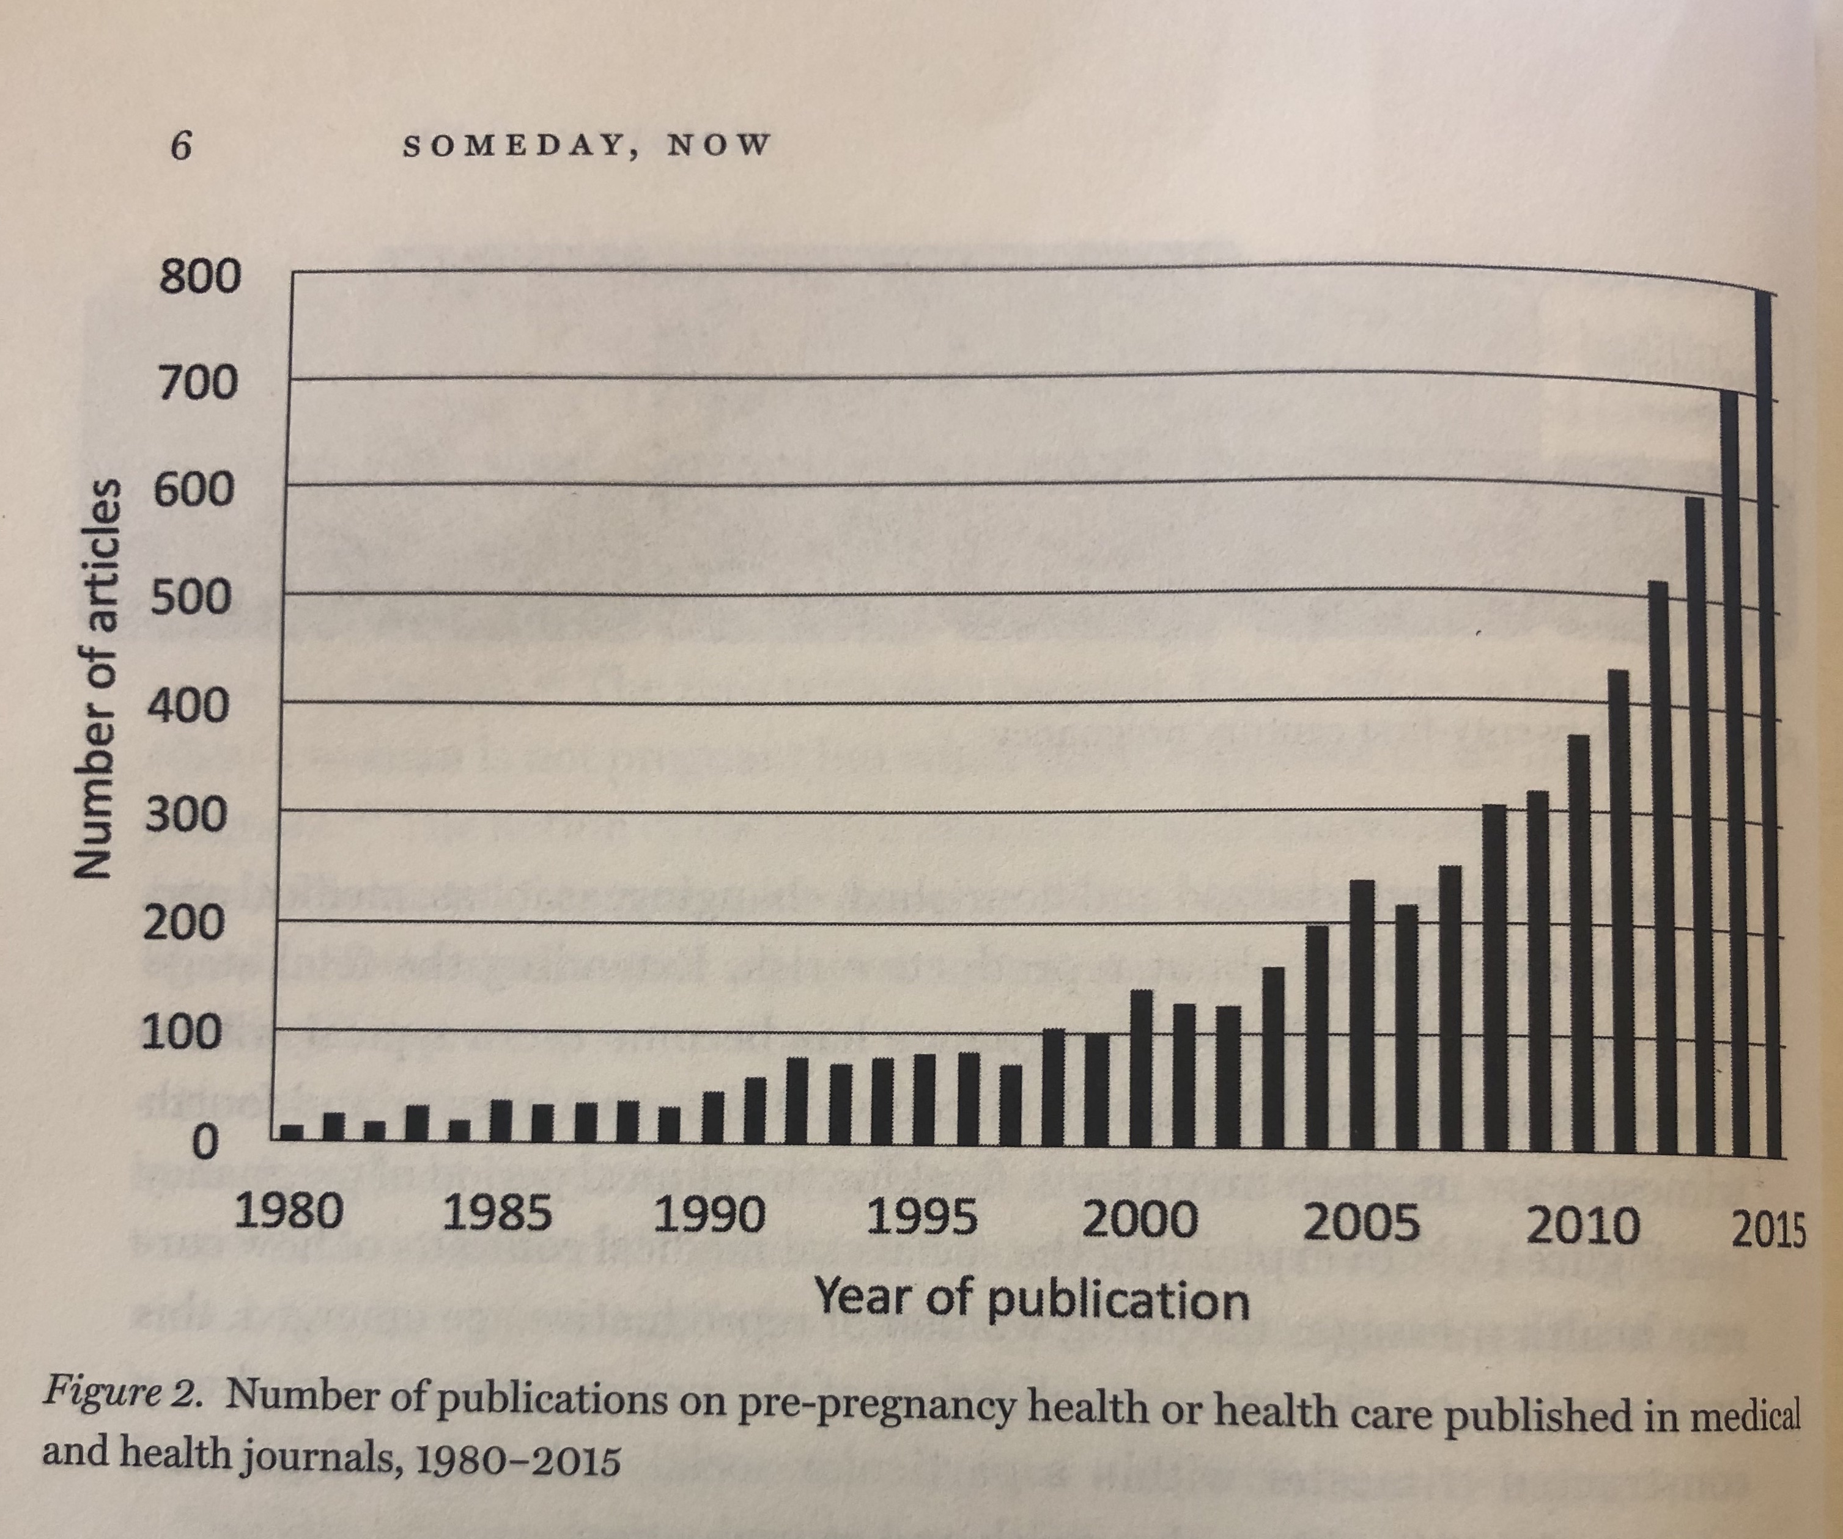

* Informed Reproductive Decision-Making: The Impact of Providing Fertility Information on Fertility Knowledge and Intentions to Delay Childbearing
  + <https://www.jogc.com/article/S1701-2163(15)30585-5/fulltext#s0005>
* A persistent misperception: assisted reproductive technology can reverse the ‘‘aged biological clock’’
  + <https://www.fertstert.org/article/S0015-0282(12)00229-4/pdf>

**Quantitative Sources:**

* Mean Age of Mothers is on the Rise: United States, 2000–2014 (<https://www.cdc.gov/nchs/data/databriefs/db232.htm)>
  + Key Findings: Data from the National Vital Statistics System
    - Mean age can affect the total number of births a mother has over a lifetime, which in turn impacts the composition and growth of the U.S. population.
    - Age of mother is associated with a range of birth outcomes, such as multiple births and birth defects.
    - The mean age of mothers has increased from 2000 to 2014 for all birth orders, with age at first birth having the largest increase, up from 24.9 years in 2000 to 26.3 years in 2014.
    - Increases in the average age for all birth orders were most pronounced from 2009 to 2014.

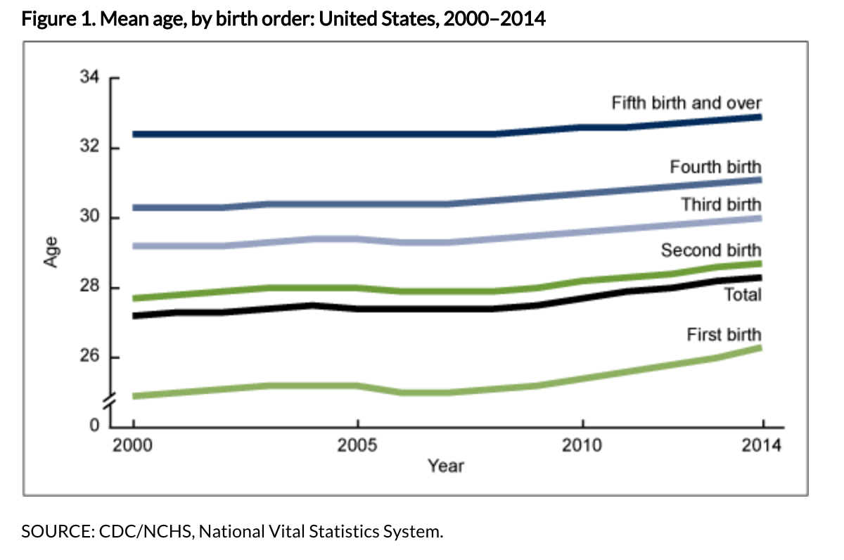

* Trends in Fertility and Mother’s Age at First Birth Among Rural and Metropolitan Counties: United States, 2007–2017 (<https://www.cdc.gov/nchs/products/databriefs/db323.htm)>
  + Key Findings: Data from the National Vital Statistics System
    - During 2007–2017, total fertility rates in the United States fell for rural and metropolitan counties: 12% in rural, 16% in small or medium metro, and 18% in large metro counties.
    - For all years, the mean age of mothers at first birth was lower in rural counties compared with metro counties.
    - Downward trends in total fertility rates and increases in mean maternal age over time occurred in rural and metro counties for each selected race and Hispanic-origin group.
    - Data: <https://www.cdc.gov/nchs/data/databriefs/db323_table-508.pdf#page=3>

