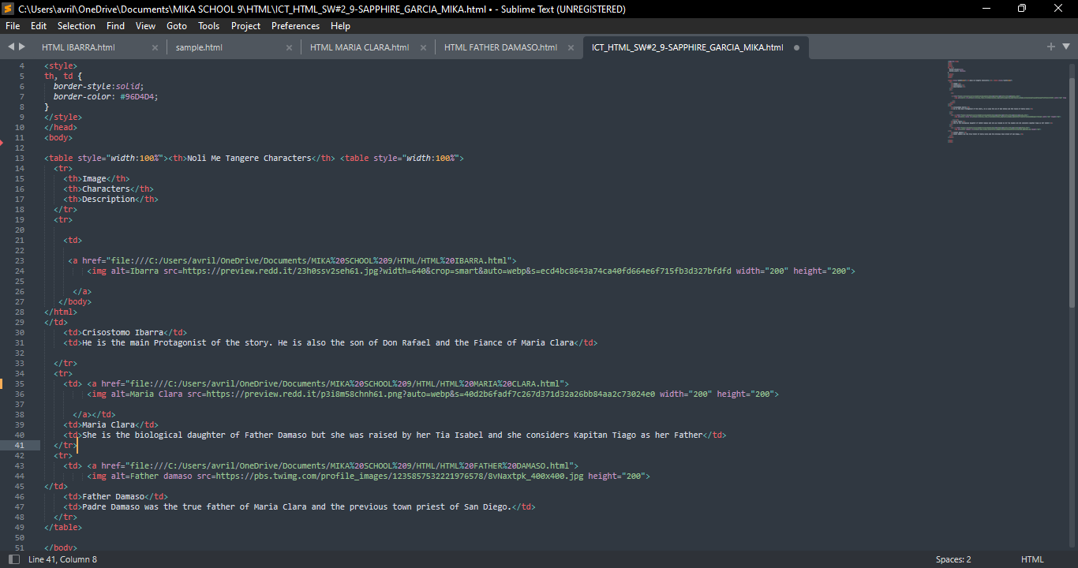

<!DOCTYPE html>

<html>

<head>

<style>

th, td {

border-style:solid;

border-color: #96D4D4;

}

</style>

</head>

<body>

<table style="width:100%"><th>Noli Me Tangere Characters</th> <table style="width:100%">

<tr>

<th>Image</th>

<th>Characters</th>

<th>Description</th>

</tr>

<tr>

<td>

<a href="file:///C:/Users/avril/OneDrive/Documents/MIKA%20SCHOOL%209/HTML/HTML%20IBARRA.html">

<img alt=Ibarra src=https://preview.redd.it/23h0ssv2seh61.jpg?width=640&crop=smart&auto=webp&s=ecd4bc8643a74ca40fd664e6f715fb3d327bfdfd width="200" height="200">

</a>

</body>

</html>

</td>

<td>Crisostomo Ibarra</td>

<td>He is the main Protagonist of the story. He is also the son of Don Rafael and the Fiance of Maria Clara</td>

</tr>

<tr>

<td> <a href="file:///C:/Users/avril/OneDrive/Documents/MIKA%20SCHOOL%209/HTML/HTML%20MARIA%20CLARA.html">

<img alt=Maria Clara src=https://preview.redd.it/p3i8m58chnh61.png?auto=webp&s=40d2b6fadf7c267d371d32a26bb84aa2c73024e0 width="200" height="200">

</a></td>

<td>Maria Clara</td>

<td>She is the biological daughter of Father Damaso but she was raised by her Tia Isabel and she considers Kapitan Tiago as her Father</td>

</tr>

<tr>

<td> <a href="file:///C:/Users/avril/OneDrive/Documents/MIKA%20SCHOOL%209/HTML/HTML%20FATHER%20DAMASO.html">

<img alt=Father damaso src=https://pbs.twimg.com/profile_images/1235857532221976578/8vNaxtpk_400x400.jpg height="200">

</td>

<td>Father Damaso</td>

<td>Padre Damaso was the true father of Maria Clara and the previous town priest of San Diego.</td>

</tr>

</table>

</body>

</html>

