Creating a Citizen Scientist Dashboard for Robert B. Annis Water Resource Institution (AWRI) Muskegon Lake Buoy

Berg Mikaela, Data Scientist and Analytics Graduate Student*, Grand Valley State University*

**Abstract**— Robert B. Annis Water Resource Institution (AWRI) is a local research organization that does work relating to the Great Lakes, inland lakes, rivers, local ecosystems and many more fields. The Dr. Biddanda lab at AWRI collects data from the buoy on Muskegon Lake and one of the sites they display this data is on a Current Contions page hoseted by Grand Valley State University. This page shows the data off as a table of values that updates meterolrogical data every 15 minues and water data every hour. This webpage gets used by the general public and a new goal of AWRI is to have something to improve on how they show off their data that they collect from the buoy. The project is preposing a citizen dahsbaord that would display the information that appars on the Current Conditons page. The mock-up design for this project was made in Adobe Xd and received feed back from the Bopi lab in format and what they would like to see on that page. The translation from mock-up to webpage was done in Windiows Visual Studion Code with base JavaScript, CSS, and Html. The final site made has all the basic qulaites of the mock-up as a static website. The future goal for this project is to improve upon this crafted webapge and make the site fully dynamic and interactive with the general public.

**Index Terms**— AWRI, buoy, Muskegon Lake, Current Conditions, data, webpage.

Introduction

Robert B. Annis Water Resource Institution (AWRI) is a local research organization that does work relating to the Great Lakes, inland lakes, rivers, local ecosystems and many more fields. The Biddanda lab at AWRI has been collaborating and collecting data from a buoy placed in the Muskegon Lake. This buyo is in the water from the later spring to early fall months. Its data is displayed on various webpages by Grand Valley State University (GVSU). One webpage provides a tool for the user to select different variables collected by the buoy and graph those options. This page is called the Data Grapher and while it is a powerful page to explore historical data, it can be challenging for the average person that is not very familiar with this type of data.

However, there is another webpage that gets used by the public, which displays the most recent meteorological and water data from the buoy. This page is called Current Conditions page, and the data for this page is showed off as a table where the meteorological data updates every 15 minutes, and the water data updates every hour [1]. This page gets used by children who are on a boat field trip to the buoy where they collect their own data and comparer it to what this webpage reads. This page also gets used by fishermen and boaters who are observing data that could show optimal fishing and boating conditions.

While the table is a good format for users to easily access and read the data, someone who is not as familiar with the context might have a harder time reading a long table of values and text. This is where a citizen scientist dashboard might be helpful to have. A place where the same current conditions data is displayed but in a format that the user can have an easier time gaining insight into these values. When coming up with what should be on this dashboard the variables that were considered were: what web pages already exists for this data and organization, what items or concepts are missing from those webpages and who is the audience of this dashboard?

* Mikaela Berg is with Grand Valley State University Data Science and Analytics Master’s Program. E-mail: bergm@mail.gvsu.edu.

Manuscript received xx xxx. 201x; accepted xx xxx. 201x. Date of

Publication xx xxx. 201x; date of current version xx xxx. 201x.

For information on obtaining reprints of this article, please send

e-mail to: reprints@ieee.org.

Digital Object Identifier: xx.xxxx/TVCG.201x.xxxxxxx/.

The takeaway after some exploration around the AWRI webpages was that there is a place to graph historical data, a place to view historical water quality data, and a place to observe current conditions of the buoy. What is missing from these places is somewhere to show off pre curated analytical data and a place that provides a way to highlight certain variables from the buoy. To elaborate on this last point, if a fisherman wated to know the conditions of the water column it might be easier to observe water column data in a visual graphic with colours associated to values than as text on a table. As this has been stated multiples times already, the audience for this dashboard includes fisherman and children on a field trip, but the audience range for this ranges from the general public citizen scientist type to the field experts. Anticipating this the goal for the project was to make a dashboard that is easily readable, and that highlights key variables from the data that is on the current conditions page.

# Methods

The start of this project involved creating multiple mock-up dashboards and showing them to Dr. Bopi Biddanda and another lab member Anthony Weinke. Those dashboards ranged from places to show the current conditions page data off to also showing off the historical data as a dashboard. After the input from Dr. Biddanda and Anthony a design for the current condition’s dashboard was refined and used as a reference when making the webpage. The mock-up was made in Adobe Xd, and the final webpage was made in Visual Studio Code using JavaScript, Html, and CSS. Graphs were also made for the website using some historical data from the buoy in both Tableau and R Studio.

## Creating the Mock-Up

Shown in figure 1 is the final mock-up created for this project in Adobe Xd. This includes a left side and a right side. The left side containing the various widgets, while the right side contains information relevant to the large graph container on this side. For the left side, the water column is showed off with both data about the water temperature and dissolved oxygen at varying depths. The gauges are inspired from gauges on the AWRI water quality page [1]. This is to highlight the context of those values for both phycocyanin and chlorophyll-a. The importance of highlighting these values is to show if in high levels of chlorophyll-a there is a potential algal bloom and in an instance of high phycocyanin levels there is a potential harmful algal bloom underway. The windspeed container has an arrow indicating the wind direction and a compare rose to indicate the nautical direction of the wind. There was also the idea that the background of this container would change colour to indicate intensity of the wind speed. The last container on the left side was all the air meteorological information collected on the buoy.

On the right side of this container there is a drop down where the user could select different graphs to view for the current conditions. On the graph the data was on a time series, where over a 12-hour time, when new time point is added on the right it is removed from the left. There is then the time slider that would allow the user to go back or forward in time similar to the froward and reverse viewing of a weather radar.

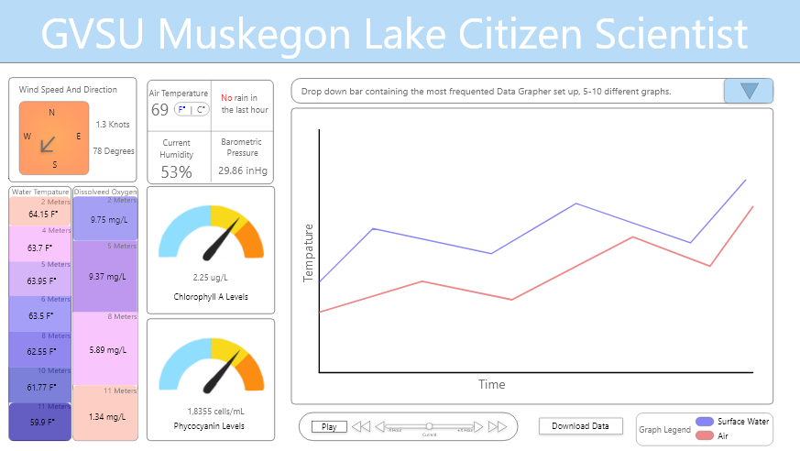

Figure : Mock-up created in Adobe Xd to showcase the Muskegon Lake buoy data that is represented on the current conditions page.

## Creating the Website

For translating the concepts of the mock-up to a real webpage, base JavaScript, CSS, and Html were used in Windows Visual Studio Code. The data used to generate the sample graphs and to place on the webpage is available on the Open Science Framework (OSF) which is a database for the Centre for Open Science (COS) [3]. To show the data on the webpage a single instance was take from the data put into a JSON file for ease of integrating data from the file onto the site. The site shown in figure 2 is still a work in progress, but it has all the main components from the mock-up.

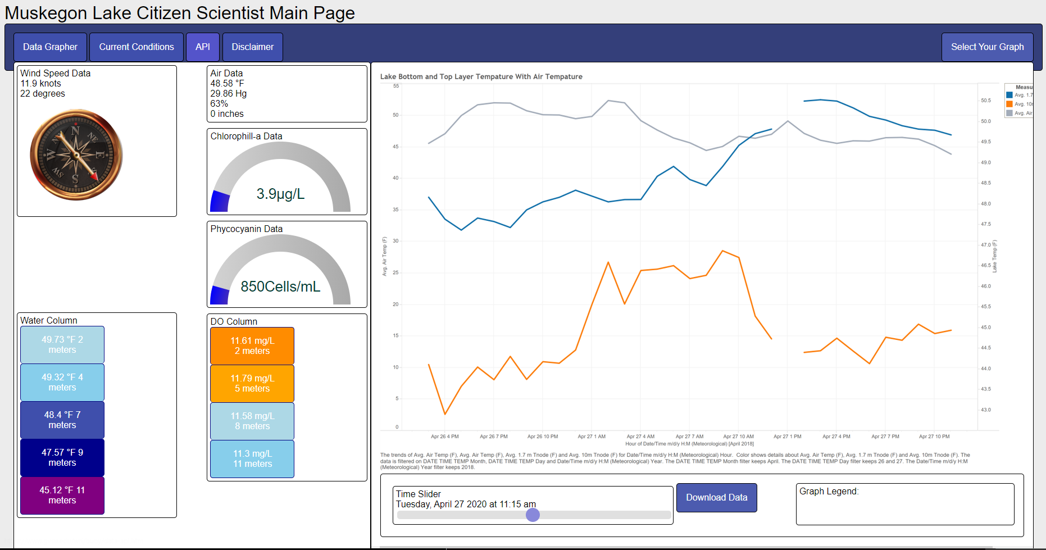

Figure : Overview of the webpage generated in Windows Visual Studio Code using JavaScript, CSS, and Html.

On the top left of navigation bar contains links to the different AWRI buoy data web pages, and on the right side is the button selector for the different graphs. The left side of this webpage shown in figure 3, contains two different widgets (the compass and the gauge) that were found from online sources [4][5]. The columns for water temperature and dissolved oxygen (DO) are simply buttons stacked on top one another with colours to attempt to match the mock-up colour scheme. The gauges also have colours that are coded to be in a gradient from blue, to yellow to orange. The right side shown contains three graphs generated in Tableau and R Studio and the slider with the data, download data button, and a container for a graph legend. This webpage is meant to be a starter page that is static. The slider is on the page it does not change anything on the page. Similar, the download data button does not download any data generated on this page.

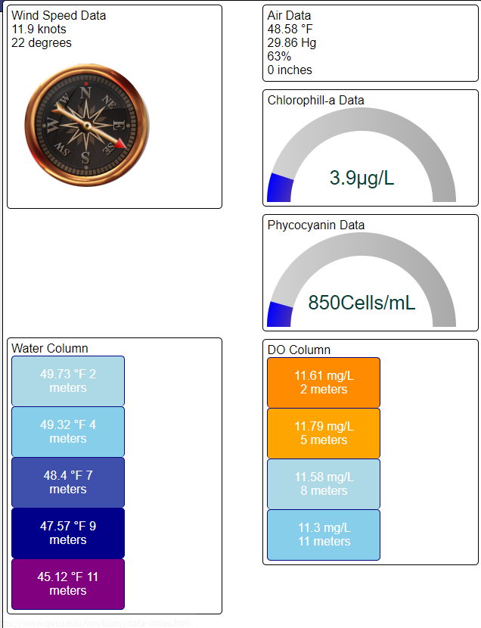

Figure : Closer view of the left side, that contains meteorological data and water data from the buoy.

### Tableau Generated Graphs

The first graph shown in figure 2, 4 and in the supplementary document figure 3. The second graph shown in figure 5 and in the supplementary document figure 4. Both graphs were generated using the most recent version of Tableau v2020.3 from the data downloaded on the OSF site, between the day April 26th and 27th  of 2018 in increments of hour.

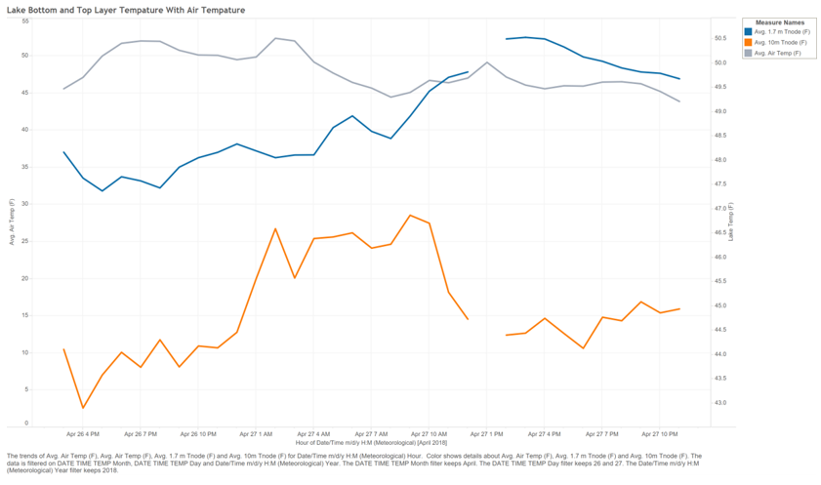

Figure : Graph showing Muskegon Lake bottom and top layer water temperature with the air temperature. Bottom temperature is at 10 meters and in orange, top temperature is at 1.7m and in dark blue, air temperature is in gray. This graph is also in supplementary document figure 3.

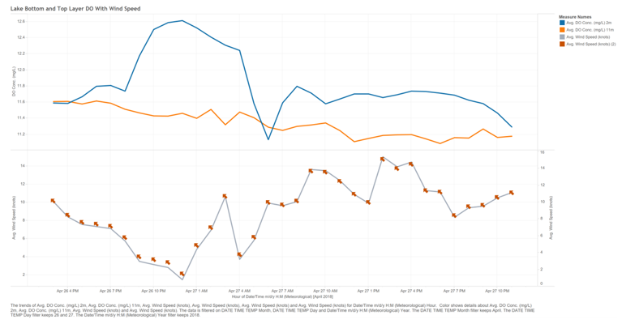

Figure : Graph showing Muskegon Lake bottom and top layer dissolved oxygen (DO) with the windspeed. Bottom DO is at 11 meters and in orange, top DO is at 2m and in dark blue, wind speed is in gray with arrows to mimic indicators of wind direction. These arrows are not indicating actual wind direction since generating a graph that does that is unknown if can be done in Tableau. This graph is also in supplementary document figure 4.

### R Studio Generated Graph

Thermocline depth is the depth at which the temperature changes dramatically compared to the layer above and below it. The package rLakeAnalyzer had a function called thermo.depth() that calculates the thermocline depth when inputted the water temperature, and depths [6]. The thermocline depth was calculated using the data for April 26th to April 27th, 2018 in hour increments for the depths 1.7, 2, 4, 6, 8, and 10 meters. The thermocline depth was calculated to be 9 meters, and this was graphed using ggplot2 as shown in figure 6.

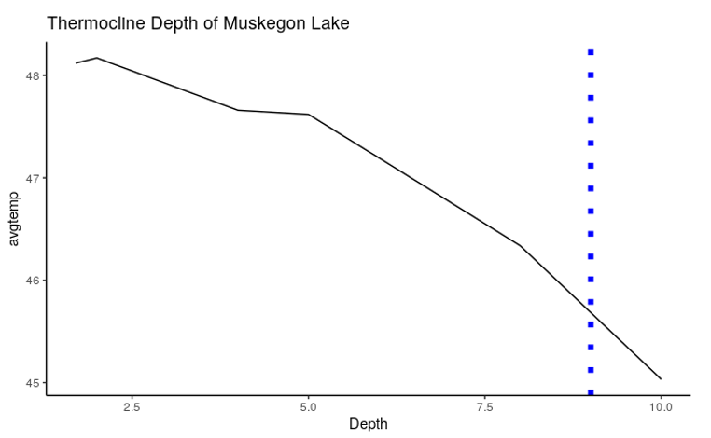

Figure : Thermocline depth of 9 meters in the blue dashed line for the data on April 26th to April 27th of 2018. This graph is also in supplementary document figure 5.

# Discussion

The final webpage that was generated is meant to be a static page that will act as a template or reference for the proposed dynamic webpage. The goal is to incorporate JavaScript D3 library for the graphing and dynamic interface of the webpage.

## Creating the Mock-Up

There are other mock-up to be made for the historical data representation, as well as a dashboard to show the Muskegon Lake buoy data with data from a nearby National Oceanic and Atmospheric Administration (NOAA) buoy on Lake Michigan. Those mock-ups will also be made in Adobe Xd, and with more dynamic outlook as with this project base methods and tools were learned about for Adobe Xd.

## Creating the Website

This project was a first exploration and attempt into making a website. Looking forward for this website there will be more incorporation into packages for web development like JQuery, or D3 that will streamline making and using dynamic components. Learning the tools to making a website takes time and lots of trial and error.

### Using Html, JavaScript, and CSS

One concept that should have been addressed first before introducing other widgets and features, was the concept of layout and formatting the website. That was one of the last things handled on this project and it suffered some obstacles because of that. Most of the JavaScript was code written by other sources and implemented into the project via trial and error. The Html and CSS was learned and implemented from W3 Schools [7]. While the website is functional there is lots of room for code cleaning and improvements in workflow.

### Using Tableau

The data was already cleaned up so really all that was done to the data was to chose what style of graph to use for the data. Both graphs used were line graphs to show off the conditions of the water at the top and bottom levels, with a third variable either wind or air temperature. The line graphs were useful in portraying information in a fast manner, however there might be other ways to graph the ideas on to convey the biological relevance that those at AWRI would like to show to their audience.

### Using R Studio

One thing that was not considered was when using the function to calculate the thermocline depth is if the temperature had to be in Celsius or Fahrenheit to get a proper output of the thermocline depth. The other thing to that could be improved on for this graph was that the way the thermocline depth was graphed, in examples the depth is on the y axis and the values go from top to bottom. In this case it would require a format and level addition to the code to portray the top of water layer at the top of the y axis. However, this graph can also be done in JavaScript D3 and the calculations for this can be done with JavaScript D3 as well.

# Conclusion

The current conditions data of the AWRI Muskegon Lake buoy is currently portrayed as a long table on a webpage and this can be difficult for users to read and conceptualize the importance of the data on the table. A graphical representation of this data could help with this issue, and this project proposed a citizen scientist dashboard for the current conditions to help fill that gap. The mock-up for this table was successful as a template for the website set up as it was able to show how certain concepts would be displayed on the stie. When it came to actual implementation and creation of the website the final place of this site has a long road of improvements, but it is a good static website base.

The future of this project is to get this website working in a more uniform style and to work dynamically as proposed initially. Either after or in conjunction of the site improvements the other site mockups and ideas can be created using this initial template or an improved version of this webpage. This website is also hosted on the GVSU public html server, and all the files and code for this project is publicly available on GitHub[8][9].

Acknowledgments

The authors wishes to thank Dr. Leidig and Dr. Wolffe for all their input and the support from graduate assistantship program. As well as Dr. Bopi Biddanda and Anthony Weinke from AWRI for their input and patience through this project.

References

1. Current Conditions—Muskegon Lake Buoy—Grand Valley State University. (n.d.). from https://www.gvsu.edu/wri/buoy/data-current.htm
2. Muskegon Lake Water Quality Dashboard—Robert B. Annis Water Resources Institute (AWRI)—Steinman Lab—Grand Valley State University. (n.d.). <https://www.gvsu.edu/wri/director/muskegon-lake-water-quality-dashboard-78.htm>
3. Weinke, A., & Biddanda, B. (2020). Muskegon Lake Observatory Buoy Dataset. <https://osf.io/bgpt3/>
4. geeksretreat. (2012, May 9). HTML 5 Canvas: An animated compass. Geek’s Retreat. <https://geeksretreat.wordpress.com/2012/05/09/html-5-canvas-an-animated-compass/>
5. dcode. (2020, April 6). Responsive Gauge (CSS-Only)—HTML, CSS & JavaScriptTutorial. <https://www.youtube.com/watch?v=FnUkVcQ_3CQ>
6. thermo.depth function—RDocumentation. (n.d.). Retrieved April 23, 2021, from <https://www.rdocumentation.org/packages/rLakeAnalyzer/versions/1.11.4.1/topics/thermo.depth>
7. W3Schools Online Web Tutorials. (n.d.). <https://www.w3schools.com/>
8. GVSU Muskegon Lake Citizen Scientist Dashboard. (n.d.)., from <https://cis.gvsu.edu/~bergm/>
9. Berg, M. (2021). Mikaelaberg/GAW21 [JavaScript]. https://github.com/mikaelaberg/GAW21 (Original work published 2021)