**ELECTIVE 3: FULLSTACK WEB DEVELOPMENT**

**MIIDTERM EXAMINATION**

***MIKAELA L. JINTALAN BSCS-32E1***

**Programming**

<https://github.com/mikaelajintalan/E3ME_JINTALAN_MIKAELA>

**Essay**

1. Create a sample code snippet that demonstrates passing a callback function from a parent component down to its child(ren) component.

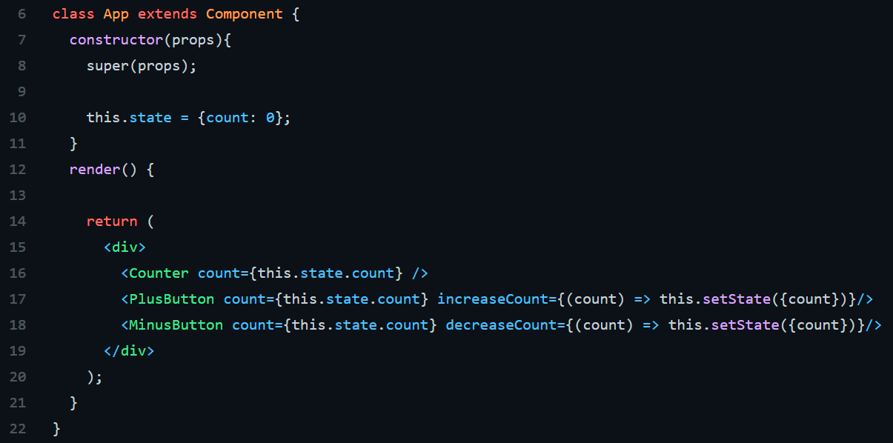

1. Explain props-drilling.

Props-Drilling is the act of passing down stuff via props like pieces of state and the functions that change that state down through the components to get them to where they need to go. For example, in the state you may be storing an array of values where each value is a “todo” and needs to be passed down to a <List> component and then to an <Item> component after that. Similarly, perhaps you have a <Button> component that allows a user to mark a to-do as done that’s a child of <Button>, now you have to pass down some sort of handleEvent function several levels deep to be able to fire it via the onClick that actually sits on the button. It’s safe to say this quickly becomes unsustainable.

Actually, Prop drilling is a common problem in React application where you pass data down from one parent component through the component layers until it reaches the designated child component, while other nested components don’t actually need them. It is also known as Threading. It is a concept that refers to the process you pass the data from the parent component to the exact child Component but in between, other components owning the props just to pass it down the chain.