Patnon,Mikaela F.
Exercise 5
- List all employees who hold the titles of “Senior Programmer” and “Multimedia Programmer”.
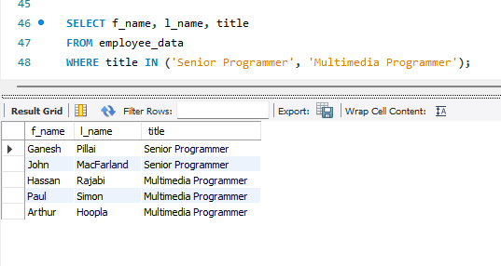
- List all employee names with salaries for employees who draw between $70000 and $90000.
