Group 6 – Group Report

Isa Orozco-Vela, Mikaela Slade, & Emily Klotz

LIS 882 Fall 2020

**Group Member Names: Isabel Orozco-Vela, Mikaela Slade, & Emily Klotz**

**Institution Name: Friends of Flora and Fauna**

**Collection Name: Amateur Wildlife Photography**

**Group and Collection Introduction**

The theme of our collection is amateur photos of wildlife in Illinois. Our collection began out of a love of Illinois’s wildlife and appreciation for nature. The founding members came together to share our photos, but the collection has grown to include hundreds of amateur photographs in a digital repository. The photos are cataloged using Simple Dublin Core, Qualified Dublin Core and MODS schemas. MODS is compatible with XML, and its interoperability with the other schemes is ideal for our purposes. We want to stress that this collection is created by amateurs because our members are 1.) not professional photographers, and 2.) we are not trained scientists. ‘Amateur’ comes from the Latin for ‘to love/loving’ and this love is truly at the root of everything we do. We began as three nature-lovers, concerned about the environment around us here in Illinois, and we have joined with others to create a database of the local wildlife we love.

We are not scientists. Other databases document scientific specificity. Those who provide photos are encouraged to provide metadata as well, though our founding members provide all the final encoding. MODS provides sufficient granularity for us. Though scientific researchers have used our collection, we are community-based laypersons. We are here to show wildlife we enjoy in and around Chicagoland. The primary users of our collection are also non-specialists. When we created our database, we decided to take advantage of the hierarchical structure of the Metadata Object Description Schema (MODS) for its rich descriptive possibilities in addition to Simple and Qualified Dublin Core. Our users can easily search the photos using MODS, with its tags based on language. As the official website from the Library of Congress says, MODS was developed as a “bibliographic element set that may be used for a variety of purposes” (MODS: Uses and Features 2016). MODS is well-suited to photography and born-digital photographs in our collection.

**Our Process**

We started communicating early and set up a shared document early. The MAP was mostly completed organically, with members adding to it as they finished their metadata. One group member, who had the best grasp of MAP concepts, completed the final editing. Further division of duties was to break up the questions for the paper, and we each contributed about a page. Once we created the metadata records, we found that while the overall outline of documents appeared the same, the real differences lay in the details. It was not until we sent the XML documents to each other and started to compare our documents that we went back to the MAP and made final decisions about what should and should not be included. Still, the crosswalk/MAP was extremely helpful in this initial comparison and we referenced it often.

One of the more difficult parts of creating the crosswalk was when we realized MODS had additional elements that did not translate directly into Dublin Core or local elements. We encountered this when deciding to include the MODS’ <recordInfo> element. The closest Dublin Core equivalent would involve adding another Creator and Date, which would confuse the One-to-One principle that we had established so far.

When it came to our MAP on its own, everything seemed good as we went along and did our work. However, there were some points towards the end when it occurred to us that some things needed to be fixed. In almost all cases, the changes made were minor, for they were simple additions/subtractions that we realized that we did/did not need. One example was with our MODS part for the photographer. The <roleTerm> was not listed and the realization was made when working on our MODS records, so we simply added it to make it complete.

Another example of an encountered problem was related to the date of the photograph. At first, we had all these different date subelements on the application profile, but after some discussion, we realized that we did not need all of them and whittled it down to the one we needed. As part of the process of whittling the list down, we had to figure out which was the better choice: <dateCaptured> or <dateCreated>. There was some discussion and a bit of research done, but in the end, we decided that <dateCreated> would be a subelement. Despite these minor changes, there was one change that can be considered as significant that was made. One person had a photo that was not taken by her, but by someone else instead. As a result, another element had to be added so that proper credit was given. That extra element we added was <recordInfo>. By having this element in, not only can it help in giving the credit to the appropriate party for making the record, but it can also be used as a way of distinguishing when the photo was taken versus when the record was made.

Another issue with mapping MODS was determining how detailed to be since MODS can qualify more elements than Dublin Core. For instance, two of us were unsure if it was necessary to include <namePart type=“family”> or <namePart type=“given”> when talking about the creator. In this case, we think it is helpful but should not be required because it is not represented in the other schemas. A lot of the amount of detail that can be included is left up to whoever is recording the metadata. In the same vein, the inclusion of <roleTerm> was not something we thought to include in our local or Dublin Core documents but included in MODS (and subsequently the MAP). The local element, “Record Information” was created last minute to account for this.

When it came to our local elements, we mostly referred to Dublin Core’s main elements since they covered most of our needs. However, we changed the names slightly to be more specific. We used the term “Photographer” instead of “Creator” and called some of our subjects “Species.” Other elements were borrowed from other sources such as Continent, Country, State, and City, which were included because of the TGN Vocabulary. We imagined that both amateurs and researchers would be interested in knowing where the photographs were taken geographically. Though not an element, we also incorporated the website/reference tool Encyclopedia of Life (EOL.org) as a local vocabulary because it provided both scientific and common names for our subjects. It helped to provide more subject terms because the other vocabularies (AAT, LCSH, and TGM) did not always provide a complete picture. For example, the Black-Crowned Night-Heron had slight spelling differences and none of the cataloging vocabularies provided its scientific name “Nycticorax nycticorax.”

We also created a local element for “Camera Type Used to Capture” because this information is interesting to photographers and is naturally included in the metadata of pictures taken on smartphones. This element was the trickiest to find equivalents in both Dublin Core and MODS. We were a little surprised that camera metadata did not inherently have a place in those schemas. The best solution we found was to include this information in “Description” for DC and <note> or <extent> for MODS.

Like in many cases with metadata, the issue of metadata quality is something that should be taken into consideration when creating it. Things like completeness, accuracy, and logical consistency and coherence are just some example characteristics that can make excellent quality metadata. As for how our group handled this, it varies a little on how we did it. When it came to completeness, everything seemed good on the first try after we had the MAP, but as we did our work and cross-checked it with the other members and previous work, we had noticed some errors/missing information not only in the MAP, but also in each other’s work. By doing this, we were able to fix things so that it was more complete. For accuracy, we made sure that the information was right, but at the same time, we made sure that certain information was not left out, otherwise the information would not be correct.

As for our ability to have logical consistency and coherence, that was something a little different and relates a bit to completeness and accuracy. When checking to make sure that our work was complete, there were the occasional inconsistencies that were noticed. One such example is the way to write our format. Some of us wrote it as ‘image/jpg’ while others wrote it as ‘image/jpeg.’ This inconsistency between our work was something that needed to be addressed. While some people might have their preferences as to how they write something, making sure that it is written in a way that is consistent and follows the way that it should be is something that we tried to do, and we managed to get it fixed. Even so, we tried to do our best so that the quality of the metadata was good while making sure that it was still useable.

**References**

Baskauf, S. J., & Webb, C. O. (2016). Darwin-SW: Darwin Core-based terms for expressing biodiversity data as RDF. *Semantic Web*. https://doi.org/10.3233/SW-150203

*Encyclopedia of life*. (n.d.). Encyclopedia of Life: Global Access to Knowledge about Life on Earth; National Museum of Natural History. <https://eol.org/>

Miller, S. J. (2011). *Dublin Core, MODS, and VRA Element Mappings*. ALA Store; ALA.org. <https://www.alastore.ala.org/sites/default/files/MDC_DC-MODS-VRA_Mapping_Table.pdf>

Miller, S. J. (2011). *Metadata for digital collections: A how-to-do-it manual*. Neal-Schuman Publishers.

Pitti, D. V. (1997). Encoded Archival Description: The Development of an Encoding Standard for Archival Finding Aids. *American Archivist*, *60*(Summer), 268-283.

Romary, L., & Riondet, C. (2018). EAD ODD: a solution for project‑specifc EAD schemes. *Arch Sci*, (18), 165-184. https://doi.org/10.1007/s10502-018-9290-y

Technical Subcommittee for Encoded Archival Standards of the Society of American Archivists (Ed.). (n.d.). *Encoded Archival Description Tag Library Version EAD3 1.1.1*.

**Record Images**

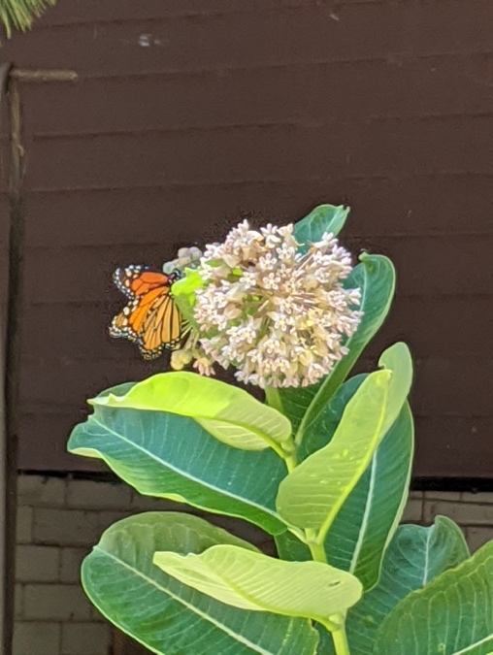**Photograph 1** Milkweed and Monarch (City of Chicago)

Monarch butterfly drinking nectar from the flower of a milkweed plant. The Monarch butterfly lays her eggs only on milkweed.

**Photograph 2** Black-Crowned Night-Heron

A Black-Crowned Night Heron spotted standing on the edge of a man-made lagoon in Chicago’s McKinley Park.

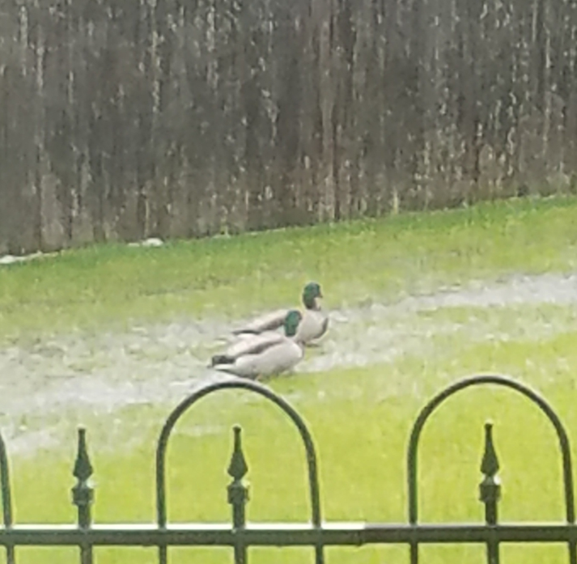**Photograph 3** A Pair of Drake (Male) Mallards

This was taken on a rainy day when the ground was so saturated that there was standing water in the grass. The ducks were waddling in the backyard as it continued to rain when this was taken.