Plastic particle processing manual

The microplastics software was extended to automatically process the NIR spectral images. Hopefully you will be able to run the program with this manual, and I will try to make it a bit more clear what is going on in the python scripts.

Summarized, the workflow goes like this:
- The lumo scanner software is used to make a scan of a set of particles. On the SO279 cruise we put the plastic particles on a black sticky background (electrical tape). The black background does not reflect so much radiation, which is nice for the image recognition software. We put the particles in bands of ~1.2 cm, which is about the field of view for the camera at the given height of the test bed.
See the ‘microplastic_manual’ document how to operate the lumo software
- The python scripts to process the spectral images can be found in the D:\software\microplastics_v2 folder. In the anaconda prompt, we can run the script. I prefer this over running the script in spyder, as spyder takes up quite some memory (>1GB), which is necessary to process some of the larger images (~4gb). In the prompt we can run:
python main_v4.py -name 09_thea_1_1_2020-12-14
The -name argument is used to specify the folder which we process
In the given folder, an ‘output’ folder will appear, where one can see the segments and the corresponding spectra.
All particle information (spectra, dimensions, metadata) are stored in the 00_spectra folder.
- Afterwards, we can check the segments. Sometimes the image recognition does not completely see the darker plastics, these might appear as different segments. We can post-process the results. In the 00_spectra folder you can find a 09_merge.txt file as an example how to do the postprocessing. Each time we specify a unique string of the folder to be processed (e.g. ‘1_1’), we specify the segments we want to delete (separated by commas) and segments we want to merge (sequences separated by commas). After filling in all the details we run the postprocessing by running:
python main_v4.py -name 09_thea_1_1_2020-12-14 -merge_file 09_merge.txt -merge_str 1_1
where -merge_file specifies the file in which the post-processing information is found, and where -merge_str is the unique string where the post-processing information can be found in the file.
In the ‘analyze_folders.py’ file there is an example script to do the post-processing for a batch of files at once.
Post-processing files are found in the same folders, with a prefix ‘post_’
- When happy with the post-processing output, we can run the analysis on the particle properties. Some example analysis can be found in the ‘analyze_particles.py’ script.

Example run
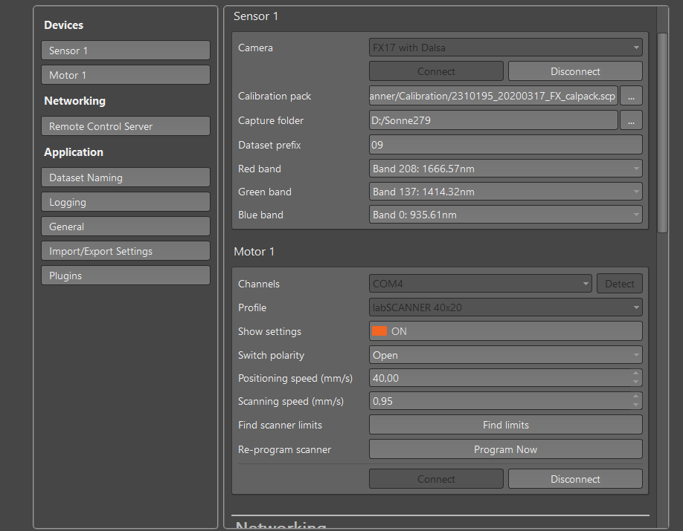
Connect to the camera and the motor

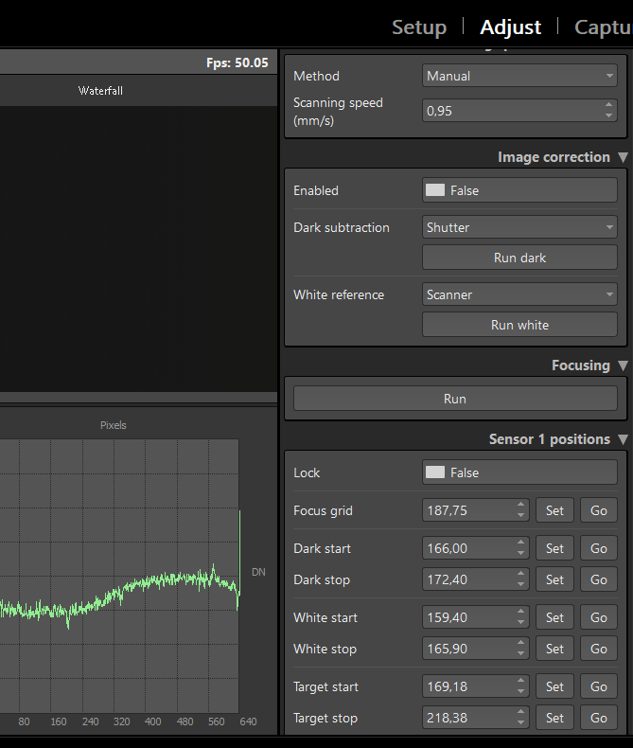
We fixed the scanning speed to 0.95, which in our case gives the right aspect ratio. Then we set the values for the white start/stop, and the target start/stop

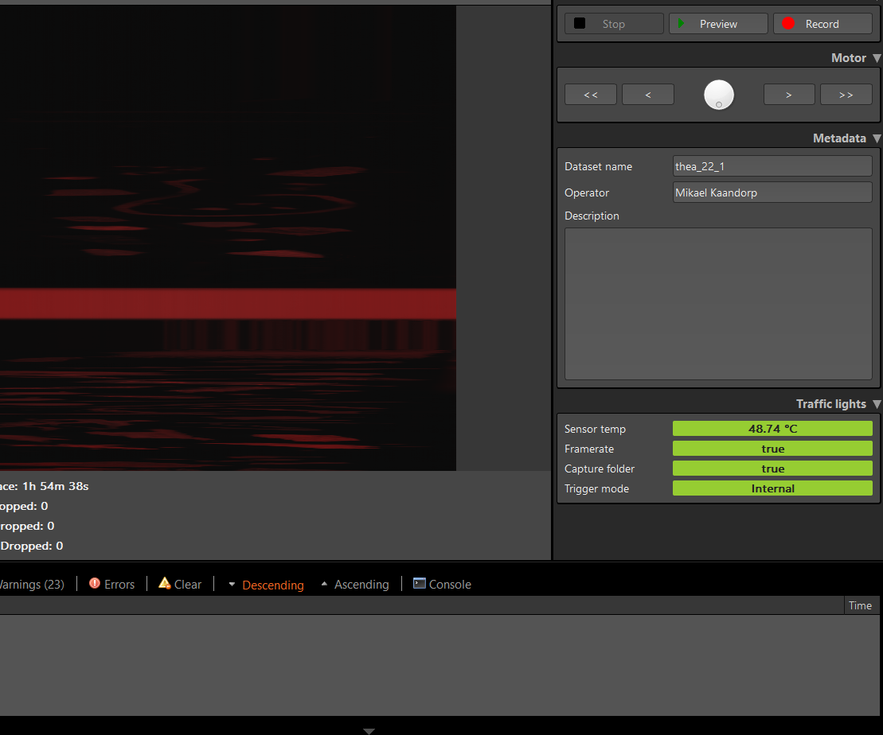
The capture tab is useful to see whether the entire strip of particles is in the field of view of the camera

We then run the analysis script for the first time. (python main_v4.py -name 09_thea_22_1_2020-12-29) We check the output images for particles which should be deleted or merged.
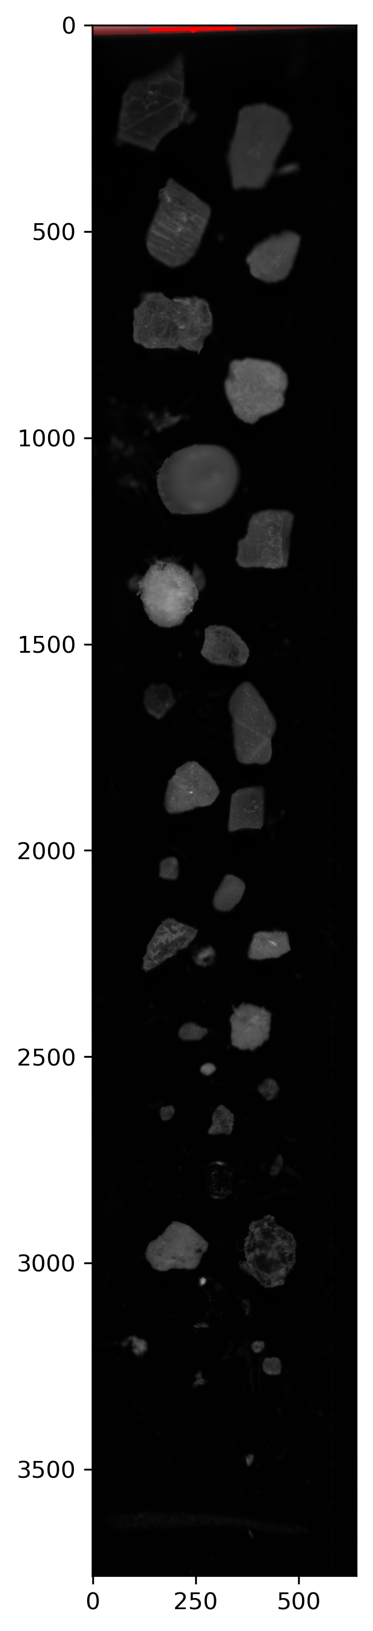

In this case a particle is detected on top (red area). We know this is not a real particle. We check the segment number and add it to the merge.txt

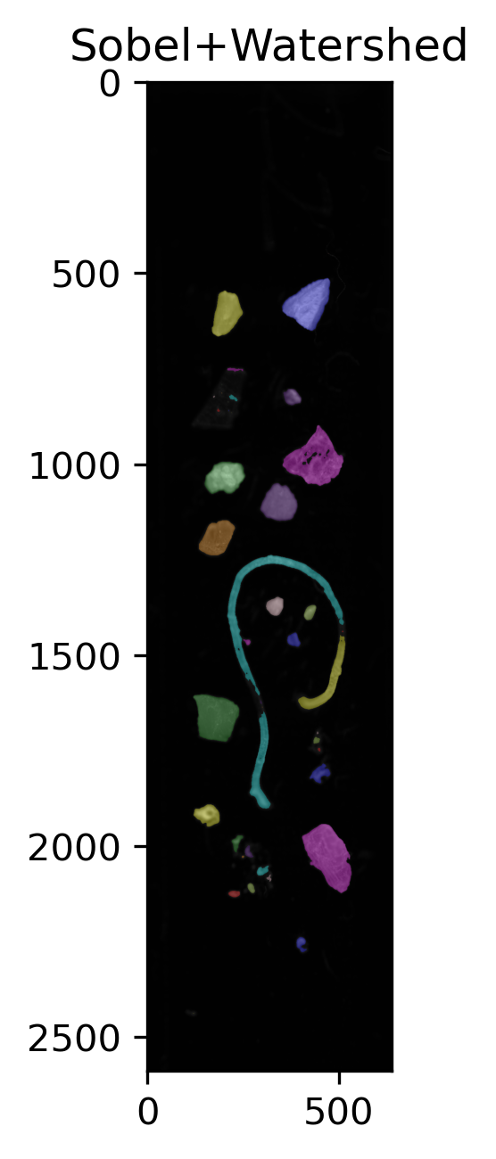

In this figure you can see that the fiber is segmented incorrectly. Each segment is a separate color: the fiber should have one uniform color in case of correct segmentation. We look the segments which need to be merged and add it to merge.txt

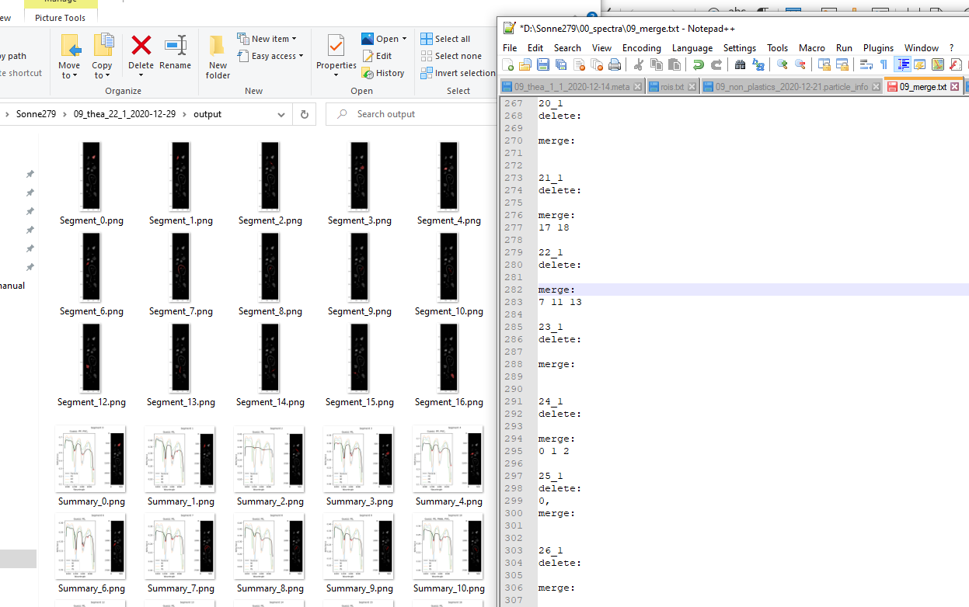
We look up the segments of the fiber to be merged, and add the sequence to line 283 in this case.
Important: make sure the numbers to be deleted are 2 lines below the identification line (‘22_1’), and the numbers to be merged 4 lines below the ‘22_1’ line.

After completing the merge.txt file, we run the python main_v4.py -name 09_thea_22_1_2020-12-29 -merge_file 09_merge.txt -merge_str 22_1
(Or the analyze_folders.py script which runs this command for you for several folders)

Python implementation details

