Install arduino IDE 1.8.10 or newer.
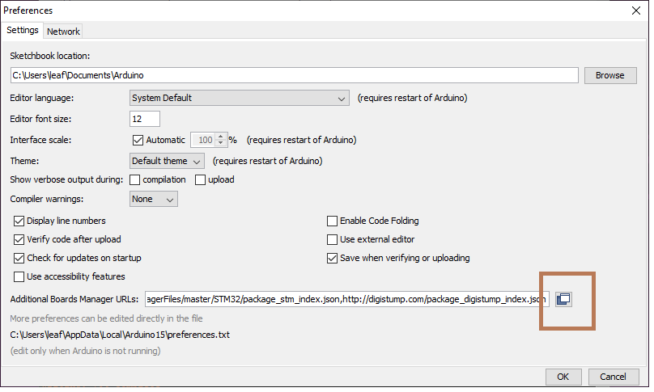Figure 1: Preferences dialog
Go to file→Preferences and click on icon to right on “Additinal Boards Manager URL:s” (Figure 1)

Add a new line with:
http://digistump.com/package_digistump_index.json
Press OK on Additional Boards Manager URLs
Press OK on Preferences.

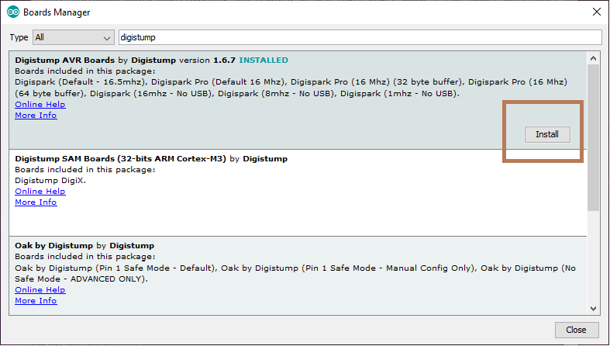Figure 2: Add digistump boards
Go to Tools→Board→Board Manager (Figure 2)
Search for digistump avr
Hover over “Digistump AVR boards”
Press install button that appear.

Install Driver
Press WIN+R (RUN) (Figure 3)
Write %appdata%\..\Local\Arduino15\packages\digistump\tools\micronucleus\2.0a4\install.exe
and press enter.
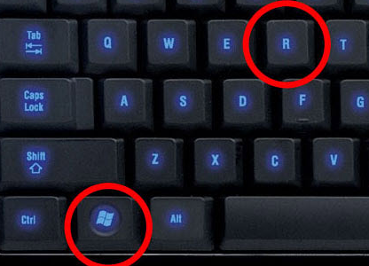Figure 3: WIN+R keyboard location
Allow install of driver, else the bootloader on the board will not work.
Note on bootloader, some USB ports/hubs will not be compatible,
if it not working try another USB Port or HUB

