Nokia 6020 LCD
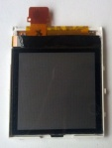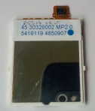
Parameter | Nokia 6020
Type | active-matrix TFT
Connector | 12 pin Hirose DF23C-12DS-0.5
Controller | Philips PCF8833
Resolution | 130×130 pixels
Visible resolution | 128×128 pixels
Native colors | 65536 (16 bit)
Supported colors | 256 (8 bit), 4096 (12 bit), 65536 (16 bit)
Color format | RGB
Interface | 9 bit SPI
To connect to LCD you need 12 pin “Hirose DF23C-12DS-0.5” connector (receptacle).
Looking from the back pinout is the following:
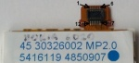
Pin number | Symbol | Description
1 | LED- | minus for display backlight
2 | VDDI | Voltage supply (1.65V – 1.95V)
3 | GND | System ground
4 | SDA(MOSI) | Serial input
5 | CSX | Chip select (active low)
6 | GND | System ground
7 | NC | not connected
8 | RESX | Reset (active low)
9 | SCL(SCLK) | Serial input clock
10 | GND | System ground
11 | VDD | Voltage supply (2.6V – 2.9V)
12 | LED+ | plus for display backlight
I didn’t find out any information about how much voltage difference between LED- and LED+ is needed for backlight. I tried 6.6V and it is not enough. With 10V the backlight works.
https://kbiva.wordpress.com/2013/07/25/nokia-6020-lcd/

