1. How did you select the slice to be analyzed in Q3a (3 pts)?

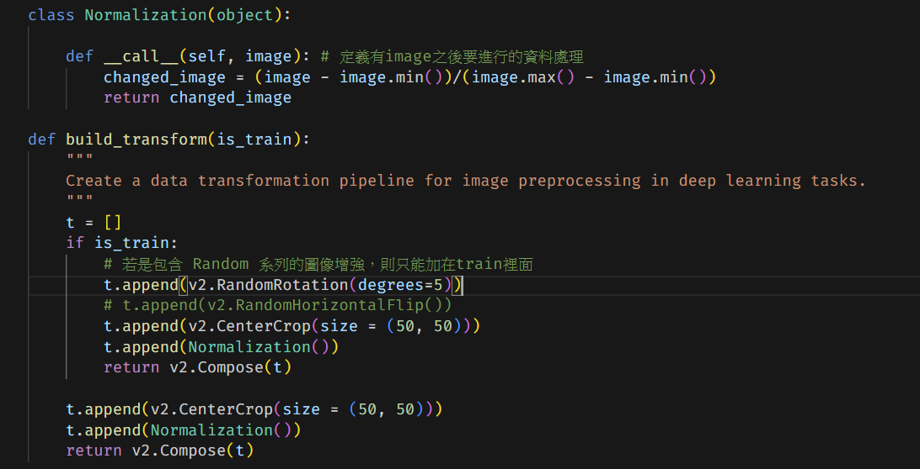

取在畫面中間50\*50的部分

1. How did you can represent three channels of our grayscale medical images for pre-trained architectures (3 pts)?

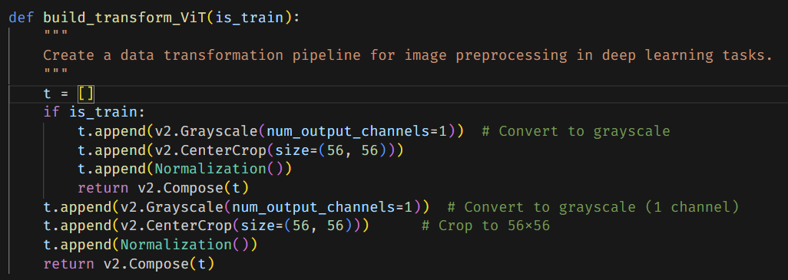

用v2.grayscale()

1. How did you incorporate age and gender into the model you used (Q3c) (4 pts)?

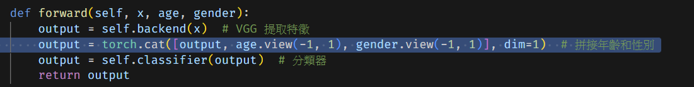

用torch.cat()

1. Reproductivity of the results (4 pts)

因為程式碼有random，所以每次都有點不同，但是結果大致相同

1. Number of parameters (2 pts) (Please write the parameter count of the final selected model.)

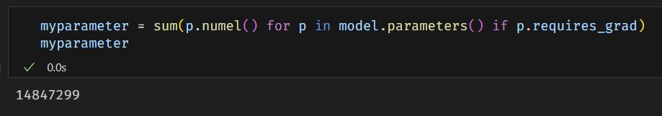

我使用VGG，parameters=14847299

1. The difficulty during training (6 pts)

了解其中的結構並且試圖改進模型最困難，常常不小心就把模型弄壞了，要很理解架構才能改，而且改之後的效果也沒有原本的好

1. Briefly explain the structures of the models you are using (You are required to do at least VGGNet, ResNet, and ViT) (8 pts)

如圖上code的註解:

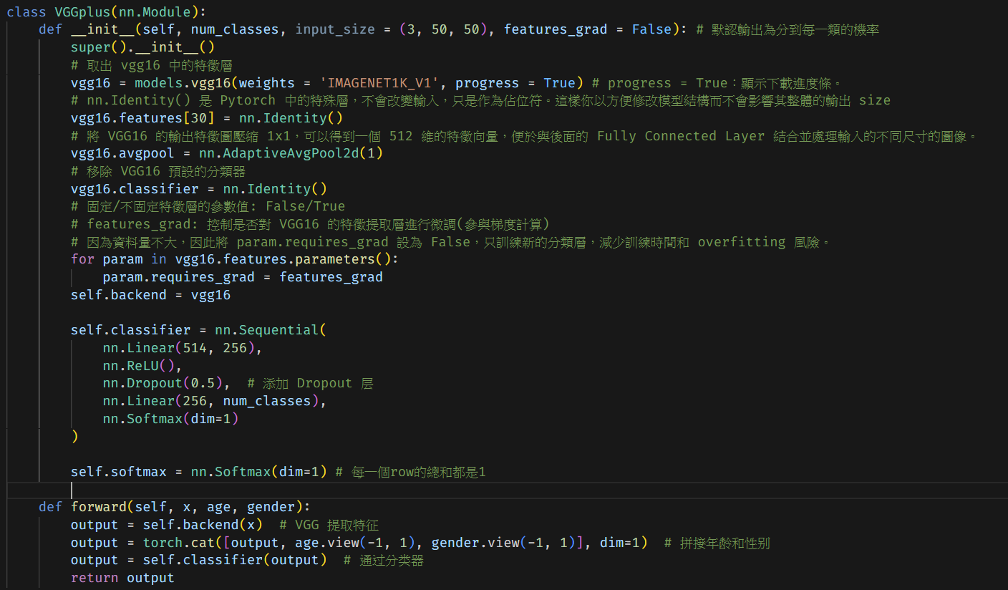

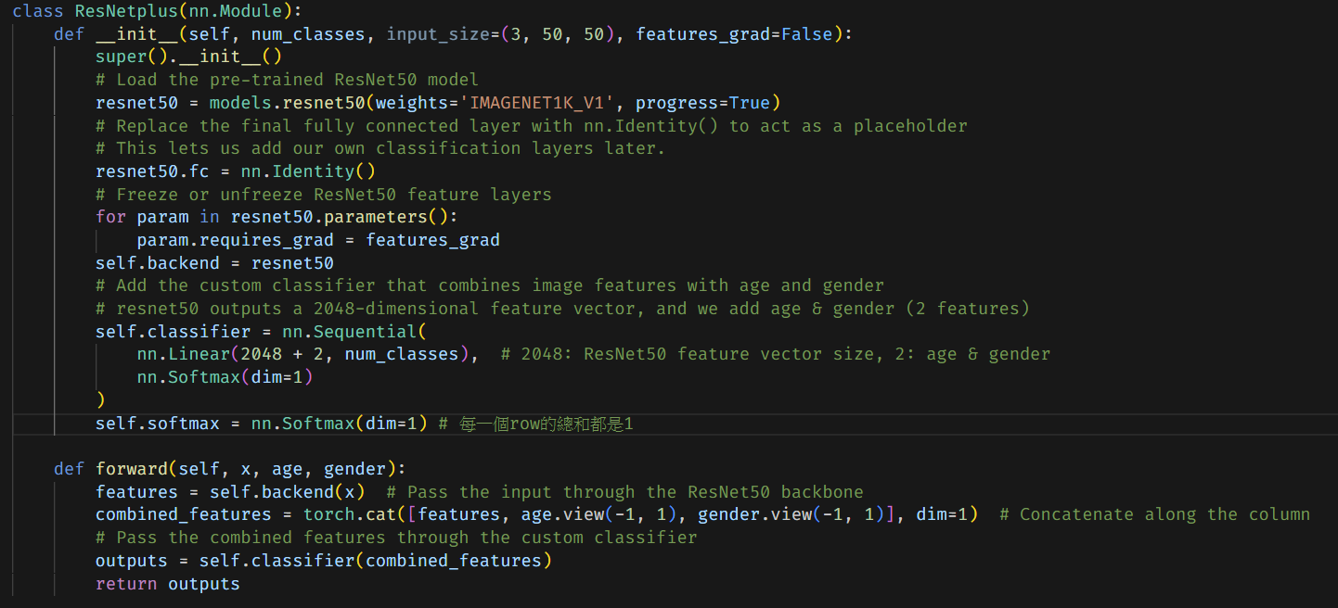

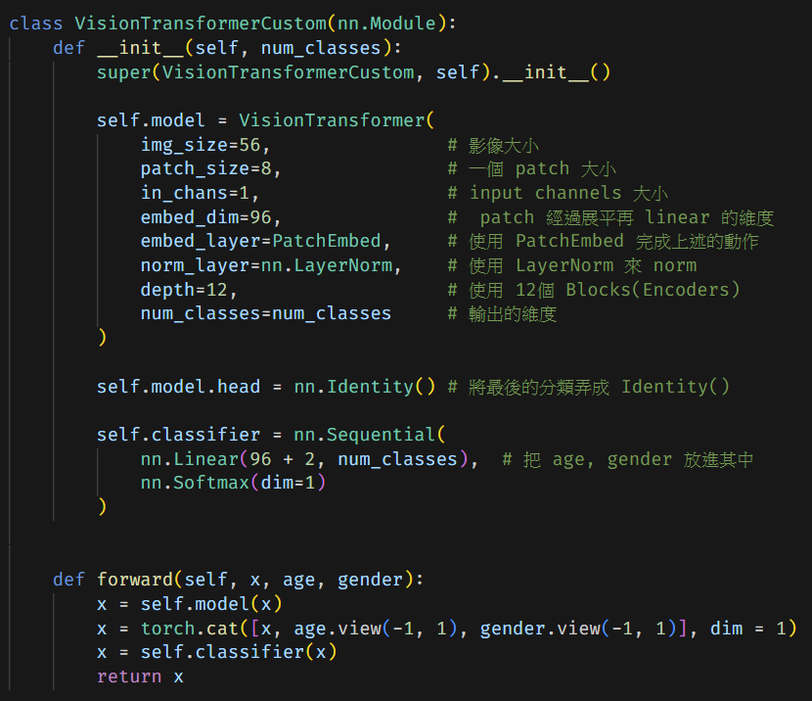

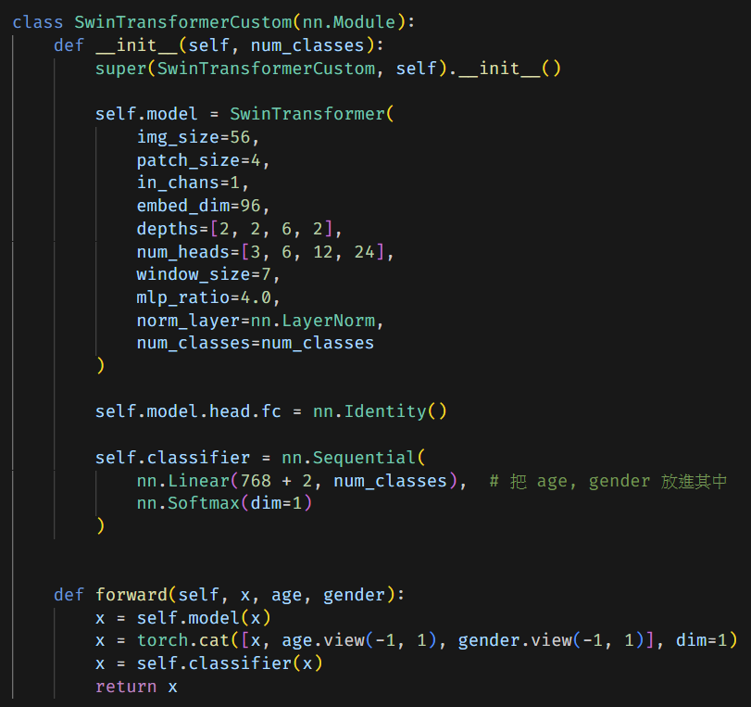

1. You should submit compile HTML file and ipynb notebook with name prefix to e3 platform. - {studentID}.ipynb {studentID}.html {studentID}.pdf
2. Note: make sure your ipynb file print out the number of parameters of the model.