Remote Access Control Policy for Lions Investments.
Mika Kouakou
Course: BUSA 533
Professor: Dr. Zaki Malik
Date: October 14, 2025

1. Policy Statement, Purpose, and Scope
- Policy Statement: All remote access to Lions Investments' corporate network, systems, and client data must adhere strictly to the secure methods and mandatory controls outlined in this document.
- Purpose: To establish and enforce robust security controls that protect client confidentiality, data integrity, system availability, and ensure compliance with financial industry regulations (e.g., FFIEC, SOX) for all remote users connecting from non-local networks.
- Scope: This policy applies to all Lions Investments employees, contractors, and third-party vendors (collectively, "Users") utilizing any corporate-issued or approved personal device (desktops, mobile computers, wireless devices) to connect to the internal network from any external location, including branch offices and remote work environments.
2. Approved Methods of Remote Connection
Lions Investments mandates the use of specific, secure technologies to minimize the attack surface presented by remote access.
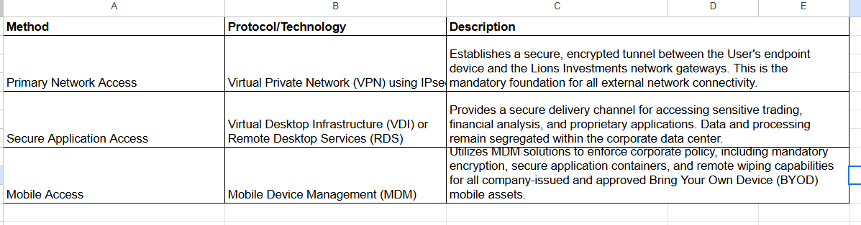

3. Mandatory Requirements for User Systems (Endpoint Security)
Before any device is granted network access via the VPN, the Network Access Control (NAC) system must verify that the following security posture requirements are met. Failure to comply will result in automatic connection denial.
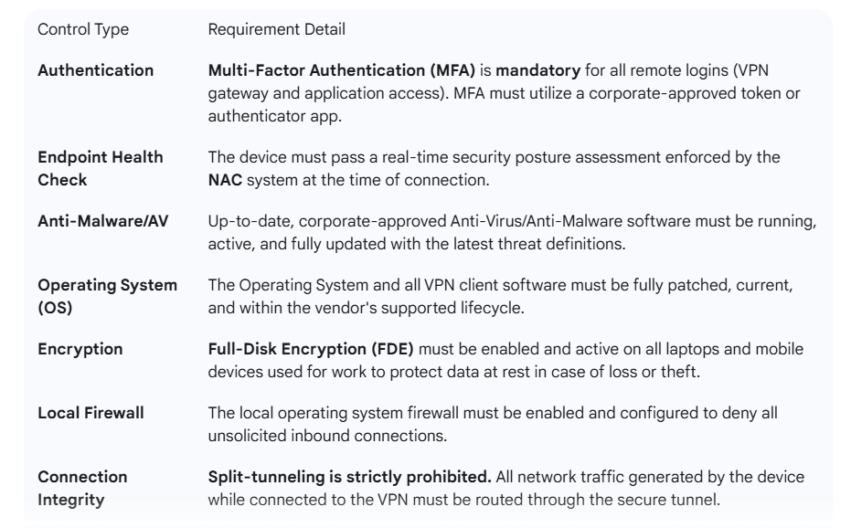
4. Design and Justification of Selected Access Controls
The chosen access control model is built on the principle of Defense-in-Depth to mitigate the high risks associated with handling sensitive client financial data across a decentralized environment.
