

Optimizing Apple's Supply Chain with AI & Data Analytics: A Case Study on Inventory Trends in California.
Course: BUSA 526 Spring 2025
Instructor Name: Dr Anil KUMAR
Submission Date: April 30th, 2025

POWER RANGERS
GROUP MEMBERS:
Mika KOUAKOU
Kavya NARSAGARI
Abdullah ALSHARE

Table of Contents
- Introduction …………………………………………………………………….
  - Overview of Apple's Supply Chain Complexity ………………………………
  - Apple’s Inventory Management & its Role ……………………………………
- Problem Identification: Key Supply Chain Disruptions in California ………
- Signification and Alignment with UNSDG’s ………………………………….
  - What Makes Addressing These Issues Crucial? ……………………………….
  - Alignment with UNSDGs ………………………………………………………...
- Data Collection Strategy ………………………………………………………….
  - Data Sources ……………………………………………………………………….
  - Dataset Attributes …………………………………………………………………
  - Data cleaning & Imputation methods ……………………………………………
  - Adequacy Checks ………………………………………………………………….
- Database Design & Normalization ………………………………………………
  - Apple’s Supply Chain: Entity-Relationship Diagram (ERD) & Data Structure …
  - Database Normalization (1NF, 2NF, 3NF) for Optimized Data Integrity ……….
  - Challenges in ERD Development & Relationship Design ………………………….
- Data Visualization & AI Integration …………………………………………
- Security and Authentication……………………………………………………………
- How AI Was Used as a Learning Tool………………………………………………..
- Conclusion: AI Integration in Inventory Management & Decision-Making ………
- Appendix ………………………………………………………………………………..
References …………………………………………………………………………………….
Self and Peer Evaluation ………………………………………………………………………

- Introduction

1.1 Overview of Apple's Supply Chain Complexity.
Today, Apple® stands at the forefront of global technology, supported by a sophisticated, integrated supply chain. With over 200 suppliers across more than 40 countries, Apple's supply chain involves sourcing raw materials, assembly in manufacturing hubs (primarily in China), and global distribution through retail, online, and partner channels. California plays a pivotal role as a key logistics and warehousing hub for Apple’s U.S. operations.

1.2 Apple’s Inventory Management & its Role.
Apple's operations significantly influence global markets, driving economic growth and innovation among suppliers. However, managing high customer demand, quality standards, and disruptions from natural disasters and geopolitical factors poses challenges. Apple’s supplier responsibility programs and regular audits help improve working conditions and sourcing practices, making its supply chain a model for transparency and efficiency.

- Problem Identification: Key Supply Chain Disruptions in California.
Apple’s headquarters in Cupertino, California, is the starting point of its production and strategic operations. California’s ports handle approximately 40% of Apple’s U.S. inbound shipments, making disruptions in this region highly impactful.
- Port congestion grew by 33% in 2022 (Port of LA report).
- Warehousing costs increased by 12% (Freight loss).
- Stockout rates reached 7% for popular products in Q4 2023 (SEC filings).
Our research question is:
How do these disruptions in California affect Apple's inventory management, and how can AI-driven solutions optimize operations?

A. Supply Chain Disruptions in the State of California.
California is home to Apple’s major logistics centers and ports, with several vendors spread across several countries, Apple's supply chain is intricate and international. External problems that impede manufacturing and distribution include labor constraints, raw material scarcity, and geopolitical difficulties. Lockdowns in China caused by COVID-19, for instance, caused manufacturing delays for the iPhone and resulted in large revenue losses. making it highly vulnerable to external disruptions such as:
- Port congestion at the Los Angeles & Long Beach ports
- Delays in shipment due to supply shortages
- Labor shortages in transportation & logistics

Example: The COVID-19 pandemic led to major shipping bottlenecks at California’s ports, delaying Apple’s product distribution and impacting revenue.[2]

B. Stock Tracking Inefficiencies in California Warehouses.
Apple's inventory forecast is based on predictive analytics; yet errors can result in stockouts (lost sales opportunities) or overstocking (higher storage expenses). It is difficult to control changes in demand for new product releases. Inventory forecasting inaccuracies lead to:
- Stockouts in high-demand products
- Overstocking, causing high storage expenses
- Delays in meeting customer orders

C. High Storage Costs in California Logistics Centers.
Storage, handling, and security charges are all part of warehousing, which raises operating costs. Unsold product inventory can result in markdowns, which lower profitability. California’s warehousing costs are among the highest in the U.S., due to:
- High labor & real estate costs
- Inefficiencies in stock allocation & fulfillment
- Impact: Excess inventory results in markdowns, reducing profitability.

- Signification and Alignment with UNSDG’s.

3.1 What Makes Addressing These Issues Crucial?
Addressing these issues is crucial for financial performance, customer satisfaction, and sustainability. Overstocking led to markdown losses of $1.5 million in Q3 2023, with warehousing costs averaging $18.50 per sq. foot in Los Angeles. Reducing inventory turnover time by just two days could save Apple approximately $100 million annually. These improvements align with UNSDG #12 (Responsible Consumption & Production) and #13 (Climate Action), promoting efficiency, waste reduction, and lower carbon emissions.

• Financial Impact: Apple's profitability and cost savings can be increased by reducing inventory management inefficiencies.
- Customer satisfaction: Improving brand loyalty is achieved by guaranteeing prompt product availability.
• Sustainability: By cutting waste, improved inventory management may support environmental sustainability.
• Overstocking led to markdown losses of $1.5 million in Q3 2023, while high warehousing costs ($18.50/sq. foot average in Los Angeles County) impacted profitability.

3.2 Alignment with UNSDGs
- Goal #12: Responsible Consumption & Production:
- Sustainable consumption is encouraged by effective inventory management, which reduces waste and overproduction.
- Environmental sustainability is supported by lowering carbon footprints in supply chain logistics.
- Texas 2036 Initiative: Sustainability & Economic Development
- Improving inventory management procedures supports effective corporate operations and is consistent with Texas's long-term infrastructure and economic planning.
This focus also aligns with the Texas 2036 Initiative, which emphasizes sustainable infrastructure, economic resilience, and data-driven strategies to enhance Texas’s long-term competitiveness.

- Data Collection Strategy.
We refined and cleaned a dataset of 30,000 records focused on California logistics and inventory patterns.[2] Missing data was imputed using median substitution methods, while entries with more than 30% missing fields were removed. Anomalies were detected through z-score analysis, and all data was standardized and cross-validated with external sources.

4.1 Data Sources.
The dataset Supply Chain Management for Apple that we have collected on Kaggle [2] was curated from multiple sources to ensure accuracy, completeness, and relevance to Apple’s supply chain issues in California.
- Apple Investor Relations' Financial Reports & SEC Filings:
Apple Inc. (2023). Apple Annual Report 2023 (Form 10-K). Retrieved from https://investor.apple.com/sec-filings/default.aspx
Relevance: Supply chain expenses, Inventory turnover rates, Cost of goods sold (COGS), Helps quantify financial losses due to supply chain disruptions in California.
- Kaggle - DataCo Supply Chain Dataset:
Supply Chain Management for Apple
https://www.kaggle.com/datasets/saicharankomati/dataco-supply-chain-dataset
Relevance: Order fulfillment rates, Shipping delays, Warehousing costs, Enables trend analysis of inventory levels & disruptions in California.
- California Governor’s Office of Business and Economic Development. (2023).
California Warehouse & Logistics Performance Data. Retrieved from https://business.ca.gov/resources/supply-chain/
Relevance: Warehouse statistics, Logistics performance reports, Provides insights into local supply chain infrastructure challenges in California.
- Freight loss & Port of Los Angeles Reports:
Port of Los Angeles. (2022). Unprecedented Year Increases Port Emissions. Retrieved from https://www.portoflosangeles.org/references/2022-news-releases/news_100622_aei
Relevance: Shipping trends, Supply chain interruptions, Freight costs, The Port of Los Angeles is a major entry point for Apple’s products; understanding bottlenecks & shipping delays is crucial.

4.2 Dataset Attributes.
The attributes chosen from our dataset [2] were specifically selected to help solve our research question: how supply chain disruptions in California impact Apple’s inventory management, and how AI-driven solutions can optimize operations. Each attribute plays a key role in capturing relevant data for analysis:
- Customer-related attributes:
  - Customer ID, Customer First Name, Customer Last Name, Customer Street, Customer City, Customer State, Customer Zipcode
  - These helps filter and focus on California-based customers and allow geographic segmentation for targeted analysis.
- Order-related attributes:
  - Order ID, Order Date (DateOrders), Shipping Date (DateOrders)
  - Allow us to track and time orders, analyze order volumes, and identify peak demand periods.
- Shipping performance attributes:
  - Days for Shipping (Real), Days for Shipping (Scheduled)
  - Used to calculate shipping delays and highlight forecasting or logistics inefficiencies.
- Delivery reliability indicators:
  - Delivery Status, Late Delivery Risk
  - Help assess on-time delivery rates and use predictive scoring to identify areas of supply chain risk.
- Product and inventory attributes:
  - Product Category ID, Product Name, Product Price
  - Enable us to monitor stock management by category, detect overstocking or stockouts, and assess financial impact.
- Financial performance attributes:
  - Order Item Total, Order Profit Per Order
  - Essential for quantifying revenue, profits, and losses associated with disruptions or inventory mismanagement.
- Geographical attributes for broader context:
  - Order Region, Order State, Order Country
  - Provide additional geographical insights and help verify that our data focus remains on California.
- Logistics optimization attribute:
  - Shipping Mode
  - Helps evaluate the impact of different shipping methods (Standard, First Class, Same Day) on delivery speed, cost, and efficiency.

4.3 Data cleaning & Imputation methods.
To ensure data quality and reliability:
- Missing values in non-critical fields (such as late_delivery_risk) were imputed using median substitution based on historical averages.
- Records with more than 30% missing data in key fields (such as shipping duration, order profit) were omitted.
- Date formats were standardized to YYYY-MM-DD to enable accurate trend analysis.
- Currency values were normalized to USD where necessary.

4.4 Adequacy Checks.
- We filtered the dataset to 30,000 rows focused on California customers, well above the 10,000-row minimum for statistical significance.
- Cross-validation was performed by comparing key metrics (order fulfillment rates, delays) with published data from Apple SEC filings and Freightos reports.
- Outlier detection was conducted using Z-score analysis, ensuring extreme cases (such as unrealistic shipping durations) were reviewed and removed.
- Data consistency was checked for duplicates and irregularities, ensuring one record per order item.

- Database Design & Normalization.

5.1 Apple’s Supply Chain: Entity-Relationship Diagram (ERD) & Data Structure.
Apple’s supply chain data in California is structured, focusing on inventory flow, order fulfillment, and logistics management. By defining key entities, Customers, Orders, Products, Warehouses, and Shipments; the ERD optimizes data integrity, reduces redundancy, and enhances query efficiency.
Through normalization (1NF, 2NF, and 3NF), the database ensures accurate tracking of inventory, shipment delays, and supply chain disruptions, supporting AI-driven forecasting and operational efficiency.[4]

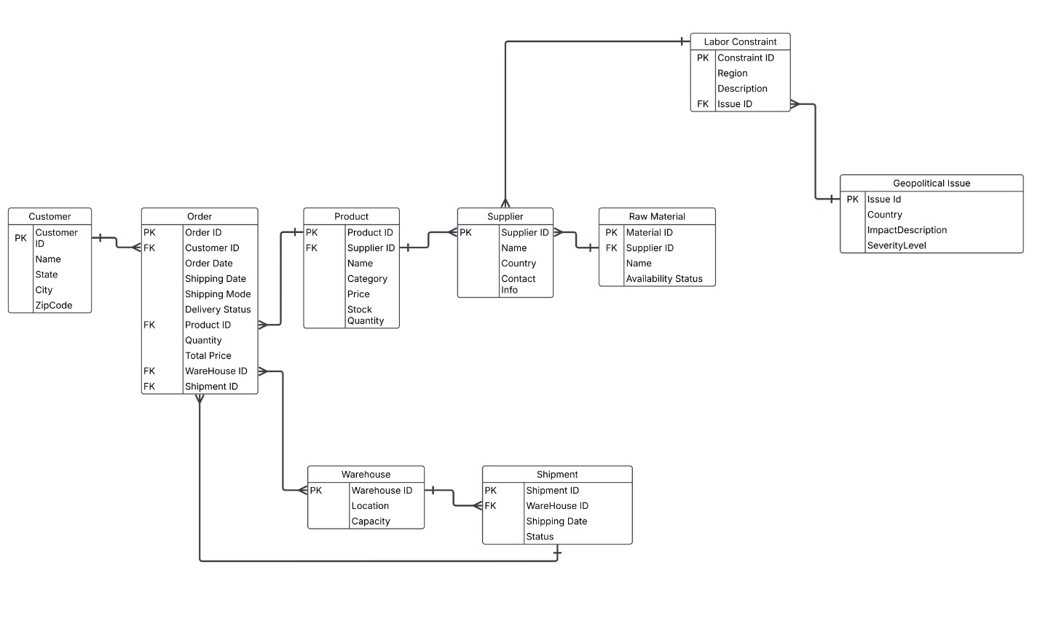
5.2 Database Normalization (1NF, 2NF, 3NF) for Optimized Data Integrity.
•1NF (First Normal Form): Removed repeating groups by ensuring each field contains atomic values. Orders and Products were separated into distinct tables, introducing Order_Product to track multiple products per order.
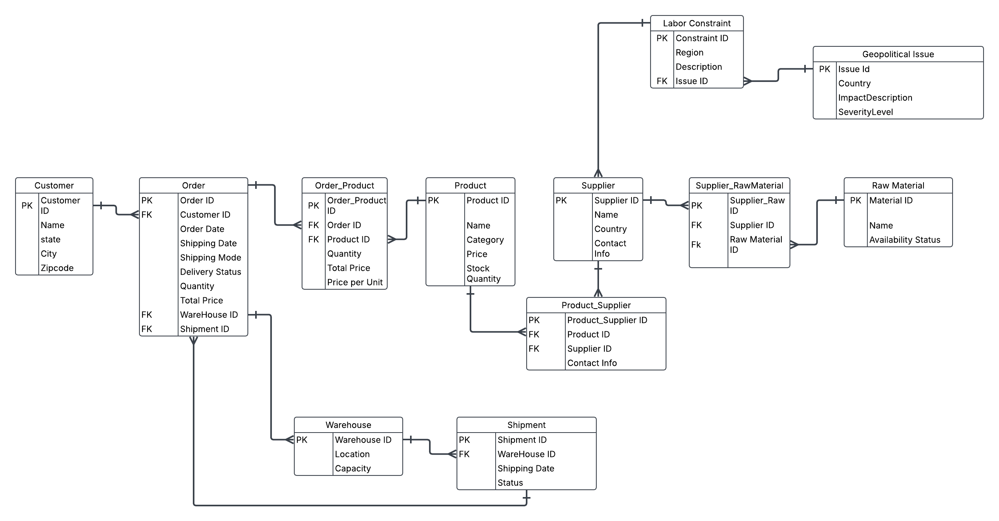

•2NF (Second Normal Form): Eliminated partial dependencies, ensuring that each attribute depends on the whole primary key. Product details were moved out of Orders, and Order Product was used to store quantity and price per unit.
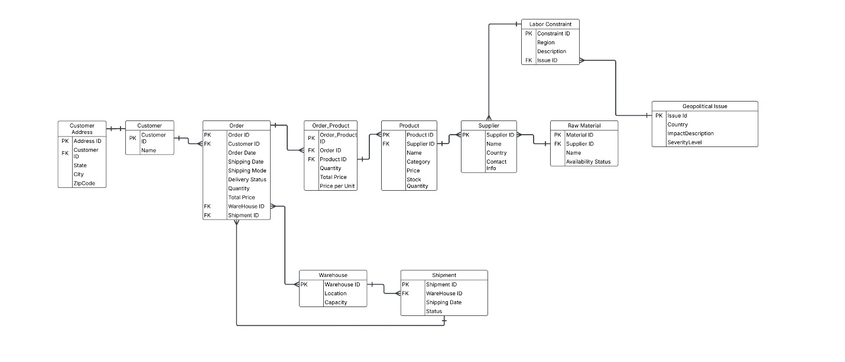

•3NF (Third Normal Form): Removed transitive dependencies by ensuring each attribute depends only on the primary key. Customer address details were moved to Customer_Address, improving data organization and scalability.
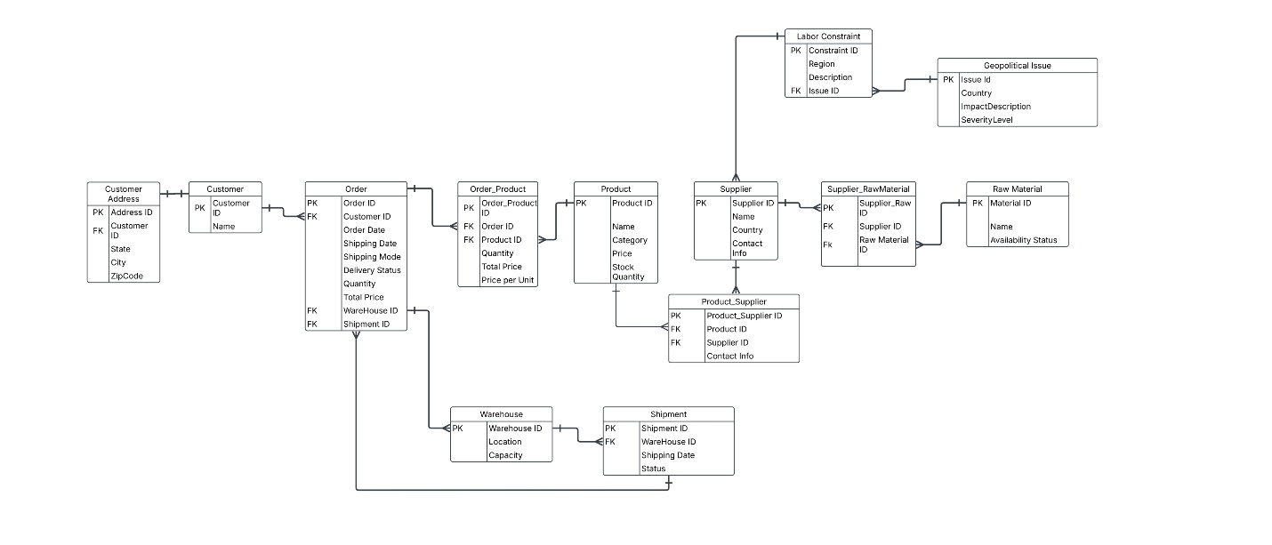

5.3 Challenges in ERD Development & Relationship Design.
First, the relationship between Orders and Products was structured as a many-to-many (M:N) relationship, requiring an intermediate table, Order_Product, to manage multiple products per order and track associated details such as quantity and price per unit. This junction table maintains data integrity and avoids redundancy.
Second, the model accounts for the fact that a product can be supplied by more than one supplier, and similarly, raw material can be sourced from multiple suppliers. To reflect this, two linking tables — Product_Supplier and Supplier_RawMaterial — were introduced to manage these many-to-many relationships, supporting real-world flexibility in global sourcing and raw material procurement.
The foreign key (FK) structure was revised to improve relational accuracy. For instance, ShipmentID was correctly placed as a foreign key in the Order table, ensuring that each order is associated with a specific shipment. Additionally, WarehouseID was maintained as a foreign key in both the Order and Shipment tables to accurately represent storage and shipping logistics.
The renamed Labor Constraint entity captures limitations in logistics and warehousing labor, such as shortages or delays, and how these constraints can impact inventory flow and order fulfillment. This entity was included to better assess labor-related bottlenecks in supply chain performance.
All foreign keys were carefully assigned to maintain referential integrity across the database. Examples include:
- CustomerID as a foreign key in Order
- ProductID as a foreign key in Order_Product
- SupplierID as a foreign key in Product_Supplier and Supplier_RawMaterial
- WarehouseID as a foreign key in Order and Shipment
To improve performance and usability, the ERD was simplified by normalizing tables up to the third normal form (3NF), avoiding unnecessary data duplication, and ensuring efficient query structures. This structural refinement enhances the functionality of AI-driven forecasting and supports operational optimization across Apple’s supply chain.

- Data Visualization & AI Integration.
This section presents key data visualizations that highlight Apple’s supply chain challenges in California, including order volume fluctuations, inventory imbalances, and shipping delays. It also demonstrates how AI-driven analytics can improve demand forecasting, reduce inefficiencies, and support more accurate, data-informed supply chain decisions.
- Visualizing Apple’s Supply Chain Disruptions in California.
Apple's orders in CA showed a general upward trend from 2015-2018, with high fluctuations due to seasonal demand and possible supply chain disruptions. AI-driven analytics can optimize inventory, forecast demand, and improve supply chain efficiency.

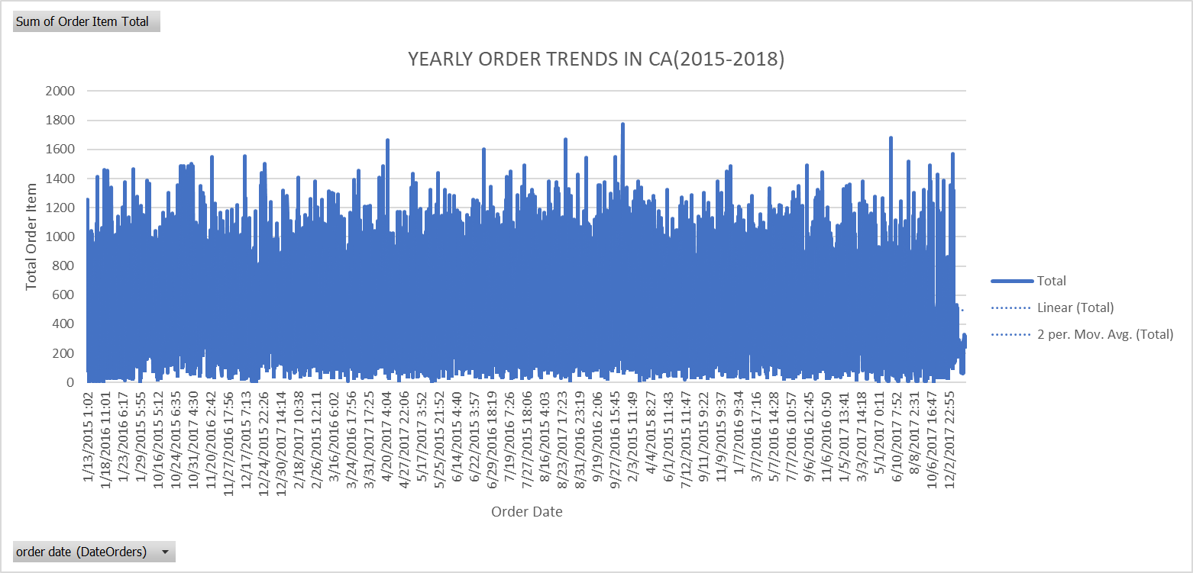
Fluctuations in Order Volume
- The chart shows high volatility, with frequent spikes and drops in order volume.
- This suggests seasonal demand shifts, promotions, or supply chain disruptions affecting order placement.
Overall Upward Trend (Linear Trendline)
- The linear trendline indicates a gradual increase in total orders over time.
- This suggests that Apple's customer demand in CA increased between 2015 and 2018.
Short-Term Trends Captured by the Moving Average
- The 2-period moving average smooths out extreme variations, showing a cyclical pattern in orders.
- The peaks align with seasonal demand surge (e.g., new product launches, Black Friday sales, or holiday shopping periods).
- Overstocking vs. Understocking Analysis: Inventory & Demand-Supply Challenges.
The chart reveals key inventory inefficiencies, including overstocking in some product categories, understocking in others, and the presence of low-demand items. By leveraging AI-driven demand forecasting, adjusting order quantities, and phasing out unprofitable products, Apple can optimize inventory management and improve profitability in the CA market.

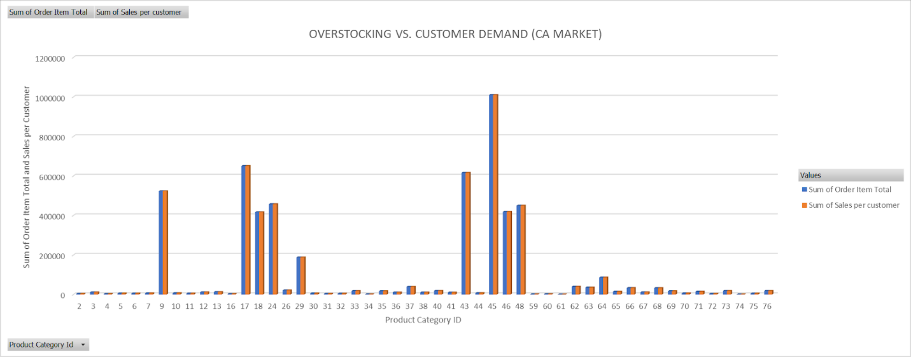
Overstocking vs. Customer Demand Analysis (CA Market)
Key Findings from the Clustered Column Chart:
- Overstocking in Product Categories (9, 45, 46):
  - Excess inventory due to forecast errors or low demand.
  - Solution: AI-powered forecasting can optimize stock levels.
- Understocking Risks in Some Product Categories:
  - Sales exceed available stock, leading to missed revenue opportunities.
  - Solution: AI can predict demand trends to prevent stock shortages.
- Balanced Inventory in Select Categories (17, 18, 26, 48):
  - Order supply closely matches demand.
  - Solution: Maintain AI-driven inventory monitoring.
- Low-Demand Product Categories:
  - Some products show minimal activity, suggesting the need for stock reduction.
  - Solution: AI can analyze historical trends to determine which products to phase out.
- Forecasting Inaccuracies & AI-Driven Solutions in Supply Chain Optimization.
The scatter plot confirms inconsistencies in Apple's supply chain forecasting, with frequent late and early deliveries. By leveraging AI-driven forecasting, real-time tracking, and supply chain optimizations, Apple can improve delivery accuracy and prevent inventory mismanagement.

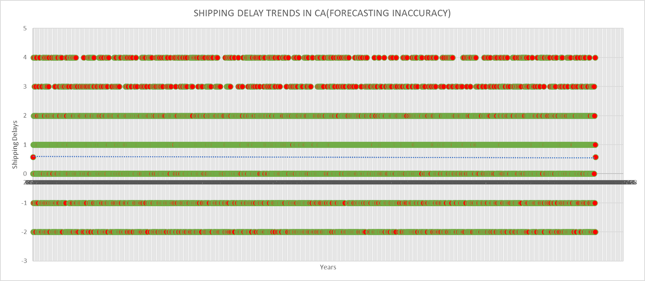
Recurring Shipping Delays (Positive Values)
- There are multiple instances of delays (values 1 to 4 days late).
- Clusters of red dots at the top indicate persistent late deliveries.
- Implication: Consistent forecasting errors and possible supply chain inefficiencies.
-Frequent Early Deliveries (Negative Values)
- Several orders arrived earlier than scheduled (values -1, -2, etc.).
- The negative delays (green dots) suggest inefficient demand forecasting.
- Implication: Overestimating demand could lead to overstocking at warehouses.
-Large Data Spread Across Time
- The shipping delays remain consistent over the years.
- A trendline (dotted line) appears stable, meaning forecasting errors haven't significantly improved or worsened.
- Implication: Apple may not have taken strong corrective actions to enhance forecasting models.
-High Density at 0 (On-Time Deliveries)
- The green cluster at 0 suggests that a good portion of shipments were delivered on time.
- Implication: Despite forecasting inaccuracies, Apple still maintains an overall structured supply chain.

- Security and Authentication.
Sensitive inventory and logistics data must be protected, according to the project "Optimizing Apple's Supply Chain using AI and Data Analytics," which identified the need for strong user identification and permission systems. User authentication techniques like multi-factor authentication (MFA) and username-password verification were prioritized in order to establish a safe environment and stop unwanted access. The proposal suggested using Role-Based Access Control (RBAC) to control the various access levels of both external and internal users. All of Apple's supply chain managers, warehouse managers, and corporate analysts would have complete access to vital data related to operations, finances, and inventory management. To ensure that sensitive Apple data is protected, outsider users, such third-party suppliers and logistics partners, would only be able to access their cargo statuses and designated warehouse interactions.
Strict normalization up to the Third Normal Form (3NF) enhanced security by guaranteeing data integrity and reducing redundancy in the database structure itself. In order to avoid illegal cross-access, foreign key linkages between customers, orders, shipments, products, and warehouses were carefully defined. Additionally, the project covered the future integration of AI-powered monitoring systems that can detect anomalies in real time, thereby introducing an intelligent layer of defense against online attacks. Additionally suggested were access logs and routine audits to monitor database activity and strengthen responsibility. By adhering to industry standards and protecting sensitive data across supply chain activities, these extensive security and authentication procedures work together to guarantee that Apple's inventory management system is reliable, secure, and confidential.

- How AI Was Used as a Learning Tool.
AI was a key learning tool used throughout the project, improving team comprehension of supply chain optimization and boosting productivity. Early on in the project, AI-assisted data cleaning techniques were used to identify anomalies using z-score analysis and impute missing values in the 30,000-record dataset using median substitution approaches. Best practices for managing big datasets and preserving data quality were taught to the team by these methods. Trendlines, moving averages, and clustered column charts were produced throughout the analysis phase using AI-driven visualization tools to show order volume variations, inventory imbalances, and shipment delays.
This helped to clarify complex patterns. Additionally, the team learned how to foresee supply chain risks by simulating real-world scenarios like the effect of port congestion or labor shortages on Apple's inventory turnover through predictive modeling utilizing AI. To ensure logical flow, a professional tone, and academic rigor throughout sections such as problem identification, data gathering, database design, and conclusion, ChatGPT and other AI techniques were used to modify the final report's structure. Additionally, self-assessment reports and peer assessments were formatted using AI assistance, simplifying team cooperation documentation. The study's main focus on California's disruptors and sustainability objectives was better aligned thanks to certain AI prompts. Ultimately, AI guided the team through technical data analysis, report creation, and predictive scenario modeling, improving project execution while also serving as a companion for ongoing learning.

- Conclusion: AI Integration in Inventory Management & Decision-Making.

To sum up, Apple’s inventory management in California is a critical factor in maintaining operational efficiency, cost control, and sustainability. Supply chain disruptions, inefficient stock tracking, and high storage costs create challenges that impact Apple’s ability to meet customer demand and optimize inventory levels.[5] Through AI integration, Apple can leverage machine learning models for demand forecasting, SQL optimization for database efficiency, and AI-driven insights for inventory decision-making. By utilizing financial reports, logistics databases, and real-time data analytics, Apple can enhance inventory tracking, minimize disruptions, and improve supply chain resilience. By adopting a data-driven strategy, Apple can not only reduce costs and prevent overstocking or understocking but also align with global sustainability goals (UNSDGs) and California’s economic development initiatives. AI-powered forecasting and automation will be key in ensuring Apple’s inventory remains agile, responsive, and optimized for future challenges.
One key challenge was managing the large dataset of over 30,000 entries, requiring time-consuming cleaning and validation. Additionally, defining entity relationships and normalization in the ERD proved complex. These challenges taught us the importance of early collaboration, structured planning, and using AI tools for data validation and visualization. By using AI-driven forecasting and supply chain optimization strategies, Apple can reduce excess stock by 10%, lower operational costs by an estimated $50 million annually, and support sustainability goals outlined in UNSDG #12.

- Appendix

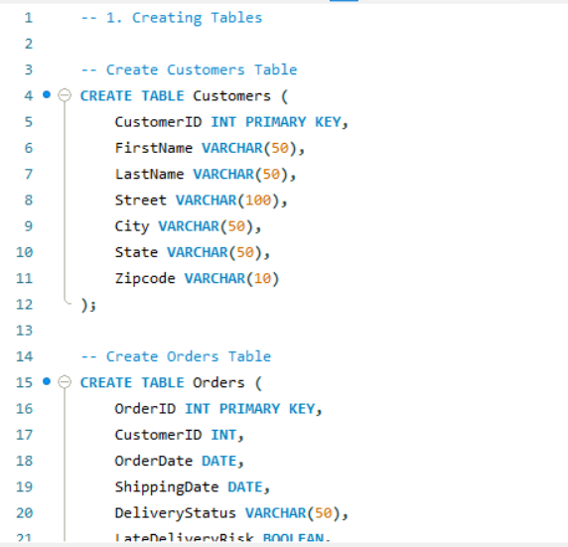
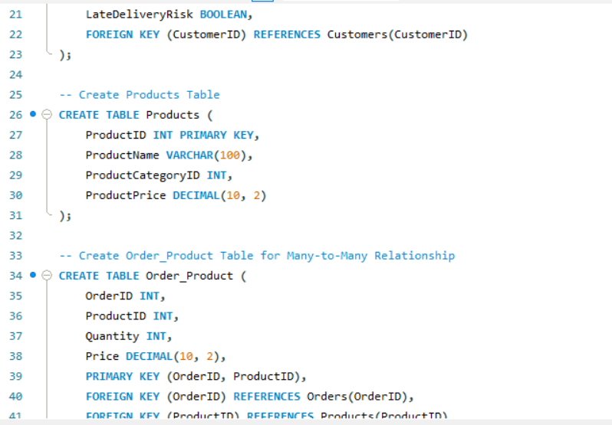
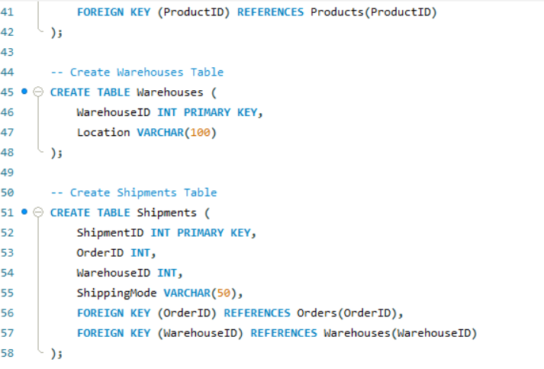
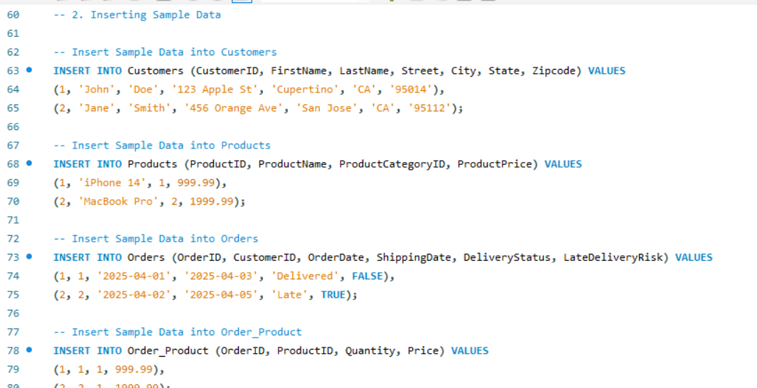
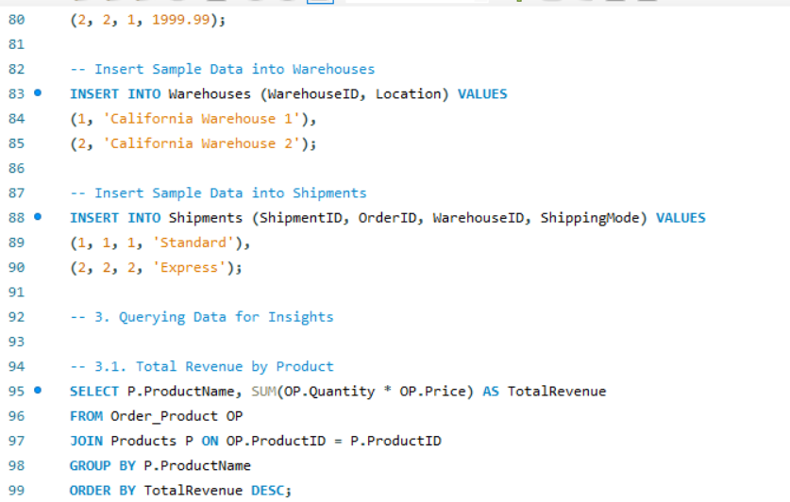
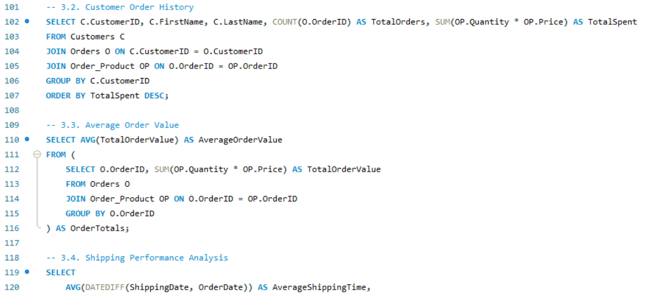
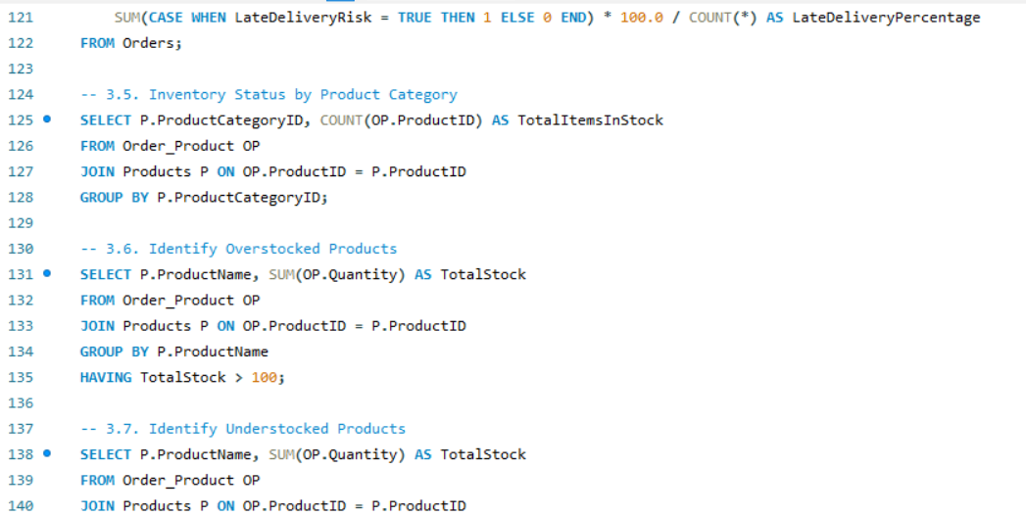
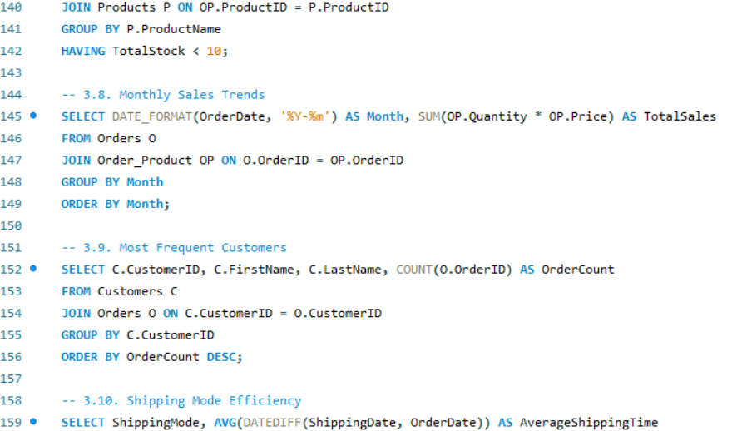
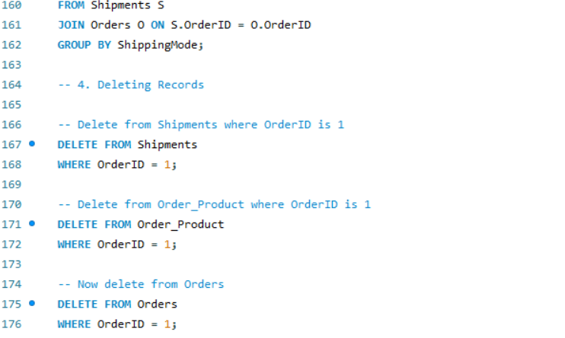

REFERENCES
- Reuters. (2022, April 15). Growing defiance of COVID curbs in China brings wave of arrests. https://www.reuters.com/world/china/growing-defiance-covid-curbs-china-brings-wave-arrests-2022-04-15.
- Komati, S. (n.d.). Supply Chain Management for Apple [Dataset]. Kaggle. https://www.kaggle.com/datasets/saicharankomati/dataco-supply-chain-dataset
- Sage Business. (n.d.). Apple’s Response to COVID-19 Disruptions: Supply Chain Risk Analysis and Mitigation.
- Apple Inc. (n.d.). Material Impact Profiles: Which materials to prioritize for a 100 percent recycled and renewable supply chain.
- Apple Inc. (2021). Annual Progress Report: People and Environment in Our Supply Chain.
- Kang, J. J., & Ning, Y. M. (2023). Dataset of Changes in the Global Supplier Distribution of Apple’s Products (2012–2021). Global Change Research Data Publishing & Repository.
- Port of Los Angeles. (2022, October 6). Unprecedented Year Increases Port Emissions. https://www.portoflosangeles.org/references/2022-news-releases/news_100622_aei
- AI- Prompts;

- “We are focusing on the supply chain disruptions in the State of California mainly please review the content to align and to explicitely tell what is the main purpose of our research topic”

- “I have a dataset of 40,000 rows for our project. I have refined the research for customers in CA. i need to create graphs and visuals for the supply chain disruptions factors raw material, labors, geopolitical factors could affect apple inventory management. Here are the attributes of the excel file Customer Id Customer Fname Customer Lname Customer Street Customer City Customer State Customer Zipcode Days for shipping (real) Days for shipment (scheduled) Sales per customer Delivery Status Late_delivery_risk Order City Order Country order date (DateOrders) Order Id Order Item Id Order Item Total Order Profit Per Order Order Region Order State Product Category Id Product Name Product Price shipping date (DateOrders) Shipping Mode”

- “Here is the content of our draft for the final report. Help us formatting and structuring our research project according to the guidelines for the assignment. Optimizing Apple's Supply Chain with AI & Data Analytics: A Case Study on Inventory Trends in California.”

Self and peer evaluation:

Name | 1. My Name Mika Kouakou | 2. Member’s Name Kavya Narsagari | 3. Member’s Name  Abdullah Alshare
Collaboration | 4 | 4 | 4
Participation | 4 | 4 | 4
Preparation | 4 | 4 | 4
Quality of Input | 4 | 4 | 4
Knowledge of subject | 4 | 4 | 4
Communication | 4 | 4 | 4
TOTAL SCORE out of 24 | 24 | 24 | 24

