multi_homework10

Mikala

February 15, 2016

library(vegan)

## Loading required package: permute

## Loading required package: lattice

## This is vegan 2.3-3

data(dune)  
data("dune.env")  
dune_mds = metaMDS(dune)

## Run 0 stress 0.1192678   
## Run 1 stress 0.1183186   
## ... New best solution  
## ... procrustes: rmse 0.02026955 max resid 0.06495394   
## Run 2 stress 0.1192679   
## Run 3 stress 0.1183186   
## ... procrustes: rmse 9.758681e-05 max resid 0.00031657   
## *** Solution reached

plot(dune_mds, type='n')  
text(dune_mds, 'sp', cex=.5)  
color_vect = rev(terrain.colors(6))[-1]  
points(dune_mds, 'sites', pch=19,   
 col=color_vect[dune.env$Moisture])  
legend('topright', paste("Moisture =", 1:5, sep=''),   
 col=color_vect, pch=19)

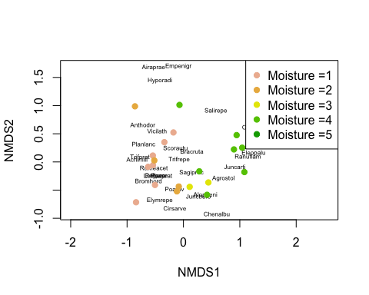

# The goal of creating this plot is to look at trends of how amounts of moisture are related. The plot shows that species with similar amounts of moisture plot along similar axies in the plot, indicating that moisture is potentially a significant predictive variable  
dune_cca = cca(dune ~ dune.env$A1 + dune.env$Moisture + dune.env$Management + dune.env$Use + dune.env$Manure)  
dune_cca

## Call: cca(formula = dune ~ dune.env$A1 + dune.env$Moisture +  
## dune.env$Management + dune.env$Use + dune.env$Manure)  
##   
## Inertia Proportion Rank  
## Total 2.1153 1.0000   
## Constrained 1.5032 0.7106 12  
## Unconstrained 0.6121 0.2894 7  
## Inertia is mean squared contingency coefficient   
## Some constraints were aliased because they were collinear (redundant)  
##   
## Eigenvalues for constrained axes:  
## CCA1 CCA2 CCA3 CCA4 CCA5 CCA6 CCA7 CCA8 CCA9 CCA10   
## 0.4671 0.3410 0.1761 0.1532 0.0953 0.0703 0.0589 0.0499 0.0318 0.0260   
## CCA11 CCA12   
## 0.0228 0.0108   
##   
## Eigenvalues for unconstrained axes:  
## CA1 CA2 CA3 CA4 CA5 CA6 CA7   
## 0.27237 0.10876 0.08975 0.06305 0.03489 0.02529 0.01798

plot(dune_cca, type='n')  
text(dune_cca, 'sp', cex=.5)  
color_vect = rev(terrain.colors(6))[-1]  
points(dune_cca, 'sites', pch=19,   
 col=color_vect[dune.env$Moisture])  
legend('topright', paste("Moisture =", 1:5, sep=''),   
 col=color_vect, pch=19)

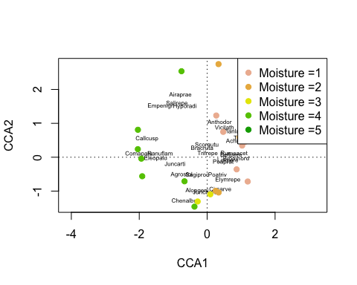

dune_cca

## Call: cca(formula = dune ~ dune.env$A1 + dune.env$Moisture +  
## dune.env$Management + dune.env$Use + dune.env$Manure)  
##   
## Inertia Proportion Rank  
## Total 2.1153 1.0000   
## Constrained 1.5032 0.7106 12  
## Unconstrained 0.6121 0.2894 7  
## Inertia is mean squared contingency coefficient   
## Some constraints were aliased because they were collinear (redundant)  
##   
## Eigenvalues for constrained axes:  
## CCA1 CCA2 CCA3 CCA4 CCA5 CCA6 CCA7 CCA8 CCA9 CCA10   
## 0.4671 0.3410 0.1761 0.1532 0.0953 0.0703 0.0589 0.0499 0.0318 0.0260   
## CCA11 CCA12   
## 0.0228 0.0108   
##   
## Eigenvalues for unconstrained axes:  
## CA1 CA2 CA3 CA4 CA5 CA6 CA7   
## 0.27237 0.10876 0.08975 0.06305 0.03489 0.02529 0.01798

1.5032 / 2.1153

## [1] 0.7106321

# R-squared value for entire model (0.7106) Indicates that the model explains a relatively high amount of the variance  
plot(dune_cca, ylim=c(-20, 20), display=c('sp','bp'), scaling=1)

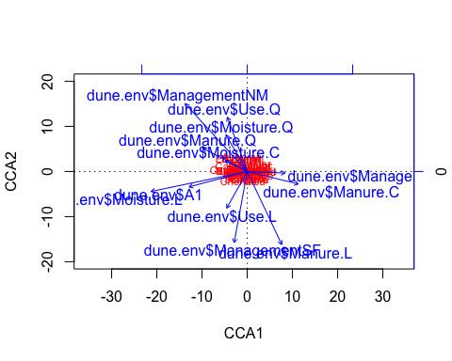

anova(dune_cca)

## Permutation test for cca under reduced model  
## Permutation: free  
## Number of permutations: 999  
##   
## Model: cca(formula = dune ~ dune.env$A1 + dune.env$Moisture + dune.env$Management + dune.env$Use + dune.env$Manure)  
## Df ChiSquare F Pr(>F)   
## Model 12 1.5032 1.4325 0.025 *  
## Residual 7 0.6121   
## ---  
## Signif. codes: 0 '***' 0.001 '**' 0.01 '*' 0.05 '.' 0.1 ' ' 1

# P-value for the entire cca model (0.025) also indicates the model is significant   
anova(dune_cca, by='margin')

## Permutation test for cca under reduced model  
## Marginal effects of terms  
## Permutation: free  
## Number of permutations: 999  
##   
## Model: cca(formula = dune ~ dune.env$A1 + dune.env$Moisture + dune.env$Management + dune.env$Use + dune.env$Manure)  
## Df ChiSquare F Pr(>F)  
## dune.env$A1 1 0.11070 1.2660 0.256  
## dune.env$Moisture 3 0.31587 1.2041 0.215  
## dune.env$Management 2 0.15882 0.9081 0.589  
## dune.env$Use 2 0.13010 0.7439 0.791  
## dune.env$Manure 3 0.25490 0.9717 0.509  
## Residual 7 0.61210

# gives P values for each factor included in model. Soil moisture and soil depth are the best predictive varioables, although the P-values are above the significance level  
a1_partial= cca(residuals(cca(dune ~ . - A1, data=dune.env)) ~ dune.env$A1)  
a1_partial

## Call: cca(formula = residuals(cca(dune ~ . - A1, data = dune.env))  
## ~ dune.env$A1)  
##   
## Inertia Proportion Rank  
## Total 0.72280 1.00000   
## Constrained 0.05013 0.06936 1  
## Unconstrained 0.67267 0.93064 8  
## Inertia is mean squared contingency coefficient   
##   
## Eigenvalues for constrained axes:  
## CCA1   
## 0.05013   
##   
## Eigenvalues for unconstrained axes:  
## CA1 CA2 CA3 CA4 CA5 CA6 CA7 CA8   
## 0.29404 0.11410 0.09078 0.06315 0.03818 0.03412 0.02399 0.01430

0.05013 / 0.72280

## [1] 0.06935529

# R-squared value (0.0694) for cca model with all factors except A1 (thickness of soil A1 horizon), R-squared value indicates that the model can explain much less of the variance without taking A1 into consideration  
# The two analyses seem to complement each other with regards to identifying moisutre as a potentially important variable in explaining dune vegetation growth. Both plots portray the different levels of moisture plotting in groups along the same axes, and the CCA model analysis showed that moisture was one of the best explanatory variables in the model. However, further analysis of the CCA approach also identified A1 to be an important explanatory variable, since the model did a much worse job when it was removed. I find the direct ordination analysis to be more useful, since I feel it better explained relationships and predictive strengths of the included variables and provided a better analysis of the model as a whole.