**Hardware and Software Module for UAV for Fast Estimation of Agricultural Fields Maps**

**N.V. Bogdanov V.V. Ganchenko**

The State Scientific Institution «The United Institute of Informatics Problems of the National Academy of Sciences of Belarus»

***Abstract:*** *A hardware and software module for unmanned aerial vehicle (UAV) designed to adjust maps of agricultural fields state. The module allows performing a fast estimation of photographic images of field along the UAV route, forming required commands to adjust the maps and corresponding control signals for the UAV.*

***Keywords*:** monitoring, precision agriculture, computer vision, image processing, UAV.

**1. INTRODUCTION**

Precision agriculture is now gaining ground in many countries. Precision agriculture technology examines every farm field as a non-uniform in relief, soil cover, agrochemical contents and involves the use of every part of the field of various agricultural technologies [1, 2]. The basis of the technology is maps of vegetation state, which are constructed using remote sensing methods, these maps require correction before agro-technical measures. Images that receive terrestrial or airy robotic systems for agricultural purposes are used for correction.

Existing UAVs of this type are characterized by low productivity of data processing, inability to store large amounts of data and lack of stable communication with a base station. In this context, development presented in the article of hardware and software modules for fast estimation of vegetation state is important.

**2. DESCRIPTION OF MODULE WORK**

Hardware-software module is a single-board computer that is running a program that consists of four main subprograms (subsystems, Figure 1.): subsystem for selection of area for investigations, comparison subsystem, subsystem for correcting position of the UAV, subsystem to form a data for sending.

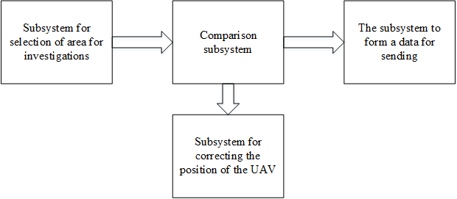

**Fig. 1. Block diagram of the software module**

*Subsystem for selection of area for* *investigations* is implementing search and copy area, for processing. It allocates border of the processed image according to given attributes and separates it from the overall image for further analysis. Work result of the subsystem is stored in an intermediate file for convenience of further work of the program.

*Subsystem for correcting the position of the UAV* monitors patterns, which are on resulting image, and compares them with those that must be on a given route. In case of displacement, the resulting coordinates are subtracted from those, which must be drones. Result of this subtraction generates and sends a signal to the UAV control system.

*The subsystem to form a data for sending* extracts from the data that are saved on memory card, coordinate areas required for further study.

*The comparison subsystem* uses a quality factor. Quality factor is calculated according to values of the image in HSV color space. This is done to reduce effect of lighting conditions.

*Hue* value is calculated as follows:

 (1)

and *Sat* – by formula:

 (2)

*Hue* can take values from -π/2 to π/2. *Sat* – from 0 to 255. In Table 1, values given *Hue* and *Sat* for different types of segments. Data on hue and saturation values were obtained by expert, on basis of analysis of the color characteristics of individual plants images and aerial photographs potato field [3].

**Table 1. Value of color ranges**

|  |  |  |
| --- | --- | --- |
| **Type segment color saturation** | **Hue Range** | **Range Sat** |
| Healthy (Green) | [0.1; π/2] | [110; 255] |
| Diseased (Yellow) | [1.0; π/2] | [170; 255] |
| Diseased (brown-green) | [1.0; π/2] | [128; 175] |

HSV colorspace coordinate values are calculated for each pixel. After determining of values calculating the number of pixels of a healthy segment would produced. Also the number of pixels that do not fall into any ranges would be calculated. From total number of pixels subtracted the number of pixels that do not fall in any of the ranges.To calculate the quality factor: it is necessary to take ratio of the number of pixels from a healthy segment to the obtained number of pixels after the subtraction. This coefficient characterizes state of the agricultural field.

An important consideration in design of hardware and software modules is need of realizing constraints single-board computer (SBC) with on-board systems (Fig. 2). Therefore, in addition to the main program a number of service programs are present. These service programs form control signals for data sending systems, photography, management, and others. In order to match on-board voltage and voltage required for work of hardware and software module a power adapter is necessary. Communication can be done through established on most single-board computers interfaces (USB, Ethernet) [4].

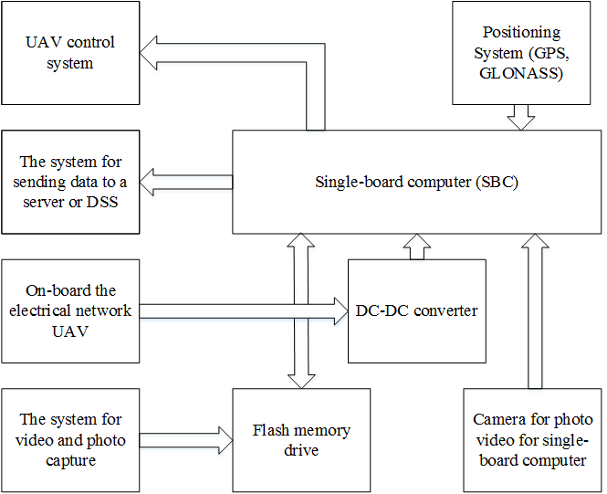

**Fig. 2. Communications on hardware level: UAV systems and modules**

**3. THE ALGORITHM OF THE SOFTWARE PART OF THE SYSTEM**

The program works according to algorithm, which consists of next steps:

1. Alignment of the white balance of the resulting image.

2. Searching on the received image an area to investigation. Patterns for comparison should be created in advance.

3. Found section copied to RAM devices. Also copied the file name

4. If the section is not found, then quick search according to patterns should be executed. In case of pattern detection in another area, coordinates deviation is calculated and sent control signals to the UAV. If you do not match any pattern signal of returning to the base is required.

5. Calculate the quality factor of the field and compare the resulting avalue with a reference value the quality factor for of field.

6. If there are significant deviations, the filename is transmitted to sending data subsystem for processing on decision-making system. Deviations boundary was set by operator. It depends on type of vegetation and vegetation period. It is also, possible, for on-ground processing factor is stored in a separate array.

The algorithm is repeated until the last file for comparison will be read or until a command is received from the operator.

**4.CONCLUSION**

Software module and scheme of its interaction with the on-board equipment at the hardware level are result of the algorithm. The program carries out fast estimation and monitoring functionality for vegetation status. This functionality allows to reduce expenditure on agricultural activity by reducing the number areas for a thorough analysis. Program for module tracking route of the UAV and corrects it if necessary by controlling UAV nodes. Usage of single-board computer allows to simplify debugging of equipment for specific tasks and allows to extend functionality as needed.

**5. REFERENCES**

1. Greenbelarus [electronic resource]. – Access mode: http://greenbelarus.info/files/downloads/zashchita_rasteniy_v_organicheskom_selskom_hozyaystve.pdf. – Access Date: 22.02.2016.

2. Nsu [electronic resource]. – Access mode: http://www.nsu.ru/xmlui/bitstream/handle/nsu/318/03.pdf;jsessionid=F6A19137B3C6CC404E3CF081A2FEDF8F?sequence=1#page=2&zoom=auto,-202,556. – Access Date: 02.09.2016.

3. Zastosowanie technikanalizy obrazu do wczesnego wykrywania patogeno w ziemniaka. Pracanie publicowana / B. Sobkowiak [et al.]. – Poznan`: PIMR, 2006.

4. SBC [electronic resource]. – Access mode: Https://dl.dropboxusercontent.com/u/4035896/a320_downloads/SBC_comparison44.pdf. – Access Date: 20.03.2016.