HARDWARE AND SOFTWARE MODULE FOR UAV FOR QUICK ASSESSMENT MAPS AGRICULTURAL FIELDS

NV Bogdanov VV Ganchenko

*A hardware and software module for unmanned aerial vehicle (UAV) designed to adjust the card status of agricultural fields. The module allows you to perform a quick assessment of photographic images of the field along the route of the aircraft, form teams of the need to adjust the mapping and appropriate control signals for the UAV.*

**Introduction**

Precision agriculture is now gaining ground in many countries. Precision agriculture technology examines every farm field as a non-uniform in relief, soil cover, agrochemical contents and involves the use of every part of the field of various agricultural technologies [1, 2]. The basis of the technology is state of vegetation maps, which are constructed by methods of remote sensing of the Earth from space, which require correction before the agro-technical measures. For correcting use the images that receive terrestrial or airy robotic systems for agricultural purposes.

Existing UAVs of this type are characterized by low productivity of data processing, the inability to store large amounts of data and the lack of stable communication with the base station. In this context, the development presented in the report of the hardware and software modules for the rapid assessment of condition of vegetation is important.

**1. Description of module operation**  
  
Hardware-software module is a single-board computer that is running a program that consists of four main subprograms (subsystems, Figure 1.): subsystem for selection of area for investigations, comparison subsystem, subsystem for correcting the position of the UAV, the subsystem to form a data for sending.

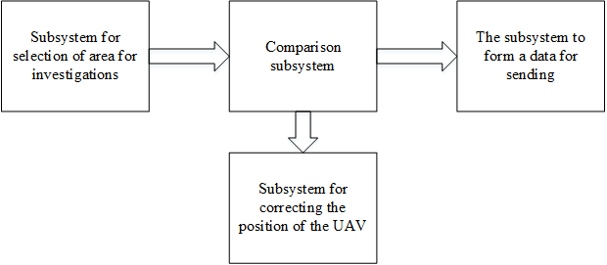

Fig. 1. Block diagram of the software module

The *subsystem for selection of area for investigations* is implementing search and copy area, for research. It allocates the border researched image according to given attributes and separates it from the overall picture for further analysis. The result of the subsystem is stored in an intermediate file for the convenience of the further work of the program.

*Subsystem for correcting the position of the UAV* monitors the patterns, which are on the resulting image, and compares them with those that must be on a given route. In the case of the displacement, the resulting coordinates are subtracted from those, which must be drones. The result of this subtraction generates and sends a signal to the UAV control system.

*The subsystem to form a data for sending* extracts from the data that are saved on the memory card, the coordinate areas required for further study.

*The comparison subsystem* uses a quality factor. Quality factor is calculated according to the values of the image in the HSV color space. This is done to reduce the impact of lighting conditions.

Hue value is calculated as follows:

|  |  |
| --- | --- |
|  | (1) |

Sat - by the formula:

|  |  |
| --- | --- |
|  | (2) |

Hue can take values from -π / 2 to π / 2. Sat - from 0 to 255. In Table 1, the values given Hue and Sat for different types of segments. Data on the hue and saturation values were obtained by the expert, on the basis of the analysis of the color characteristics of individual plants images and aerial photographs potato field [3].

Table 1

The color values ​​range

|  |  |  |
| --- | --- | --- |
| Type segment color saturation | Hue Range | Range Sat |
| Healthy (Green) | [0.1; π/2] | [110; 255] |
| The patient (Yellow) | [1.0; π/2] | [170; 255] |
| The patient (brown-green) | [1.0; π/2] | [128; 175] |

HSV space coordinate values are calculated for each pixel. After determining the values produced calculating the number of pixels of a healthy segment. Also considered to be the number of pixels that do not fall into any of the ranges. From the total number of pixels subtracted the number of pixels that do not fall in any of the ranges. To calculate the quality factor: it is necessary to take the ratio of the number of pixels from a healthy segment to the obtained number of pixels after the subtraction. This factor characterizes the state of the agricultural sector.

An important consideration in the design of hardware and software modules is the need of realizing the constraints single-board computer with on-board systems (Fig. 2). Therefore, in addition to the main program on the SBC operates a number of service routines that form the control signals for the data sending systems, photography, management, and others. In order to match the on-board voltage and voltage required for work of hardware and software module necessary a power adapter. Communication can be done through the established on most single-board computers interfaces (USB, Ethernet) [4].

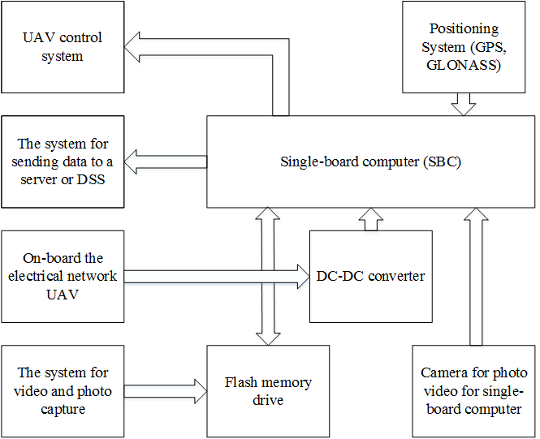

Fig. 2. Communications on the hardware level: UAV systems and modules

2. The algorithm of the software part of the system

The program works according to the algorithm, which consists of the next steps:

1. Carried alignment of the white balance of the resulting image.

2. Searching on the received image an area to explore. Standard sections for comparison created in advance.

3. Found section copied to RAM devices. Also copied the file name

4. If the section is not found, then done a quick search according to patterns. In the case of pattern detection in another area, the deviation is calculated and fed the control signals to the UAV nodes. If you do not match any of the pattern signal is fed back to the base.

5. Calculate the quality factor the site and compares the resulting factor with a reference value the quality factor for of the site.

6. If there are significant deviations from the boundary area, the filename is transmitted to the sending data system for processing on decision-making system. Deviations boundary set by the operator. It depends on the type of vegetation and the vegetation period. It is also, possible, for the on-ground processing, factor is stored in a separate array.

The algorithm is repeated until the last file for comparison will be read or until a command is received from the operator.

**Conclusion**

The result was an algorithm of software for module and the scheme of its interaction with the on-board equipment at the hardware level. The program carries out a rapid assessment and monitoring function of vegetation status. This reduces the expenditure on agricultural activity by reducing the number areas for a thorough analysis. Program for module tracking the route of the aircraft and corrects it if necessary by controlling the UAV nodes. The use of single-board computer allows you to simplify debugging of the equipment for specific tasks and allows you to extend the functionality as needed.

Bibliography  
  
1. Greenbelarus [electronic resource]. –

modeдоступа:http://greenbelarus.info/files/downloads/zashchita_rasteniy_v_organicheskom_selskom

_hozyaystve.pdf. - Access Date: 22.02.2016.

2. Nsu [electronic resource]. - Access

mode:http://www.nsu.ru/xmlui/bitstream/handle/nsu/318/03.pdf;jsessionid=F6A19137B3C6CC404E3C

F081A2FEDF8F?sequence=1#page=2&zoom=auto,-202,556. - Access Date: 02.09.2016.

3. Zastosowanie technik analizy obrazu do wczesnego wykrywania patogeno`w ziemniaka. Praca nie publicowana / B. Sobkowiak [et al.]. - Poznan`: PIMR, 2006.

4. SBC [electronic resource]. – Https://dl.dropboxusercontent.com/u/4035896/a320_downloads/SBC_comparison44.pdf Access. - Access Date: 20.03.2016.