STATISTICS OF Multi-threaded producer-consumer.
*(The greek version is richer , this needs to be updated)*
Bellow there are reported some of the statistics we got about the waiting time of a Workfunction in the queue . These measurements are achieved by using the matlab script that is located inside the data folder in the project.
- Overall Mean Waiting time
Queue size =10
Overall mean waiting time for QUEUESIZE=10
Queue size =1000
Overall mean waiting time for QUEUESIZE=1000

By seeing the tables and the graphs above we understand , that in general , for constant number of producers p , if the number of consumers q is increasing we get smaller values for the mean waiting time , until we get a really small value of mean waiting time , and the mean waiting time has a really small variation (practically is stable).Also we can see that for larger queues , we get bigger execution times in general.

- Mean Waiting time of ¾ of executions
Queue size =10
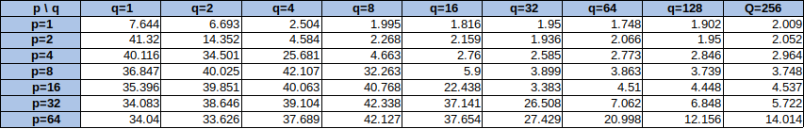Mean Waiting time for the 3/4 of the executions( QUEUESIZE=10)
Queue size =1000
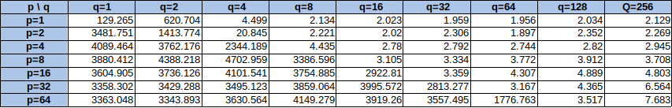Mean Waiting time for the 3/4 of the executions( QUEUESIZE=1000)
As we can see for the values of the mean waiting time in the ¾ of the total executions ( (¾) * P*LOOP) is about the same as the overall mean wait time. That mean that the total number of executions are big enough to give as statistical conclusions. Also the graphs for the two statistics are the about the same as we can see bellow.

Furthermore bellow we can see the absolute difference between the mean waiting time at the ¾ of the executions and the absolute mean waiting time:
Queue size =10
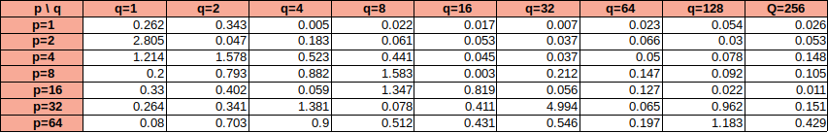Absolute Difference between mean waiting time at the ¾ of executions and the overall mean waiting(QUEUEASIZE=10)
Queue size =1000
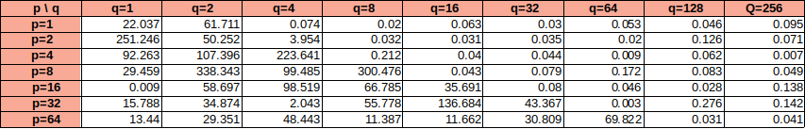Absolute Difference between mean waiting time at the ¾ of executions and the overall mean waiting(QUEUEASIZE=1000)
We see from the tables above that the absolute difference between mean waiting time at the ¾ of executions and the overall mean waiting time is a value so small , not comparable with the two statistics .

- Standard Deviation of waiting times

Queue size =10
Standard Deviation of waiting times (QUEUESIZE=10)
Queue size =1000

Standard Deviation of waiting times (QUEUESIZE=1000)
As we can see standard deviation gets significant values that are comparable with mean waiting time value and for some compinations of p and q , standard deviations also get bigger values . That means that the waiting times in our experiments vary in time . This is something we expected to see as soon as there are functions that are going to come out immediately (especially in the beginning of the programm, as we first spawn the consumer threads) and there are functions that are going to be in pending state inside the queue for a portion of time .

