Phraxis InterGraft System

Contents

1 The InterGraft System 0

2 Pre-Procedure Checklist 0

2.1 Required Supplies 0

3 InterGraft System Procedure 0

3.1 Prepare Arterial InterGraft 0

3.1.1 Deliver Arterial InterGraft 0

3.2 Prepare Venous InterGraft 0

3.2.1 Deliver Venous InterGraft 0

# 1 The InterGraft System

The InterGraft system is a minimally invasive procedure for delivering an arteriovenus graft.

The Phraxis InterGraft System connects a standard 6-millimeter arteriovenous graft without sutures. The connectors are delivered via a catheter, and they employ stent-like technology to provide both venous and arterial flow to the graft. Unlike a standard sutured graft, the InterGraft System is designed to provide a smooth, controlled flow.The InterGraft System is a minimally invasive procedure that takes about 30 minutes, and can provide next-day vascular access for hemodialysis.

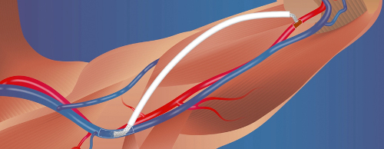

# 2 Pre-Procedure Checklist

## 2.1 Required Supplies

Prepare these items prior to the InterGraft procedure

Example

Two micro puncture kits (needle, access wire, 4F sheath)

One 11F introducer sheath (maximum length 11 cm)

One 7F introducer sheath (maximum length 11 cm)

One 0.018" diamter soft tip guidewire (length 145 cm)

One 0.014" diameter soft tip guidewire (length 145-185 cm)

Three stopcocks

Graft tunneling set

Atraumatic vascular graft clamp

One each sterile 3 cc and 10 cc syringe

Sterile saline solution

Sterile 50:50 heparinized saline for flush

Contrast agent

6 mm sterile stright graft (non-tapered), length appropriate for planned AV access

# 3 InterGraft System Procedure

## 3.1 Prepare Arterial InterGraft

Arterial InterGraft system preparation

Follow these steps prior to delivering arterial InterGraft connection

Using sterile technique, open AIG package and place InterGraft delivery system in a sterile field.

Remove the white graft grippers.

Attach stopcocks to each of the two T-B ports **A**, **F** and open the valves **B**,**C**. Close valve C and flush sterile saline through port **F**. Close stopcock on port **F** and remove 10 cc syringe.

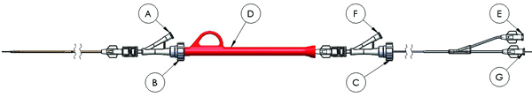

Close valve **B** and flush sterile saline through port **A**.

Close stopcock on port **A** and remove 10 cc syringe.

Flush guidewire lumen through port **G** using sterile saline.

Gently tighten T-B valves **B**,**C**.

Attach stopcock to balloon luer **E**. Evacuate balloon using a 10 cc syringe, close stopcock and remove syringe.

Draw up 50:50 contrast/saline soultion in a 3 cc syringe, attach to stopcock, open stopcock and inject solution.

Visually confirm positioning balloon inflation.

Withdraw contrast from the balloon, close the stopcock, and leave 3 cc syringe connected to luer.

Loosen T-B valves **B**,**C**, backload 0.014" wire into AIG delivery system and gently tighten T-B valve **B**.

Deliver Arterial InterGraftArterial InterGraft implant procedure

### 3.1.1 Deliver Arterial InterGraft

Arterial InterGraft implant procedure

Follow these steps to implant the aterial InterGraft connection

Prepare Arterial InterGraftArterial InterGraft system preparation

Identify arteriotomy site and mark with surgical clamp.

Attach vessel loops or vascular clamps for proximal and distal control of artery. Do not tighten at this stage.

Gain access to artery using a micropuncture kit, insert wire, remove needle and insert 4F sheath.

Exchange 4F sheath for 7F sheath - replace micropuncture wire with 0.0014" wire.

Load AIG delivery system over the 0.014" wire.

Under fluoroscopic guidance, advance AIG over the wire and into the artery approximately 1 - 2 cm past arteriotomy.

Arrow points to clamp tip at arteriotomy site.

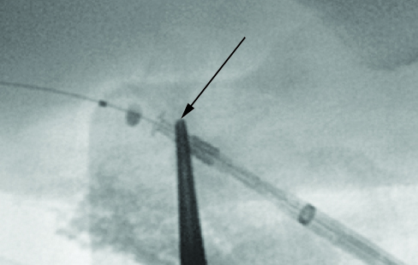

Remove red deployment lock labeled D and position AIG marker band approximately 2 cm central to clamp tip that marks the arteriotomy site.

Loosen T-B valve **B**.

Reconfirm marker band position, remove 7F sheath and deploy AIG under floroscopy using standard "pin and pull" technique until **only the tines** emerge from the delivery sheath.

Inflate positioning baloon, pull the inflated baloon back to engage tines, tighten T-B valve **B**.

Slowly pull entire AIG system up vertically from artery until resistance is felt.

Resistance indicates apposition of the tines at the artery wall.

Complete deployment of the AIG using "pin and pull" technique, deflate balloon and remove entire system and guidewire.

Grasp protruding end of AIG to control bleeding, stabilize base of AIG by grasping.

Insert AIG into graft.

Remove clamp and verify flow through circuit.

Release vessel loops or vascular clamps, close incisions.

## 3.2 Prepare Venous InterGraft

Venous InterGraft delivery system preparation

Follow these steps prior to delivering venous InterGraft connection

Using sterile technique, open VIG package and place InterGraft delivery system in sterile field.

Remove the white graft grippers.

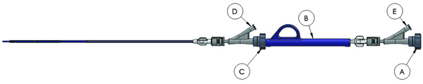

Attach a stopcock to each of the T-B ports **D**,**E**.

Loosen the T-B valves **A**,**C**.

Using 10cc syringe, flush the delivery system with sterile saline solution. Close valve **A**

To load the 0.018" guide wire into the VIG delivery system, loosen both T-B valves **A**, **C**.

Backload wire into delivery system and gently close T-B valve **C**.

Deliver Venous InterGraftVenous InterGraft implant procedure

### 3.2.1 Deliver Venous InterGraft

Venous InterGraft implant procedure

Follow these steps to implant the venous InterGraft connection

Prepare Venous InterGraftVenous InterGraft delivery system preparation

Pre-tunnel graft with ends adjacent to target vein and artery anastomotic sites using specified tunneling procedure.

Identify target venotomy site and mark with a surgical clamp.

Access the vein using micropuncture kit, insert wire, remove needle and insert 4F sheath.

Exchange 4F sheath for 11F sheath--replace micropuncture wire with 0.018" wire.

Load VIG delivery system over the wire.

Under flouroscopic guidance, advance VIG over the wire and into vein, approximately 1 cm past venomy.

Remove blue deployment lock labeled B and position marker band approximately 1cm peripheral to clamp.

Arrow points to marker band.

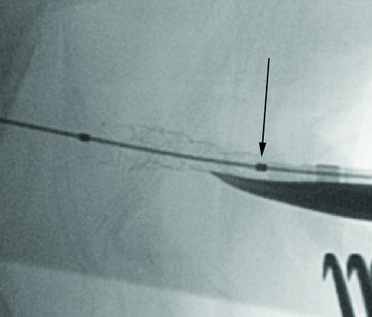

Loosen T-B valve **C** and under fluoroscopic guidance slowly advance the hypotube until it just engages the VIG or

"closes the gap"



Reconfirm the marker band position and remove the 11F sheath from vein.

Deploy VIG under floroscopy using standard "pin and pull" technique, ensuring the marker bands and venotomy clamp remain in position throughout deployment.

Remove VIG delivery system and wire, gently grasp and compress protruding end of VIG to control bleeding and insert VIG into pre-tunneled graft end.

Verify blood flow through graft

Clamp graft to stop venous back-bleeding

Prepare 10 cc syringe with hepranized flush

Remove graft clamp

Flush graft

Reattach clamp