Developing an e-ducation tool online with Open Source tools

Abstract

This paper discusses the development of the Geodetic Data Modeling System (GMDS), a final year Computer Engineering project at the University of Canberra, Australia (http://www.canberra.edu.au). This application was developed using online tools with developers being able to work independently of each other in different physical locations. It is intended that GDMS will be used as a data visualization and manipulation tool to assist in the e-ducation of future GPS researchers. GDMS also has the potential to be harnessed for other educational fields, such as speech recognition, mathematics, and engineering.

This paper focuses on the online collaboration methods used to enable to project.

About the author

Michael Still is a Computer Engineering student at University of Canberra, Australia. He has contributed to a variety of Open Source projects including a PDF generator, and the Linux kernel itself – further details are available from http://www.stillhq.com. He may be contacted at mikal@stillhq.com.

An introduction to GDMS

GMDS is a C++ application designed to run within the X windows environment on machines running the Linux operating system. GDMS has however been developed with portability as a goal, and should also work on other Unices, as well as Microsoft Windows. GDMS is licensed under the GNU GPL version 2, an Open Source license which allows other education institutions to contribute to the development of GDMS, as well as being able to adapt the application to their own education needs.

Online development

One of the major requirements of the GDMS development process was that developers need to be able to develop the code base whilst located in physically separate locations. Whilst all of the developers currently reside in Canberra, Australia, there is no reason that the addition of an international developer would change the complexity of the development process.

This distributed development model was implemented using CVS, an online distributed source code repository. CVS allows developers to “check out” the latest version of the code for the application, make the changes they are currently working on, and then “check in” the code. CVS has been developed with use on the Internet in mind, and works well in this scenario.

The source code repository for GDMS is available for online browsing at http://www.stillhq.com/cgi-bin/cvsweb/cep/

Whilst CVS allows multiple people to be editing one source file at a given time, in order to minimize the amount of hand correction of “merge conflicts” (the result of two people changing the same lines of code at essentially the same time), the source code for GDMS is broken into a series of modules which are contained in separate source files. This also has the advantage that a small change in one module will hopefully not result in a recompilation of the entire code base being required.

Developing documentation in a online friendly manner

The documentation for GDMS is developed using DocBook, an SGML documentation DTD. An example of this SGML format is:

<sect3><title>Batch user interface</title>
<para>
There are two common implementation methodologies for scripting languages. Both of these were considered for the <command>GDMS</command> implementation. The most common manner for implementing the parser and grammar for a scripting language is by using the compiler construction tools <command>yacc</command>, and <command>lex</command> (or their free versions, <command>bison</command> and <command>flex</command>).
</para>

<sect4><title>Compiler construction tools</title>
<para>
<command>Lex</command> and <command>flex</command> are parser generation tools. They take a lexical specification file, and generate a LALR finite state machine for matching input strings (Aho, Sethi &amp; Ullman 1986). A sample of a lexical specification is shown below (in this case for the PDF file format):
</para>

This format is then trivially formatted into PostScript and PDF using a variety of common Open Source tools. The major advantage of using SGML for the documentation development is that the source files are merely text files with tags inserted into the document. This can then be edited by several people at once, and checked into and out of the same CVS repository that stores the application source code.

This DocBook documentation concept has been extended further, with each class definition with the source code having a specially formatted comment, which contains the documentation for that class. These are then automatically extracted when the documentation is generated, and inserted into the documentation. This ensures that the documentation for the source code is always synchronized with the latest version of the written documentation.

The latest versions of the documentation for GDMS are always available at http://www.stillhq.com/extracted/cep/thesis/GDMSthesis.pdf and http://stillhq.com/extracted/cep/manuals/usermanual.pdf.

An e-ducation tool

GDMS is a visualization tool for time series data. Currently, the data is derived from Global Positioning System (GPS), Very Long Baseline Infereometry (VLBI), and Satellite Laser Ranging (SLR) techniques. This data is then presented to the user in their option of an X windows or Internet based user interface. An example dataset is Ceduna:

North:

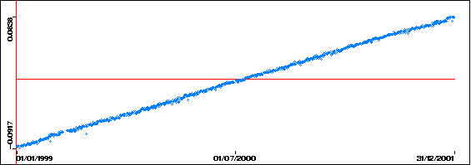

East:

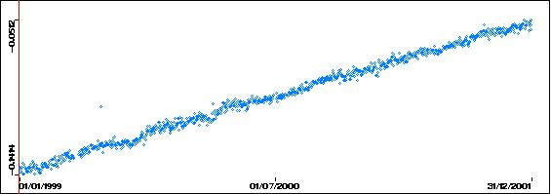

Up:

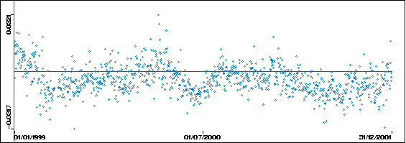

From this data it is apparent to users of GDMS that there is a periodic noise occurring in the “up” direction. Within the application the user can then choose to perform a Fast Fourier Transform, which will make this noise more apparent:

Up, after a Fast Fourier Transform:
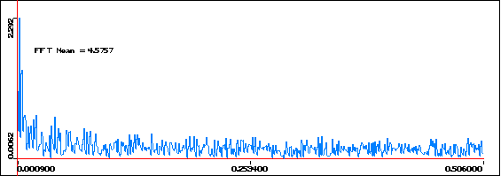

This sort of processing has several advantages: it allows the users of the system to rapidly and accurately visualize the data they have at their disposal. It also offers a method by which to teach students the effects of various mathematical operations. For example, in the scenario described above, students would have discovered the usefulness of Fast Fourier Transforms for determining noise within data.

Another example of the power of the visualization tools provided by GDMS is windowing. Windowing is a common mathematical operation which involves slicing up available data into a number of “windows” these are then processed individually. For example, the Alice Springs dataset contains the following north movement data:

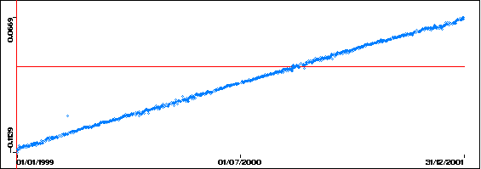

After a Hamming window has been applied, the data is transformed to:

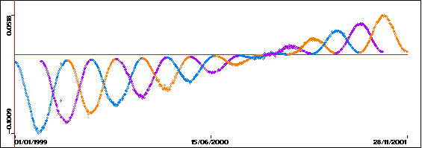

This graphical representation of the data reinforces the effect of the windowing process, thus enhancing student understanding.

Conclusion

Unfortunately, it is not possible to discuss all of the mathematical operations available in GDMS within this document. However, GDMS is a powerful e-ducation tool, which was developed by students undertaking learning via e-ducation. The Open Source license adopted by the GDMS implementation team enhances the opportunities for other education institutions to contribute, and use GDMS for their own purposes.

Ceduna is located in South Australia, more information about the VLBI capabilities of this location may be found at http://www-ra.phys.utas.edu.au/observatories/ceduna.html.

