What is geodesy:

“Geodesy is the discipline that deals with the measurement and representation of the earth, including its gravity field, in a three-dimensional time varying space”

Technologies used:

- GPS (Global Positioning Satellites): Global Positioning System (GPS) is a constellation of 24 satellites which is used for navigation and precise geodetic position measurements. Daily position estimates are determined from satellite signals which are recorded by GPS receivers on the ground.
GPS is not renowned for its integrity. Measurements here can be very precise, however, its precision is extremely variable and depends heavily upon satellite availability. This lack of consistency is a major concern for parties, such as the Geodetic community, who are measuring movements of mere millimeters.
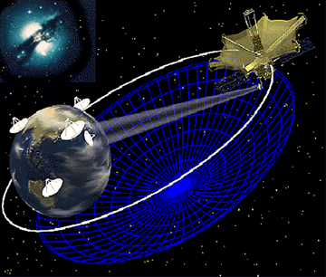
- VLBI (Very Long Baseline Interferometry): VLBI is a well-established observing technique used by radio astronomers. Radio telescopes around the world can be linked together electronically to create an earth-sized "interferometer," which creates the effect of one giant telescope as large as the earth. These enormous (or VLBI) telescopes can "see" astrophysical objects in better detail than any other telescopes in use. This is due to the fact that, in general, the bigger the telescope, the better the detail.
VLBI provides a very accurate measurement of the earth's orbit, independent of atmospheric effects. The low sample rate is immune from high frequency noise (to which GPS data is highly susceptible). This noise immunity makes it an ideal candidate for providing a means for error reduction in the GPS data.
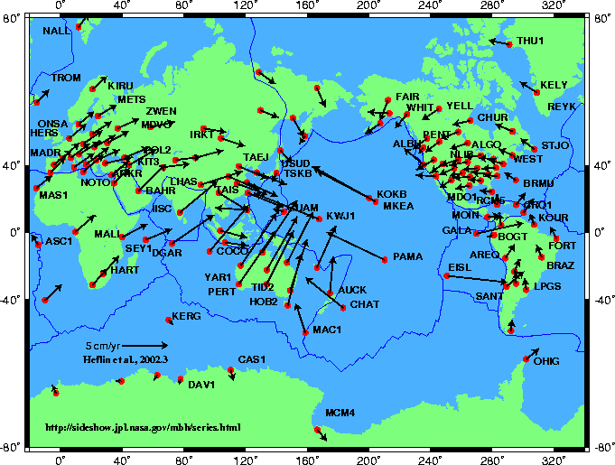

- SLR (Satellite Laser Ranging): Used for satellite calibration. The orbit of the satellite is accurately measured using high energy lasers. The satellite is “pinged” for a short period and an orbit is calculated. Numerous base stations range to the satellites, and the combined results are used to calculate a very accurate track. The precision of the ranging process is claimed to be better than 5mm in the x-y direction and better than 10mm in the z direction.

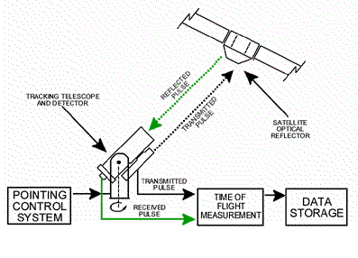

What is Space VLBI, Jet Propulsion Labs, NASA, http://sgra.jpl.nasa.gov/us-space-vlbi/tutorial/svlbi.html
Based on approximate fugures for the Mt Stromlo SLR Station run by Electro Optic Systems pty ltd

