Geodetic Data Modelling System (GDMS)
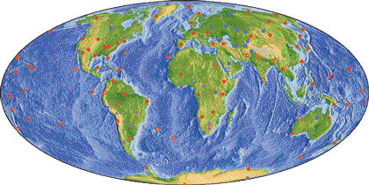

Blake Swadling – u982087

Daniel Fernandez – u991672

Nick Wheatstone – u983131

Kristy Van Der Vlist – u983118

Michael Still – u964076

Introduction

The Geodetic Data Modelling System (GDMS) is a software package to aid in the analysis of space geodesy data. This system offers support for the following three types of geodetic data.

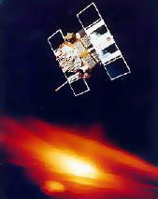
Global Positioning System (GPS)

GPS is a constellation of 24 satellites, which are used for navigation and geodetic position measurements. Position estimates are determined from satellite signals, which are recorded, daily, by GPS receivers on the ground.
A GPS Satellite
The quality of the measurements can vary considerably, depending upon satellite availability. A major concern expressed by Airservices Australia is that “it is not known when the integrity of the measurements is not acceptable”. This lack of consistency is also problematic for the geodetic community, who are measuring movements by mere millimetres.

Very Long Baseline Interferometry (VLBI)

Radio telescopes around the world can be linked together electronically to create an earth-sized "interferometer," which creates the effect of one giant telescope as large as the earth. These enormous telescopes can be used to see astrophysical objects in better detail than any other telescopes currently in use.

VLBI is a well-established observing technique used by radio astronomers. It provides a very accurate measurement of the earth's orbit, regardless of atmospheric effects. In addition, it uses a low sample rate which not affected by high frequency noise. This noise immunity makes it ideal for providing a means for error reduction in the GPS data.

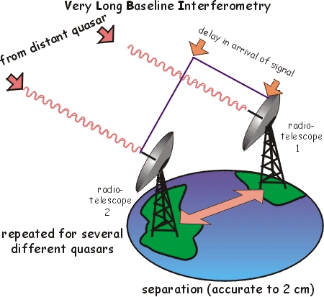

Basic VLBI Operation.
Satellite Laser Ranging (SLR)

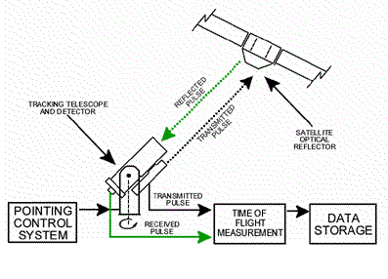
Basic SLR Operation.

The orbit of satellites is accurately measured using high-energy lasers. The satellite is “pinged” for a short period and an orbit is calculated. Numerous base stations range to the satellites, and the combined results are used to calculate a very accurate path.
The precision of the ranging process is claimed to be better than 5mm in the x-y direction and better than 10mm in the z direction.

GDMS Functionality

The GDMS offers the following types of modelling and analysis of GPS, VLBI and SLR data.

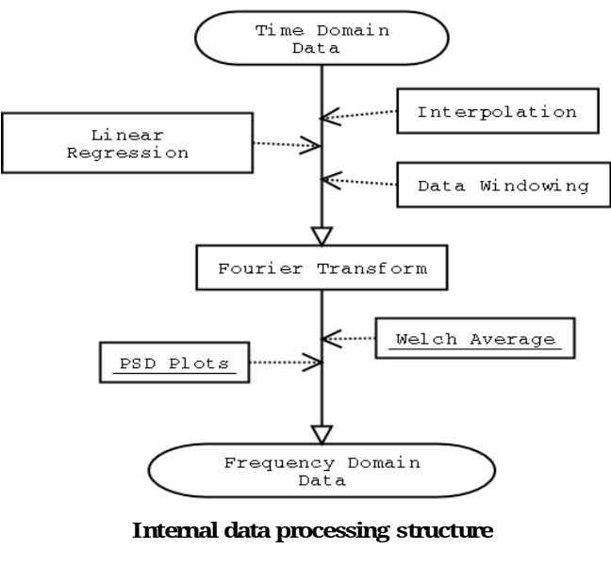

Time Domain Analysis

Linear regression modelling

- Provides an average rate of continental drift.
- Allows white noise and random walk to be seen.
- Measures the magnitude of data abnormalities.

The GDMS offers two types of linear regression modelling in the time domain, both based on least squares:

- Diagonal variance co-variance (VCV) - optimized for speed.
- Non-diagonal matrix optimized for precision.

Data Filtering

The data processed by GDMS needs to be filtered for the following reasons:

- The data may have been sampled at irregular intervals.
- The sample rate of the data is lower than some frequencies of interest resulting in aliasing.

To overcome these problems numerical interpolation is used:

- To set a regular sampling rate.
- To provide a much higher sampling rate thus removing aliasing effects.

For maximum flexibility, the GDMS offer four interpolation techniques:

- Cubic splines.
- Newton divided differences.
- Linear interpolation.
- Nearest neighbour.

Frequency Domain Analysis

By converting the data into the frequency domain, the GDMS can detect and account for non-random errors. Converting back to the time domain allows the effects of error correction to be seen.

The option of a Welch average will be available to:

- Reclaim lost accuracy due to numerical interpolation.
- Reduce the amount of random noise visible in the frequency data making it easier to see non-random frequency peaks.

Customers

This project was initiated by Associate Professor Peter Morgan at the University of Canberra, Australia, with some input from Massachusetts Institute of Technology.

Potential customers include:
- National Mapping Division, Geoscience Australia.
- Universities Worldwide.
- Organisations with a need for geodetic data processing.

Contact Information

Blake Swadling
blake@swaddling.com

Daniel Fernandez
daniel.Fernandez@ise.canberra.edu.au

Nick Wheatstone
nick.wheatstone@ise.canberra.edu.au

Kristy Van Der Vlist
kristy.vandervlist@ise.canberra.edu.au

Michael Still
mikal@stillhq.com

The Boeing Company, http://www.boeing.com, 28 July 2002
Ely, B., Development of Australia's Ground-based Regional Augmentation System for GPS, IEAust seminar, 21 May 2002
Dynamic Earth, http://earth.leeds.ac.uk/dynamicearth, 28 July 2002
Electro Optic Systems, http://www.eos-aus.com, 28 July 2002.
Based on approximate figures for the Mt Stromlo SLR Station run by Electro Optic Systems Pty Ltd

