**TERADATA CASE STUDY-2**

Name: SANTANU ADHIKARY

Employee ID : 2320846

Cohort Code : CSDAIA24DB002

Create database, table and insert values to it.

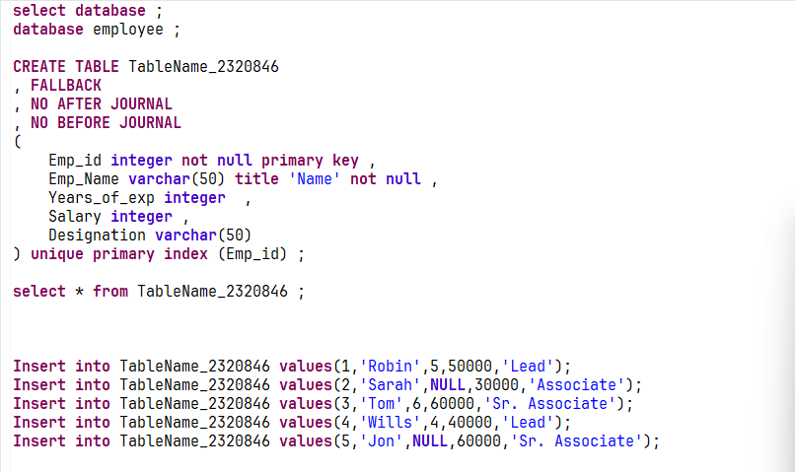

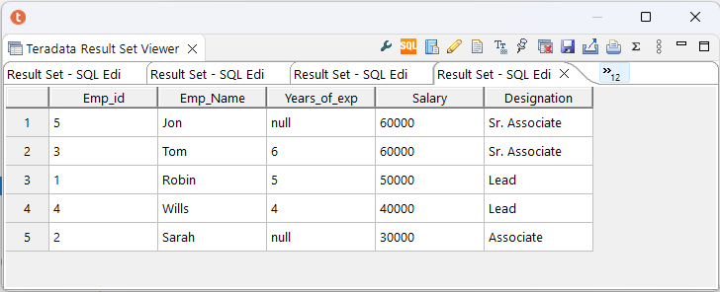

QUESTION 1

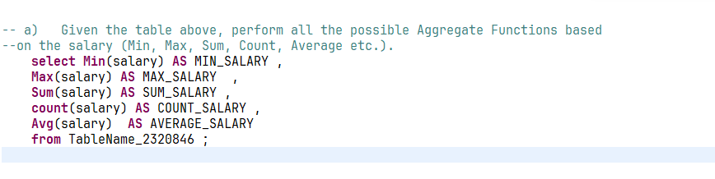

QUESTION 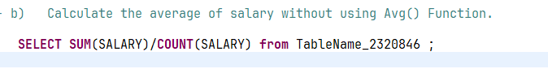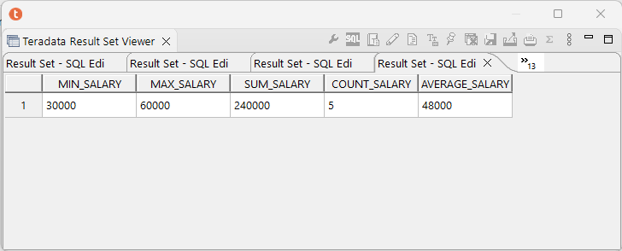 2

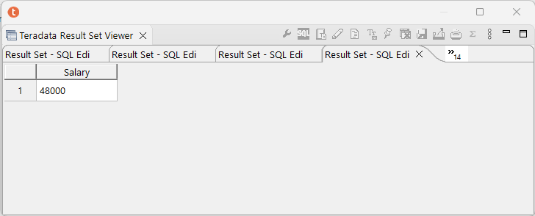

QUESTION 3

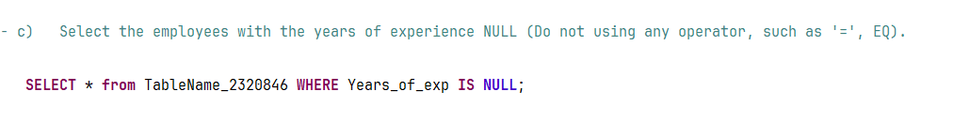

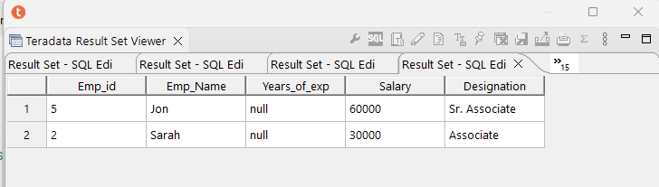

QUESTION 4

