**TERADATA CASE STUDY- 4**

Name: SANTANU ADHIKARY

Employee ID : 2320846

Cohort Code : CSDAIA24DB002

Create database, table and insert values to it.

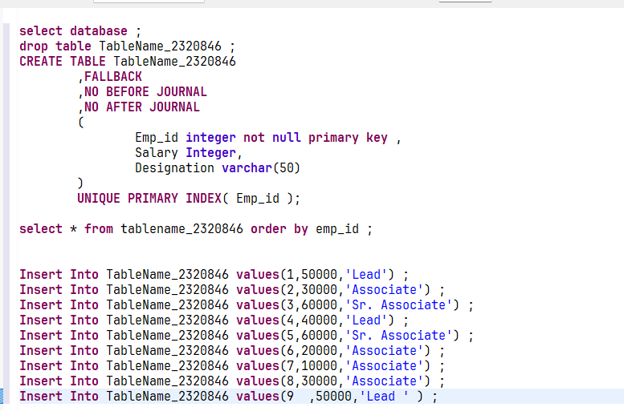

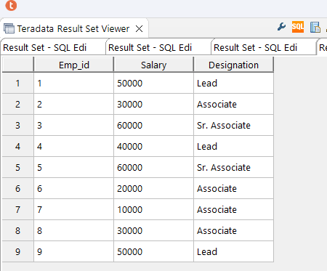

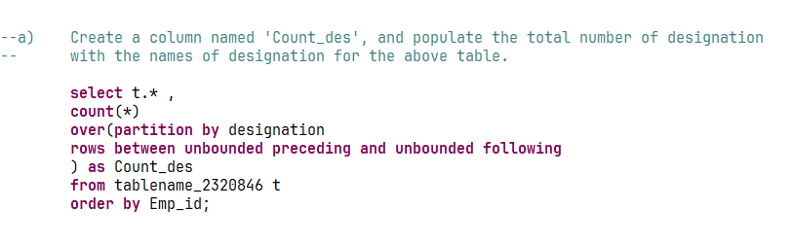 Question 1 :

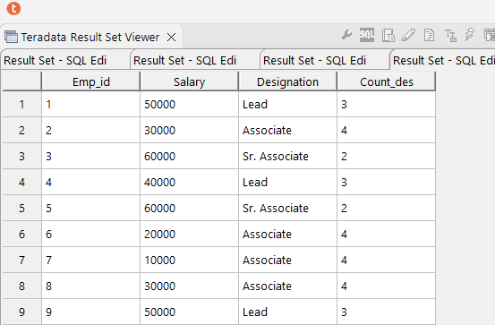

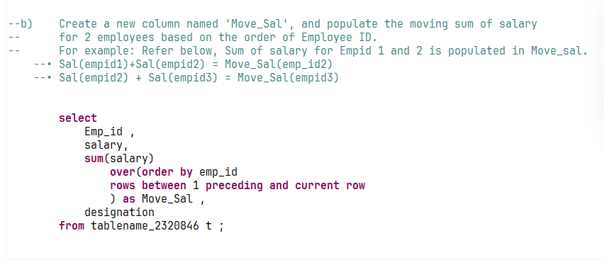Question 2 :

