**TERADATA CASE STUDY-5**

Name: SANTANU ADHIKARY

Employee ID : 2320846

Cohort Code : CSDAIA24DB002

Create database, table and insert values to it.

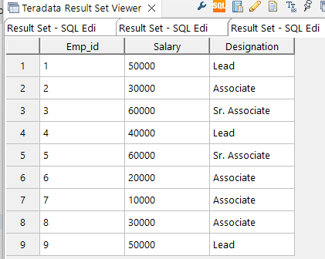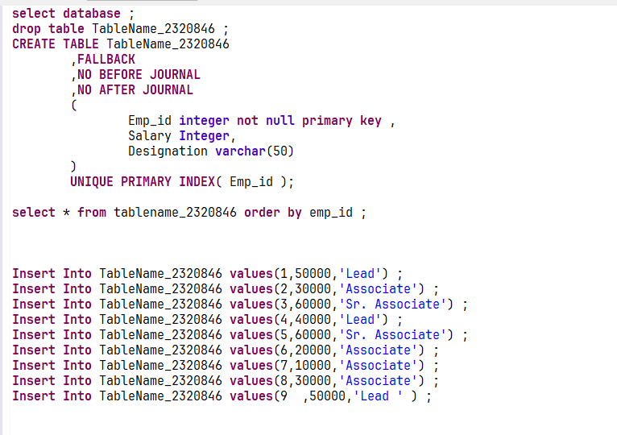

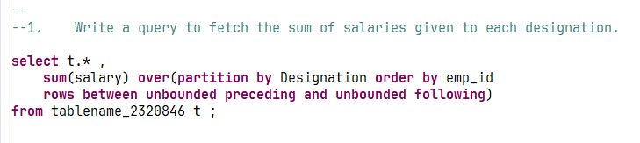Question 1 :

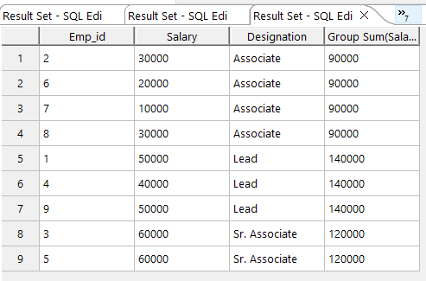

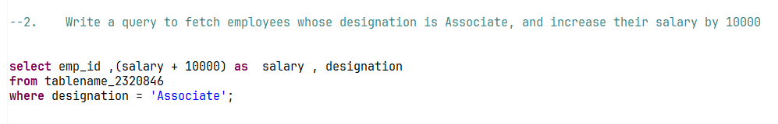Question 2:

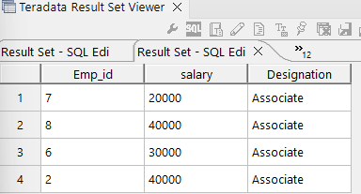

Question 3:

